The Paw Print |  |  | Fall Issue 2014
Straughn Middle School
  2014-2015 SMS Student Council  President:Tucker Reynols Vice President: Cameron Stephens Secretary: Samuel Driver Treasurer: Allie Kelley Reporter: Jack Pettus  6th Grade Reps: Will Driver , Spirit Hall, Zach Howard  7th Grade Reps: Mason Barnes,Noah Fallin  8th Grade Reps:  Morgan Bledsoe, Ty Cobb  What a great start to a new school year! Straughn Middle School proudly welcomes 101 sixth graders, 112 seventh graders, and 106 eighth graders. Of the 319 students enrolled, 21 are new-to-Straughn students. These students were invited to attend our annual Tiger Pride party and enjoyed refreshments as they got acquainted with each other.  In addition to the new students, two new teachers were added to the SMS team. Ms. Shanda Osborn, a 2008 graduate of Straughn High School is teaching eighth grade math and coaching volleyball and softball. Mr. Jim Bedsole teaches sixth grade history and coaches football and baseball.  At SMS, the faculty and staff are on a mission to provide students with the skills and knowledge to become respectful, responsible, and resourceful  members of society. We will provide a safe and supportive learning environment, where all students are treated fairly. We will work to carry on the rich tradition of producing well-educated, hardworking, and caring students who will become productive citizens.  How can parents support our mission? Parents can support our mission by creating a strong partnership with the school. A number of studies have connected  school-home collaboration to better learning, healthy self-esteem, and more positive attitudes and behavior in life. Parents can help contribute to a successful school year by encouraging his/her child to do the following:  - Attend school daily and arrive on time  - Complete all homework assignments  - READ! READ! READ!  - Discuss his/her school experiences daily  - Communicate with teachers  SMS invites parents to be partners. We welcome parents to become actively involved in their child’s educational experience. Volunteers accepted! Feel free to contact the office if you would like to serve on committees, tutor students, plan activities/events, help with outdoor projects, and/or any other contribution which will benefit the school and students in a positive manner.  Looking forward to a Terrific year!  - | New Students, New Teachers, New Opportunities!
 | By: Ms. Scott , Principal
Looking Ahead:

Oct 23 Report cards
Oct 27 Picture
Deadline
Oct 31 DTF Program
Oct 31 Fall Festival
Oct 31 Box Top Bash
Nov 11 Veteran’s Day
Nov 12 Veteran’s
Program
Nov 20 Progress
Report
Nov 24-Nov 28
Thanksgiving
Holidays
Dec 19 Christmas
Program
Dec 22- Jan 5
Christmas
Holidays
iNow
Home Portal

The iNow Home Portal is now available to all SMS parents and guardians. This home portal website allows you to view your child’s grades, attendance and discipline information. Announcements and updates pertaining to events taking place at SMS are also visible through the Home Portal. Each student was issued a unique username and password needed in order to log-in to the website. Instructions for accessing the iNow website were also distributed to each student. Additional assistance for accessing the information is available to anyone by calling Ellen Sikes @ (334) 222-4090.
Following The Seven Decisions in 8th Grade
Bright Beginning to a New Year
By Paula Simpson

It’s another full house for SMS as we welcome the new 6th graders to the mighty middle school campus. 101 eager new faces join our student body, happy and full of school spirit! And who better to lead them in school spirit than our 2014-2015 JV Cheerleaders and newly added mascots!

The JV cheer squad is composed of 15 young ladies in the 7th and 8th grade. They have been working very hard since the Spring to bring their best to our school. Recently, they participated in the Auburn University Cheer Extravaganza. Not only did Auburn defeat San Jose State, but our girls were AWESOME!

Not only have these young ladies been working hard at practice and on the field, but they have been hitting the books! The cheer sponsors, Mrs. Lee Lumpkin and I have issued the HONOR ROLL Challenge. The squad is to try to obtain the highest grades than any other extra curricular group/ club in the middle school! So we would like to challenge the JV football team, the 7th grade boys basketball team, the 8th grade boys basketball team, the Girls ’basketball team and the middle school volleyball team. Good Luck!

By: Mrs. Burleson
The 8th grade has begun the year with enthusiasm and promise. As the English teacher, I am excited to introduce the students to Michael Holder as we read our first novel, The Young Traveler's Gift, by Andy Andrews. Michael began his journey as the last young traveler to receive the unique gifts of wisdom offered by historical greats. In his senior year of high school, Michael hit rock bottom. After being caught in the wrong place at the wrong time, he was suspended from the track team and lost his college scholarship. His coach was angry and his parents disappointed. He was diving headfirst into a downward spiral. Facing the bleak future ahead, he saw no way out and wondered if life was really worth living. But now, with some divine intervention, he's been given a second chance and offered a once-in-a-lifetime journey of discovery.
Background information for the novel began with the students completing a mini-research project that was presented on September 7th. Using the Alabama Virtual Library on iPads, students researched a person from history who contributed positively to society. Helen Keller, Molly Brown, Dr. Seuss, Thomas Edison, and Martin Luther King, Jr. are a few of the people students chose.
Please, ask your student what the Seven Decisions are as we study this novel. My hope is that this novel impacts my students' lives, and you, as parents and guardians, see the results in their lives. I envision a productive and rewarding year with the current 8th grade class! We will follow the Seven Decisions, and we will make this the best year ever!

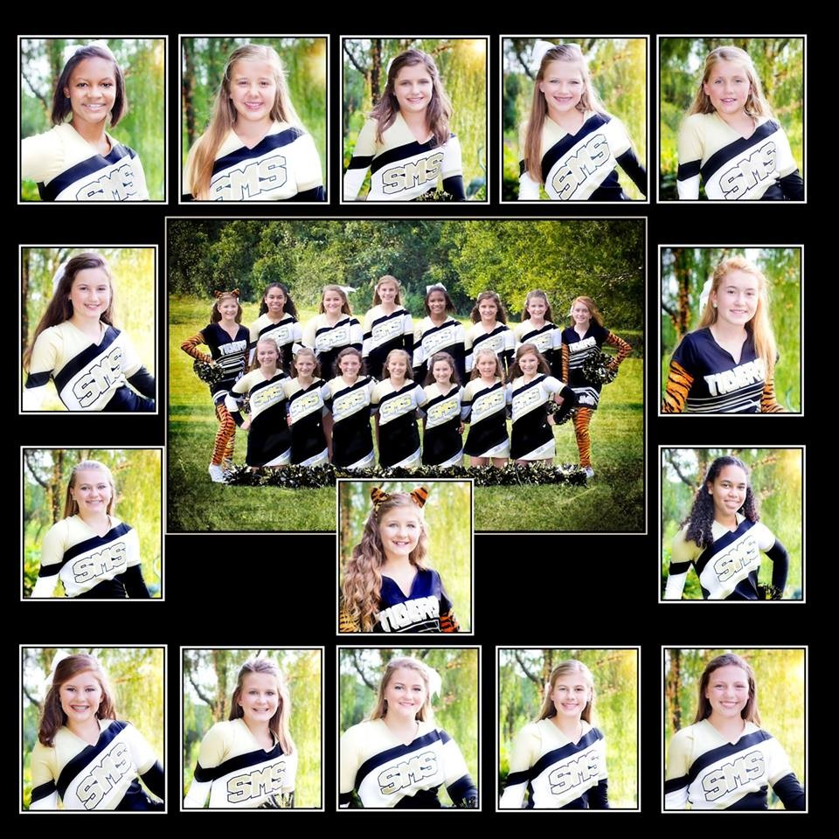

Equal Opportunity Policy: It is the official policy of Covington County School System that no person shall, on the ground of race, sex, religion, color, creed, national origin, handicap, or age, be excluded from participation in, be denied the benefits of or be subjected to discrimination under any program, activity, or employment. Inquiries of complaints regarding compliance with federal regulations on 504, Title I, Title II, and Title IX may be directed to Donny Powell, Covington County Board of Education, 807 C.C. Baker Avenue, Andalusia, AL. 36420, (334) 222-7571.

