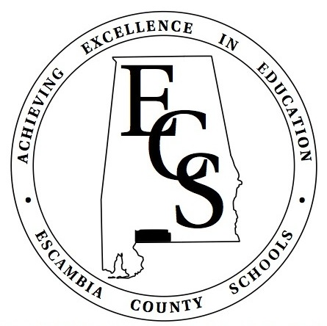

Virtual School Program

Student Handbook 2020-2021

escambiak12.schoolsplp.com
Username
Password

Escambia County Virtual School Parent Letter

Dear Parents/Guardians,

The Escambia County Board of Education is providing our students and their families a digital learning pathway through the Escambia County Virtual School by incorporating a program called SchoolsPLP. This program provides our students in grades K-12 the option to complete comprehensive and rigorous on-line courses in a flexible manner. SchoolsPLP was also selected as an approved content provider by the Alabama State Department of Education. The content included in this platform is aligned to the Alabama College and Career Ready Standards.
Through SchoolsPLP, students will engage in coursework that is tailored to their individual needs while meeting state requirements. Students will interact with the content and will complete all their work in a digital manner. Students will have access to program support help and their teachers at their base schools through email and messaging tools built within the program.
You and your student will be given specific login information and credentials to access the virtual learning program and content. If at any time you have any questions or concerns, please contact your zoned school principal or teacher. You can also contact me, Patricia Frazier, the Virtual School Program Coordinator, at 251-296-4113 or patricia.frazier@escoschools.net.
Included in the student handbook, you will find the SchoolsPLP course catalog, the SchoolsPLP-The Student’s View, and an agreement page which you will sign and return. In addition, all policies, rules, and regulations that apply to all regular traditional students attending traditional school (brick and mortar), apply to the Virtual School students as members of the Escambia County School District. You will be given a base school handbook and a Student Code of Conduct. There may be times that your child in grades K-12 will be required to be on-campus such as for state testing.

Sincerely,

Patricia L. Frazier

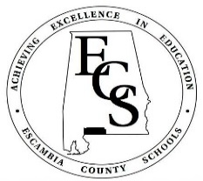
Welcome to the
Escambia County Virtual School Program

At Escambia County Schools we recognize that every student is unique. Our engaging, online curriculum provided through SchoolsPLP, is tailor made to fit your student’s individual needs. The Escambia County School System chose SchoolsPLP as our on-line learning platform, because it is a state recognized and fully accredited private virtual school for grades K-12. The high-quality instructional content is fully aligned to the Alabama College and Career Ready Standards.

How It Works:
It will be the parent’s/guardian’s responsibility to notify the zoned school principal and/or school counselor of their choice to attend Virtual School. After the parent notifies the school, the school counselor will inform Patty Frazier, the Virtual School Program Coordinator. After participating in the required Virtual School Orientation, parents will receive further instructions.

Escambia County Schools will work cooperatively with the parent/guardian and student to ensure that student schedules, and courses are aligned to the student’s needs and that all parties are collaboratively monitoring student progress and reporting grades. All virtual school program students in grades K-12, may be required to take state mandated tests at their zoned schools.

Students who utilize the virtual option assume full responsibility in personal time management, organization, self-direction, self-motivation, and personal discipline to complete course requirements on time. Parents are responsible in monitoring student work and completion.

While there are NO fees required for the enrollment of students in the Escambia County Virtual School Program, parents must be able to provide the student with internet service and computer related needs, commit to monitoring student on-line learning, communicate regularly with the supervisor, school teachers, and/or principal and understand that the student must complete the current quarter (NINE WEEKS) before being eligible to withdraw from the virtual school program. Parents must also understand that once a student opts out during a school year, the student can not re-enroll in full virtual school for the remainder of that school year. It will be at the Superintendent’s discretion to allow any other changes concerning enrollment on a case by case basis.

Who will be my child’s teacher?
Your child will be assigned to an Escambia County Schools teacher. You will be able to communicate with the teacher(s) through email and messaging built within the SchoolsPLP program.

What is the curriculum?
The curriculum is provided through SchoolsPLP. All the content is built into the on-line program and your student will work within the program. It is not a face-to-face virtual delivery method.

How long can a student remain in the Virtual School Program?
Students have the option to remain in the virtual school program for the entirety of the school year 2020-2021. However, if a student or a parent decides that they do not want to continue in the virtual option, the students must remain in the virtual school program through the completion of their currently enrolled quarter (current nine weeks) before transitioning back to traditional school. Do keep in mind that if a student/parent withdraws from of the virtual school program during the school year, that student will not be allowed to re-enroll in the virtual school program for the remainder of the school year. Withdrawal from the virtual school program will not exempt a student from the possibility of remote instruction. Remote instruction could be required by the school in the event of a school closure or to protect the health and safety of students and faculty. It is important to remember that once a student withdraws from the virtual program, they will not participate in virtual instruction for the remainder of the school year unless they are instructed to by the school.

Does my student have to take the required state assessments?
Yes. Your student is required to take all the state required assessments at the regular school.

Is attendance taken daily?
Yes. Attendance is taken daily and seatwork time is computed and time stamped. The program has built-in components that record these aspects. Virtual students will follow the regular school calendar for all students regardless of their instructional delivery method.

Helpful Hints:
- Set up a school work area in your house.
- Do not get behind in any of the coursework.
- Contact your teacher if you need assistance.
- Students must work in every subject every day.
- Set a schedule and stick with it daily.
  - Example:
8:00 a.m. Breakfast/free time
8:30 a.m. Social Studies
9:30 a.m. Language Arts
10:30 a.m. Math
11:30 a.m. Recess
12:00 p.m. Lunch
1:00 p.m. Science
2:00 p.m. Rotating extra lesson
3:00 p.m. End of Day

Suggested Virtual School Supply List to Help You Be Successful:
- Quality Internet service, printer, paper, and ink cartridges
- Pens, pencils, highlighters (crayons, markers), pencil sharpener
- Notecards, sticky notes, poster paper
- Folders or a means to organize your work (bookshelf, crates, or bins)

Log In
URL: escambiak12.schoolsplp.com
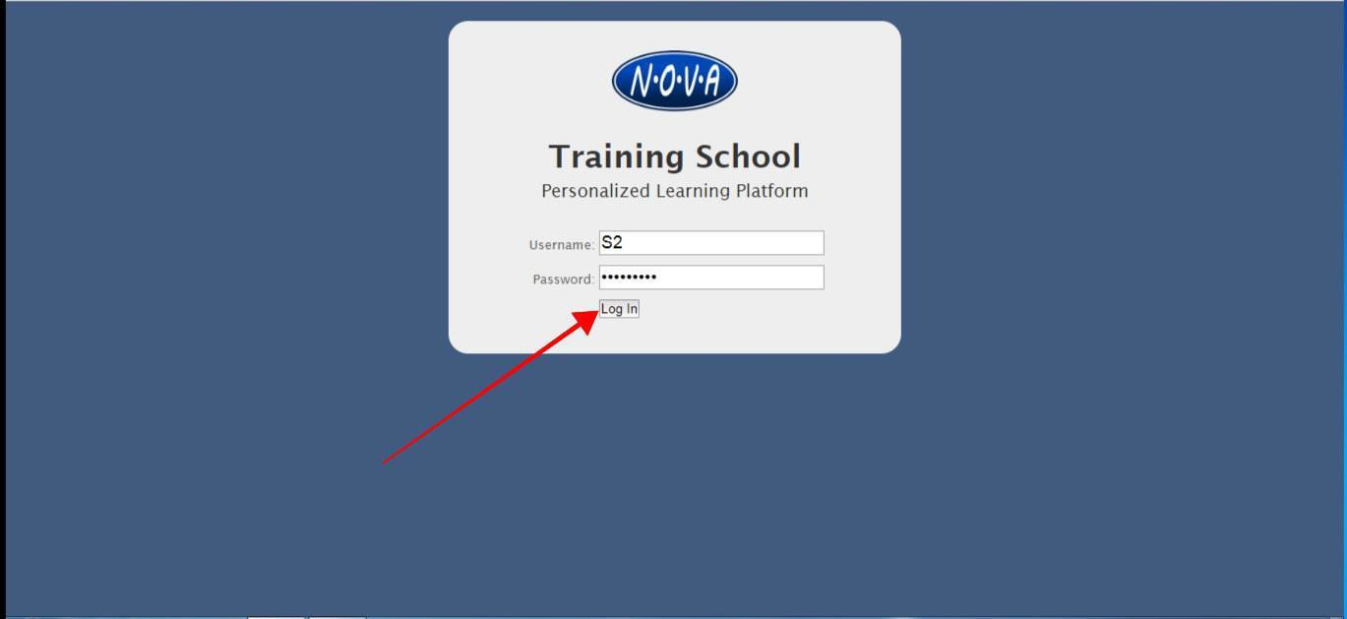
Username and password is on the cover of this handbook.

Student Overview
The student overview lists students’ courses, along with progress, performance, and the latest activity. This is the default page that opens when a student logs in. The only exception is if a student has a message from his/her teacher.
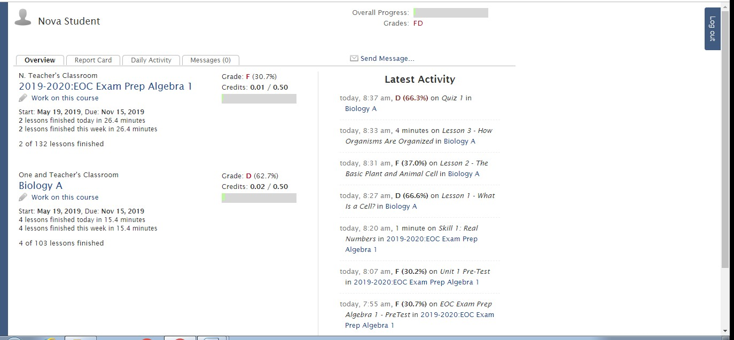

Report Card
This tab provides a detailed report of the students’ progress and performance in each course.
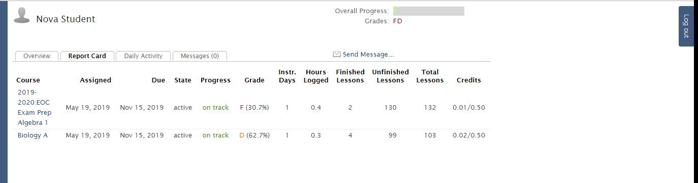

Daily Activity
This tab lists activity by the student each day. NOTE: The times listed are MST (Mountain Standard Time). Add 3 hours during our Daylight Savings Time and 2 hours during our Eastern Standard Time.
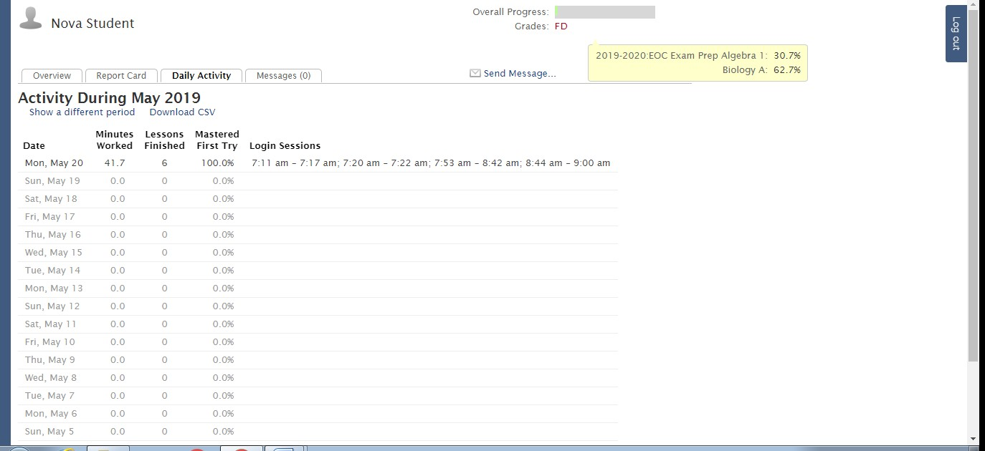

Messages
If a student has a message from the teacher, this screen will be the default when a student logs in. The student must click on the message and then reply or acknowledge the message before he/she can go to Overview and begin work.

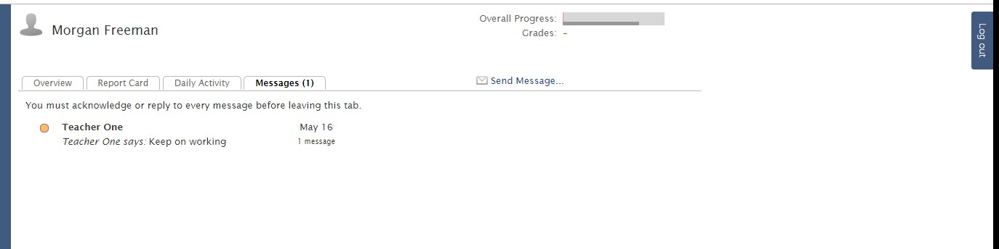

A student may also send the teacher a message from this page.
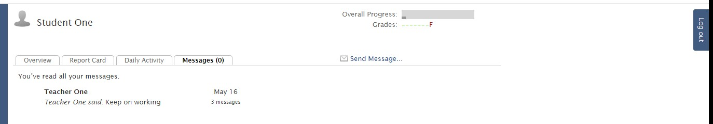

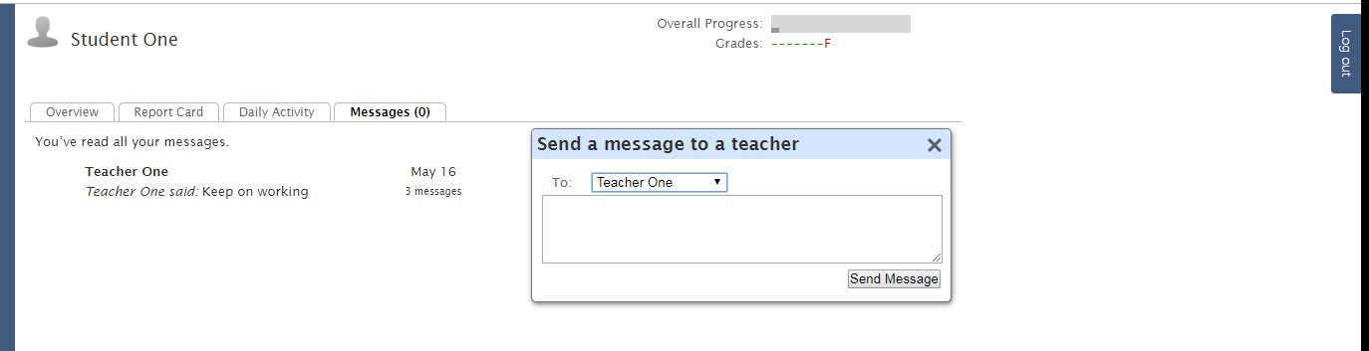

Working on a Course
From the Overview screen, students may click on the name of the course to get assignment details
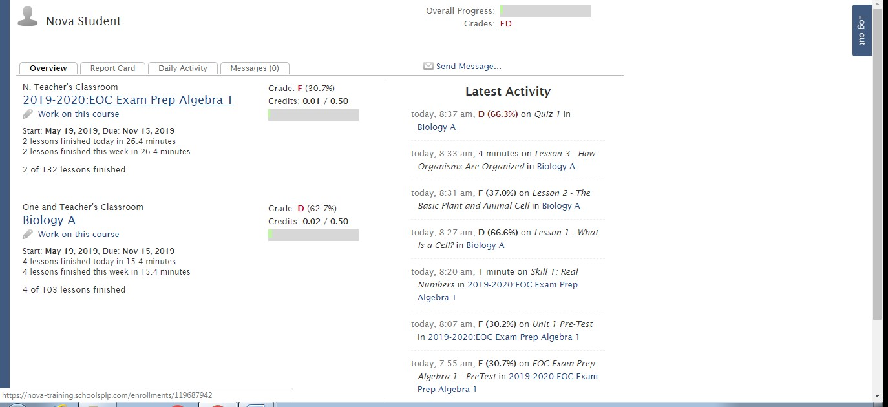

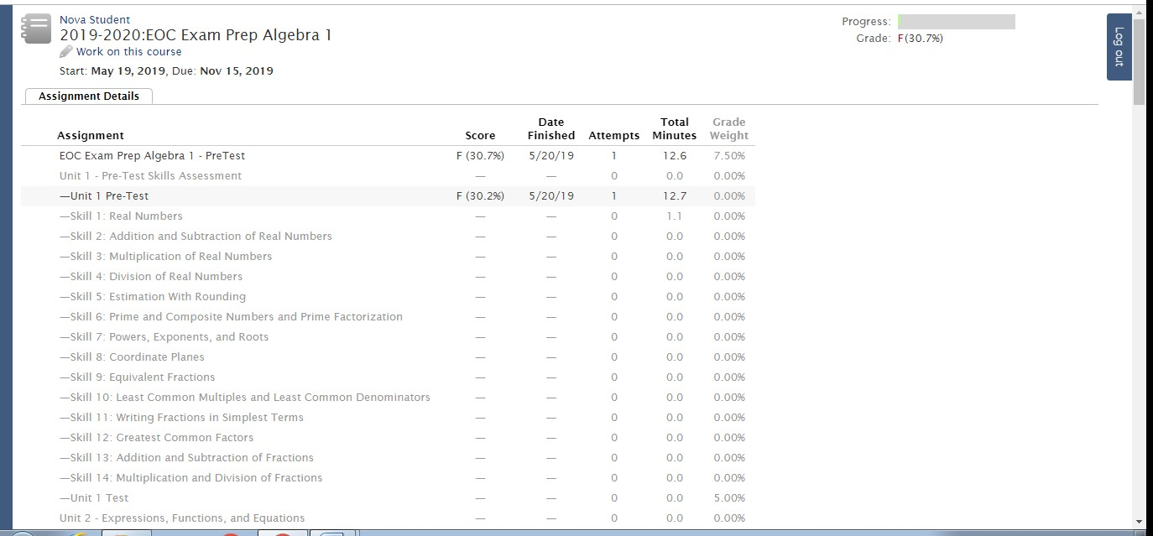

On the Overview screen, the student may also click on Work on this course (pencil) to enter the course.
On the Overview screen, the student may also click on Work on this course (pencil) to enter the course.

After entering a course, the view is just like it was in PCx, since PLP is also built on the Agilix platform.
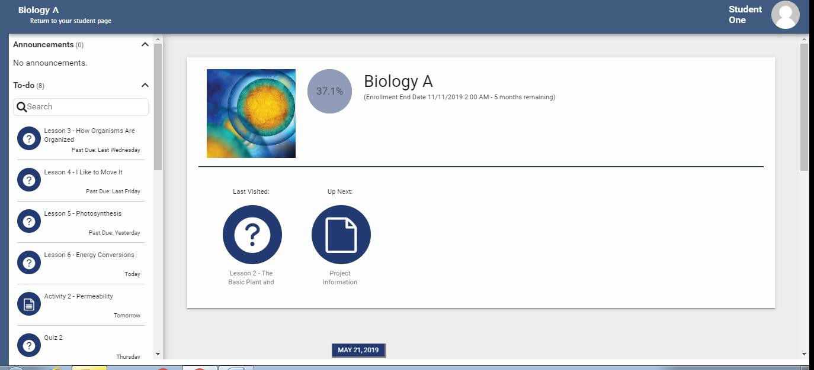

The student will click into an assignment and work through the information, which may include reading,
answering questions, watching videos, etc. When finished with an activity, he/she will click SUBMIT.
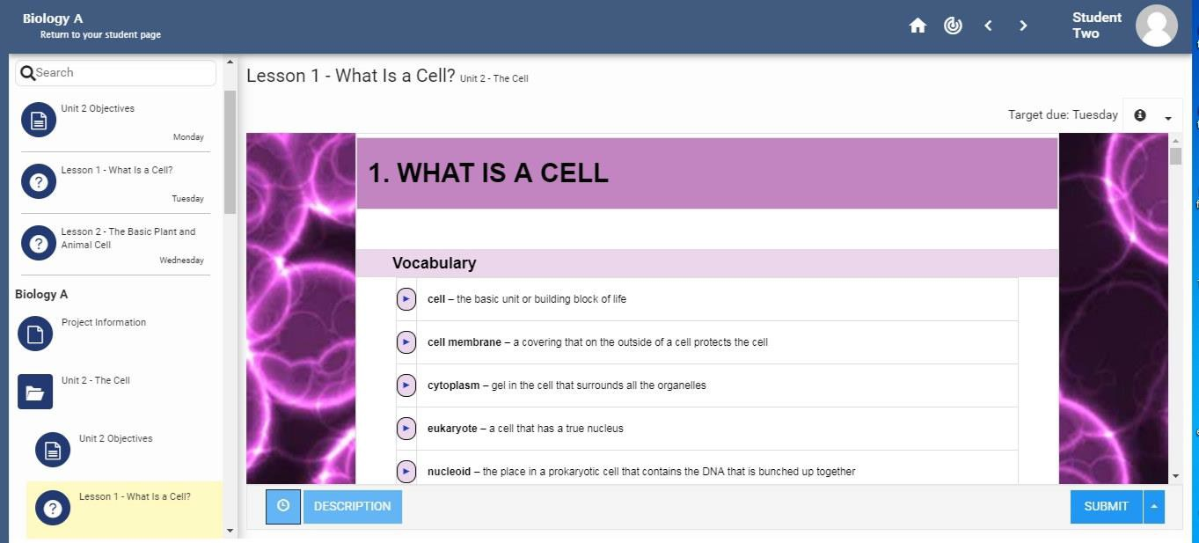

To return to the Student Page, click on the link below the course name in the upper left corner.

Exiting the Program
Students log out of the program by returning to the student page and clicking on Log out on the top right side of the page.
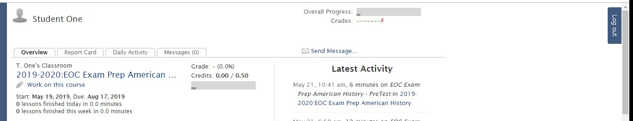

Internet Acceptable Use/Copyright Policy
Students and employees are provided with the opportunities to access a variety of informational technologies. The primary goal of the technology environment is to support the educational and instructional endeavors of the students and employees of Escambia County schools.
Information technologies in the Escambia County schools include all computers owned by the district as well as hardware, software, data, communication networks, modems, telephones lines, etc. associated with these systems. These guidelines apply to all persons who may attempt to use a computer resource owned by the system.
All technology resources will be used in accordance with any and all school system policies and procedures, as well as with local, state, and federal laws and/or guidelines governing the usage of technology and its component parts.
- School personnel must take all reasonable precautions to prevent unauthorized access to accounts, passwords and data and any other unauthorized usage within and outside the Escambia County schools.
- Duplication of any copyrighted software is prohibited unless specifically allowed for in a license agreement.
- Backup copies of software should be made only if allowed in license agreement
- Single copy programs are to be used on one computer at a time.
- Only district-level personnel or a local school designee shall sign license agreements for a school in the system or for the system itself. System-wide agreements will be distributed to all schools.
- District technology personnel must install or supervise the installation of all software in use on local networks. Students and staff members are not authorized to install network software.
- Personal software may not be loaded on a computer without prior written authorization from district technology personnel.
- Individuals are not authorized to make copies of any software or data.
- Students and employees may not download any copyrighted material and duplicate in any form.
- Under no condition should a user provide a password to another student.
- Students may not trespass in another person’s folder or work files.
- Students must not delete or attempt to delete any program or data other than their own.
- Students will promptly disclose inappropriate messages or information to the teacher or administrator.
- Escambia County schools will cooperate fully with local, state, and federal officials in any investigation related to any illegal activities conducted through school internet accounts.
- No one must attempt to modify technology resources, utilities/configurations or breach any technology security system.

Acceptable Use Policy for Technology Resources
Escambia County Schools (ECS) recognizes that access to technology in school gives students greater opportunities to learn, engage, communicate, and develop skills that will prepare them for work, life, and citizenship. We are committed to helping students develop 21st-century technology and communication skills. To that end, we provide access to technologies for student and staff use. That access carries with it responsibilities and obligations as expressed in this Acceptable Use and Internet Safety Policy (AUP). This AUP outlines the guidelines and behaviors that all users are expected to follow when using school provided technologies or when using non-Escambia County Schools devices.
- The ECS network is intended for educational purposes.
- All activity over the network or using district technologies may be monitored and retained.
- Access to online content via the network may be restricted in accordance with our policies and federal regulations, such as the Children's Internet Protection Act (CIPA).
- All users are expected to follow the same rules for good behavior and respectful conduct online as offline.
- Misuse of school resources can result in disciplinary action for both students and staff. These actions could include expulsion for students and termination for staff.

ECS makes a reasonable effort to ensure users' safety and security online, but will not be held accountable for any harm or damages that result from use of school technologies. Users of the district network or other technologies are expected to alert IT staff immediately of any concerns for safety or security.

Technologies Covered
ECS may provide Internet access, desktop computers, mobile computers or devices, videoconferencing capabilities, online collaboration capabilities, message boards, email, and more. As new technologies emerge, ECS will attempt to provide access to them. The policies outlined in this document are intended to cover all available technologies, not just those specifically listed. User owned devices that are not property of ECS might be connected to the network in some manner. In this case, those devices are covered under this AUP.

General Usage Policies
All technologies provided by the district are intended for education purposes. All users are expected to use good judgment and to follow the specifics of this document as well as the spirit of it: be safe, appropriate, careful and kind; don't try to get around technological protection measures; use good common sense; and ask if you don’t know.

Internet Access/Web Access
ECS provides its users with access to the Internet, including websites, resources, content, and online tools. That access will be restricted in compliance with CIPA regulations and school policies. Web browsing may be monitored and web activity records may be retained indefinitely. Users are expected to respect that the web filter is a safety precaution, and should not try to circumvent it when browsing the Web. If a site is blocked and a user believes it shouldn't be, the user should follow district protocol to alert an IT Services staff member or submit the site for review. ECS provides a network for use by employees, students, and guests. Users should not connect a device to the network without following district protocols. All online services provided by the district are not private for the users of the service. Applications such as online testing software or learning management systems are monitored and can be reviewed by the administration of ECS at any time without notice. Users who bring devices onto Escambia County Board of Education property which have access to cellular data that is not filtered by the ECS, should not use these devices in a way to circumvent the protocols set in place to monitor and filter web access.

Email and Google Apps for Education
Escambia County Schools has created email accounts for all students in grades 9-12 to allow for collaborative sharing using Google Apps for Education. These accounts will be used at school for school related projects.

Google Apps
A web-based platform utilized in instruction, Google Apps has thousands of educational applications which teachers can use in all classrooms. Through Google Apps, students will be able to:
- Email teachers
- Create and save documents, presentations, spreadsheets
- Collaborate virtually with partners or groups on school projects
- Turn in assignments and assessments through the web, and more!

Philosophy
Escambia County Schools encourages the use of student email and Google Apps as an effective and efficient way to improve communication between students, faculty members and administrative staff. The primary purpose of student email is to support teaching and learning. Escambia County Schools email accounts are housed on a Google mail server, thereby giving student access to Google Docs (word processor, spreadsheet, and presentation software) and also allowing teachers and students to share information housed in these file areas with others through Google Drive.

Official Email Address
All students in grades 9-12 will be assigned an escoschools.net email account. This account will be considered the student's official Escambia County email address until such time as the student is no longer enrolled.

Prohibited Conduct
Student email may not be used in the following ways:
- Unlawful activities---including harassment and/or bullying
- Commercial purposes
- Personal financial gain
- False identity in email communications
- Misrepresentation of Escambia County Schools
- Interference with Escambia County Schools technology operations through
  - electronic chain letters
  - unsolicited electronic communications
  - disruption of electronic communications

Access Restriction
Access to and use of student email is considered a privilege afforded at the discretion of Escambia County Schools.

Security
Escambia County Schools cannot and does not guarantee the security of electronic files located on the Google system. Although Google does have a powerful content filter in place, Escambia County Schools cannot assure that users will not be exposed to unsolicited information.

Privacy
The general right of privacy will be extended to the extent possible in the electronic environment. Escambia County Schools and all electronic users should treat electronically stored data as confidential and private. There is an acknowledged trade-off between the right of privacy of a user and the need of system administrators to gather necessary information to ensure the continued functioning of these resources. In the normal course of system administration, system administrators may have to examine activities, files, and electronic mail to gather sufficient information to diagnose and correct problems with system software or hardware. Users of student email are strictly prohibited from accessing files and information other than their own. The System reserves the right to access the escoschools.net Google domain, including current and archival files of user accounts when there is reasonable suspicion that unacceptable use has occurred.
If you have any questions or concerns, or wish to decline these services for your child, please feel free to contact us via email support@escoschools.net.

Devices/Mobile Devices Policy
ECS may provide users with mobile computers or other devices to promote learning outside of the classroom. Users should abide by the same acceptable use policies when using school devices off the school network as on the school network. Users are expected to treat these devices with extreme care and caution; these are expensive devices that the school is entrusting to the user's care. Any loss, damage and malfunction should be reported to the appropriate administrative authority. Users may be financially accountable for any damage resulting from negligence or misuse. Use of ECS issued mobile devices off the school network may be monitored.

Non-ECS Devices Policy
ECS maintains a cell phone policy to cover the use of cell phones in the school setting. Because of security concerns, when non-ECS mobile devices are used on campus, they should be connected only to the guest network. This includes vendor presentations or any non-school related entity that needs to access the internet.

Online Safety/Security
Users are expected to take reasonable safeguards against the transmission of security threats over the school network. These safeguards include not opening or distributing infected files or programs and not opening files or programs of unknown or untrusted origin. If you believe a computer or mobile device you are using might be infected with a virus, please alert IT. Do not attempt to remove the virus yourself or download any programs to help remove the virus.

Downloads
Users should not download, attempt to download, or run executable or install package programs not directly related to instruction. You may be able to download other file types, such as images or videos. For the security of our network, download such files only from reputable sites, and only for education purposes.

Netiquette
Users should always use the Internet, network resources, and online sites in a courteous and respectful manner. Users should recognize that among the valuable content online there is also unverified, incorrect, or inappropriate content. Users should use trusted sources when conducting research via the Internet. Users should also remember not to post anything online that they wouldn't want parents, teachers, or future colleges or employers to see. Once something is online, it's out there and can sometimes be shared and spread in ways you never intended.

Digital Citizenship/Plagiarism
Users should not plagiarize (or use as their own, without citing the original creator) content, including words or images, from the Internet. Users should not take credit for things they didn't create themselves, or misrepresent themselves as an author or creator of something found online. Research conducted via the Internet should be appropriately cited, giving credit to the original author.

Personal Safety
Users should never share personal information, including phone number, address, social security number, birthday, or financial information, over the Internet without adult permission. Users should recognize that communicating over the Internet brings anonymity and associated risks, and should carefully safeguard the personal information of themselves and others. Users should never agree to meet someone they meet online in real life without parental permission. If you see a message, comment, image, or anything else online that makes you concerned for your personal safety, bring it to the attention of an adult (teacher or staff if you're at school; parent if you're using the device at home) immediately.

Cyberbullying
Cyberbullying will not be tolerated. Harassing, dissing, flaming, denigrating, impersonating, outing, tricking, excluding, and cyberstalking are all examples of cyberbullying. Don't be mean. Don't send emails or post comments with the intent of scaring, hurting, or intimidating someone else. Engaging in these behaviors, or any online activities intended to harm (physically or emotionally) or incite harm on another person, will result in severe disciplinary action and loss of privileges. In some cases, cyberbullying can be a crime. Remember that your activities may be monitored and retained.

Education of Digital Citizenship
ECS will follow the Alabama Course of Study in teaching digital citizenship. Each grade level has a state approved technology course of study that will be used to guide instruction.

Examples of Acceptable Use

I will:
- Use school technologies for school-related activities.
- Follow the same guidelines for respectful, responsible behavior online that I am expected to follow offline.
- Treat school resources carefully, and alert staff if there is any problem with their operation.
- Encourage positive, constructive discussion if allowed to use communicative or collaborative technologies.
- Alert a teacher or other staff member if I see threatening, inappropriate, or harmful content (images, messages, and posts) online.
- Use school technologies at appropriate times, in approved places, for educational pursuits.
- Cite sources when using online sites and resources for research.
- Recognize that use of school technologies is a privilege and treat it as such.
- Be cautious to protect the safety of myself and others.
- Help to protect the security of school resources.
This is not intended to be an exhaustive list. Users should use their own good judgment when using school technologies.

Examples of Unacceptable Use

I will not:
- Use school technologies in a way that could be personally or physically harmful.
- Attempt to find inappropriate images or content.
- Engage in cyberbullying, harassment, or disrespectful conduct toward others.
- Try to find ways to circumvent the school's safety measures and filtering tools.
- Use school technologies to send spam or chain mail.
- Plagiarize content I find online.
- Post personally-identifying information, about myself or others.
- Agree to meet someone I meet online in real life.
- Use language online that would be unacceptable in the classroom.
- Use school technologies for illegal activities or to pursue information on such activities.
- Attempt to hack or access sites, servers, or content that isn't intended for my use.

Limitation of Liability
ECS will not be responsible for damage or harm to persons, files, data, or hardware. While ECS employs filtering and other safety and security mechanisms, and attempts to ensure their proper function, it makes no guarantees as to their effectiveness. ECS will not be responsible, financially or otherwise, for unauthorized transactions conducted over the school network. Any resources given to students are for educational uses only. ECS will not be responsible for any student misusing the resources that have been given to them.

ESCAMBIA COUNTY SCHOOLS ANNUAL NOTIFICATION OF RIGHTS UNDER FERPA
The Family Educational Rights and Privacy Act (FERPA) affords parents and students who are 18 years of age or older ("eligible students") certain rights with respect to the student's education records. These rights are:
- The right to inspect and review the student's education records within 45 days after the day Escambia County Schools receives a request for access. Parents or eligible students should submit to the school principal a written request that identifies the records they wish to inspect. The school official will make arrangements for access and notify the parent or eligible student of the time and place where the records may be inspected.

- The right to request the amendment of the student’s education records that the parent or eligible student believes are inaccurate, misleading, or otherwise in violation of the student’s privacy rights under FERPA. Parents or eligible students who wish to ask Escambia County Schools to amend a record should write the school principal, clearly identify the part of the record they want changed, and specify why it should be changed. If the school decides not to amend the record as requested by the parent or eligible student, the school will notify the parent or eligible student of the decision and of their right to a hearing regarding the request for amendment. Additional information regarding the hearing procedures will be provided to the parent or eligible student when notified of the right to a hearing.

- The right to provide written consent before the school discloses personally identifiable information (PII) from the student's education records, except to the extent that FERPA authorizes disclosure without consent. One exception, which permits disclosure without consent, is disclosure to school officials with legitimate educational interests.
A school official is a person employed by the school as an administrator, supervisor, instructor, or support staff member (including health or medical staff and law enforcement unit personnel) or a person serving on the school board.
A school official also may include a volunteer or contractor outside of the school who performs an institutional service of function for which the school would otherwise use its own employees and who is under the direct control of the school with respect to the use and maintenance of PII from education records, such as an attorney, auditor, medical consultant, or therapist; a parent or student volunteering to serve on an official committee, such as a disciplinary or grievance committee; or a parent, student, or other volunteer assisting another school official in performing his or her tasks.
A school official has a legitimate educational interest if the official needs to review an education record in order to fulfill his or her professional responsibility. Upon request, the school discloses education records without consent to officials of another school district in which a student seeks or intends to enroll, or is already enrolled if the disclosure is for purposes of the student’s enrollment or transfer.
- The right to file a complaint with the U.S. Department of Education concerning alleged failures by Escambia County Schools to comply with the requirements of FERPA. The name and address of the Office that administers FERPA are:
Family Policy Compliance Office
U.S. Department of Education 400 Maryland Avenue, SW Washington, DC 20202
FERPA permits the disclosure of PII from students’ education records, without consent of the parent or eligible student, if the disclosure meets certain conditions found in §99.31 of the FERPA regulations. Except for disclosures to school officials, disclosures related to some judicial orders or lawfully issued subpoenas, disclosures of directory information, and disclosures to the parent or eligible student, §99.32 of the FERPA regulations requires the school to record the disclosure. Parents and eligible students have a right to inspect and review the record of disclosures. A school may disclose PII from the education records of a student without obtaining prior written consent of the parents or the eligible student:
- To other school officials, including teachers, within the educational agency or institution whom the school has determined to have legitimate educational interests. This includes contractors, consultants, volunteers, or other parties to whom the school has outsourced institutional services or functions, provided that the conditions listed in §99.31(a)(1)(i)(B)(1) - (a)(1)(i)(B)(2) are met. (§99.31(a)(1))
- To officials of another school, school system, or institution of postsecondary education where the student seeks or intends to enroll, or where the student is already enrolled if the disclosure is for purposes related to the student’s enrollment or transfer, subject to the requirements of §99.34. (§99.31(a)(2))
- To authorize representatives of the U. S. Comptroller General, the U. S. Attorney General, the U.S. Secretary of Education, or State and local educational authorities, such as the State educational agency in the parent or eligible student’s State (SEA). Disclosures under this provision may be made, subject to the requirements of §99.35, in connection with an audit or evaluation of Federal- or State-supported education programs, or for the enforcement of or compliance with Federal legal requirements that relate to those programs. These entities may make further disclosures of PII to outside entities that are designated by them as their authorized representatives to conduct any audit, evaluation, or enforcement or compliance activity on their behalf. (§§99.31(a)(3) and 99.35)
- In connection with financial aid for which the student has applied or which the student has received, if the information is necessary to determine eligibility for the aid, determine the amount of the aid, determine the conditions of the aid, or enforce the terms and conditions of the aid. (§99.31(a)(4))
- To State and local officials or authorities to whom information is specifically allowed to be reported or disclosed by a State statute that concerns the juvenile justice system and the system’s ability to effectively serve, prior to adjudication, the student whose records were released, subject to §99.38. (§99.31(a)(5))
- To organizations conducting studies for, or on behalf of, the school, in order to: (a) develop, validate, or administer predictive tests; (b) administer student aid programs; or (c) improve instruction. (§99.31(a)(6))
- To accrediting organizations to carry out their accrediting functions. (§99.31(a)(7))
- To parents of an eligible student if the student is a dependent for IRS tax purposes. (§99.31(a)(8))
- To comply with a judicial order or lawfully issued subpoena. (§99.31(a)(9))
- To appropriate officials in connection with a health or safety emergency, subject to §99.36. (§99.31(a)(10)
- Information the school has designated as “directory information” under §99.37. (§99.31(a)(11))

Notice for Directory Information
The Family Educational Rights and Privacy Act (FERPA), a Federal law, requires that Escambia County Schools, with certain exceptions, obtain your written consent prior to the disclosure of personally identifiable information from your child’s education records. However, Escambia County Schools may disclose appropriately designated “directory information” without written consent, unless you have advised the District to the contrary in accordance with District procedures. The primary purpose of directory information is to allow Escambia County Schools to include this type of information from your child’s education records in certain school publications. Examples include:
- A playbill, showing your student’s role in a drama production;
- The annual yearbook;
- Honor roll or other recognition lists;
- Graduation programs; and
- Sports activity sheets, such as for wrestling, showing weight and height of team members.

Directory information, which is information that is generally not considered harmful or an invasion of privacy if released, can also be disclosed to outside organizations without a parent’s prior written consent. Outside organizations include, but are not limited to, companies that manufacture class rings or publish yearbooks. In addition, two federal laws require local educational agencies (LEAs) receiving assistance under the Elementary and
Secondary Education Act of 1965 (ESEA) to provide military recruiters, upon request, with names, addresses and telephone listings – unless parents have advised the LEA that they do not want their student’s information disclosed without their prior written consent.
If you do not want Escambia County Schools to disclose directory information from your child’s education records without your prior written consent, you must notify the District in writing within 10 days after the distribution of this annual notification. Escambia County Schools has designated the following information as directory information:
- Student’s name
- Participation in officially recognized activities and sports
- Photograph
- Grade level
- Weight and height of members of athletic teams
- Degrees, honors, and awards received
- The most recent educational agency or institution attended

ECS VIRTUAL SCHOOL HANDBOOK
PARENT/GUARDIAN AND STUDENT ACKNOWLEDGEMENT AND ASSURANCES
- This code has been developed to help your son/daughter gain the greatest possible benefit from his/her school experience. The policies apply to all students and parents in Escambia County School System (virtual or traditional), to all school campuses, school buses and school-related activities and events.

- Parents/guardians have the responsibility for the actions of their children and are encouraged to be involved in their child’s education

- Students: As a user of the Escambia County Schools computer network, I hereby agree to comply with the acceptable Use/Copyright Policy/Internet Use Policy – communicating over the network in a reliable fashion while honoring all relevant laws and restrictions.

- Parents/Guardians: As the parent or legal guardian of a student, I grant permission for my child to access networked computer services such as electronic mail and the Internet. I understand that individuals and families may be held liable for violations. I know that Escambia County Schools do not control the content of the network systems. I accept responsibility for guidance of Internet uses by my child. I give permission to use my child’s video image or likeness thereof on district web pages and other advertisements.
Parent Copy

- Loaned devices are the sole property of Escambia County Schools. Students accept financial responsibility and possible disciplinary action for losing, destroying, or otherwise failing to return the mobile device at the time and location designated by the school administration and all accessories in its original condition at the end of the mobile device assignment. Any mobile device not returned using procedures designated by the school administration will be considered lost or stolen and will be processed as such. All repairs and parts replacements, including device charger, must be made through Escambia County Schools.

- This mobile device agreement ends on the last day of the current school year, the last day that the student is enrolled in Escambia County Schools, or upon the transition from virtual school to traditional school, whichever comes sooner. Failure to return the device by this designated date will result in a full cost of replacement charge to the parent/legal guardian responsible for this agreement.

- The full cost of replacement will be applied for intentional damage that cannot be repaired, and for lost or stolen computers. The parent/legal guardian will be held responsible for paying the full replacement cost of the device. Replacement mobile device chargers must be purchased through the school.

- Failure to return this acknowledgement will not relieve students, parents/guardians from their responsibility to know the contents of the virtual school handbook and will not excuse any student’s non-compliance with the virtual school handbook.

- I have read and understand the Escambia County Schools annual notification of rights under the Family Educational Rights and Privacy Act (FERPA).

To be completed by the student:
I have read the Escambia County Schools Virtual School Program Handbook, and understand and agree to abide by its requirements in all respects. I have read the Acceptable Use Policy, and understand and agree to abide by its requirements in all respects. Should I violate any aspect of either agreement, I shall accept and be subject to all ramifications, including but not limited to access and other privileges and other disciplinary actions.
Printed Student Name Student Signature Date

To be completed by parent/legal guardian
I request that my child be issued the equipment described below for use outside of the classroom and school. I understand and agree that if the device is lost, stolen, confiscated by law enforcement, or damaged beyond repair intentionally or due to negligence, I will be held responsible for paying the full replacement cost.
NOTE: Your signature on this acknowledgment is binding and establishes that you understand the terms and conditions of this agreement and the Acceptable Use Policy and their significance. Escambia County School Board Policies may be obtained at www.escambiak12.net.
Parent/Legal Guardian Printed Name Parent/Legal Guardian Signature Date

Device Serial / Control Number: __________________

Virtual Student Meal Distribution
The Escambia County Schools Child Nutrition Program is excited to offer distribution of meals for virtual students. Pick up days, time and location will be announced after feedback is received. Please indicate below if your student will be participating in our meal program.
Check here if you are interested in picking-up meals for your student while enrolled in virtual school.

Parent / Guardian e-mail address
ECS VIRTUAL SCHOOL HANDBOOK
PARENT/GUARDIAN AND STUDENT ACKNOWLEDGEMENT AND ASSURANCES
- This code has been developed to help your son/daughter gain the greatest possible benefit from his/her school experience. The policies apply to all students and parents in Escambia County School System (virtual or traditional), to all school campuses, school buses and school-related activities and events.

- Parents/guardians have the responsibility for the actions of their children and are encouraged to be involved in their child’s education

- Students: As a user of the Escambia County Schools computer network, I hereby agree to comply with the acceptable Use/Copyright Policy/Internet Use Policy – communicating over the network in a reliable fashion while honoring all relevant laws and restrictions.

- Parents/Guardians: As the parent or legal guardian of a student, I grant permission for my child to access networked computer services such as electronic mail and the Internet. I understand that individuals and families may be held liable for violations. I know that Escambia County Schools do not control the content of the network systems. I accept responsibility for guidance of Internet uses by my child. I give permission to use my child’s video image or likeness thereof on district web pages and other advertisements.
School Copy

- Loaned devices are the sole property of Escambia County Schools. Students accept financial responsibility and possible disciplinary action for losing, destroying, or otherwise failing to return the mobile device at the time and location designated by the school administration and all accessories in its original condition at the end of the mobile device assignment. Any mobile device not returned using procedures designated by the school administration will be considered lost or stolen and will be processed as such. All repairs and parts replacements, including device charger, must be made through Escambia County Schools.

- This mobile device agreement ends on the last day of the current school year, the last day that the student is enrolled in Escambia County Schools, or upon the transition from virtual school to traditional school, whichever comes sooner. Failure to return the device by this designated date will result in a full cost of replacement charge to the parent/legal guardian responsible for this agreement.

- The full cost of replacement will be applied for intentional damage that cannot be repaired, and for lost or stolen computers. The parent/legal guardian will be held responsible for paying the full replacement cost of the device. Replacement mobile device chargers must be purchased through the school.

- Failure to return this acknowledgement will not relieve students, parents/guardians from their responsibility to know the contents of the virtual school handbook and will not excuse any student’s non-compliance with the virtual school handbook.

- I have read and understand the Escambia County Schools annual notification of rights under the Family Educational Rights and Privacy Act (FERPA).

To be completed by the student:
I have read the Escambia County Schools Virtual School Program Handbook, and understand and agree to abide by its requirements in all respects. I have read the Acceptable Use Policy, and understand and agree to abide by its requirements in all respects. Should I violate any aspect of either agreement, I shall accept and be subject to all ramifications, including but not limited to access and other privileges and other disciplinary actions.
Printed Student Name Student Signature Date

To be completed by parent/legal guardian
I request that my child be issued the equipment described below for use outside of the classroom and school. I understand and agree that if the device is lost, stolen, confiscated by law enforcement, or damaged beyond repair intentionally or due to negligence, I will be held responsible for paying the full replacement cost.
NOTE: Your signature on this acknowledgment is binding and establishes that you understand the terms and conditions of this agreement and the Acceptable Use Policy and their significance. Escambia County School Board Policies may be obtained at www.escambiak12.net.
Parent/Legal Guardian Printed Name Parent/Legal Guardian Signature Date

Device Serial / Control Number: __________________

Virtual Student Meal Distribution
The Escambia County Schools Child Nutrition Program is excited to offer distribution of meals for virtual students. Pick up days, time and location will be announced after feedback is received. Please indicate below if your student will be participating in our meal program.
Check here if you are interested in picking-up meals for your student while enrolled in virtual school.

Parent / Guardian e-mail address

