Fayette County School System’s

RtI Plan

Berry High School

Revised October 2013

Table of Contents

RtI: PST Committee Members 3
Introduction and Overview 4
Alabama’s Tiered Instruction a and Intervention Model 7
Steps in the Problem solving Process 15
Benchmarks and Goals 16
Problem Solving Team Actions 17
Procedures for Implementation 18
RtI Forms 21

Appendix A-1 22
Appendix A-2 23
Appendix A-3 24
Appendix B-1 25
Appendix B-2 26
Appendix C 27
Appendix D-1 28
Appendix D-2 29
Appendix E 30
Appendix F 32

Problem Solving Team (PST)

- Trevor Kribbs, Principal
- Pam Traweek, Counselor
- Cheli Jacobs, Special Education Teacher
- Erik Kirkland Classroom Teacher
- Kerri Smith, Classroom Teacher
- Meredith Northington, RTI Facilitator

Introduction and Overview

Response-to-Instruction (RtI) is the process of aligning appropriate assessment with purposeful instruction for all students. Response to Instruction is based in the general education classroom where teachers routinely implement a strong and rigorous standards-based learning environment. The tiered approach to providing layers of intervention for students needing support requires a common understanding of system-wide, non-negotiables in term of instructional practices.

RtI is understood to be an evidence-based approach to providing early intervention to struggling learners in general education settings. Its core principles are that Tier 1 evidence-based instruction is provided with fidelity, student progress is monitored frequently, students’ responsiveness to instruction is evaluated, and instruction is adapted as needed (National Association of State Directors of Special Education, 2005; Vaughn & Fuchs, 2003). It has come to the forefront of education reform efforts in recent years, with both federal legislation and state initiatives promoting use of RtI and similar initiatives. RtI has promise in serving as a mechanism to address NCLB and IDEA 2004 mandates, concerns about traditional special education identification procedures, the disproportionate representation of minorities in special education, the integration of general and special education, and the delivery of evidence-based programs to students.

The RtI process includes several key components:

- Evidence-based instruction as the core of classroom pedagogy.
- Evidence-based interventions utilized with increasing levels of intensity based on progress monitoring.
- Variety of ongoing assessment data to determine which students are not meeting success academically and/or behaviorally.
- Faculty and staff instructional teams in each school serve as the driving force for instructional decision making in the building.
- Purposeful allocation of instructional resources based on student assessment data.

All students participate in general education learning. Students requiring interventions to meet individual learning expectations will receive support through a systematic and purposeful process. The number of students requiring interventions will decrease as the level of intensity of the intervention increases.

Introduction and Overview
What is Response to Instruction (RtI)?
RtI integrates core instruction, assessment, and intervention within a multi-tiered system to maximize student achievement and reduce behavior problems. Through implementation of RtI, schools identify and monitor students at risk, use problem-solving and data-based decision making to provide research-based interventions and adjust
the intensity of interventions based on the student’s response. Response to Instruction done well at the classroom level will provide data from which educators can make instructional decisions for individuals and groups of students. Given high quality decisions, RtI shows promise in supporting all students, especially those at risk of failing to achieve state performance standards.

What are the Core Principles of RtI?
• Students receive high-quality, research-based instruction by qualified staff in their general education setting.
• Use of a multi-tiered model of service delivery facilitates differentiated instruction and early intervening services for struggling learners.
• Movement between tiers should be guided by a data-driven decision-making process.
• Universal screening and progress monitoring are the basis for instructional decisions.

How is behavior addressed in the RtI model?
Positive Behavior Supports (PBS) is a national research-based model for reducing discipline referrals, reducing the number of students suspended and/or expelled, reducing the number of students in special education, and improving student achievement. PBS uses a behaviorally-based systems approach to enhance the capacity of schools, families, and communities to design effective environments that improve the link between research validated practices and the environments in which teaching and learning occur. This model is consistent with RtI principles.

The goal of PBS in Fayette County Schools is to enhance the capacity of schools to educate all students, especially those with challenging social behaviors, by establishing an effective continuum of PBS systems, data, and practices model. The proactive design for PBS is to address the needs of students in Tier I, whole school/district; Tier II, strategic interventions for students with challenging behavior; and Tier III which addresses the more serious behaviors that often require functional behavior assessments and behavior intervention plans.

Key Elements of PBS
Effective, efficient, and relevant school wide discipline is based on a balance of four key elements:
1. Clearly specified outcomes that are related to academic achievement and social competence.
2. Data-based decision making that guides selection and modification of curricula and practices, evaluation of progress, and enhancement of systems.
3. Evidence-based practices that have a high probability of outcome achievement for students.
4. Systems that support adult adoption, high fidelity implementation, and sustained use of effective practices.

Introduction and Overview

Who are the key players and what are their roles?

Central Office Leader—Know the Response-to- Instruction process and support the implementation through a vision of outcome-based service delivery and tangible support for a successful effort.

Principal—Know the Response to Instruction process and support the implementation through a vision of outcome-based service delivery and resources for successful implementation.

Building Level Data Specialist—Gather and organize data and provide coaching for data interpretation. Monitor and organize the problem-solving process. It’s best that this person does not have fulltime classroom responsibilities.

General Education Teacher—Implement instruction and interventions with fidelity, evaluate, and identify students who are at risk and adhere to decision-making protocol adopted at the district and school level.

Special Education Teacher—Collaborate with general education teacher to support core instruction and small group interventions and adhere to decision-making protocol adopted at the district and school level.

Specialist and Support Staff—Collaborate with general education teacher to support core instruction and small group interventions and adhere to decision-making protocol adopted at the district and school level.

Parent/Families/Guardians—Collaborate with teachers regarding identified need, share information about child and family as appropriate, and support student learning at home.

Response to Instruction (RtI) is based on a multi-tier approach to meeting the needs of all students.

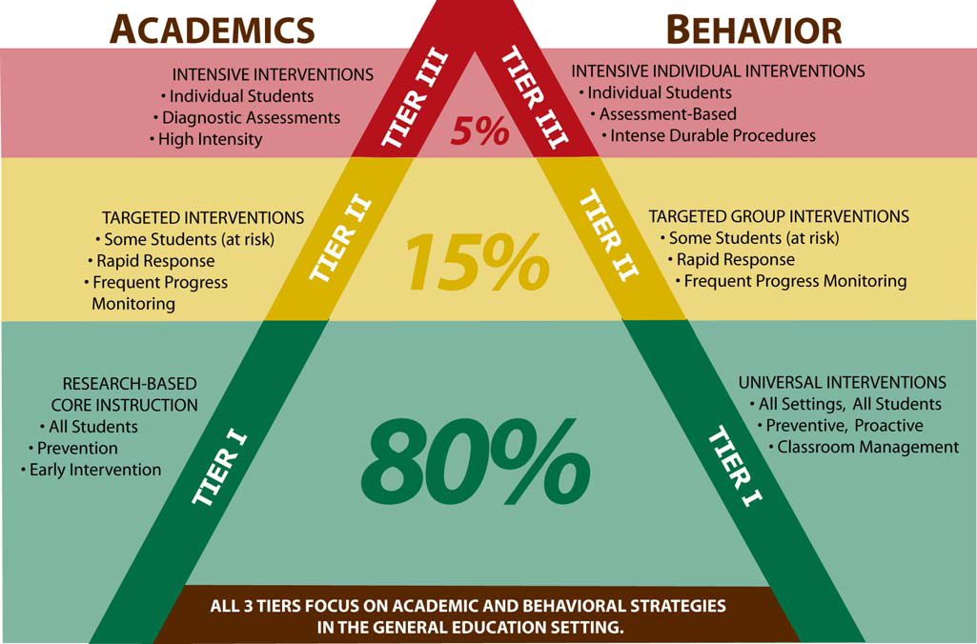
Problem Solving Teams
Student Support Teams
Problem Solving Teams
Student Support Teams

RtI Tier I

What is Tier I Instruction?

Tier I instruction is core instruction delivered by the general education teacher and should meet the needs of 80% of students in the classroom through high quality researched based core instruction.

What the Standards are for Tier I Instruction?

At BHS the expectations for high quality instruction that is delivered with fidelity has been defined in the non- negotiable in terms of instructional practices of “Teaching, Learning. Monitoring” and outlined in school walk through form.

What Are the Universal Screeners Used in Tier I?

Universal Screeners are used to measure effectiveness of Core Instructional. Some examples of Universal Screeners for academics are DIBELS, Alabama Reading and Mathematics Test and Stanford 10 state assessments, curriculum based assessments based on the Course of Study. An example of Behavior Universal Screeners is response to Tier I school wide Positive Behavior Support program.

What Does Research Indicate the Expectations are at Tier I?

Research shows that 80% of students should be successful with evidence based differentiated instruction implemented with fidelity in the classroom.

What Should I Do If Students Do Not Meet Standards Based on Universal Screeners?

Students who need additional interventions based on Universal Screeners for all students should be referred to your Tier II Problem Solving Teams at your school.

RtI Tier II

Who are the key players on a Problem Solving Team (PST)?
PST membership must include administrators and classroom teachers. Teams may also include special education teachers, literacy/ reading coaches, school counselors, and specialists. PSTs are usually best accomplished by grade level teacher teams or department teams. The number of PSTs in a school will be determined by each school’s needs.
Who makes the decision to refer a student to a Problem Solving Team (PST)?
Classroom teachers, grade level teams, administrators and counselors may refer a student to a PST.
When should a student be referred to a Problem Solving Team (PST)?
- If a student is screened for academic, attendance and behavioral concerns, and is identified as being high-risk for being unsuccessful, that student should be referred to a PST. Three times a year – fall, winter and spring, teachers will review data on student performance (DIBELS, etc) and other indicators such as attendance, in order to evaluate the effectiveness of core instruction implementation.
- Once instruction begins, if a student exhibits little or no success with Tier I interventions, the student should be referred to a PST.
  - In the initial referral to a PST, the teacher must provide the following:
    - Student work samples
    - Results of universal screening and progress monitoring
    - Student attendance
    - Parent contact logs
    - Any other available documentation
How should parents be involved in Tier II?
Parents must be notified by the referring teacher that additional intervention may be needed for the student. A parent letter and progress reports will be sent to notify parents of intervention and progress. Documentation of parent contact through phone calls, written communications, etc., must be provided by the referring teacher.
RtI – Tier II

What are the steps in the process?

RtI – Tier II

What services should be provided to a student in Tier II?
Tier II interventions are designed for students who are not adequately progressing in Tier I instruction. These interventions provide additional attention, focus, and support and usually take place in the general education classroom. Tier II interventions should begin as soon as possible after students have been identified through screening or benchmark assessments and should be monitored regularly. Materials and strategies should be specialized, research or evidence-based interventions that are based on the needs of the students. Steps should be taken to ensure interventions are implemented with fidelity. Materials and strategies should also be aligned with Tier I instruction and should include more opportunities for modeling, providing examples, corrective feedback, and student practice.
Teachers can maximize instruction by offering each student the following:
Academic Interventions | Behavioral Interventions
- Opportunities for re-teaching in short sessions using a brisk pace.  - Opportunities for multiple, flexible grouping of students.  - Adjust and extend time on task for students with skill deficits.  - Drill repetition and/or practice review using technology or supplemental resources to allow students to access content in multiple ways.  - Opportunities for completing tasks in smaller steps.  - Increased opportunities for concept reinforcement using visuals, charts and models. | - Assign students to Check and Connect to provide increased mentoring and monitoring of behavior.  - Provide regularly scheduled small group counseling sessions.  - Re-teach behavioral expectations thoroughly and reinforce on a regular basis.  - Provide increased positive, active supervision.  - Reduce the amount of down time between activities.  - Intervene quickly at the first sign that the student is losing control.  - Allow time for students to refocus and regain control.

Tier II Intervention is explicit, systematic, and aligned with Tier I instruction. Instructional interventions are differentiated, scaffolded, and targeted based on the needs of individual students as determined by assessment data.
Tier II instruction for enrichment should contain sufficient depth, breadth, and complexity to increase individual student skills and concept formation.
How should progress with Tier II interventions be monitored?
Assessment should be more focused, diagnostic in nature, and should be based on specific skill needs. Results should lead directly to intervention services. Once an intervention is in place, response to the intervention should be monitored regularly (i.e. bi-weekly or weekly).
When selecting assessments at the Tier II level, the focus should be on identifying the specific skills that need work and how to best meet specific academic or behavioral needs. Discussion of student progress in Tier II should take place formally in team meetings as well as informally between the general education teacher and interventionist or specialized teachers.

RtI Tier III

What does Tier III mean?
Tier III interventions are designed for students who are not responding to Tier I or II instruction and interventions. These interventions should be provided by a specialized teacher who is highly skilled in the area of weakness. Materials and strategies should be specialized research or evidence-based interventions based on the needs of the students who will receive the intervention.

Tier III interventions should be provided by a specialized teacher/counselor or special education teacher who is highly skilled in the particular area of weakness.

Tier III interventions usually take place outside the general education classroom (could be before or after school).

What services should be provided in Tier III?
Tier III interventions are intended for students with significant deficits or underachievement and require the most intensive services available. A decision to move a student to Tier III interventions is determined by a problem-solving team after several documented individualized interventions in Tier II have resulted in limited progress (i.e., achievement gap between student’s progress and expected benchmark remains significant). The interventions in Tier II are skill specific and should be delivered by someone highly skilled in that area. (See List of Academic Interventions/ Behavior Interventions attached).

What type and how often should a student be progressed monitored at Tier III?
The frequency of assessment should increase in Tier III to weekly or biweekly. There is an extreme sense of urgency; therefore, the response to the intervention should be monitored more frequently. Communication and interpreting progress monitoring data occurs most easily through graphing student progress. The graph serves as a convenient performance record that can be easily understood by teachers, administrators, parents, and students.

Decisions regarding Tier II intervention services are determined by a Student Support Team and should be based on diagnostic assessments and progress monitoring. Plans should be made by the team to review student progress on a regular basis in order to make timely instructional decisions. When teams are discussing prescriptive interventions at Tier III, they should consider a reasonable target for the student within a specified period of time to implement the intense services. If the student is successful with the intervention and demonstrates sufficient progress the team may consider whether the student is able to move to Tier I or Tier II. If the student does not make sufficient progress in Tier III, the team may consider several options, including referring the student for a special education evaluation. It is imperative that proof is available to confirm that the interventions were implemented with fidelity.

What does grouping look like at Tier III?
Intensity of instruction is increased by increasing the amount of time provided to the student per day and decreasing the group size.

How long should Tier III plans last?
In the case of school-based referrals the School-wide Student Support Team will develop Tier III Plans with the help of the student’s parent/guardian. Documentation from Tier I and Tier II Plans must be provided prior to consideration for Tier III plans by the SSST. Data from progress monitoring, including behavior and academic, must be included. A student may continue on the Tier III plan indefinitely. Movement between tiers should be fluid. According to Alabama Administrative Code, “Before a child is referred for special education services, pre-referral intervention strategies must be implemented in the general education program and monitored [ by the Student Support Team ] for a minimum of eight weeks and be determined unsuccessful.” Therefore, the Tier III plan must be implemented for a minimum of eight school weeks (i.e. 40 instructional days).

What about parent referrals for students to be evaluated for Special Education Services? (IDEA)
In the case of parent referrals the School-wide Student Support Team will invite the parent to help develop a Tier III plan and inform the parent about the referral process. After the plan is developed and data is collected a MET will be scheduled and a Referral for Evaluation will be considered. If the Referral for Evaluation is accepted at the MET, the Tier III plan will be implemented simultaneously with evaluation process. If the parent referral is not accepted the SSST will reconvene to determine the appropriate plan for the child.

Who are the members on the School-wide Student Support Team?
This committee comprises faculty/staff from the entire school-across grade levels and subject areas. The following individuals will be on the SSST:
Administrator – principal or assistant principal
Teacher requesting support (i.e. general ed. teacher of the child)
Counselor
At least one teacher
Auxiliary members may include, but are not limited to: special ed. teachers, paraprofessionals, reading coaches, school nurse, OT/PT, graduation coaches.

What about students who are declassified from IDEA services?
Once a child is no longer eligible for special education services, they will be referred to the School-wide Student Support Team to determine support needed for the student to transition back to the classroom. Accommodations that were in the student’s last Individual Education Plan (IEP) will be included in the plan.

Tier III Services

Academic Interventions

Tier I instruction with additional scientifically researched based programs in area of deficiency (Math/Reading)

One-on-One intensive instruction in area of deficiencies

Small group instruction for additional reinforcement

Behavior Interventions

Functional Behavior Assessment

Behavior Intervention Plans

One-on-One Check-“n”- Connect Program

Individualized Positive Behavior Support Awards Program to acknowledge appropriate behavior.

Small group instruction in conflict resolution, anger management or social skills class based on need.

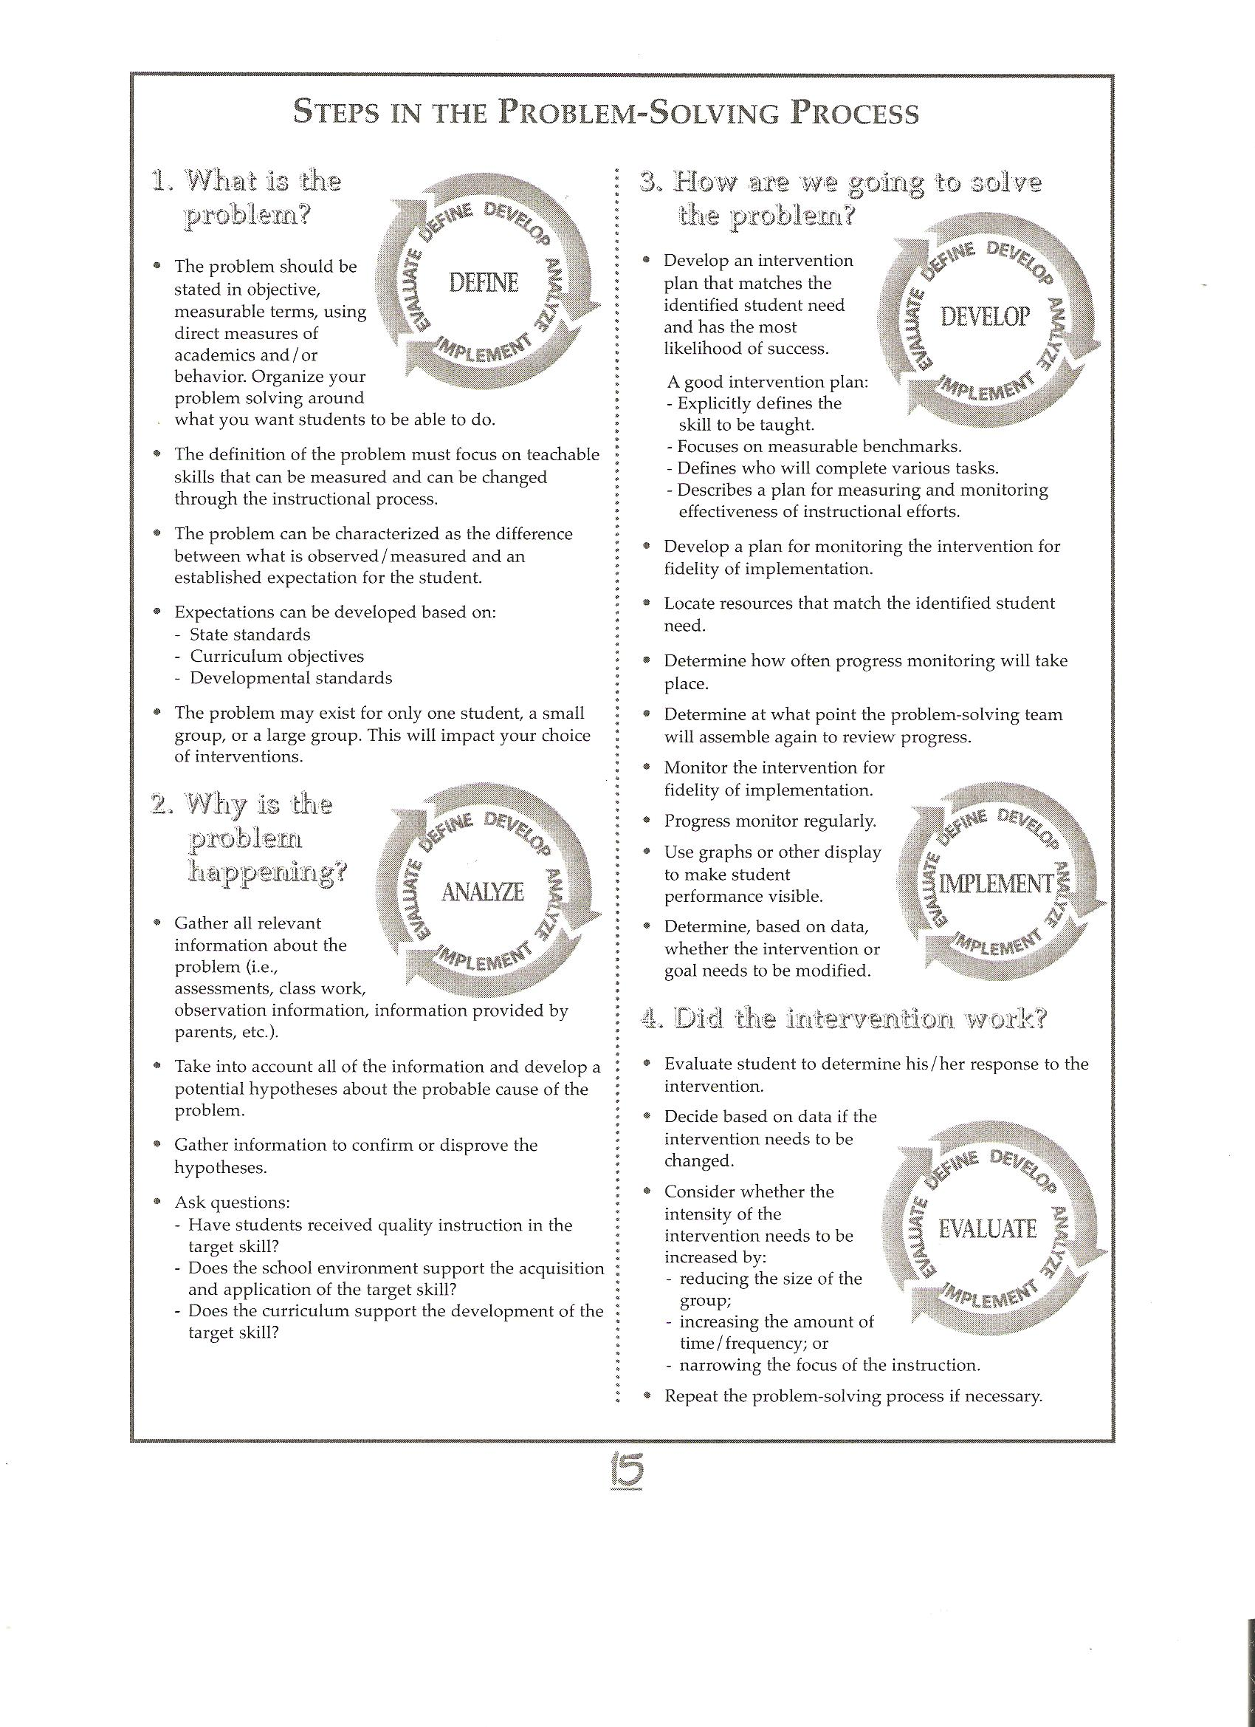

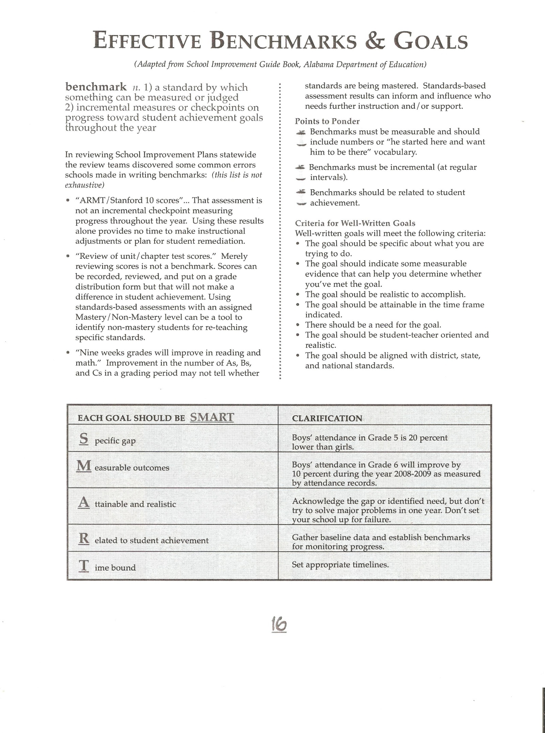

Team Actions for the Continuum of Instruction

Tier I | Tier II | Tier III
- Universal screening or benchmarking conducted at school level.  - Evidence based curricula and strategies in place for all students and differentiation documented through the general education environment.  - At risk students identified in an area of instructional delay (language, academics, behavior).  - Data gathered and analyzed by classroom general education teacher for decision making that indicates a need for Tier 2 interventions.  - Notify parents of student progress. | - Parents notified that additional intervention may be needed for student. . Required documentation-RtI Student Plan.  - Document parent contact through phone calls, written communications, etc. Required-Parents must be notified of progress.  - Progress monitoring to determine if a change in delivery or strategy is required.  - If data indicates regression or no progress, the teacher will refer student to the Problem Solving Team | - Additional interventions deemed by the Problem Solving Team.  - Baseline and progress monitoring data from Tier II are analyzed to create specific goals for student improvement.  - Problem Solving Team may determine the need for additional information on the student.  - Members of Problem Solving Team collaborate to identify specific interventions to utilize with the student.  - Student Support Team may initiate a referral to special education if the intervention plan and its revisions are not successful in helping the students meet the goals after a minimum of 40 instructional days.

Procedures for Implementation at Berry High School

Academic

Step 1: Screening
Universal Testing at the Start of School (all students)
Screeners:
7th-8th Grade 9th -12th Grade
ACT Aspire Scores ACT Aspire Scores
Grades Grades
Study Island Graduation Tracking System (GTS)
ACT Periodics Study Island
ACT Periodics

Step 2: Tier I Interventions
Classroom teachers will use small group and differentiated instruction within the classroom. The teacher will progress monitor the students’ progress for 3 weeks. If progress is made the teacher will continue the program. Documentation will be required using the forms provided by the PST.

Step3: Tier II Interventions
To identify students for Tier II, the Problem Solving Team will look at pretesting, failing grades, plus two other areas to enter Tier II. (7th -10th)
Grade 12th will look at grades and pretest.
Tier II students will go to the RTI Teacher twice a week (40 minutes) for small group work or individual work. Documentation forms will be required.

Step 4: Tier III Referral
If a student has shown no improvement, the Problem Solving Team can refer a student for Tier III. This will include retesting and more intensive interventions. Student will go to RTI Teacher four times a week (40 minutes) for one-on-one help with RTI Teacher. If progress is made the Problem Solving Team can decide to move student back to Tier I or Tier II, or the student can be referred for Special Education testing. Documentation from all Tiers will be required.

Behavioral
Behavioral Plan will depend on the problem the student is having. The Problem Solving Team will meet and decide on a plan of action based on information gathered about the student. The team will look at attendance, office referrals, detentions, and input from the faculty. With this information, the Problem Solving Team will determine a plan of action for the student. Documentation will be needed for each step taken. Interventions for behavioral is different from academic as behavioral can be attendance as well as other behavioral problems.

Tier | RTI Activity |  |  | Who is Responsible |  | Progress Monitoring Timeline
Tier I | Screen Students using Progress reports, report cards, attendance, behavior, and test data. |  |  | Problem Solving Team; Grade level teachers. |  | Every 3 weeks
 | Develop a Tier I intervention plan for identified students. Record using the Tier I Documentation Form. Contact parents. |  |  | Problem Solving Team; Individual classroom Teacher. |  | Every 3 weeks
 | Examine data and determine if further interventions are needed. Continue Tier I and /or try new interventions. Update parents. |  |  | Problem solving Team or Individual Classroom Teacher |  | Every 3 weeks  Repeat this step if appropriate.
Tier |  | RTI Activity | Who is Responsible |  | Progress Monitoring Timeline
Tier II |  | Examine data and determine whether or not Tier II interventions are needed. Problem solving team will work to develop an action plan that includes Tier II interventions. Document using RTI forms | RTI Tier II Teacher |  | As long as progress is being made.
 |  | Examine data and determine whether or not further Tier II interventions are needed. Problem Solving Team will work to determine if further Tier II interventions are needed or refer the student back to Tier I or on to Tier III. Document using RTI forms | Problem Solving Team and RTI II teacher |  | If student meets bench marks can be moved back to Tier I if no progress is made will be referred for Tier III.
Tier III |  | Make appropriate referrals and collect documentation for Tier III interventions. Contact Parents.  Examine data and determine appropriate Tier III interventions for the student | Problem Solving Team with RTI Teacher and guidance counselor. |  | As long as progress is being made.

RtI Forms

APPENDICES A-F

FAYETTE COUNTY APPENDIX A-1 (SDE Appendix C-1)
K-3 Reading or Math Tier 1 or 2 Walkthrough

Teacher_________________________________________ Grade Level______ Date__________

Person Completing this Walkthrough/Observation_______________________________________

Rating Scale: 1 = minimal evidence noted; 2=evidence noted; 3 = outstanding implementation
************************************************************************************************************
Classroom Environment
__ Classroom is arranged to accommodate whole group instruction, teacher-led small group instruction, and independent student centers.

__ Daily Class Schedule is posted which includes the agreed upon minimum number of minutes of core academic instruction (reading and math) plus an additional block of time for intervention.

__ Displays, including student work and curriculum materials (e.g., math facts, formulas, visual representations, word banks, posters, vocabulary lists), reflect the current instructional topic or theme.

Materials
___ Evidence exists of program materials being used as designed.

___ Teacher uses the Teacher’s Edition during instruction.

Teacher Instruction
___ Teacher follows the selected program’s instructional routines as designed.

___ Teacher fosters active student engagement and motivation to learn.

___ Classroom behavior management system is effective in providing an environment conducive to learning.

___ Transitions are smooth and quick.

Small Group, Differentiated Instruction
___ Small group instruction is provided at different levels depending on student need.

___ At independent student learning centers, students are working on activities that directly build reading or math skills.

___ Student products are completed and submitted as appropriate.

___ Centers are clearly defined and labeled.

Classroom Environment
___ Teacher and student interactions are mutually respectful and positive in tone.

___ Evidence exists that the teacher provides all students with an opportunity to learn.

___ Evidence indicates that the teacher implements activities that support student diversity.

READING
Phonemic Awareness
____ Grade-level appropriate activities are apparent

Phonics
___ Grade-level appropriate activities are apparent

Fluency
___ Grade-level appropriate activities are apparent

Vocabulary
___ Grade-level appropriate activities are apparent

Comprehension
___ Grade-level appropriate activities are apparent

_________________________________________
Principal's signature

MATH
Conceptual Understanding
____ Grade-level appropriate activities are apparent

Computational Facility and Fluency
____ Grade-level appropriate activities are apparent

Problem Solving
____ Grade-level appropriate activities are apparent

Fractional Relations
____ Grade-level appropriate activities are apparent

Geometry and Measurement Concepts
____ Grade-level appropriate activities are apparent

____________________________________________
Teacher's signature
FAYETTE COUNTY APPENDIX A-2 (SDE Appendix C-2)
Grade 4-12 Strategic Teaching Walkthrough
(use for Tiers I and II)

Teacher_______________________________ Subject__________________ Date__________

Person Completing this Walkthrough/Observation_____________________________________

Rating Scale: 1 = minimal evidence noted; 2=evidence noted; 3 = outstanding implementation
***********************************************************************************************************
Classroom Setting
_____ Classroom is arranged to accommodate whole group instruction and small group/partner student work.
_____ Displays and curriculum materials (e.g., word walls with content vocabulary, posters, scoring rubrics, routines/procedures

Materials
_____ Evidence exists of various materials being used to facilitate student engagement/learning
___ textbook ___computers ___ other print materials ___ objects ___ lab/activity sheet
___ content-specific manipulatives ___ overhead/flip chart ___ video ___ graphic organizer.

Teacher Instruction

____ Content teaching strategies (introduce, define, or explain a concept; relate a concept to other concepts; assist students in recalling concepts; quality questing, etc.)

____ Learning strategy instruction (before, during, and after strategies; vocabulary strategies)

____ Interaction with students during small-group activities (listening, use of neutral comments)

____ Evidence of differentiated strategic teaching (recognition of student needs, intentional grouping)

____ Instruction that includes student writing about content-area learning

____ Posted or assigned student work that exhibits thinking about texts

Student Actions

____ Evidence of student engagement

____ Partnered learning strategies (turn & talk, jigsaw modified, numbered heads together, 3 part interview)

____ Evidence of collaborative small-group or partner reading/writing/learning

____ Evidence of active versus passive learning

Classroom Environment
______ Teacher and student interactions are mutually respectful and positive in tone.

______ Evidence exists that the teacher provides all students with an opportunity to learn.

______ Evidence indicates that the teacher implements activities that support student diversity.

Strategies observed during walkthrough:

_____________________________ ______________________________ Principal's signature Teacher's signature

FAYETTE COUNTY APPENDIX A-3 (SDE Appendix C-3)
TIER III Intervention Walkthrough
(use for Tier III)
Teacher_______________________________________ Grade Level______ Date__________

Intervention being provided_____________________________________________________

Person Completing this Walkthrough/Observation_____________________________________

Rating Scale: 1 = minimal evidence noted; 2=evidence noted; 3 = outstanding implementation
***********************************************************************************************************
Classroom Setting
_____ Space is appropriate for intervention implementation.

Materials
_____ Evidence exists of program materials being used as designed.

_____ Teacher uses the Teacher’s Guide during intervention.

Teacher Instruction
_____ Teacher follows the selected program’s instructional routines as designed.

______ Evidence exists that activities are student goal directed.

_____ Teacher fosters active student engagement and motivation to learn.

______ Classroom behavior management system is effective in providing an environment conducive to learning.

_____ Transitions are smooth and quick.

Student Actions

____ Evidence of active versus passive learning

____ Evidence of student engagement

Classroom Environment
______ Teacher and student interactions are mutually respectful and positive in tone.

______ Evidence exists that the teacher provides all students with an opportunity to learn.

______ Evidence indicates that the teacher implements activities that support student diversity.

Other comments:
_________________________________ ______________________________
Principal's signature Teacher's signature

FAYETTE COUNTY APPENDIX B-1 (SDE Appendix D-1)
INTERVENTION NEEDS ASSESSMENT PROFILE-ELEMENTARY

Student:_______________________________Date of Birth:_________ Grade:______

School:________________________________Date of Review:___________________

Intervention Team Members: ______________________________________________

 | Area Assessed | High Risk  SS Below 80  Percentile < 10 | Moderate Risk  SS 80-90  Percentile 11-24 | Low Risk  SS >90  Percentile >25
Cumulative Data | High stakes testing  (i.e. SAT10, ARMT, etc)
Cumulative Data | High stakes testing
Cumulative Data | High stakes testing  )
Screening  Data-Reading | R-CBM –passages  (DIBELS, AIMSWEB, STEEP, etc)
Screening  Data-Reading | Mazes  (AIMSWEB, STEEP, etc)
Screening  Data-Math | M-CBM – calculation  (AIMSWEB, STEEP, etc)
Screening  Data-Math | Math Concepts and Applications  (AIMSWEB, STEEP, etc)
Additional
Assessment
Additional
Assessment
Additional
Assessment
Additional
Assessment
Additional
Assessment
Additional
Assessment
Additional
Assessment
Additional
Assessment
Additional
Assessment
Grades / Grades Repeated
__________________________________________________________________________
Intervention History:
Date(s) Intervention Results

Intervention Recommendations:
Date(s) Intervention Results

FAYETTE COUNTY APPENDIX B-2 (SDE Appendix D-2)
INTERVENTION NEEDS ASSESSMENT PROFILE-SECONDARY

Student:_______________________________Date of Birth:_________ Grade:______

School:________________________________Date of Review:___________________

Intervention Team Members: ______________________________________________

 | Area Assessed | High Risk  SS Below 80  Percentile < 10 | Moderate Risk  SS 80-90  Percentile 11-24 | Low Risk  SS >90  Percentile >25
Cumulative Data | High stakes testing  (i.e. SAT10, ARMT, AHSGE, etc)
Cumulative Data | High stakes testing
Cumulative Data | High stakes testing
Cumulative  Data | High stakes testing
Screening  Data-Reading | R-CBM –passages  (DIBELS, AIMSWEB, STEEP, etc)
Screening  Data-Reading | Mazes  (AIMSWEB, STEEP, etc)
Screening  Data-Math | M-CBM – calculation  (AIMSWEB, STEEP, etc)
Screening  Data-Math | Math Concepts and Applications  (AIMSWEB, STEEP, etc)
Additional
Assessment
Additional
Assessment
Additional
Assessment
Additional
Assessment
Additional
Assessment

:Grades / Grades Repeated
___________________________________________________________________________Intervention History:
Date(s) Intervention Results

Intervention Recommendations:
Date(s) Intervention Results

FAYETTE COUNTY APPENDIX C (SDE Appendix I-1)
Student Intervention Documentation Form (SID)
School Year:___________________
School:____________________________________
Attendance Key:
P=Student Present
A= Student Absent
TA= Teacher Absent
NS=No school

Student:______________________________________________ Grade:__________

Intervention:___________________________________Goal:____________ ROI:____

Intervention Provided by:___________________________________ Tier: __________

WK | Date | M | T | W | Th | F | PM Data | ROI | Team Recommendations (continue/intensify/dismiss) | Progress Report to Parent
1
2
3
4
5
6
7
8
9
10
11
12
13
14
15
16
17
18
19
20
21
22
23
24
25
26
27
28
29
30
31
32
FAYETTE COUNTY APPENDIX D-1 (SDE Appendix J-1)
LETTER EXPLAINING INTERVENTION INITIATION

Berry High School
Trevor Kribbs - PRINCIPAL
18242 HIGHWAY 18 EAST-BERRY, ALABAMA 35546
PHONE (205) 689-4467 – FAX (205) 689-8819

Date
Dear Parent/Guardian,

All students in Alabama schools are provided with standards-based, research-validated core academic instruction accompanied by classroom behavioral supports. A tiered system of academic and/or behavioral assistance or intervention is provided based upon identified student needs. Interventions typically include specialized, research-based teaching strategies provided within the classroom or in small-group settings. As required by the Alabama Department of Education, a problem solving team consisting of teachers, administrators, and other support personnel reviews student data regarding need for assistance; recommends the type of assistance to be provided; reviews data reflecting progress being made by students; and informs parents of this progress and of any recommendations regarding needed changes in interventions.

Berry High School is using Study Island to check student performance in reading and math so we can provide help to students as needed. Based on the first assessment, we have decided that your child would benefit from assistance or intervention. We will be providing this assistance twice weekly and progress monitoring every three weeks. We will be sharing this information with you by sending you a progress chart with the report card and with the mid-grading period progress report.

Please verify receipt of this letter by notifying one of the contacts below by sending an email stating you received this letter or calling the number listed:

Trevor Kribbs, Principal tkribbs@fayette.k12.al.us (205) 689-4467

Meredith Northington, RTI Facilitator mnorthington@fayette.k12.al.us

As a school staff, we look forward to working with your child and are pleased to be able to provide this additional help. If you have any questions, please feel free to contact us.

FAYETTE COUNTY APPENDIX D-2 (SDE Appendix J-2)
PROGRESS REPORT

Berry High School
Trevor Kribbs - PRINCIPAL
18242 HIGHWAY 18 EAST-BERRY, ALABAMA 35546
PHONE (205) 689-4467 – FAX (205) 689-8819

Dear _______________________________,

We are providing ______________________________________ with extra assistance daily by using intervention strategies which target:
___ reading comprehension skills
___ word-level reading skills
___ math computation skills
___ math reasoning and problem-solving skills
___ behavior skills
___ other ______________________________________________

We measure the progress being made every three weeks, and the results of these progress measurements are graphed in the chart which is attached. Based on our progress measurements, we believe that, at this time, your child is:

____ making good progress and we plan to continue the intervention at this time.

____ making some progress and we plan to continue the intervention at this time.

____ making limited progress and we plan to consider changes in the intervention we are providing.

____ making insufficient progress and we are changing the intervention in an effort to assist your child achieve academic success.

As a school staff, we are pleased to have this opportunity to provide your child with this needed help. If you have any questions, please feel free to contact your child’s classroom teacher.

(Attach this letter to the graph of the progress monitoring data which was most recently reviewed by the PST. A convenient schedule for notifying parents would be to send this letter and graph with the report card and with the mid-grading period progress report. Maintain copies of these letters and attached graphs in the Student Intervention Folder described in Appendix M.)

FAYETTE COUNTY APPENDIX E (SDE Appendix K-1)

PROBLEM SOLVING TEAM (PST) STUDENT INTERVENTION PLAN FORM

SECTION I. FACTORS CONSIDERED IN DETERMINING NEED FOR INTERVENTION

Student’s Name: ________________________ Sex: Race: ______ Date: ___________

School:______________________ Grade: Age: ____ Birth date:_________________

Specific Concern(s):

Specific screening/benchmark data:

Hearing Screening Date: Pass _____Fail_____

Vision Screening (near ) Date: ___Pass___Fail___ Vision Screening (far) Date ______ Pass____Fail___

SECTION II. INTERVENTION PLAN

Teacher(s) Responsible for Intervention Implementation:

Identified Concern(s) to be Addressed (Choose one or more from the following):
[ ] | 01 | Reading
[ ] | 02 | Math
[ ] | 03 | Behavior

Types of Interventions: (Choose all that apply to this intervention plan)
[ ] | Tier II Intervention Date initiated_______________  [ ] reading: word-level intervention  [ ] reading: comprehension intervention  [ ] math: computation intervention  [ ] math: reasoning/problem solving intervention  [ ] behavior intervention  [ ] other intervention
[ ] | Tier III Intervention Date initiated______________  [ ] reading: word-level intervention  [ ] reading: comprehension intervention  [ ] math: computation intervention  [ ] math: reasoning/problem solving intervention  [ ] behavior intervention  [ ] other intervention

Intervention goal: In____ weeks, the student will:

ROI goal (weekly improvement needed to achieve intervention goal):

Progress Monitoring Tool:

Intervention Materials:

(Attach additional goal sheets if multiple intervention goals are established by the PST)

SECTION III INTERVENTION PLAN REVIEW (plan to be reviewed at least monthly)

See the attached Student Intervention Documentation (SID) Form for outcome information.

Signatures:

PST Chair Initiation Date Completion Date

PST Secretary Initiation Date Completion Date

FAYETTE COUNTY APPENDIX F (SDE Appendix L)
System-Level PST Annual Report

RtI EFFECTIVENESS
SCHOOLWIDE COMPILATION
Statistical Breakdown Current School Year:___________

School ___________________________________ Date ______________________

Total number of students enrolled in the school

Students Receiving Interventions During the Current School Year

Total number of students in any Tier II or Tier III intervention
Percentage of total students in Tier II or Tier III intervention
Total number of students in any Tier II intervention
Percentage of total students in any Tier II intervention
Total number of students in Tier II reading intervention
Percentage of total students in Tier II reading intervention
Total number of students in Tier II math intervention
Percentage of total students in Tier II math intervention
Total number of students in Tier II behavior intervention
Percentage of total students in Tier II behavior intervention
Total number of students in any Tier III intervention
Percentage of total students in any Tier III intervention
Total number of students in Tier III reading intervention
Percentage of total students in Tier III reading intervention
Total number of students in Tier III math intervention
Percentage of total students in Tier III math intervention
Total number of students in Tier III behavior intervention
Percentage of total students in Tier III behavior intervention

More Intensive Intervention Needed by Students:

Students Moving From Tier II to Tier III During the Current School Year

Total number of students in all Tier II interventions
Total number of students in all Tier II interventions moving to Tier III
Percentage of Tier II students moving to Tier III intervention
Percentage of reading Tier II students moving to Tier III intervention
Percentage of math Tier II students moving to Tier III intervention
Percentage of behavior Tier II students moving to Tier III intervention

Students Moving From Tier III to SPED During the Current School Year

Total number of students in all Tier III interventions
Total number of students in all Tier III interventions moving to SPED
Percentage of Tier III students moving to SPED
Percentage of reading Tier III students moving to SPED
Percentage of math Tier III students moving to SPED
Percentage of behavior Tier III students moving to SPED

Less Intervention Needed by Students:

Students Moving From Tier III to Tier II During the Current School Year

Total number of students in all Tier III interventions
Total number of students in all Tier III interventions moving to Tier II
Percentage of Tier III students moving to Tier II intervention
Percentage of reading Tier III students moving to Tier II intervention
Percentage of math Tier III students moving to Tier II intervention
Percentage of behavior Tier III students moving to Tier II intervention

Students Moving From Tier II to Tier I During the Current School Year

Total number of students in all Tier II interventions
Total number of students in all Tier II interventions moving to Tier I
Percentage of Tier II students moving to Tier I intervention
Percentage of reading Tier II students moving to Tier I intervention
Percentage of math Tier II students moving to Tier I intervention
Percentage of behavior Tier II students moving to Tier I intervention

Data Regarding Race/Ethnicity of Students Receiving Intervention

Indicate number of students in Tier II and Tier III interventions according to race/ethnicity:
Hispanic/Latino of any race
American Indian or Alaska Native
Asian
Black or African American
Native Hawaiian or other Pacific Islander
White
Two or more races

**DUE TO RTI SUPERVISOR AT THE CENTRAL OFFICE BY JUNE 15th

