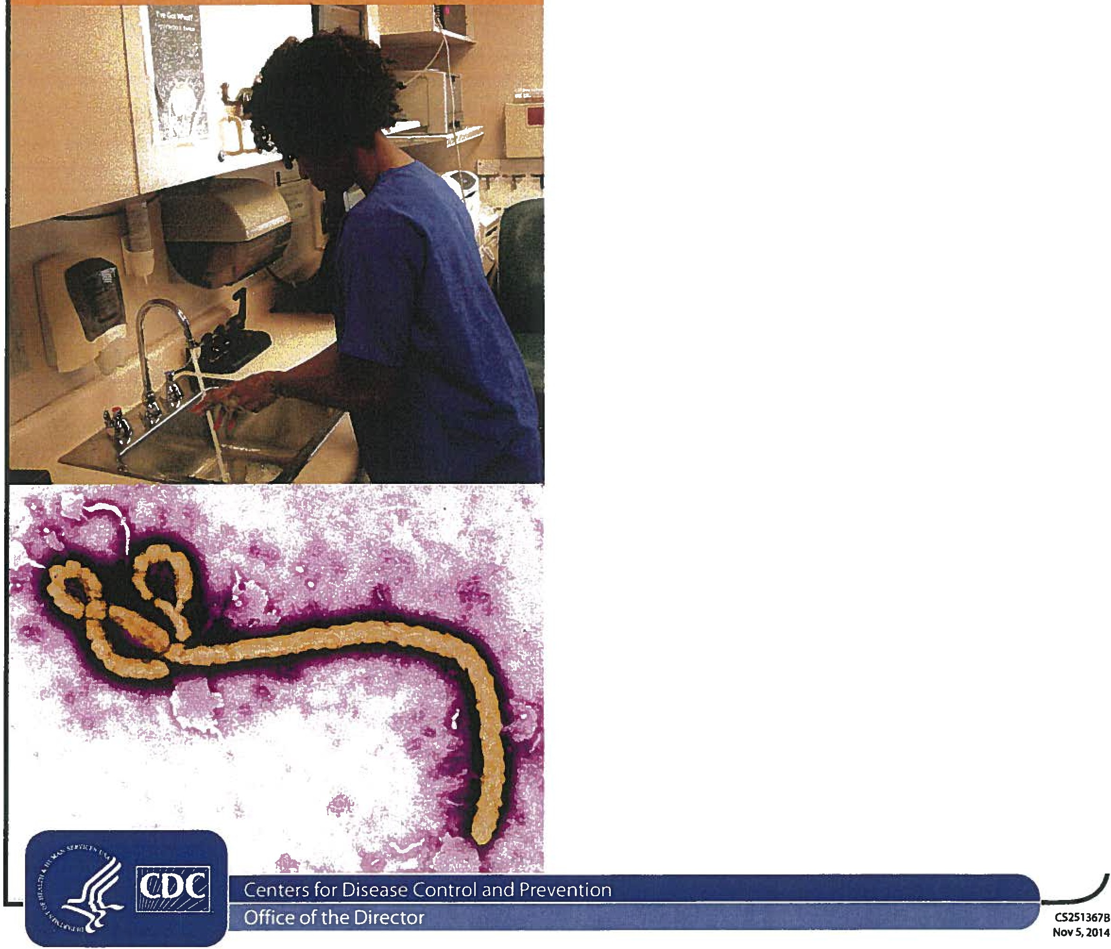The 2014 Ebola ep1demic is the largest in history
The outbreak is affecting multiple countries inWest Africa.Two imported cases,including one death,and two locally acquired cases in healthcare workers have been reported in the United States.
CDC and partners are taking precautions to prevent the further spread of Ebola within the United States.
A person infected with Ebol a can't spread the disease u nti l symptoms appea r
The time from exposure to when signs or symptoms of the disease appear (the incubation period) is 2 to 21 days, but the average time is 8 to 1O days.Signs of Ebola include fever and symptoms like severe headache,fatigue,muscle pain,vomiting,diarrhea, stomach pain,or unexplained bleeding or bruising.
Ebol a is spread throu gh d irect contact with blood and body flu ids
Ebola is spread through direct contact (through broken skin or mucous membranes) with
- Blood and body fluids (like urine,feces, saliva, vomit,sweat, and semen) of a person who is sick with Ebola.
- Objects (like needles) that have been contaminated with the blood or body fluids of a person sick with Ebola.
Ebola is not spread through the air, water,or food.
Protect you rself against Ebola
There is no FDA-approved vaccine available for Ebola. Experimental vaccines and treatments for Ebola are under development,but they have not yet been fully tested for safety or effectiveness.
To protect yourself from Ebola
- DO wash your hands often with soap and water or use an alcohol-based hand sanitizer.
- Do NOT touch the blood or body fluids (like urine, feces, saliva, vomit,sweat,and semen) of people who are sick.
- Do NOT handle items that may have come in contact with a sick person's blood or body fluids, like clothes, bedding,needles, or medical equipment.
- Do NOT touch the body of someone who has died of Ebola.

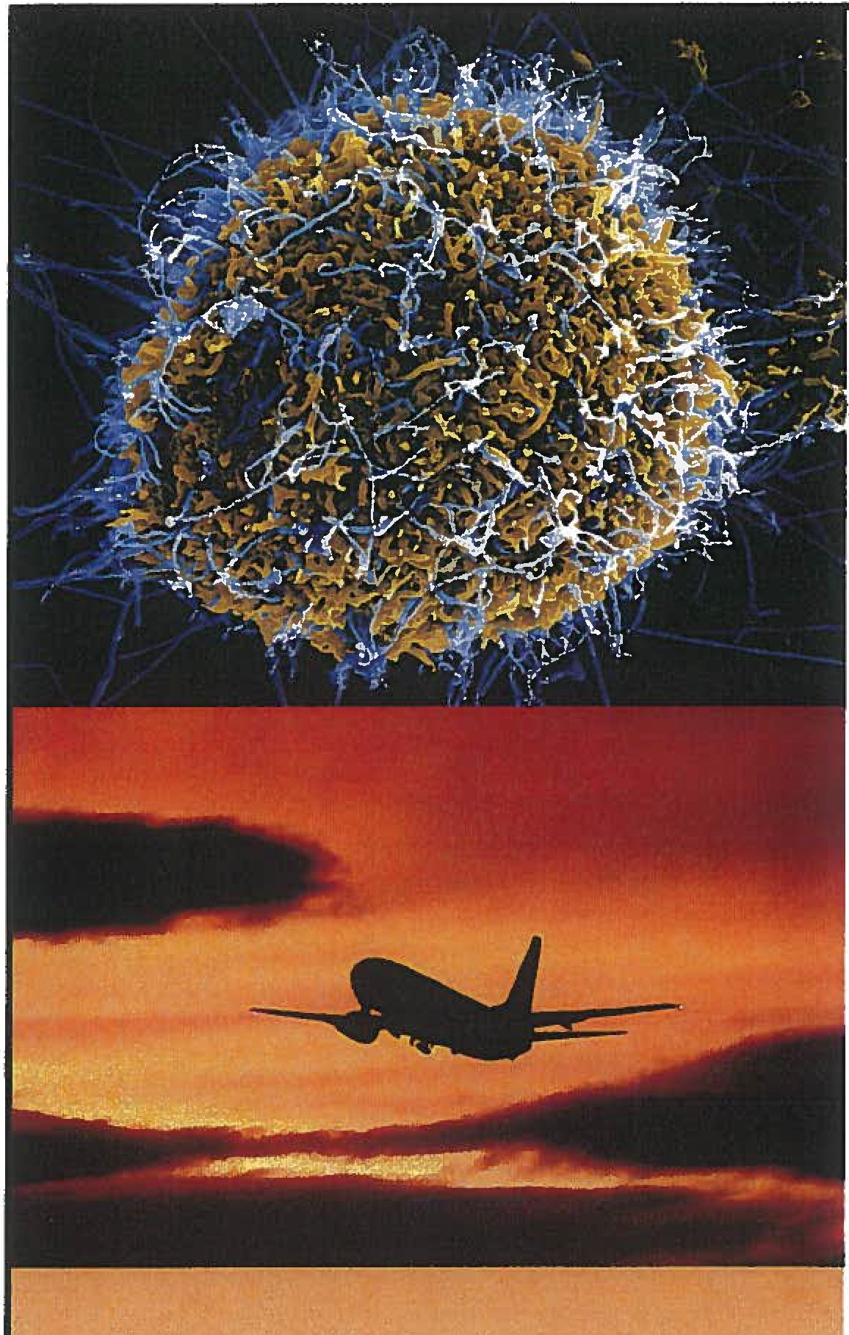

u,Werecognize that even asingle case of Ebola in the.Unitet! States seems threat­ ening,but the simple ·truth is hat we do know how to stop thesprea olJ.bola betweenpeople."-Beth Bell,Mb,MPH,
Director of the National Center for Emerging and Zoonotic Infectious Diseases
What to do if you are exposed to Ebol a U you have traveled to an area with an Ebola outbreak or had close contact with a person sick with Ebola, you may b at risk if you
- Had direct contact with blood or body fluids or items that came into contact with blood or body fluids from a person with Ebola.
- Touched bats or nonhuman primates (like apes or monkeys) or blood,fluids, or raw meat prepared from these animals.
- Went into hospitals where Ebola patients were
  - being treated and had close contact with the patients.
- Touched the body of a person who died of Ebola.

You should check for signs and symptoms of Ebola for 21 days
- Take your temperature every morning and evening.
- Watch for other Ebola symptoms, like severe headache,muscle pain,fatigue,vomiting, diarrhea, stomach pain,or unexplained bleeding or bruising.
- Call your doctor even if you do not have symptoms. The doctor can evaluate your exposure level and any symptoms and consult with public health authorities to determine
if actions are needed.

Ifyou get sick after you come back from an area with an Ebola outbreak
- Get medical care right away if you have a fever, severe headache,fatigue,muscle pain, vomiting, diarrhea, stomach pain,or unexplained bruising or bleeding.
- Tell your doctor about your recent travel to West Africa or contact with a person who was sick with Ebola and your symptoms BEFORE you go to the doctor's office or emergency room. Calling before you go to your doctor's office or emergency room will help the doctor or emergency room care for you and protect other people who may be in the office or emergency room.

ATTE NTION
A LL PAT IENT S

IF YOU

recently traveled internationally or had close contact with someone who recently traveled internationally and was ill,

•••••

••••

•••••••••
•••

••• ••
• •.
•
• ••
••.
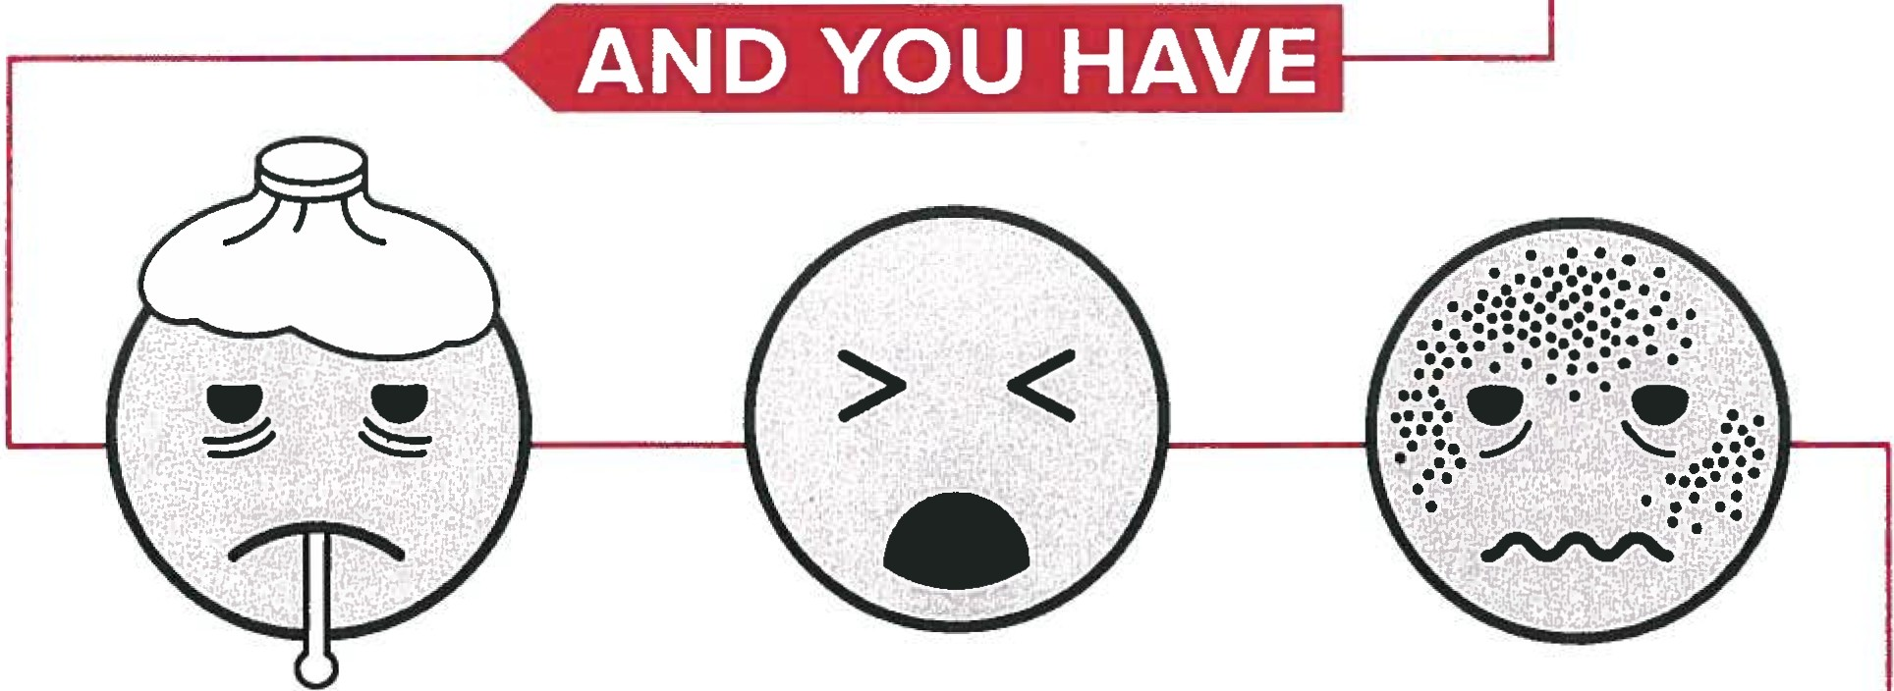•••

fever,cough,trouble breathing, rash,vomiting o'r diarrhea,

··3

,
AT EN
.
A TODOS LOS PACIENTES
SI USTE D

realiz6 un viaje internacional recientemente o tuvo contacto cercano con alguien que recientemente realiz6 un viaje internacional y estuvo enfermo,

••••••

••···..
••

••••

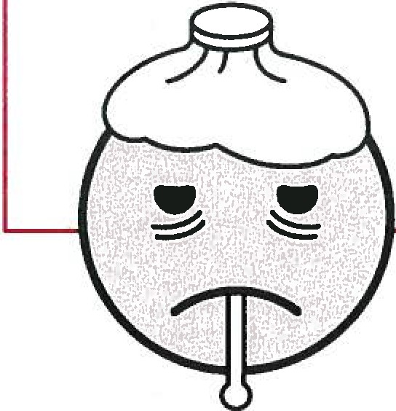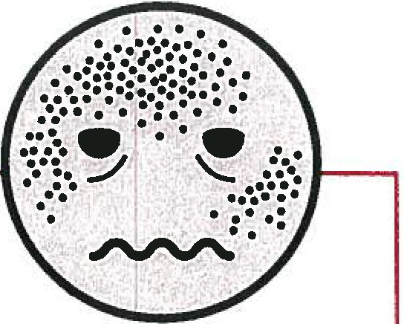
Y LISTE D TI ENE
.••
•••
•••
•••
fiebre, tos, dificultad para respirar,sarpullido, v6mitos o diarrea,

November 6, 2014

The State Department of Education (SOE) is closely monitoring the current outbreak of Ebola Virus Disease (EVD) in Ebola-affected countries through the Centers for Disease Control and Prevention (CDC), the World Health Organization, and the U.S. Department of State, as well as through communications with the Alabama Department of Public Health (ADPH).

It is the objective of the SOE to provide students, faculty, and employees with a safe environment for education and work. CDC has issued warning travel notices for individuals traveling to and from countries with widespread Ebola transmission. CDC does not recommend that schools isolate or quarantine students, faculty, or employees based on travel history alone. We recommend schools follow these guidelines:

  - The parent or guardian of any student, student, faculty member, or employee who has been in countries with widespread Ebola transmission within the past 21 days must identify themselves to a designated school official.
  - The school nurse or designee will conduct a risk assessment of these students or staff members who have been in countries with widespread Ebola transmission within the past 21 days.
  - Such risk assessment shall consist of using the ADPH EVD Algorithm for Evaluation of the Return Traveler and EVD Consultation Record. In addition, the ADPH Division of Epidemiology must be contacted at 1-800-338-8374 whenever the EDV Consultation Record is completed.
  - If a student, faculty member, or employee has had NO symptoms of Ebola for 21 days since leaving a country with widespread Ebola transmission, no further assessment is needed.
  - If a student, faculty member, or employee warrants additional monitoring based on consultation with ADPH, this individual will receive thorough instructions from the school nurse or designee about the importance of immediately reporting symptoms and staying away from other people if symptoms develop.
  - Subject to any reporting regulations implemented by CDC, or other similarly established authorities, any and all personal health information related or pertaining to this policy shall be protected pursuant to HIPAA standards and requirements.

According to CDC, Ebola poses little risk to the U.S. general population and is not contagious until symptoms appear. It is spread through direct contact with blood or body fluids (such as urine, saliva, sweat, feces, vomit, and semen) of an infected person, or with objects (such as needles) that have been contaminated with the virus. This includes through intimate contact, such as sex, since Ebola can still be found in semen for 7 weeks after a person has recovered.

The situation is rapidly changing, and the State Department of Education continues to monitor it daily. Should new information become available, it will be distributed promptly. For more information on the Ebola outbreak, please refer to the following:

ADPH: http://www.adph.org/ebola
CDC: http://www.cdc.qov/vhf/ebola/index.html WHO: http://www. who. int/csr/disease/ebola/en/
  - State Department Travel Alerts and Warnings:
http://travel.state.gov/content/passports/enqlish/alertswami ngs.html

Ebola Virus Disease (EVD) Screening for Outpatient Facility & Pharmacies
•

I
Patient assessment criteria for isolation/hospital notification are likely to be:

Travel to countries with widespread EVD transmission
per www.cdc.gov/vhf/ebola/outbreaks/2014-west-afri ca/distribution-map.html gr contact with a suspected or confirmed EVD patient within 21 days (3 weeks) of symptom onset.
AND
    - Fever, headache, muscle pain, weakness, diarrhea, vomiting, abdominal pain, or unexplained bleeding.

If both criteria are met:
- The patient should be isolated and STANDARD, CONTACT, and DROPLET precautions followed during further assessment, treatment, and transport.
- Notify Alabama Department of Public Health, Epidemiology Division: 1-800-338-8374 to report an Immediate Extremely Urgent 4-hour Notifiable Disease.
- Complete Ebola Consultation Record www.ADPH.org/Ebola/Default.asp?id=6785 and fax to 334-206-3734 or emailto CDFax@ADPH.state.AL.US .
- Compile a list of healthcare workers and patients that may have come in contact with the patient, along with their personal contacts.
- Notify Hospital Emergency Department before transport and arrange for transport via non-public transportation or ambulance.

Source:www .ADPH.or g/Ebola 10/31/14

Self Monitor Chart: Morning (AM) and night (PM) for 21days

Name:
Date of Exposure.: -

H you have exposure to Ebola patient(s) or travel to an affected Ebola area and have Ebola signs or symptoms, seek medical care immediately. Call ahead and tell the doctor about your recent Ebola exposure and your symptoms. Advance notice will help the doctor care for you and protect other people who may be inthe doctor's office or hospital
Ifyou don't have symptoms, limit contact with people and avoid public transportation while self monitoring. Document on the reverse side of chart,
everyone you have contact with and where you traveled.
Day: Date:  Time of check: | Date after Ebola exposure = |  | .
 | Day 1 |  | Day 2 |  | Day 3 |  | Day 4 |  | Day s |  | Day 6 |  | Day 7
 | AM | PM | AM | PM | AM | PM | AM | PM | AM | PM | AM | PM | AM | PM
Daily ture
Symptoms: (Yes/No)
Fever >100.4° F
Severe headache
Muscle pain
Vomitini.t
Diarrhea
Stomach pain
Unexplained
bleeding or bruising

Day: Date:
 | Day 8 |  | Day 9 |  | Day lO |  | Day 11 |  | Day 12 |  | Day 13 |  | Day 14
 | AM | PM | AM | PM | AM | PM AM |  | PM | AM | PM | AM | PM | AM | PM
Daily temoerature
Symptoms: (Yes/No)
Fever >100.4° F
Severe headache
Muscle pain
Vomiting
Diarrhea
Stomach pain
Unexplained bleeding or bruising

Time of check:

Day 15
Day l6
Day 17
Day 18
Day 19
Day 20
Day 21
AM
PM
AM
PM
AM
PM
AM
PM
AM
PM
AM
PM
AM
PM
Daily temperature
Fever >100.4° F
Severe headache
Muscle pain
Vomiting
Diarrhea
Stomach pain
Unexplained bleeding or bruising
Day: Date:

Time of check:

Symptoms: <Yes/No)

Document Contacts and Travel While Self Monitoring
 | Contact names | Contact phone | Travel location | Travel time
Day 1
Day 2
Day 3
Day 4
Day 5
Day 6
Day 7
Day 8
Day 9
Day 10
Day 11
Day 12
Day 13
Day 14
Day 15
Day 16
Day 17
Day 18
Day 19
Day 20
Day 21

. .

If you have questions, please contact Epidemiology Division at 1-800-338-8374. 2

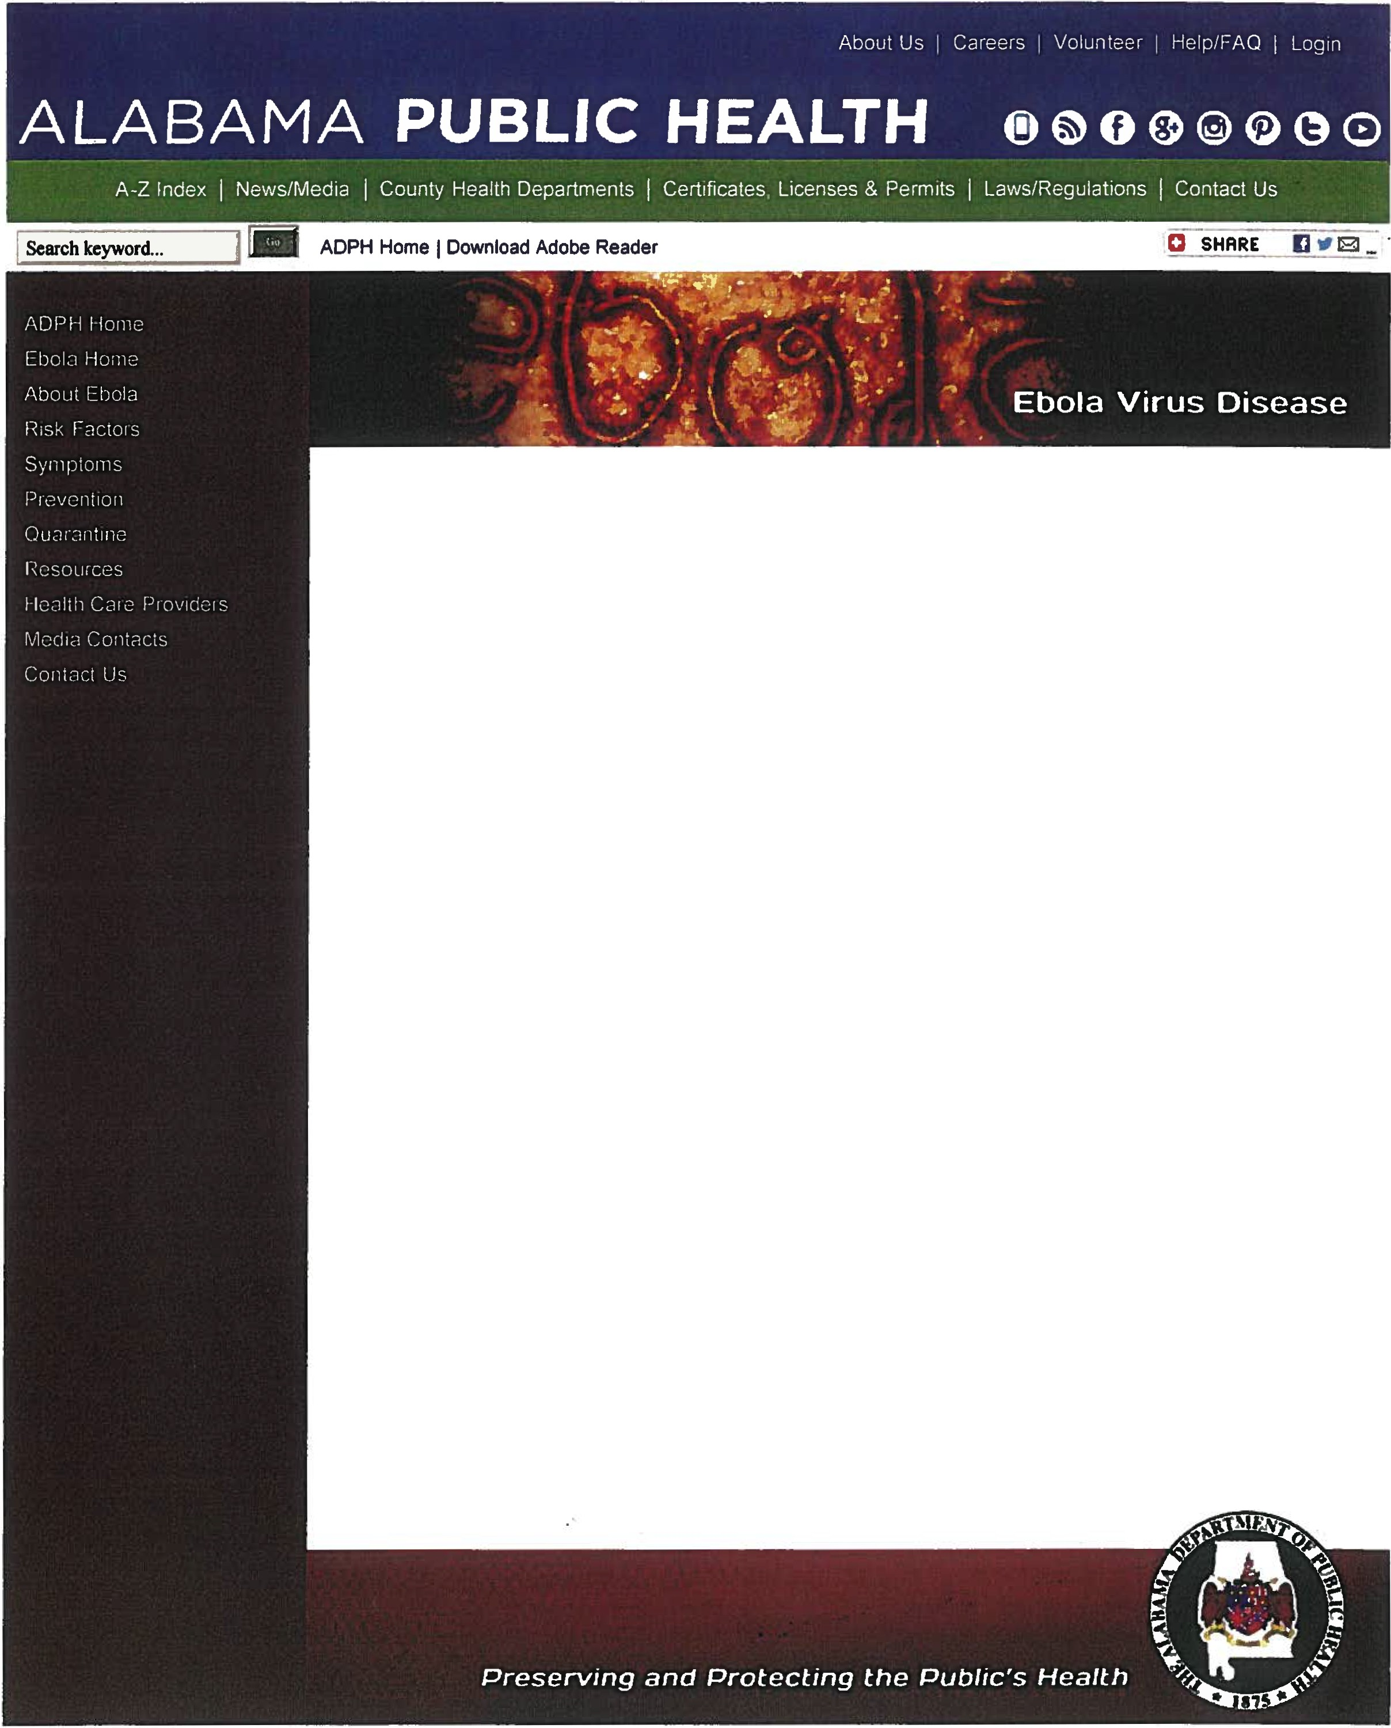

The 2014 Ebol a outbreak is the largest Ebola outbreak in history, and is of great concern to many people. At this time, there are no confirmed cases of patients with Ebola in Alabama. Ebola is not spread through the air, by water, or in general, by food. The Alabama Department of Public Health is taking several steps to ensure that if a case occurs in our state, we will be able to respond effectively.

About Ebola
Ebola is also known as Ebola Virus Disease (EVD) or Ebola Hemorrhagic Fever (EHF). There are five Ebola subspecies, four of which are known to cause the disease. To learn more, visit AbQU1 Ebma.. Also view What You Need To Know About Ebola.
To determine if it Is The Flu or Ebola, read the common symptoms of each to tell the difference. What's New?
  - Nyrses Matter: Ebola 101 and Personal Protectjye Egulpment (ALPHTN Webcast, 11/05/14)
  - Quarantine Poljcy Newl
  - Ebola :30 TV PSA MP! I'l:lNt:i. (right click to save) Newt
  - Ebola :30 Radio PSA ME.3. (right click to save) ISgjQt Newl
  - Message from the State Health Officer "Ebola· What You Need to Know"
  - Latest CDC I nformation on the 2014 Ebola Outbreak jn West Mi ca
  - ADPH jssues response concemjng ill patient (10/09/14)
  - Ebola Preparedness jn Alabama News Conference (10/08/14)
  - Governor State Health Officer and Alabama Hospital Association djscuss state's Ebola preparedness activities
(10/08/14 News Release)
  - Ebola Preparedness Webcast #1
Program faculty discuss what we know about Ebola, and provide important information for health care providers caring for patients with Ebola.
  - ADPH jssues alert to health care proyjders on Ebol a (08/08/14 News Release)

Contact Us
  - Consumers with questions should call our Center for Emergency Preparedness (CEP) at 1-866- 264-4073.
  - Healthcare providers with questions should call our Epidemiology Division at 1-800-338-8374.
  - Local media may contact their area dsk commynjcator for more information about Ebola.

ittp://www .adph.org/ebola/[I In12014 7:52:17 AM]

