The Bullpup BowWow


Geneva County Elementary School Ann Stafford, Principal
Sandy Kinman, Editor November, 2017
“We are G.C.E.S” Achieving Excellence Together

Principal’s Corner

Hello, and welcome to November! This year is passing so quickly! It will be 2018 before we know it. We here at GCES have had a busy October.

The PTO’s Fall Festival was held on October 23rd, and it was a huge success. We want to thank everyone who came out and supported our school. We have a great group of PTO officers and members who work very hard to raise money for our children. If you are not an active PTO member, I want to encourage you to join and get involved in all of the great projects at our school.

Please remember that there will be no school on Nov. 10th. Students will be out in observance of Veteran’s Day.
Thanksgiving break is fast approaching! GCES students will be out Monday-Friday November 20th-24th for Thanksgiving Break this year. Eat lots of turkey, but don’t forget to read each day! The DIBELS assessment will be given in December, and we want all of our students to reach their winter benchmark goals. If you are not sure what your child’s goal is, please contact his/her teacher for that information.

We appreciate your support and help. Please contact the school if you have questions for concerns.

Pre-K News

Pre-K Teachers would like to congratulate our Good Citizens. Miss Merritt’s class is Shay Prescott and from Mrs. Rice’s class-Skarlett Crawford. Great job!
As the newness wore off during the month of October, we really dove into letter study and continued our journey of learning through play! We began with letter Gg and worked our way through Jj this month. We studied topics such as Mother Goose, fall, explored our 5 senses, and wrapping up the month with a monsters theme to celebrate Halloween! Also during October, we hosted a “Cookies with Cops” event as a small thank you to Geneva County Sherriff’s Department and Hartford Police Department whom we have become very fond of!
Themes for November include Fun on the Farm, Give Thanks, and after returning from Thanksgiving break, we will have a winter unit that includes Polar Express!

Kindergarten News

It’s HERE…. The holiday season in kindergarten! This fall has been busy and we will keep it that way until Christmas time. This month we have explored bats, spiders, pumpkins and crops. We are gearing up for our fall field trip to Corn Dodgers Farm on Thursday, Nov. 9th in Headland, Alabama. Student cost is $12 and DUE no later than Wednesday, Nov. 1st. Chaperones will pay at entrance of farm on the date of the event, cost is $6. Chaperones must provide their own transportation and lunch. The bus will arrive in Headland at approximately 9:00 a.m. We would also like to invite you to Thanksgiving Lunch on Wednesday, Nov. 1st at 10:30 a.m.. Cost for an adult meal is $5. A detailed calendar listing upcoming Christmas events will come home in folders later in November. At home, continue to flash alphabet cards, sight word cards and numeral cards 1-10. Congratulations to this month’s Good Citizens: Abby Hall- Mrs. Brown’s Class, Truitt Cotton- Mrs. Justice’s Class,
Sophie Reid- Mrs. Miller’s Class, and Kirra McDaniel- Mrs. Rousseau’s Class

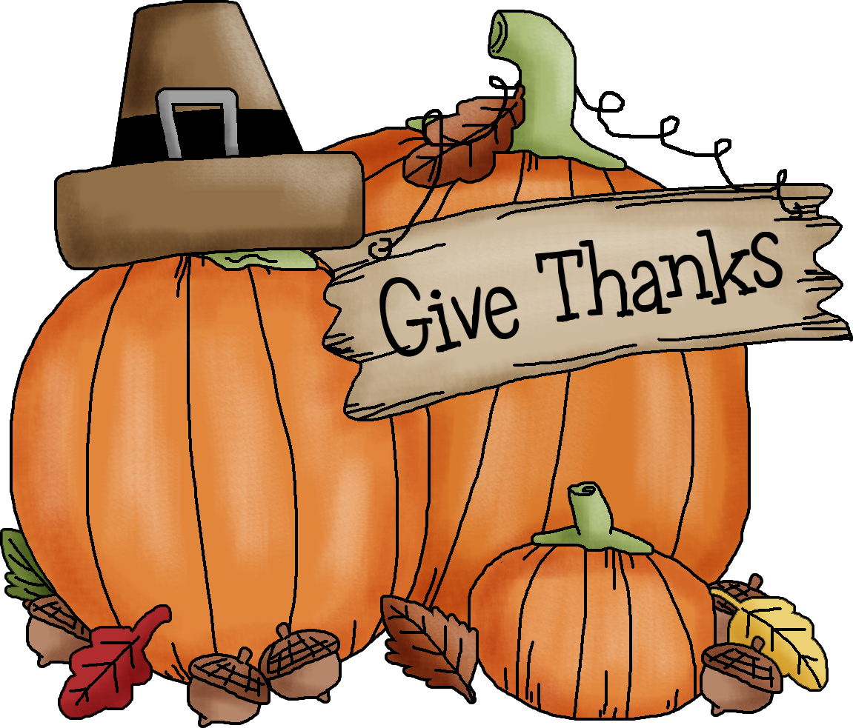

First Grade News

Happy Thanksgiving Season! We have tons to be thankful for in first grade! Reading is off to a great start! Please assist your child in blending words when reading at home and practice nonsense words in purple folder. We have started subtraction in math. Practice addition and subtraction to 20 with your child. Make it fun and use items around the house to use as “counters” such as coins, beans, blocks, etc. We have a lot to cover in this second nine weeks and it’s very important that folders are checked, work is reviewed, and reading, math, and spelling practice is taking place at home. We are so thankful our GCES students and for the great parental involvement we have which ensures first grade student success! Congratulations to our Good Citizen this month: Lexis Coker, Joseph Hendrix, Lily Jensen, and Braxton Tate. Great job!

Second Grade News

Happy Fall! We would like to say thank you to all the parents and students who participated and donated items to the Fall Festival. It was a great success! Please make sure your child is studying their Reading vocabulary words and spelling words each night. These words go home every Friday for the following week. Also, students should be practicing their fluency passage each night. Students should be reading at least 111 words by the end of the school year. Please work with your child on their basic addition and subtraction facts using flash cards. They need to be fluent with these facts in order to add and subtract larger numbers. We are planning a field trip to Landmark Park on December 8. More information will be going home about this next week. We would like to congratulate Khloe Dunn and Addison West for being our Good Citizen for this month. Great job girls!

Third Grade News

Happy November! In reading we are continuing to work on fluency and comprehension. Reading every night is the only way to ensure that your child is being exposed to a variety of words that will not only help their vocabulary, but their comprehension and fluency will soar. In math, we have been focusing on Addition with Regrouping. We have also started working on Subtraction with Regrouping. As this is a very hard skill to master, it is crucial that your child draws the hundreds, tens, and ones to better understand this process. We will begin multiplication and division with numbers 6-9. Please have your child study their multiplication facts. In Social Studies the students will be learning about Achievements of 'Ancient Civilizations. In Science the students will be Measuring Temperature and Building a thermometer. Thank you for giving third grade the support needed to make sure all students succeed.

The Good Citizen's citizens selected for the month are Madison Beard, Sandy Saens Herrera and Aniya Turner. Congratulations!

Fourth Grade News

Fourth grade is staying busy this fall season. The field trip to the capitol was an awesome experience! Students got to tour the capitol building and museum, experiencing Alabama’s history firsthand. Thursday, November 2, fourth grade will welcome parents, guardians, and friends to eat a Thanksgiving lunch. In Science, we will be finishing up the Electric Circuit Unit, and will be starting the Energy Works Unit. In Alabama History, we will begin learning about Native American Indians from our area. Keep practicing those math facts!! Students should be reading A.R. every night for 30 minutes. Students who have 42 points by the end of the semester will be going on a field trip!! Good Citizens for this month are Carlie Davis from Mrs. Blackmon’s class, Lillie Claire Turner from Mrs. Coker’s class, Drew Duncan from Mrs. Lassiter’s class, and Kirsten DelValle from Mrs. Sewell’s class.
Keep up the good work fourth grade!

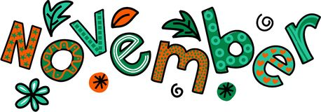

The mission of the Geneva County School System, in partnership with its parents and community, is to educate all students in a safe, supportive, challenging environment where they can learn to be responsible and productive citizens of a culturally diverse society.

Counselor’s Comments

Internet Safety Tips for Parents and Guardians
- Begin a dialogue with your kids about Internet use and supervise their online activities
- Consider rating, blocking, monitoring, and filtering applications for your computer
- Make Internet use a family activity
- Encourage your kids’ critical-thinking skills
- Set reasonable rules
- Encourage your kids to go to you when they encounter problems online
If you are having trouble logging in to your Parent Portal account, please call the school at 588-2923 or email me at jacksont@genevacoboe.org. We are on Facebook! Go to Geneva County Elementary School Counselor Corner and LIKE us! I look forward to hearing from you. My door is always open!

Fifth Grade News

A big thank you for all of your help and support in making our fall festival a huge success. The kids had a blast playing the variety of games.
4-H will be coming at the end of November. The children enjoyed creating spaghetti towers. They will be performing impromptu skits at the next class meeting.
We will be observing Veteran’s Day on Friday, November 10, 2017. Thanksgiving break will be the week of November 20-24, 2017.
Please continue to check your child’s planner. Homework should be written down on a daily basis. They are given time in class to complete this task. Please hold your child accountable.
Fifth grade would like to welcome our new interns for the 2nd nine weeks: Mrs. McDuffie will be working with Ms. Whitehurst and Mrs. Reeves will be working in Mrs. Reynolds. We are excited to have them join our team.
Please remember that we will need one baby picture for our graduation PowerPoint Presentation. It will also be put in this year’s yearbook. We could also use group pictures from previous years as well (sports pictures, birthday parties, school activities, etc).
Congratulations to our Good Citizens for this month: Hunter Sher (Reynolds); Ronald Saens (Matyjasik); Leslie Fernandez (Whitehurst)

AR and Library News

We have reached the middle of the first Semester of school. This means that we are half way to our first AR party. Students who earn their Semester goals will travel to the movie theater for a movie and popcorn. Please continue to encourage your child to read his/her books and take tests. The last day to earn points for this party is fast approaching Dec. 19. You can see your child’s progress in AR by login on to the Home Connect website. The link for this website can be located on our school’s website at http://genevaes.genevacountyschools.com/.

The mission of the Geneva County School System, in partnership with its parents and community, is to educate all students in a safe, supportive, challenging environment where they can learn to be responsible and productive citizens of a culturally diverse society.



From the Nurse:

It’s that time of year again—Time to get your flu shot! HNH immunizations will be on campus November 29th to provide flu vaccines to our students. Please note this is the flu shot, and not the mist. Permission forms will be sent home in your child’s folder soon!
Please sign up for Remind messages from Nurse Nancy! You will receive reminders about screenings and health related events, as well as individual reminders/notifications about your child. Text @4dbb3 to 81010 to sign up!
Have a safe and happy Thanksgiving!
Nurse Nancy

