Samson Schools
Emergency Preparedness
Management Plan
Table of Contents

PAGE
I. Samson High School Safety Planning Committee 4

II. Introduction 5
Statement of Commitment 5
III. School Floor Plans 9
Samson High School Tornado Procedure 10
Samson High School Outside Classrooms Tornado Procedure 11
Samson High School Cafeteria Tornado Procedure 11
Samson Middle School Tornado Procedure 12
Samson High Administrative Building Tornado Procedure 13
Samson High School Fire and Bomb Procedure 14
Samson High School Outside Classrooms Fire and Bomb Procedure 15
Samson High School Cafeteria Fire and Bomb Procedure 15
Samson Middle School Fire and Bomb Procedure 16
Samson Administrative Building Fire and Bomb Procedure 17

IV. Emergency Contact Information 18
School Crisis Team/Plan 19-24
Emergency Supplies 24
Safety Information 25-27
Communication 27
Emergency Technology 27-28
Buildings and Grounds Security 28
Transportation 29
Recovery 29
Crisis Management Plan/Team 30-37
Off Campus Procedures 38
Body Fluids Procedures 39
Lock Down Procedures 40
Fire Procedures 40
Severe Weather Procedures 41
Bomb Threat Procedures 42
Bomb Explosion Procedures 43
Crime Reporting 43
Student Disturbance Procedures 44
Hazardous Materials Procedures 44
Earthquake Procedures 44
Death/Serious Injury by Violence 44
Suicide 45
Sexual Assault/Harassment 45
Student Lost, Runaway/Adduction

V. Student with Weapon 46
Shooting on Campus 46
Campus Intruder Procedure 46
Hostage Procedure 47
Utilities Failure 47
Air Disaster Procedure 47

- SCHOOL SAFETY PLANNING COMMITTEE

ASHLEY SANDERS, SMS PRINCIPAL
665 Buck Vaughn Road
Chancellor, AL 36316
334-714-1316 (C)
334-898-2371 (W)
REBECCA GREEN, SECRETARY
500 W. Pullum Street
Samson, AL 36477
334-248-1102 (C)
334-898-2371 (W)
R. DEWAYNE HAMILTON, SHS PRINCIPAL
405 W. Main Street
Samson, AL 36477
334-248-1195 (C)
334-898-2371 (W)

LISA JENKINS, PROFESSIONAL
206 DENMAN CIRCLE
COFFEE SPRINGS, AL 36318
334-806-8885 (C)
334-898-2371 (W)
ASS POLICE CHIEF POLICE CHIEF
P.O. BOX 52 SAMSON, AL 36477
334-898-7118 (W)
AMANDA SANDERS, PROFESSIONAL
665 Buck Vaughn Road
Chancellor, AL 36316
334-449-2166 (C)
334-898-2371 (W)
CLAY KING, MAYOR
403 N. BROAD STREET
SAMSON, AL 36477 334-248-2381 (C)

CARA JESSE, PROFESSIONAL
600 W. LEE STREET
ENTERPRISE AL 36330
910-261-6547 (C)
334-898-2371 (W)

MICKI MCKNIGHT, PROFESSIONAL
P.O. BOX 195
SAMSON, AL 36477
334-726-2435 (C)
334-898-2371 (W)

II. Introduction
All the planning and practice will not stop potentially destructive events, but to have a plan is a step in the right direction. Schools have always been vulnerable to disaster because a large number of diverse people are collected in relatively small spaces. As a result, accidents or intentional intrusions that involve a school can have devastating effects on students, staff, parents, and the community.
Schools are inherently vulnerable due to the openness of the campus.
We cannot change the campus design, but we can have contingency plans available to enable quick, effective responses to minimize the disastrous effects of problems that do arise.
It is important that all school personnel know their responsibilities during a school emergency. It is, therefore, necessary to provide relevant information guidance to all school personnel. This plan is possessed and reviewed with all school personnel.
Statement of Commitment to School Safety
Samson High School is committed to safety in our school. We at Samson are committed to on-going planning, practice, and training in dealing effectively with emergencies. The following safety plan is designed to contain the basic elements or steps necessary for effective assessment, intervention, management, and follow-up of any threat to safety of the students and staff of Samson High School. The guide has been prepared in cooperation with the, Geneva County Board of Education, Samson Police Department, and Samson Rescue Squad.
Due to the rural location of our school, or in case of a widespread emergency, it is recognized that available government resources may be overtaxed or unable to respond immediately. This plan assumes that the school must be self-sufficient for a time.
It is important for our school to have a comprehensive, effective plan to deal with the broad spectrum of unpredictable crises. It is, therefore, necessary to provide training to all staff members and parents. Training will be provided through school workshops, conferences, PTO meetings, open houses, and/or faculty meetings at the beginning of each school year. The instructions for the safety plans will be coordinated with the police department, and local fire department. Training will involve the components of the school and district plans including (1) prevention activities, (2) immediate crisis response, and (3) follow- up/recovery. The plan will be reviewed and updated annually.

Samson High School
Emergency Procedures

Fire/Bomb Procedure
- Signal - a long, continuous ring of the bell or an announcement over the intercom system. In the case of electrical failure, a megaphone will be used to deliver instructions.
- Follow the posted fire route to the outside of the building.
- If emergency evacuation is necessary, close all windows and leave all bulky items such as textbooks and backpacks in the room.
- Follow the instructions of your teacher. During an evacuation it is very important that all students remain quiet, calm, and attentive.
- Follow an evacuation drill, return to class in reverse order.

Tornado Procedure
- Signal - A continuous series of short rings of the bell.
- Follow the posted tornado route to the necessary place in the building. Stay on an interior wall, away from windows as much as possible.
- Face the wall and cover your head
- Following the drill, return to class in reverse order.
Lockdown Procedure
- A lock-down may be necessary if we have to hold our students locked in class.
- The code for a lock-down is the announcement,“Mr. Brownstone, please report to the office”.
- Get all students in the room, close the blinds and cover the windows in the door.
- During a lock-down it is imperative that no student leave the room.
The lock-down will end with the announcement,“Mr. Jones, your grilled cheese is ready”.

Samson High School
Emergency Procedures

Fire/Bomb Procedure
- Signal - a long, continuous ring of the bell or an announcement over the intercom system. In the case of electrical failure, a megaphone will be used to deliver instructions.
- Follow the posted fire route to the outside of the building.
- If emergency evacuation is necessary, close all windows and leave all bulky items such as textbooks and backpacks in the room.
- Follow the instructions of your teacher. During an evacuation it is very important that all students remain quiet, calm, and attentive.
- Follow an evacuation drill, return to class in reverse order.

Tornado Procedure
- Signal - A continuous series of short rings of the bell.
- Follow the posted tornado route to the necessary place in the building. Stay on an interior wall, away from windows as much as possible.
- Face the wall and cover your head
- Following the drill, return to class in reverse order.

Lock-Down Procedure
- A lock-down may be necessary if we have to hold our students locked in class.
- The code for a lock-down is the announcement “_________________________”.
- Get all students in the room, close the blinds and cover the windows in the door.
- During a lock-down it is imperative that no student leave the room.
- The lock-down will end with the announcement “_________________________ ”.

Samson High School
Emergency Procedures

Fire/Bomb Procedure
- Signal - a long, continuous ring of the bell or an announcement over the intercom system. In the case of electrical failure, a megaphone will be used to deliver instructions.
- Follow the posted fire route to the outside of the building.
- If emergency evacuation is necessary, close all windows and leave all bulky items such as textbooks and backpacks in the room.
- Follow the instructions of your teacher. During an evacuation it is very important that all students remain quiet, calm, and attentive.
- Follow an evacuation drill, return to class in reverse order.

Tornado Procedure
- Signal - A continuous series of short rings of the bell.
- Follow the posted tornado route to the necessary place in the building. Stay on an interior wall, away from windows as much as possible.
- Face the wall and cover your head
- Following the drill, return to class in reverse order.

Lock-Down Procedure
- A lock-down may be necessary if we have to hold our students locked in class.
- The code for a lock-down is the announcement “Mr. Brownstone, please report to the office”.
- Get all students in the room, close the blinds and cover the windows in the door.
- During a lock-down it is imperative that no student leave the room.
- The lock-down will end with the announcement “Mr. Jones, your grilled cheese is ready”.

A lock-down may be necessary if we have to hold our students locked in class.

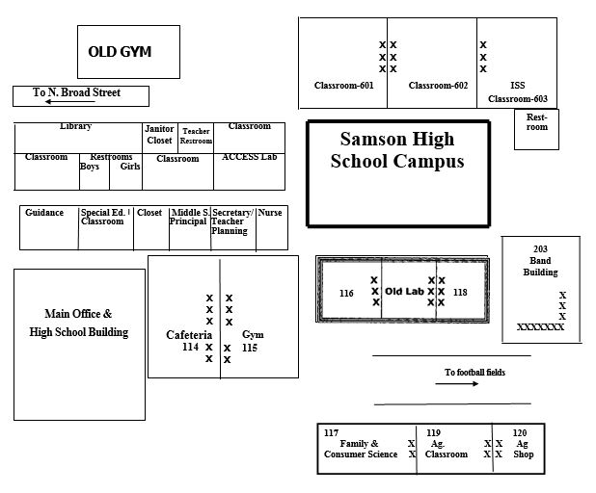
III. School Floor Plans
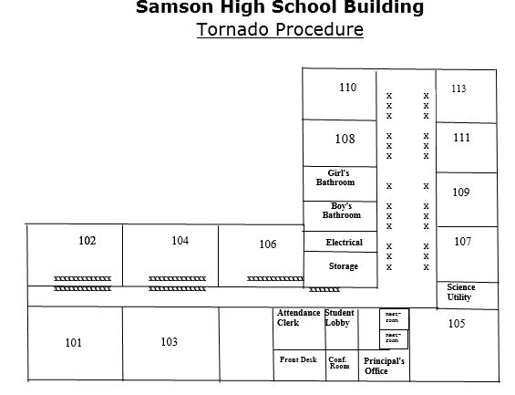
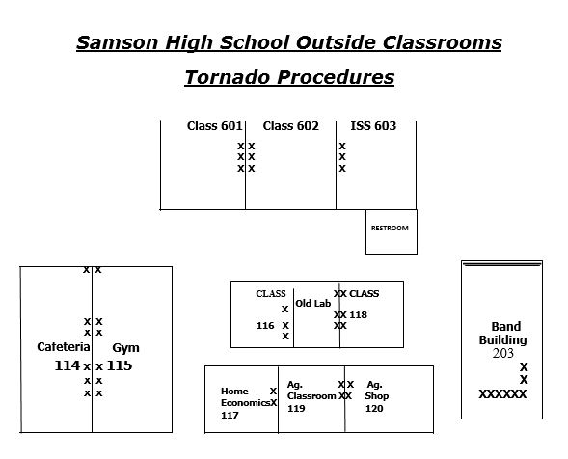
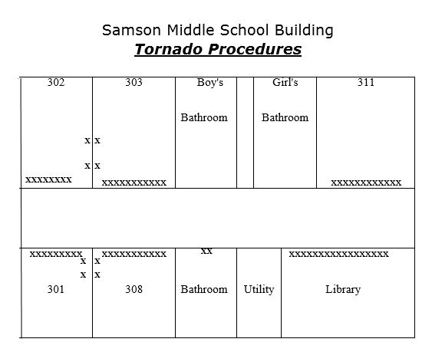
12

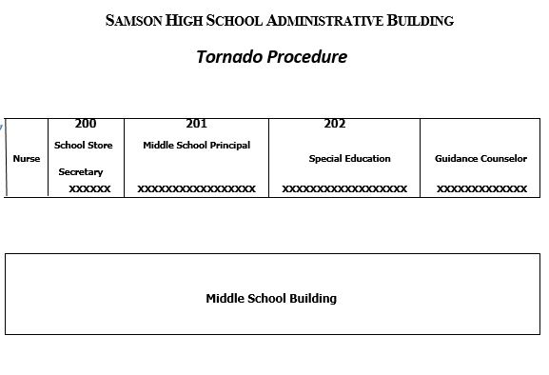

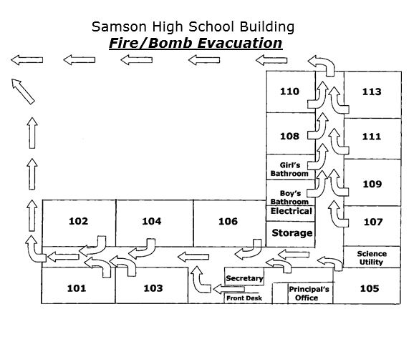

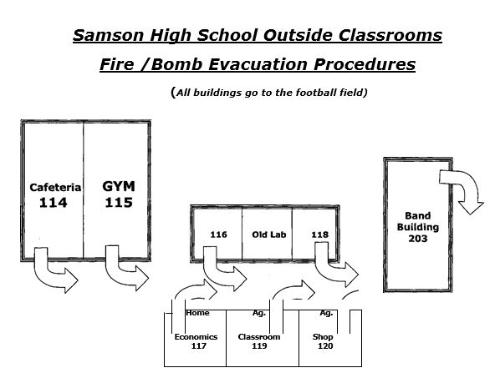
15
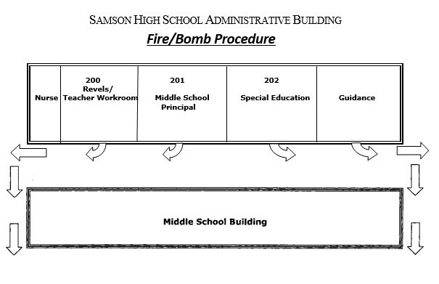
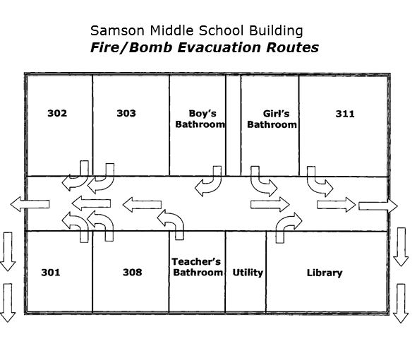
BECKY BIRDSONG, SUPERINTENDENT
(C) 334-726-9757
(W) 334-684-5690
SAMSON LEDGER 334-684-2280 ENTERPRISE LEDGER 334- 347-9533
DOTHAN EAGLE 334-792-3141

EMERGENCY CONTACT INFORMATION
RALPH RILEY, ASSISTANT SUPERINTENDENT
(C) 248-2089
(W) 684-5690
SHERRIE Winingham, GUIDANCE SUPERVISOR Stephanie dillard, CHILD NUTRITION Supervisor
(W) 684-5705 (W) 684-5701
DANNY BRANCH, TRANSPORTATION, MAINTENANCE SUPERVISOR
(W) 684-5707
POLICE 334-898-7118
FIRE DEPT. 334-898-2221
RESCUE SQUAD 334-898-7118
SHERIFF 334-684-5664
POISON CENTER 1-800-292-6678
STATE TROOPERS 334-983-4587
EMERGENCY MANAGEMENT AGENCY 334-684-5677
FEDERAL BUREAU OF INVESTIGATION 334-792-7130
WIREGRASS MEDICAL CENTER 334-684-3655
SEVERE WEATHER (EMA) 334-684-5677
NATIONAL CENTER FOR MISSING CHILDREN 1-800-843-5678
U.S. MARSHAL 334-223-7401
UTILITIES-SAMSON 334-898-7541
COVINGTON ELECTRIC 334-898-2085

MEDIA CONTACTS
TV STATIONS
WDFX-TV 334-794-3434 WDHN-TV 334-793-1818 WTVY-TV 334-792-3195 WSFA-TV 334-288-1212
RADIO STATIONS
WESP-FM 334-671-1025 WOUF-FM 334-792-1149 WGEA-AM 334-684-7673 WAMI-FM 334-493-3588 WKMX-FM 334-793-2274 WTVY-FM 334-792-0048 WXUS-FM 334-598-3374
NEWSPAPERS

SAMSON HIGH SCHOOL CRISIS TEAM
CRISIS TEAM PHONE CONTACT
Becky Birdsong, Superintendent 334-684-5690
Ralph Riley, Assistant Superintendent 334-684-5690
Lena Lindsey, GCHS 334-588-2943
Trish Jackson, GCES 334-588-2923
Cara Jesse, Samson HS 910-261-6547
Misty Ballard, Samson MS 910-358-2025
Amee Fulford, Samson ES 334-898-7439
Candace Lawerence, Slocomb HS 334-886-3350
Michelle Strickland, Slocomb MS

Barbara Hughes, Slocomb ES 334-886-2132

If the crisis calls for a larger number of resources, the following agencies/churches will be contacted for assistance:
Individual
Agency
Phone Number
Tabitha England
Tina Dixon
Betty Belisle
Kelly Nichols
Linda Owens
Pastor
Pastor
SpectraCare
Geneva High School
Geneva Middle School
Samson First Baptist
684-9615 684-9379
684-6431
Dept. Human Resources 684-5800
Geneva Co. Health Dept. 684-2256
898-2213
Samson United Methodist 898-2243
Pastor
New Life Assembly
898-7699

COUNTY AND SCHOOL CRISIS TEAM MEMBERS ROLES AND RESPONSIBILITIES
BECKY BIRDSONG, SUPERINTENDENT
- DIRECTS ALL OPERATIONS OF THE SCHOOL SYSTEM IN THE MANAGEMENT OF THE EMERGENCY
- ASSESSES THE EMERGENCY SITUATION AND ASSIGNS TASKS BASED ON THE OVERALL NEEDS FOR MANAGING THE EMERGENCY
- KEEPS THE SCHOOL BOARD ABREAST OF THE ON GOING PROCESS
- ASSIGNS RESOURCES (PERSONS AND MATERIALS) TO VARIOUS SITES FOR SPECIAL NEEDS
- ARRANGES FOR THE PAYMENT OF FUNDS NEEDED TO RESPOND TO THE EMERGENCY SITUATION
- ARRANGES FOR THE DELIVERY OF OUTSIDE SERVICES AND MATERIALS NEEDED FOR THE MANAGEMENT OF THE EMERGENCY
- MEETS WITH PARENTS OF STUDENTS AND SPOUSES OF ADULTS WHO HAVE BEEN ADMITTED TO THE HOSPITAL

RALPH RILEY, ASSISTANT SUPERINTENDENT
- GATHERS INFORMATION FROM ALL ASPECTS OF THE EMERGENCY FOR USE IN MAKING
APPROPRIATE DECISIONS ABOUT THE MANAGEMENT OF THE EMERGENCY
- DIRECTS ALL ACTIVITIES OF CENTRAL OFFICEAND SCHOOL STAFF IN THE MANAGEMENTOF THE
EMERGENCY
- PLANS AND IMPLEMENTS POST CRISIS MEETING WITH AFFECTED STAFF AND ADMINISTRATION TO EVALUATE AND CRITIQUE THE CRISIS
- GOES TO THE SITE IMMEDIATELY AND KEEPS THE SUPERINTENDENT ABREAST OF THE CRISIS

KEITH BURCH, MAINTENANCE FOREMAN
- ESTABLISHES AND MAINTAINS CONTACT WITH THE LEADERS OF THE EMERGENCY SERVICE AGENCIES AND LAW ENFORCEMENTAGENCIES WORKING WITH THE EMERGENCY
- SUPERVISES THE EMERGENCY COMMUNICATIONS NETWORK
- PREPARES AND MAINTAINS AND EMERGENCY LIST THAT CONTAINS FLOOR PLANS, TELEPHONE LINE LOCATIONS, COMPUTER LOCATIONS, AND OTHER COMMUNICATIONS EQUIPMENT
- ESTABLISHES AND MAINTAINS THE EMERGENCY PLAN
- SERVE AS A LIAISON BETWEEN EMERGENCY SCHOOL SITES AND THE EMERGENCY SUPPORT THAT MAY BE NEEDED IF THE CRISIS IS OFF CAMPUS
- COORDINATES AND DIRECTS COMMUNICATIONS BETWEEN THE EMERGENCY SITE AND COUNTY
AND STATE AGENCIES

- Obtains and directs the placement of generators when power must be restored for a temporary period
- Coordinates and directs the acquisition of water when there is a disruption of the water serviceto the campus
- Coordinates and directs school and rescue operations when necessary
- Makes recommendations for the restarting and use of school facilities affected by the crisis
- Serves for a backup to other supervisors, as necessary
- Keeps the Superintendent abreast of actions
Danny Branch, Maintenance &Transportation Supervisor
- Coordinates and directs transportation services for injured persons, students, staff, and parents
- Provides other duties as requested by the Superintendent
- Keeps the Superintendent abreast of all actions
stephanie dillard, Child Nutrition Supervisor
- Plans and coordinates the arrangement for food services during the crisis
B.Works with appropriate state agencies in a food related crisis
C.Provides other duties as requested by the Superintendent
D.Keeps the Superintendent abreast of all activities
nancy tindell, County Nurse
Amber Merritt, School Nurse
- Goes immediately to the school site to assist with first aid techniques or other medical assistance that may be needed
- Works with the local or remote hospitals if students and adults are being sent there for treatment
- Provides other duties as requested by the superintendent
- Keeps the superintendent abreast of all activities

Cara Jesse, Guidance Counselor
- Authorizes and collects the release of information to the public
- Responds to rumors through the dissemination of accurate verifiable information to public and Media
- Determines information to be disseminated based on the Freedom of Information Act and the Family Education Rights and Privacy Act
- Plans and coordinates press conferences to help the media
- Arranges interviews for the school and central office staff involved in the emergency if necessary
- Notify parents of continuing care to include local and state agencies as necessary
- Assists with planning community forums on follow up activities
- Assists in planning and implementing post crisis meetings with affected staff and administration to evaluate the crisis and determine need for further guidance counseling
- Assist in securing secretarial help or volunteers from faculty to answer telephones, etc.
J. Work with the local school counselor to establish an area(s) for counseling (individual and group)
K. identify faculty/staff who are in need of mental health support services
L. Identify and coordinate crisis recovery personnel who can work with groups or individuals. Maintain recommendations for the parent to provide support
General Local School Administrative Responsibilities, Principal
- Use telephone tree to notify faculty before arrival back to school and/or place information in mailboxes at beginning of day and have someone designated to answer questions.
- Walk the entire campus and inspect all buildings before faculty/students return
- Meet with faculty before the students return and provide handouts covering recommendations for dealing with a situation in the classroom and procedures for referring students for counseling
- Have as much evidence as possible removed prior to students returning to campus
- Set up a procedure to keep staff updated on events and circumstances so as to provide only hard facts in hopes of reducing rumors
- Be highly visible to show presence, support, and control of situation at all times
- If appropriate, announce situation to entire school. Be precise and provide facts to reduce rumors and exaggerations
- Restrict campus visitors until crisis is resolved

- Arrange for selected class visitors to speak to students/staff
- Follow up with short faculty meeting, to review facts of incident and role of
faculty in assisting with the situation. Allow the faculty to become involved and
use their leadership, experience, and suggestions to assist in the recovery process
- Arrange for excused absences for students/staff wishing to attend funerals
- Arrange for rescheduling any test or other activities that interfere with conflict resolution
R. DeWayne Hamilton, Jr., Principal
- Notify parents of students and spouses of staff who are involved in the emergency
- Check records of all injured students and staff to determine special medical needs on file
- Manage the professional and support staff at the respective local schools
- Communicate with community and staff, as directed by Central Office
- Reports to the appropriate Supervisor and/or Superintendent
- Have a designated staff trained in the knowledge of utility cutoff in their respective areas
- Have a building blueprint for each building and know the location of the cutoff for all utilities to the building
- Develop a signal system to communicate with staff in those incidences that require special consideration such as a student is on campus with a weapon. Inform your central office

Faculty Responsibilities
Chris Littleton and Bill Porter
- Identify students who would like an opportunity to attend a group or individual counseling session
- Identify students obviously in distress and talk with them or have another student escort them to a group or individual counseling activity
- Keep the Administration and counselor appraised of signs of distressed students in your classes
- Be flexible with seating arrangements and structure of assignments and test as needed
- Use class time to provide opportunity for students to discuss the loss, stages of grief, or other topics that will help them deal with the crisis and learn from the experience

- Keep the students focused and active to help overcome restlessness or
internal conflict
- Encourage support networks in school (peer counselors, club members)
- Discuss funeral to prepare students who plan to attend
- Keep an accurate up to the dav record of all students in each of your classes.
Have it available to take with you if you must evacuate the room.
**The fire department must be involved in determining evacuation sites and
alternate evacuation sites
Emergency Supplies
SUPPLIES LOCATION

Geneva County BOE
Samson Elementary
Nurse’s Office
Principal’s Office
Principal’s Office
Principal’s Office
Crisis Team
Principal, Assistant,
Counselor
Principal’s Office
County B.O.E.
Nurse’s Office
- Countywide school RN
- Local school nurse
- Emergency First Aid Kit
- Computer data base on students and faculty
- School Crisis Procedure Guide
- Portable Bullhorn
- Radios
- Cell Phone
- Samson High Emergency Management Plan
- Portable generator
- First Aid Manual

Safety Information
In order to effectively manage a school emergency, some determination must be made by the school principal as to the magnitude and the intensity of the situation so that appropriate resources can be mobilized. The Geneva County School System will use a three level crisis identification system.
Considerations to be used in determining a Crisis level:
(These are examples and not an inclusive list)
- Degree of life threat and/or danger
- Immediacy of crisis or possible long-term effects
- Duration of trauma and number of persons affected
- Amount of damage or destruction
- Potential for escalation of the crisis
- Exposure to death
- Amount of moral conflict
Level I - Essentially a day-to-day crisis that will be handled by the school administration. Any doubt concerning the level of the crisis at any time during or after the onset of the crisis will be resolved in cooperation with at central office supervisor. Where notification alone is required, use an appropriate agreed upon countywide format.
Level I: Examples (not exclusive)
- Student fights or disruptions
- Accidents involving students or staff
- Disruptive intruders
- Vandalism (property damage)
- Utilities cutoff

- Minor weapons offense (ex: pocket knife)
Notification to District OfficeRequired

No, unless extensive
No, if no medical treatment needed
No, if no law enforcement called
No, if minor in scope
No, if short duration and power
company involvement
No, if resolved in house

Level II - Essentially a school crisis that will include the involvement of at least a Central Office Supervisor and the school principal. Immediate rather than follow- up notification to the Central Office Supervisor is required.
Level II Examples (not exclusive)
Series of school fights
Sexual assault report Catastrophic Illness
Disruptive intruders
Lost/Runaway students
Serious accident at school or off-campus (needing medical attention)
School related Death of Student or Staff
Violence with weapons on campus where crime or personal injury results Assault of faculty or staff member
Kidnapping of students from school site
Explosion threat
School fires (small and contained locally)
Extended utilities cutoff

Level III - Essentially a full-blown crisis that will require the assistance of the Central Office and the involvement of law enforcement, emergency preparedness, and other appropriate government and community agencies. Immediate notification to the Central Office is required.
Level III Example (not exclusive)
Natural disaster (tornado or storm damage)
Serious accidents (Multiple/Serious injury)
Suicide/Homicide of student/Staff during school day or on school function Poisoning or chemical spills Bombs/explosion damage
Hostage situation on campus involving students/staff Sexual assault during school day or on school function
Communications
The primary objective for establishing effective communications during an emergency is to collect all information relevant to the persons and events involved in the emergency and to disseminate all appropriate information to parents, families, law enforcement agencies, medical services agencies, print and electronic media representative, and others concerned. The effective dissemination of information will counter problems caused by unfounded rumors.
There is a plan for employing the system wide response team, and the local response team.
Emergency Technology
Samson High School will be prepared for effective communication when an emergency occurs. Samson High School possesses the following items to be used in an emergency:
- Two telephone lines
- One data line attached via modem to the school computer
- Walkie-talkies for the staff who patrol the buildings and grounds, one walkie-talkie for central office
- One walkie-talkie channel designated for the police department
- A bullhorn that recharges its batteries and can produce the evacuation sounds

- A current backup copy of all student and computer files
- Emergency phone list for county and region
- All call to all rooms
- Call button to front office from all rooms
- Media
The school provides access to all public information through cooperative efforts among representative of the media and school personnel while considering the responsibilities of both agencies.
The primary objective for effective media utilization is to provide necessary services to the schools system’s students and staff and to the families of those persons. Furthermore, the effective dissemination of information is necessary to counter problems caused by unfounded rumors.
Buildings and Grounds Security
Alarm Systems
- The school is equipped with a surveillance system that has eleven cameras throughout the school, with a VCR for taping and monitor located in the principal’s office.
- Codes will be stated on the school-wide intercom system according to written emergency procedures.
- A bullhorn is available as a back-up alarm.
- The following personnel use eight VHF FM Radios throughout the day: principal, secretary, guidance counselor, nurse, parent involvement aide, and two P.E. teachers.
- The following personnel use 3 Southern Link 2 way radio/phones throughout the day. Principal, Assistant Principal, Counslelor
Traffic
- Teachers/staff are assigned morning and afternoon duty to monitor students in hallways and cafeteria.
- Principal is on duty morning & afternoon to monitor bus loading and unloading.
Building Design
- There is a 7- 8th grade building, 9th - 12th grade building, and cafetorium for helping keep older students away from the younger students.
- Evacuation routes are posted in every classroom and in the cafetorium.

- All classroom doors must remain locked at all times.
- Fire extinguishers/fire alarms are located in all buildings.
Security
- All visitors on school campus must report to the front desk to sign-in and obtain a dated visitor’s pass. This is posted at each entrance of the building.
- Side doors are locked so that all visitors must enter at the front desk.
- Students must have a hall pass in hand when unattended by a teacher/staff.
- Classroom doors cannot be opened until visitor shows pass.
Transportation
- Introduction
During an emergency, students, parents, and administrators may need to move from one location to another. For example, students may have to be evacuated from a school very rapidly. Administrators or parents may need to travel great distances to meet with injured or stranded students in some remote location. School buses may have to be summoned quickly and dispatched to school to take students home.
- General Guidelines
- The Transportation Supervisor will coordinate and direct transportation services for injured person and members of their families.
- No student will be released to any adult without authorization from an administrator. Upon direction from the supervising administrator, arrangements will be made for the safe dismissal of all students.
- The decision to transport students in other than authorized school vehicles will be made by the Transportation Supervisor or Superintendent.
- Each school will designate a safe holding area, located in close proximity to the school buildings, for students to wait for the arrival of buses and/or parents. Alternate sites must also be selected and used during drills to acquaint students with proper holding technique. These areas will be kept free of vehicle traffic.
Recovery
Students will be release to parents/guardians through normal sign-out procedures. The Parent Involvement Personnel, will coordinate the sign-out of students. A sign-out sheet will be issued to the teacher in charge in which the parent/guardian will sign their child out.

Immediate Emergency Response
When a school or system-wide crisis arises, adequate pre-planning actions must be taken to manage and resolve the crisis effectively. A crisis may involve one or more schools or the whole school system. In this section, we will cover two things: (1) define crisis levels within the schools, and (2) define the Central Office’s role in such.
Central Office Role
- To help schools intervene effectively in an emergency to restore
equilibrium in the school
- To facilitate communication with all agencies, the public, and the media
during an emergency
- To facilitate decision - making about the emergency response
- To provide the school with additional crisis response follow up
General Guidelines for Central Office Personnel
- Follow procedures outlined in the Emergency Management Plan
- Communicate the need to follow the process to other personnel during the crisis
- Know the responsibilities of all personnel under your direction
- Keep the Superintendent informed of all pertinent information
- Do not engage in speculation with anyone regarding rumors
- Do not provide information to the media unless you are a designated spokesperson
Central Office Emergency Procedures
Level III Full Blown Crisis Call
- A designated person from each school will call the Superintendent’s Office.
- The Superintendent’s office will notify the following as needed.
- Designated Supervisors
- Maintenance Supervisor
- Transportation Supervisor
- Child Nutrition Supervisor
- Technology Supervisor
- County Nurse
- Guidance Supervisor
- Principals
- Media
- Other investigative agencies

Pre-Crisis Preparation
(For Central Office Personnel and School Personnel)
- Identify key support staff at the central office and school level
- Determine the duties of each key support staff position
- Train school and central office personnel to:
- Learn the system of levels
- Know key personnel and their duties
- Learn system of procedures
- Determine chain of command for system and schools’ crisis coordinatorand
other key personnel
Post-Crisis Actions
(For Central Office Personnel and School Personnel)
After a crisis has begun, the following steps will need to be taken:
- Verify information regarding tragedy before calling administrative
Supervisor/Superintendent (Principal)
- Determine level of response (Principal)
- Notify Superintendent’s office (Principal)
- Ensure all faculty/Staff have telephone tree numbers at home and school (Principal)
- Be prepared to call in emergency medical support personnel to medically
manage students exhibiting severe emotional stress reaction (Supervisor/Superintendent)
- Remove personal items of deceased from lockers, desks, etc (Principal)
- Stop any disciplinary, scholarship, testing or special placement notification
that may inadvertently be sent to the family (Principal)
- Contact family personally and offer support (Counselor)
- Establish a family communication pattern (Counselor)
- Obtain information regarding funeral visitation, home visits, food/flowers, names of surviving siblings, and school attended. (Counselor)
Curriculum and Prevention Training
Samson High School includes several programs and lessons as a part of its overall emergency management plan.

Teacher Training
- Training is available at the school each year in basic CPR. A certified instructor conducts this training. Many teachers participate in this program.
- County provides assemblies concerning safety topics
Student Training
- Each year students have the Code of Conduct taught to them.
- Each student will discuss the importance of acceptance and informing of odd behavior.
- The Guidance Counselor works with students on proper behavior.
Parent Training
- Parents & others will be trained through Parent/Teacher conferences, Open House, and PTO meetings.
General Administrative Responsibilities(School Administration)
- Use telephone tree to notify faculty before arrival back to school and/or place information in mailboxes at beginning of day and have someone designated to answer questions.
- Walk the entire campus and inspect all buildings before faculty/students return
- Meet with faculty before the students return and provide handouts covering recommendations for dealing with a situation in the classroom and procedures for referring students for counseling
- Have as much evidence as possible removed prior to students returning to campus
- Be highly visible to show presence, support, and control of situation at all times
- If appropriate, announce situation to entire school. Be precise and provide facts to reduce rumors and exaggerations
- Restrict campus visitors until crisis is resolved
- Arrange for selected class visitors to speak to students/staff
- Follow up with short faculty meeting, to review facts of incident and role of faculty in assisting with the situation. Allow the faculty to become involved and use their leadership, experience, and suggestions to assist in the recovery process.

- Make arrangements for excused absences for students/staff wishing to attend funerals.
Make arrangements for rescheduling any tests or other activities that interfere with conflict resolution.
Faculty Responsibilities
- Identify students who would like an opportunity to attend a group or individual counseling session
- Identify students obviously in distress and talk with them or have another student escort them to a group or individual counseling activity.
- Keep the Administration and counselor abreast of signs of distressed students in classes
- Be flexible with seating arrangements and structure of assignments and test as needed
- Use class time to provide opportunity for students to discuss the loss, stages of grief, or other topics that will help them deal with the crisis and leam from the experience
- Keep the students focused and active to help overcome restlessness or internal conflict
7. Encourage support networks in school (peer counselors, club members)
8. Discuss funeral to prepare students who plan to attend
9. Keep an accurate up to the dav record of all students in each of your classes.
Have it available to take with you if you must evacuate the room.
Drug Prevention
- The Guidance Counselor will conduct Drug Prevention lessons with each homeroom class.
- Spectra-Care will present anti-drug programs to all homeroom classes.
- The Samson Police Department will present Drug Prevention assemblies at various times during the school year.
- Different activities will be done during Red Ribbon Week for the awareness of Drug Prevention.
Administration of Medication
The nurse or other staff members who have been trained in proper administration of medicine will give all medicine. The following guidelines have been adopted by the Geneva County Board of Education:
- Prescription medication will require:

- A signed statement from parent/guardian giving school personnel permission to administer medication.
- A signed statement from a licensed prescriber that includes:
- Name of student.
- Name of medication with dosage and route (oral, topical, etc.)
- Frequency and time of administration.
- Date of order and discontinuation date, if applicable. The licensed prescriber and parent/guardian permission form is required at the beginning of each school year and/or before any medication is given at school. If the medication order is changed during the school year, a newly signed medication administration form is necessary.
- A current medication container/bottle from the pharmacy that includes:
- Name of student.
- Name of medication with dosage and route (oral, topical, etc.)
- Frequency and time of administration.
- Name of prescriber.
- A parent/guardian/adult designee to hand deliver
medication to school nurse/designee for medication count. (This will also assure proper handling of student(s)’ medication. Enough medication may be brought to cover the student’s needs from one to four weeks.)
- List of known food/drug allergies.
- Data regarding potential side affects, contraindications, and reactions to medicine prescribed.
- Non-prescription medication will require:
- A signed statement from parent/guardian giving school personnel permission to administer medication.
- Parent/guardian will check those medications they give nurse/designee permission to give from the non-prescription list of medications provided on medication administration form.

NO PORTABLE PHONES, PAGERS, CELL PHONES ARE TO BE USED
School Emergency Procedures Bomb Threat
- Obtain all information (use checklist)
- Activate Fire Alarm
- Notify Superintendent 684-5690
- Monitor the Teachers evacuating their students from the building
- Notify Police Department: Samson 898-7118

- Staff should be aware of unusual or suspicious boxes, packages, noises, devices, or disturbances in their classrooms or in the hallway as they evacuate the building.
- Do not touch anything that looks suspicious. Report suspicious items to the principal.
- Designated school personnel will assist with searching, under the guidance of the law enforcement personnel.
- Stay in a safe designated area until the principal indicates it is safe to return to the building.
- If an explosion occurs before evacuation, students should seek cover under their desks, if possible. At all times they should cover their heads with their hands and take a kneeling face down position on the floor and should stay in this position until flying debris ceases.
Bomb Explosion Procedures
- Determine location and extent of explosion
Notify Police Dept. 898-7118
Fire 898-2221
- Notify Superintendent 684-5690
- Activate Fire Alarm with specific instructions dependent upon location of explosion
- Monitor the evacuation, Assist with injured, Secure Area
- Staff should be aware of unusual or suspicious boxes, packages, noises, devices, or disturbances in their classrooms or in the hallway as they evacuate the building
- Do not touch anything that looks suspicious. Report suspicious items to the principal
- Designated school personnel will assist with searching, under guidance of the law enforcement personnel.
- Stay in a safe designated area until the principal indicates it safe to return to the building
- If an explosion occurs before evacuation, students should seek cover under their desks, if possible. At all times they should cover their head with their hands and take a kneeling face down position on the floor and should stay in this position until flying debris ceases.
Tornado/Severe Thunderstorm/Hurricane
- Severe thunderstorms, tornado watches, and tornado warnings will be sent to school buildings over the tone alert radios in school offices so the radio must be left on at all times. Central office will also notify all schools for tornado watches or warnings by telephone.
- Warning signal: move to shelter area
- Monitor student movement

- Teachers close classroom doors, take class rolls with them
- Monitor student positions in shelter area
- Keep students quiet
- Teacher is to account for all students especially outlying areas (gyms & cafeterias)
- Remain in shelter area until notified by Principal to return to class
Tornado Strike-Storm Damage
- Same as for Tornado Warning but consider evacuation based on affected areas and advise staff/students accordingly
- Notify necessary Emergency Services-
- Police Fire Rescue Squad
  - 898-2221 898-7118
4. Determine need to evacuate or maintain school
5. Notify Central Office of damage if valid threat exits 684-5690

RESOURCES
Geneva County Board Of Education P.O. Box 250 Geneva AL 36340
American Red Cross (Montgomery Chapter)
364 South Ripley Street Montgomery, Alabama 36104
American Meteorological Society
45 Beacon Street
Boston, Massachusetts 01208
Consumer Information Center Pueblo, Colorado 81009
EMA OFFICE
606 South Academy Street
Geneva, Alabama 36340

FEMA National Emergency Training Center Learning Resource Center 16825 South Seton Avenue Emmitsburg, Maryland 21272
Houston County BOE OFFICE
404 W. Washington Street
Dothan, Alabama 36301

National Fire Prevention Association Customer Service Department 1 Batterymarch Park
Quincy, Massachusetts 02269

National Safety Council
444 N. Michigan Avenue
Chicago, Illinois 60611

National Weather Service-NOAA 1325 East-West Highway, Rm. 14370 Silver Springs, Maryland 20910
National Hazards Research and Applications University of Colorado
Boulder, Colorado 80309

V. Off-Campus Emergency-Steps Of Action
(Levels I, II, or III)
Includes personal injury or illness, automobile or bus accident.
Definition: Emergencies that take place off school grounds while students are on a school sponsored activity.
Steps of Action:
Upon the occurrence of an off-campus emergency, the school personnel will take the following steps:
- Assist in identifying students who require first aid
- Contact emergency assistance by calling 911
- Contact Transportation Supervisor, who will notify the appropriate personnel (See page 3)
- If it is necessary to stay with injured individual(s), assign supervisory responsibilities to alternate personnel
- Central Office to provide assistance as needed
NOTE
Teachers, chaperones, and the school office need to have a list of students during school hours, for all trips. After hours trips, including sports, band, and other extra curricular activities, must keep lists in school office and must fax a copy to the Transportation Supervisor-684-5609.

COMMUNICABLE DISEASES (Level l or level II)
Guidelines for Handling Body Fluids in School
Does Contact with Body Fluid Present A Risk?
The body fluids of all persons should be considered to contain potentially infectious agents (germs). The term “body fluids” includes: blood, semen, drainage from scrapes and cuts, feces, urine, vomit, respiratory secretions (e.g. nasal discharge) and saliva. Contact with body fluids presents a risk of infection with a variety of germs. In general, however, the risk is very low and dependent on a variety of factors including the type of fluid with which contact is made with it.
What Should Be Done To Avoid Contact with Body Fluids?
When possible, direct skin contact with body fluids should be avoided.
Disposable globes should be available for custodians, nurses, and others who come in direct contact with body fluids. Gloves are recommended when direct hand contact with body fluids is anticipated. Hands should be washed after gloves are removed and gloves discarded in a plastic bag.
What should be done if Direct Contact Occurs?
Hands and other affected skin areas should be washed with soap and water. Clothing and other non-disposable items should be rinsed and plastic bags. Disposable items should be handled as with disposable gloves.
How Should Spilled Body Fluids be removed From the Environment?
Schools should stock absorbent agents specifically intended for cleaning body fluid spills. Disposable gloves should be worn when using these agents. The dry material is applied to the area, left for a few minutes to absorb the fluid, and then vacuumed or swept up. Then clean with 1:10 Clorox solution. The vacuum bag or sweepings should be disposed of in a plastic bag. Broom and dustpan should be rinsed in a disinfectant.
Hand Washing Procedures
Proper hand washing requires the use of soap and water and vigorous washing under a stream of running water from ten seconds to a full minute. Use paper towels to thoroughly dry hands. An intermediate level of detergent, disinfectant of Clorox 1:10 solution should be used to clean surface contaminated with body fluids.

Disinfection of Hard Surfaces And Care Of Equipment
After removing the soil, a disinfectant is applied. Mops should be soaked in the disinfectant after use and rinsed thoroughly or washed in a hot water cycle before rinse. Non-disposable cleaning equipment should be thoroughly rinsed in the disinfectant. The disinfectant should be disposed down a drainpipe.
Disinfection of Rugs
Apply sanitary absorbent agent, let dry. And vacuum. If necessary, mechanically remove with dustpan and broom, them apply rug shampoo (a germicidal detergent) with a brush and re-vacuum. Rinse dustpan and broom in disinfectant.

Local School Emergency Procedures
Lockdown Procedures
In the event, it becomes necessary to secure the campus, as with an intruder, the following steps will be taken.
- An all call will be made announcing our code phrase; “Mr. Brownstone, please report to the office.”
- Teachers will ensure halls are cleared and cover window in door.
- Lights are to be turned off.
- Windows should be covered.
- Notify administration by any means accessible if a child is missing from the classroom.
- Students should remain away from windows and door until all clear is sounded.

Fire Procedures (Level II or III)
- Sound fire alarm
- Notify the Fire Department: 898-2221
- Have one staff person ready to meet the first responder. This person is to have necessary keys and a walkie-talkie and stay with the first responder to provide any necessary information.
4. Evacuate the building according to the following procedures:
- Students will walk out of the designated exit in a quiet orderly manner. Teachers should check the classroom and be the last individual to leave.
- Teachers will take their class roster as they exit the classroom.
- Do not close windows.
- First student to reach exit door will remain to hold it open for the others in their class.
- Students must go to a pre-designated area that is a safe distance from the building and must not stand in any driveway.

- Students not in the classroom when the alarm sounds should be instructed to report to their teachers’ designated area outside the building. Under no circumstances are they to go back to the building.
- Teachers are responsible for the students under their supervision and should take attendance and account for each student. Students who are unaccounted for are to be reported to the principal/assistant principal at some outside pre-determined area immediately.
- The fire drill plan for evacuating the buildings is to be posted in each classroom or other areas where students may be located. If the normal evacuating route is blocked, use an alternate route as directed by the Principal.
- Office personnel and other staff must also have areas assigned to them and an evacuation route. A designed staff member is to be responsible for accounting for all involved.
J. Notify the Central Office as soon as possible. 684-5690
K. Students and staff members will be allowed to return to the building at the direction of the principal.
Severe Weather
Tornado/Severe Thunderstorm/Hurricane
(Level I- Warning; Level III- Strike)
- Sound Warning Signal to Move to Safe Area
- Students Take Kneeling Position, Faces Down
- Teachers Close Classroom Doors, Take Roll Book
- No Talking
Signal: Continuous Short Rings of Bell
Plan of Action: Teachers are to be familiar with the area of the building in which
they work. They should locate on diagram the area of greatest tornado
resistance nearest the area. This area is not to be considered as tornado
resistant, but the best available for locating students during a tornado.
- Alarm will be given with school-wide intercom of bells, continuous ringing of the bell. If power failure occurs, alarm will be given with a whistle or siren, followed by voice instructions.
- Follow alarms, teacher will move students into appropriate tornado resistant areas.
- During a warning the students should be in areas offering the greatest protection; seated on their knees facing the wall with hand covering their head. Coats and jackets could be used to cover heads, arms, and legs, to reduce the number of injuries from flying missiles of glass and other debris.
- Exterior doors leading into the tornado resistant areas should be opened against the adjacent wall. Students should be located as far as possible from all exterior walls in corridors, particularly if they contain windows or doors.

Severe Weather Warnings: Teachers will be notified when these conditions exist.

Severe Thunderstorm Watch: means that weather conditions are such that a severe thunderstorm may develop. Review severe weather plan of operation. Severe Thunderstorm Warning: means that a severe thunderstorm has developed and will probably effect those areas stated in the Weather Bulletin. Relocate all students from portable classrooms to main school building. Tornado Watch: means that weather conditions are such that a tornado may develop. Review tornado plan and notify all teachers of impending weather conditions. Relocate all students from portable classrooms to main school building.
Tornado Warning: means that a tornado has formed, been sighted and may affect those areas stated in the Weather Bulletin. Relocate students to areas offering the greatest tornado resistance.
Bomb Threat
- Obtain all information (use checklist)
- Activate Fire Alarm
- Notify Superintendent 684-5690
- Monitor the Teachers evacuating their students from the building
- Notify Police Department 898-7118
- Staff should be aware of unusual or suspicious boxes, packages, noises, devices, or disturbances in their classrooms or in the hallway as they evacuate the building.
- Do not touch anything that looks suspicious. Report suspicious items to the principal.
- Designated school personnel will assist with searching, under the guidance of the law enforcement personnel.
- Teachers call roll to be sure all students have exited the building safely; notify administration immediately if a student appears missing.
- Stay in a safe designated area until the principal indicates it is safe to return to the building.
- If an explosion occurs before evacuation, students should seek cover under their desks, if possible. At all times they should cover their heads with their hands and take a kneeling face down position on the floor and should stay in this position until flying debris ceases.

PORTABLE RADIOS, CELLULAR PHONES, WALKIE-TALKIES, PAGERS, AND MICROWAVES MUST BE TURNED OFF DURING A BOMB THREAT INCIDENT
Bomb Explosion Procedures
- Determine location and extent of explosion
- Notify Police Department
898-7118
- Notify Fire Department
898-2221
- Notify Superintendent
684-5690
- Activate Fire Alarm with specific instructions dependent upon location of explosion
- Monitor the evacuation
- Assist with injured
- Secure Area
- Staff should be aware of unusual or suspicious boxes, packages, noises, devices, or disturbances in their classrooms or in the hallway as they evacuate the building
- Do not touch anything that looks suspicious. Report suspicious items to the principal
- Designated school personnel will assist with searching, under guidance of the law enforcement personnel.
- Stay in a safe designated area until the principal indicates it safe to return to the building
- If an explosion occurs before evacuation, students should seek cover under their desks, if possible. At all times they should cover their head with their hands and take a kneeling face down position on the floor and should stay in this position until flying debris ceases.
Crime Reporting
- Determine Facts
Notify Law Enforcement: 898-7114
- Notify Central Office: 684-5690

Student Disturbance
- Re-establish normal routine
- Isolate disruptive persons
- Call Law Enforcement if necessary: Police: 898-7118 EMA: 684-5677
- Notify Central Office if necessary: 684-5690
- Assess problem
- Notify Parents
- Prepare news release if necessary
Hazardous Material Incident
- Identify Threat to School
- Communicate findings to Emergency Services Police EMA
898-7118 684-5677
- Determine need to evacuate or maintain school
- Notify Central Office if valid threat exists 684-5690
Earthquake
- Sound fire alarm
- Assess injuries - render first aid
- Call or notify emergency services Police Rescue
898-7118 898-7118
- Notify Central Office 684-5690
- Cut off utilities- gas- water- electrical using designated staff
Death or Serious Injury by Violence
- Notify Law Enforcement Police Rescue
898-7118 898-7118
- Determine danger and secure safety of students/staff
- Determine injuries- render first aid
- Notify Central Office 684-5690
- Restore calm
- Gather facts
- Inform faculty, staff

Suicide
1. | Notify Law Enforcement | Police | Rescue
 |  | 898-7118 | 898-7118
2. | Determine danger and secure safety of students/staff
3. | Determine injuries- render first aid
4. | Notify Central Office |  | 684-5690
5. | Restore calm
6. | Gather facts
7. | Inform faculty, staff
In case of a suicide, the following are recommendations:
- Do not dismiss school or encourage funeral attendance during hours
- Do not dedicate a memorial to the deceased without checking with parents and considering the emotional welfare of all students.
- Do not have a large assembly.
- Do give the facts to the students.
- Do emphasize prevention and everyone's role.
- Do provide individual and group counseling.
- Do emphasize that help is available and that there are alternatives to suicide.
- Do contact the family of the deceased immediately and offer support of the faculty and staff.
Sexual Assault/Harassment
- Notify Parents/guardian
- Notify Law Enforcement Police Rescue
898-7118 898-7118
- Determine danger and secure safety of students/staff
- Determine injuries- render first aid
- Notify Central Office 684-5690
- Restore calm
- Gather facts
- Inform faculty, staff
Student Lost, Runaway, or Abduction
- Notify Central Office 684-5690
- Call Law Enforcement Police Sheriff State Trooper
898-7118 684-5664 983-4587
- Get a description of the student to have for Law Enforcement, include picture, age, sex, and clothes worn.

Student Possession of a Weapon on Campus
- Identify the student and location
- Alert office by signal - send a red folder to the office
- Alert staff by signal
- If firearm, notify law enforcement 898-7118
- Notify Central Office 684-5690
- Try to obtain weapon (do not risk student discharging weapon)
- Call student’s parents
Shooting on Campus
- Identify the student and location of shooting
- Alert office by signal - send a red folder to the office
- Alert staff by signal
- If firearm, notify law enforcement 898-7118
- Notify Central Office 684-5690
- Try to obtain weapon (do not risk student discharging weapon)
- Call student’s parents

Campus Intruder

- Notify principal
- Announce code
- Teachers are to lock classroom, students are not to enter hallway until all clear signal is given
- Isolate person from students
- Request person to leave campus
- Notify police, if necessary

Code: A predetermined "code word" or "sentence" that will indicate to the teachers and staff that a suspicious person is in the building. For Samson High the code is:“Mr. Brownstone, please report to the office”.

Code: If teachers notice a suspicious visitor Teachers are to send red folder tooffice.
- Visitors should be provided identification badges and signed in through the main office.
- Any person without a badge should be stopped by staff to inquire as to their business in the building.
- Contact the office to be sure they have registered.
- Follow steps listed above for campus intruder.

Hostage Situation
- Notify Law Enforcement
- Notify Central Office
- Alert office by signal - send a red folder to the office
- Alert staff by signal
- Move students away from affected area
- Work with Law Enforcement to gather facts
- Have floor plan affected buildings for Law Enforcement
- Prepare news release with public relations
Utilities Failure
- Call Utility Company
City Hall
Alabama Power
Covington Electric
- Call Central Office
- If there is a gas line break treat as a fire drill.

Air Disaster Procedures
1. Determine Location and extent of Air Disaster
2. Notify Police Department 898-7118
3. Notify Fire Department 898-2221
4. Notify Superintendent 684-5690
5. Activate Fire alarm with specific instructions dependent upon fire location of disaster.
6. Monitor the evacuation
7. Assist with the injured
8. Secure the area

SCHOOL EVACUATION PROCEDURES
- DETERMINE LOCATION AND EXTENT OF DISASTER
- NOTIFY POLICE 898-7118
- NOTIFY FIRE DEPARTMENT 898-2221
- NOTIFY SUPERINTENDENT 684-5690
- NOTIFY EMERGENCY BUS DRIVERS (LOCAL SCHOOL STAFF)
- DRIVERS: V. MILLER, J. HUDSON, A. SANDERS, M. JORESKI

- NOTIFY EMERGENCY EVACUATION SITE
1. NATIONAL GUARD ARMORY 684-9068
2. SFC DONNIE 0. WEEKS 684-9068

- ACTIVATE FIRE ALARM WITH SPECIFIC INSTRUCTIONS DEPENDENT UPON
LOCATION OF DISASTER
- MONITOR THE EVACUATIONS

- CHECK OUT MONITORS
CARA JESSE
REBECCA GREEN
MISTY BALLARD
- ASSIST WITH INJURED
- SECURE AREA

