Red Ribbon Week
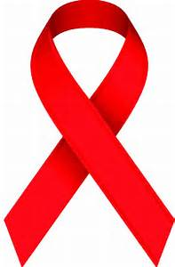
Oct. 23-27
Healthy body, Healthy choices, Helping others
Monday: Teens Needing Teens & RRW History
TNT purpose: Support students, provide help, spread love, and show kindness all while educating them about drugs and alcohol that affects people with their decision-making process.
Tuesday: Yes I CAN be drug free! (Donate all week to the Community Food Bank of Central Alabama)
“The Community Food Bank of Central Alabama feeds people in need today and fosters collaborative solution to end hunger tomorrow.
There are over 80,000 children in Central Alabama at risk of hunger – which is more than the entire population of Homewood, Anniston and Vestavia combined.
To meet this need, the Food Bank supplies over 10 million meals a year to 240 food pantries, shelters and children programs.
Where there are gaps in service, we directly feed families and children through our Child Hunger and Healthy Eating Initiatives.”
List of Most Needed Foods:
Canned Tuna
Chicken
Peanut Butter and Jelly (non-glass)
Cereal / Oatmeal / Grits Dried
Canned Beans Macaroni and Cheese* Pasta and Pasta Sauce*
Canned Vegetables
Canned or dried Fruit
Brown Rice *Whole Wheat Preferred ~ Low Sodium or No Salt Added Preferred
*What not to donate: Opened Food Home canned goods, Unlabeled food (Avoid glass jars as they easily break in transit and cause a safety hazard)

Wednesday: UNITY DAY: Together against bullying. United for kindness, acceptance and inclusion. Wear Orange: Make a statement!
Thursday: Wear Red

Friday: Pledge and sign personal contract

