Greystone Elementary School
Library Media Center – Policy and Procedure Guidelines

Julie Richey, Library Media Specialist

Updated
8/2014

Table of Contents

Vision Statement…………………………………………………………………………3
Mission Statement………………………………………………………………………..4
Organizational Goals and Objectives….............................................................................5
Instructional Goals and Objectives……………………………………………………….6
Performance Goals and Objectives……………………………………………………….7
Literacy Standards………………………………………………………………………..8
Challenged Materials……………………………………………………………………..9
Copyright and Fair Use…………………………………………………………………..13
Collection Development………………………………………………………………….14
Cataloging………………………………………………………………………………..20
Circulation………………………………………………………………………………..20
American Library Association Bill of Rights……………………………………………22
Budgeting Procedures……………………………………………………………………23
Personnel…………………………………………………………………………………24
Donations and Gifts……………………………………………………………………...26
Public Relations and Advocacy………………………………………………………….27
Services/Activities Offered……………………………………………………………...28
Disaster Preparedness…………………………………………………………………….29
Evaluation of the Library Media Center…………………………………………………30
Greystone Elementary Library Schedule………………………………………………...31
Vision Statement

In collaboration with the school’s learning community, Greystone Elementary School’s library media program will constantly strive to be the center of teaching and learning by providing access to quality comprehensive collections and current technologies and by extending services beyond the libraries’ physical spaces and the school day. The Greystone Elementary School strives to provide students, faculty, and staff with the resources and instruction in information literacy needed to become life-long learners. The Greystone Elementary School library will support and complement the school’s changing curriculum and personal interests of the patrons.

Mission Statement

Greystone Elementary School’s Library Media Plan expresses the mission of Hoover School’s library media programs as supporting the school’s instructional program to improve student learning and student achievement. This mission is accomplished by:

- Ensuring learners will be able to independently access, inquire, think critically, gain, create, and share knowledge in real and virtual time.

- Participating in curriculum development and design of learning activities.

- Facilitating professional development for the learning community.

- Foster a love of literature and reading.

Organizational Goals and Objectives

- Organize the library staff to include certified personnel, parent volunteers, and student assistants to provide the best library services possible

- Certified personnel will assign duties to and supervise non-certified personnel.
- Volunteers will assist in shelving returned books and circulation duties. They will also help with special projects such as book fairs and Young Authors’ Week.
- Student assistants (Library Pages) will assist in circulation duties, shelving books, and preparing computers for each day.
- Adopt qualitative and quantitative standards for book and non-book materials and equipment

- The library staff, using national, regional, and state guidelines, will establish long-range standards for the local school library.

- The library staff, using the long-range standards, will establish standards for the following school year.

- Organize book and non-book materials in the simplest and most effective manner for student utilization
- Materials are classified, cataloged, and processed as soon as possible upon arrival.
- Extend the use of the library to include before and after school hours when needed.
- Prepare a budget for the library after funding is determined.

Instructional Goals and Objectives
- Provide instruction on information literacy so each student will be able to locate and use the library resources

- Students will learn to locate the following resources:
- Books in non-fiction, fiction and biography
- Reference collection
- Online catalog
- Circulation desk
- Periodicals
- Internet
- Databases

- Students will receive instruction on evaluating resources with emphasis placed on identifying credible Internet sites.

- Students will receive instruction on using advanced search techniques when using the online library catalog, databases, and the Internet.

- Provide instruction as time and funding permit on updated technologies.

- Provide instruction on the library’s organization and services

- Students will receive in-depth instruction in the library’s policies and procedures through scheduled library classes.
- All students will receive additional instruction and information regarding the library in the following ways:

- When their classes come to the library
- During individual, small group, or whole group instruction
- During collaborative projects with classroom teachers as time permits
- Through brochures, handouts, and notices
- By announcements through the school television network
- Via the library’s webpage
- Through weekly school emails to parents, faculty, and students

Performance Goals and Objectives
- Provide materials, print and non-print, equipment, and facilities for the school program which complement the curriculum and interests of the students, faculty, and staff
- The librarian will develop a policy for selecting all library materials.
- The librarian, after seeking input from the faculty, staff, and students, will select periodicals for the following school year.
- The librarian, after seeking input from the faculty, staff, and students, will select books, audio-visual materials, and equipment according to the selection policy.

- Cooperate with other librarians in the community and become familiar with their collections
- The librarian will visit the other librarians in the community, meet the staff, and become acquainted with the collections.
- The librarian will cooperate with the community library staff in developing plan for disseminating information concerning school assignments.
- The librarian will cooperate in a program of interlibrary loan whenever this is feasible.

- Provide resources that will enable and encourage each student to understand, appreciate, and value his/her cultural, social, political, and economic heritage as an individual, as an American, and as a citizen of the world
- The librarian will choose materials that demonstrate moral and ethical values, patriotism, citizenship, and diversity.
- The library staff, through example, will promote these ideals and encourage exemplary behavior by students.
- Bibliographies and Resource Lists will be compiled when requested.

- The library staff will encourage students to appreciate and explore literature in various genres. The library staff will encourage creative thinking and encourage students to read for enjoyment.

- The library staff will introduce students to various authors and fiction and nonfiction books that match their interests and reading levels.

- Provide materials to aid students who have moved from another country.

- Establish rapport with the faculty and staff
- The librarian will attend all faculty meetings and work cooperatively on all committees to which he/she is appointed.
- The librarian will seek faculty requests for materials to be included in the collection.

Literacy Standards
The Greystone Elementary Library adheres to the guidelines set forth in Standards for the 21st Century Learner, created by the American Association of School Librarians, published by the American Library Association, and adopted by the Alabama Department of Education. Please visit the link below to view a copy of Standards for the 21st Century Learner.
http://www.ala.org/ala/mgrps/divs/aasl/guidelinesandstandards/learningstandards/AASL_Learning_Standards_2007.pdf

Challenged Materials
RECONSIDERATION OF MATERIAL FOR LIBRARIES/MEDIA CENTERS

The Hoover City Board of Education understands and accepts the fact that it has the final responsibility for the selection of materials to be used in the District’s libraries/media centers as well as classrooms. The Board delegates the selection of such materials to its Superintendent, principals, library/media specialists, and teachers. The Board encourages the involvement of the professional staff, parents, students, and community in the selection process.
The Board also confirms that each student and teacher have the right to intellectual freedom and subscribes to the principles of the American Library Association Library Bill of Rights. Following is an outline for the use of those in the community who wish to ask that the school reconsider its selection of material either in the library/media center or classroom:

REQUEST FOR RECONSIDERATION

Anyone in the community may object to the material in the Hoover City Schools’ library media center programs. All concerns made to staff members should be reported to the school principal immediately. The reconsideration process shall cease if, during an informal discussion between the staff member and the concerned community member, the community member decides not to pursue the matter.

The principal shall talk informally with the person voicing the concern if the matter could not be resolved during the earlier conversation with the staff member. The principal shall explain the school’s selection process, reconsideration procedure, philosophy and goals of the District and library media center, adherence to the American Library Association Library Bill of Rights, and compliance with copyright laws. The principal may delegate this responsibility to the school librarians.

If the decision is made to pursue the issue, the interested party shall be given a copy of the appended “Request for Reconsideration of a Work” from which must be completed and returned before consideration is given to the objection. If the form is not received by the principal within two (2) weeks, the request for reconsideration shall be considered closed. Copies of the completed form will be kept on file in the office of the principal and school librarians.

PROCEDURE FOR RECONSIDERATION OF MATERIAL

The material will remain in circulation during the reconsideration process.

The Review Committee, appointed by the principal, consisting of teachers, parents, school librarians, one administrator, and students, if deemed appropriate, shall review the challenged materials in a timely manner. The school librarians shall chair the committee.

The person filing the reconsideration may speak to the committee if he/she desires, but will not be involved in the decision-making.

Committee members shall accept this responsibility with the understanding that each member will read/view the material in question in its entirety and judge it on its overall value.

The Review Committee shall meet to discuss the material. The committee chair shall prepare a report on the committee’s decision.

The committee shall base its decision on the entire work.

The committee’s final decision shall be one of the following:

The material will remain on the shelves;

The material will be restricted; students must have parental permission to sue and parents must complete the appended “Permission to Use Controversial Material”;

Remove the material.

Committee members shall vote by secret ballot.

The committee chair shall notify the person filing the reconsideration by letter of the committee’s decision. A copy of the letter will be sent to the Superintendent.

The letter may include the reasons why the committee reached its decision.

The letter will include information of the appeal process.

The letter will be sent within five (5) working days of the decision being made.

Copies of the report and letter will be kept on file in the offices of the principal and school librarians.

PROCESS FOR APPEAL

The Review Committee’s decision may be appealed to the Superintendent.

Once a decision has been made, the item will not be reviewed for three (3) years within the same school.
REQUEST FOR RECONSIDERATION OF A WORK
Request initiated by ______________________________________ Date issued ____________
Address ______________________________________________________________________
City ________________________ Zip Code ____________ Telephone ___________________
Are you representing yourself or an organization? Self ________ Organization ________
Please identify the organization, if you are representing one. _____________________________
Please identify the material in question:
BOOK: Author ________________________ Title ___________________________________
AUDIOVISUAL MATERIAL (video, DVD, computer software, etc.)
Type media ________________________ Title ________________________________
- Have you read, viewed, or listened to the material in its entirety? YES NO
- How did you learn of this material? ______________________________________________
- Please cite the specific page(s), section(s), etc. to which you object and explain your objections.__________________________________________________________________
- What do you believe is the theme of this material? __________________________________
- What do you find in the material that is good? _____________________________________
- What do you believe might be the result of reading/viewing this material? _______________
- For what age group would you recommend this material? ____________________________
- What action would you recommend the school take on this matter?
__ Do not assign or recommend it to my child.
__ Withdraw it from all students.
__ Other (please specify) ______________________________________________________
- What material would you recommend to take its place? ______________________________
- Do you wish to make an oral presentation to the Review Committee? YES NO
Date _________________ Signature _______________________________________________

THIS COMPLETED FORM MUST BE RECEIVED BY THE PRINCIPAL WITHIN TWO WEEKS OF THE DATE OF ISSUE.

Copyright and Fair Use

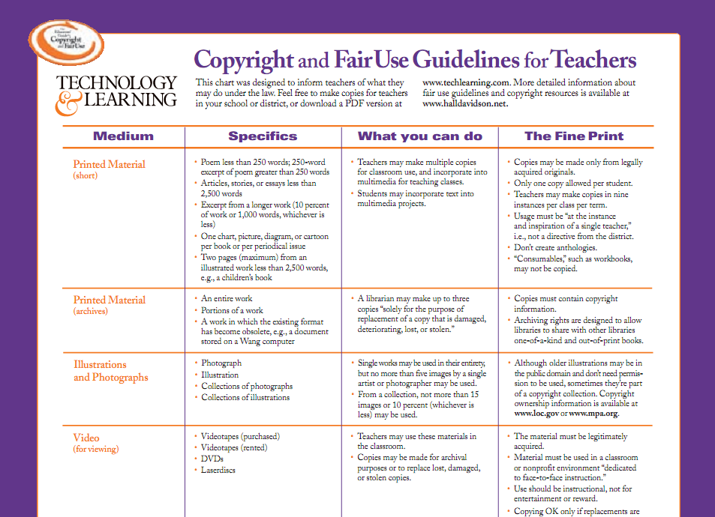

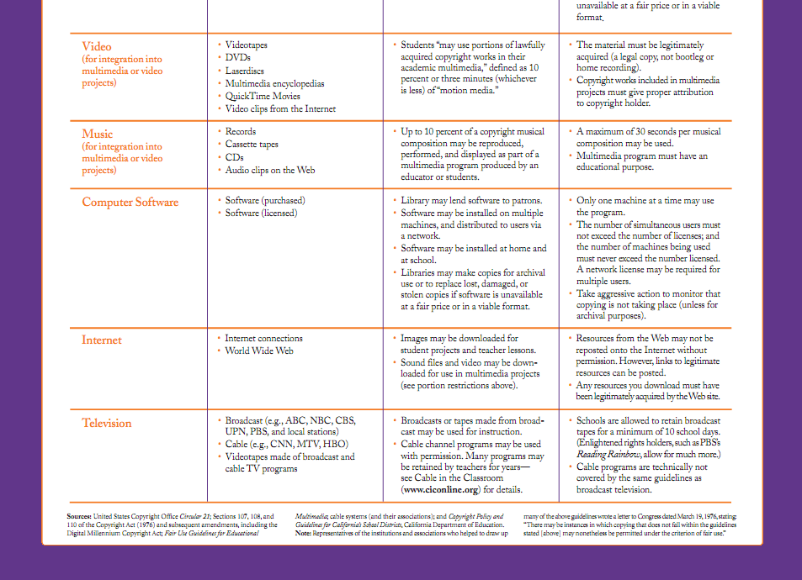

Collection Development Policy
Legal Responsibility for Selection
The legal responsibility for the selection of materials and equipment rests with the Hoover Board of Education. This responsibility is delegated to the principal and library personnel of individual schools. The librarian seeks input from the faculty, staff, students, and parents. Their requests will be given the highest consideration in selection. Selection tools and catalogs are available for those who need them.
Funding
The library is funded by donations and fundraising such as Book Fair and Birthday Book Club. PTA funds also given for books occasionally. PTA also funds our Young Authors Week.
General Principles
The collection is intended to reflect the missions of the school and library. The library collection should support and complement the curriculum and interests of the students, faculty, and staff. The overall value of the material is the major criterion used in selection. Selected materials should have literary, artistic, or historic value. Factual materials should be accurate, authoritative, and up-to-date. A balanced collection is a goal. Emphasis is placed on acquiring quality literature and guiding the students to suitable materials for the abilities and interests; however, as many requests as possible will be filled.
The freedoms of speech and press are to be exercised in the library. The Hoover City Board of Education policy for reconsideration of material will be followed if someone challenges any library material.
Standard tools of selection will be used. Some of these tools are School Library Journal, Hornbook, Booklist, and other professional journals and standard book lists.
The faculty may request that specific titles or materials in a subject area be purchased for inclusion in the library’s collection. The librarian will actively solicit requests throughout the year, and student and teacher requests (informally, in writing, or electronically through Destiny) may be submitted to the librarian at any time.
Audio-Visual Materials
Audio-visual materials are a vital part of the collection. Emphasis is placed on purchasing digital audio and DVDs. The librarian seeks to purchase materials that are of the highest quality regarding sound, color, photography, and accuracy. They are suitable for class use, but it is the responsibility of the teacher to make selections appropriate for his/her students.
Materials are bought that aid students and faculty in learning and teaching. These materials are used to enhance the reading, listening, and viewing skills of students. Audio-visual materials are discarded because of obsolescence and poor condition. Much effort is made to maintain the most current material possible within budgeting limits.

Periodicals
Periodical selection is based on the needs, interests, and requests of students, staff, and faculty. It is necessary to subscribe to magazines with academic and recreational value, especially those that enhance the curriculum. Professional periodicals are needed to help the faculty in their professional and continuing education.
Equipment
Equipment requests are submitted to the school’s technology committee. Equipment needs and purchase decisions are determined collaboratively between faculty and committee members.
Fiction
Fiction is selected to meet the educational needs of readers who have various tastes, interests, purposes, and abilities. Emphasis is placed on quality and reader development. Care is taken to offer novels of well-known authors. Classics are necessary to the collection even though they may rarely circulate. Certain novels are purchased because their insight to life might help students through particularly difficult times in their lives. High interest-low reading material is needed to help students improve their reading skills.
Non-fiction
Accurate, up-to-date non-fiction material in all subjects is a necessity for a balanced collection. These materials must be informative.

Gifts
Gifts of all types are accepted with the understanding that if they cannot be used, they are utilized as the librarian sees fit.
Binding, Discarding, Replacement, and Duplication
Only titles that cannot be replaced and are valuable to the collection are sent to the bindery. Material that is out-dated, worn and which does not merit repair or rebinding, or does not have any literary or factual value, is discarded. Discarded library material are offered to faculty on a first-come, first-served basis, and then, after a reasonable amount of time, offered to charity. Material, which is popular or valuable to the collection, is replaced when needed. Duplicates are purchased, if possible, due to need and popularity.
Weeding
The cornerstone of the library media center is its resource collection. In order to ensure balance, reliability, and comprehensiveness of the collection, materials are to be reviewed continually to locate and remove those materials that no longer meet the criteria. Factors for removal include:
- physical condition of the item;
- frequency of the item’s circulation;
- copyright of the item;
- accuracy and timeliness of information;
- replacement of a paperback with a hardback edition.
To main current, up-to-date reference materials for student research and projects, the reference collection is weeded more often than other areas of the library’s collection. In compliance with the Alabama State Department of Education standards set forth in Literacy Partners, and Southern Association accreditation, the recommended number of books per pupil is maintained and strengths and weaknesses of the collection are determined.
The Texas State Library’s Crew method, MUSTIE, is a good tool
to use for weeding. The following standards are used to discard
an item:
• M = Misleading; factually inaccurate
• U = Ugly; book is worn and torn, in disrepair
• S = Superseded by a new edition (almanacs, etc.)
• T = Trivial; of no real discernable value
• I = Irrelevant to the needs and interests of your community
• E = Elsewhere available
SUGGESTED COPYRIGHT DATE CHART FOR WEEDING
(Adapted from MUSTIE)
DEWEY # SUGGESTED YEARS TO RETAIN
000 2-10 years (Computer books age faster)
100 5-8 years
200 2-10 years (Difficult to weed because of religion)
300 5-10 years
400 3-10 years
500 5-10 years (Science books may differ)
600 5-10 years (Technology titles may be sooner)
700 5-10 years
800 Flexible (Use MUSTIE)
900 5-10 years (Some may differ – almanacs, maps)
Biography Flexible (Use MUSTIE)
Encyclopedias 5 years (AVL online versions available)
Almanacs 3 years
Periodicals 3 years for printed (AVL online versions available)
Fiction Depends on circulation use (Award winners & classics will differ)
Audio & Video Condition and content will determine
CDs/DVDs Check for format changes

Cataloging
Cataloging is done using the Destiny library catalog services. Original cataloging is sometimes necessary when other services are unavailable. The Greystone Elementary School Library catalogs and organizes books using the Dewey Decimal System. Electronic cataloging is utilized throughout our system when possible.

Circulation Procedures
Students may check out general collection books. Student book checkout policy is listed below:
Kindergarten – one fiction book per week in the first semester; two books in the second semester (choice of one fiction and one nonfiction book OR two fiction books)
First grade - two books per week (choice of one fiction and one nonfiction book OR two fiction books)
Second grade - two books per week (choice of one fiction and one nonfiction book OR two fiction books)
Third grade - three books per week (at least one of these must be a fiction book)
Fourth grade - three books checked out at a time (at least one of these must be a fiction book)
Fifth grade - three books checked out at a time (at least one of these must be a fiction book)
Students are allowed to check out additional books for a class project or by request from the teacher or parent at the discretion of the library media specialist.
All classes are scheduled to visit the library for 30 minutes every week. They may also come to the library during the open library times during the week. Fourth and fifth grade students may keep their books for 2 weeks.
Overdue Books
Students with overdue books may not check out new books. If parents contact me and let me know that they are looking for a book, I will allow the student to check out books until the book is found or the book is paid for. Students are given a printed overdue notice to help them remember what they need to return. Fourth and fifth grade students can log on to their personal Destiny account from any computer with internet access to find out what books they have checked out, renew books, place holds on books, and more. There are no overdue fines.

Lost or Damaged Books
Students or teachers that have lost or damaged items are asked to pay for the items so that they can be replaced. If the lost items are found, the patron will receive a refund.

Inventory
The Greystone Elementary School library performs an end-of-school inventory during the month of May. During this time, every item on our shelf list is accounted for.

Periodical Retention Schedule
Back issues of most magazines are kept for two years. Exceptions are made for magazines that continue to circulate regularly or single subject magazines.

Scheduling
The library schedule is determined by the principal and the scheduling committee at Greystone Elementary School. The library operates on a weekly fixed schedule for all students. Teachers may send individual students or small groups of students for check out, research, etc. during open library times. Open library times are given to teachers and posted on google docs. Students are encouraged to come to the library during the open times. The library media specialist may ask the student to come back at an open time if it takes the librarian’s attention away from the regularly scheduled class. Teachers may reserve the library in advance for research, special projects, or guest speakers. Open library times are also used for collaborate projects between the library media specialist and the classroom teacher.

American Library Association Bill of Rights

The American Library Association affirms that all libraries are forums for information and ideas, and that the following basic policies should guide their services.

- Books and other library resources should be provided for the interest, information, and enlightenment of all people of the community the library serves. Materials should not be excluded because of the origin, background, or views of those contributing to their creation.

- Libraries should provide materials and information presenting all points of view on current and historical issues. Materials should not be proscribed or removed because of partisan or doctrinal disapproval.

- Libraries should challenge censorship in the fulfillment of their
responsibility to provide information and enlightenment.

- Libraries should cooperate with all persons and groups concerned with
resisting abridgment of free expression and free access to ideas.

- A person’s right to use a library should not be denied or abridged
because of origin, age, background, or views.

- Libraries which make exhibit spaces and meeting rooms available to
the public they serve should make such facilities available on an
equitable basis, regardless of the beliefs or affiliations of individuals or
groups requesting their use.

Adopted June 18, 1948. Amended February 2, 1961, and January 23, 1980, inclusion of “age” reaffirmed January 23, 1996, by the ALA, American Library Association, Council.

Budgeting Procedures
The budget for the library is determined by the Library Media Specialist at Greystone Elementary School, with input from faculty and students. Funds are raised through Book Fairs and Birthday Book Club, with occasional funds from PTA for library resources. PTA also funds Young Authors Week each year.

Personnel
Professional Media Staff
A certified school librarian administers the school library media program and has been trained in library science to manage effectively the library media program.
Responsibilities of the professional library staff are listed below. The items are not in priority order, nor are they of equal importance.
- Assists teachers with integrating the library’s resources in their lessons.
- Consults with students and teachers on effective use of the library’s resources.
- Coordinates selection of materials for the library with input from the faculty, staff, and students.
- Evaluates the library’s collection.
- Makes long-range plans for the development of the library program.
- Assists students and teachers in using non-print resources, as well as audio-visual equipment.
- Assures accessibility to materials in the library.
- Serves on committees at the building and district level.
- Provides learning experiences for students within the library.
- Supervises support staff, volunteers, and students assistants.
- Serves as a resource person in classroom presentations or on teaching teams.
- Provides teachers with information concerning materials in the library related to specific curriculum areas.
- Publicizes the resources of the library.
- Develops the library’s budget.
- Provides training for library media center staff and teachers in effective utilization of resources and the objectives of the school library program.
- Performs minor repairs and routine maintenance on audio-visual equipment in the library.
- Determines when major repairs are necessary and handles this activity according to system policies.
- Instructs students, teachers, and others in the use of the library’s automated searching software.
- Assists in preparation of specifications for the purchase of additional audio-visual equipment if this is not handled on the system level.
- Administers the school’s library media program with the support and approval of the school administrators.
- Develops policies and procedures for achieving the goals of the library program.
- Exercises leadership in the development of the library budget and administration of the budget.
- Coordinates activities and designs job descriptions for library staff, if available, and student and adult volunteers.
- Coordinates the library media program with the school’s instructional program.
- Makes short and long range plans for development of the school library program.
- Problem-solves minor technology issues.
- Serves as intermediary between the Greystone faculty and staff, and the district’s technicians and technical trainers.
- Opens and closes daily the school computer lab, orients interactive white board, maintains printers and their supplies, provides copy of schedule (set by the principal), and coordinates with system technicians any necessary repairs.
- Tracks and records monthly and yearly library circulation and usage statistics.
- Coordinates activities and management of satellite centers (school archives, parent resource center, etc.)
- Provides professional development information to the faculty and staff.

- Student Library Assistants
Student Library Assistants perform such necessary duties as those listed below. The items are not in priority order, nor are they of equal importance.
  - Shelve returned books;
  - Assist Library Media Specialist;
  - Help maintain the appearance of the library;
  - Distribute library materials to teachers, as needed.
- Volunteers
Adult volunteers can play an important part in the school media program. They bring a variety of talents to the program; however, they should not be used in lieu of well-trained and salaried support staff. Volunteers can perform the following tasks:
  - Assisting at the circulation desk;
  - Ensure books are on the shelves in proper order and other media are in their appropriate places;
  - Help process materials;
  - Repair materials;
  - Assist with inventory.
  - Assist with bulletin boards and other media center displays
  - Organize, publicize and assist with media center fundraisers such as book fairs

Donations and Gifts

- Gifts, Donations and Memorials. Gifts and donations must meet the same criteria as the materials selected for purchase. They are accepted with the understanding that, if they do not meet the criteria of the selection policy, they may be disposed of at the discretion of the media specialist. Donations of materials or funds to enrich the library collection are welcome.

Public Relations and Advocacy

- The school librarians, in partnership with school and community groups, uses a public relations plan as noted on page 34 of the Alabama’s School Library Media Plan for the 21st Century Learner. This plan will promote advocacy for the library media program through promotional events including but not limited to those listed in Appendix D on page 43.

- The school librarians maintains a working relationship with the local public library and other libraries in the school district.
- The school librarians encourages participation by parent and community volunteers.
- The school librarians communicates with teachers, parents and community members via newsletters, email, web pages, and print materials to be sent home in Wednesday folders.

Services/Activities Offered
- Extended Library Media Center Hours
- Online Library Catalog with remote home access
- Alabama Virtual Library Database
- Book Clubs
- Book Fairs
- Author Visits
- Guest Speakers
- Student Library Aides
- Online Homework Help
- Research and Citation Assistance

Disaster Preparedness

In the situation of an emergency, school library media center staff should follow procedures that have been established by the school or administration. Severe weather and fire evacuation plans should be posted in a clearly visible area in each school library media center. In the event of an emergency, the following guidelines should be considered:
- Leave quickly – but not before you ensure that there are no students in the library media center. Check the stacks, closets, and other areas for stragglers.
- Shut all doors behind you as you leave, to slow the spread of fire, smoke, and water.
- Take only the essentials – car keys, purse, and emergency toolkit, if conditions allow.

To prepare an emergency toolkit, consider adding the following items to a plastic storage box.
- Electronic backups – critical computer files and a record of your collection should be saved. This is done at the district regularly.
- Duplicates of critical information – key contact information, an inventory of furnishings and equipment, and any other information you may need to prepare for reopening. It may also be helpful to take “before” pictures to support insurance claims before a disaster strikes. You may then use a camera afterward to document damage.
- Flashlight and batteries

Evaluation of the Library Media Center

Statistics will be documented yearly by the library media specialist in the following areas:
- Circulation
- Students working independently
- Classes visiting with teachers for checkout
- Classes visiting with teachers for research/instruction
- Planned activities, in-services, events, receptions, or meetings
- Collection statistics
  - Lost books
  - Books added to the collection
  - Overdue/books not returned/payment owed (send copy to school bookkeeper)
  - Books weeded from collection
  - Number of holds
  - Number of interlibrary loan requests
- Collaboration with teachers/resources provided

