Name________________________________ Geometry 1-3 & 1.7 Extra Practice
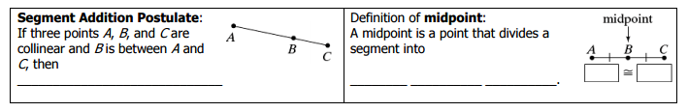

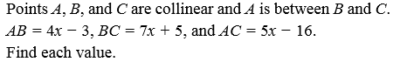
1. 2. Points N, O and P are collinear and O is between N
and P. If NO = 2y + 11, OP = 3y − 2, NP = 6y + 3, and MP = 64, find each value.

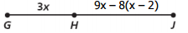
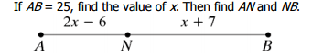
3. 4.

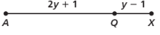
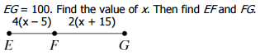
5. 6.

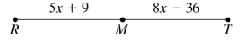
7. 8. Find KL, LM and KM.

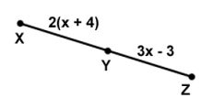
9.

Use the figure to answer 10-13.

10. Are segments $\overline{AC}$ and $\overline{BD}$ congruent? 11. Are segments $\overline{AD}$ and $\overline{BE}$ congruent?

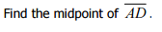
12. 13.

Find a) the midpoint of each segment and b) the distance between each point.
14. Q (9, −2) and R (3, 5) 15. D (32, 4) and E (20, 8)

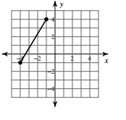
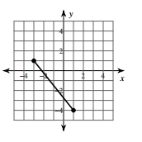
16. 17.

