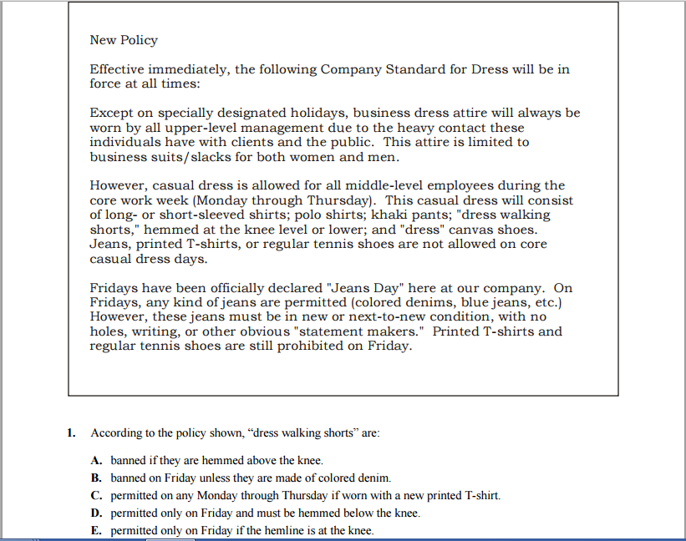

PR | 2. A short summary of the main ideas.  A-practice  B-precis  C-prophecy | 3. A preference.  A-precision  B-predilection  C-prestidigitation | 4. This means beyond what's normal.  A-prehensile  B-preternatural  C-presumptive | 5. After 40, some people read at arm’s length because the lenses in their eyes have become inflexible. That's called:  A-presbyopia  B-premaxilla  C-prestissimo

