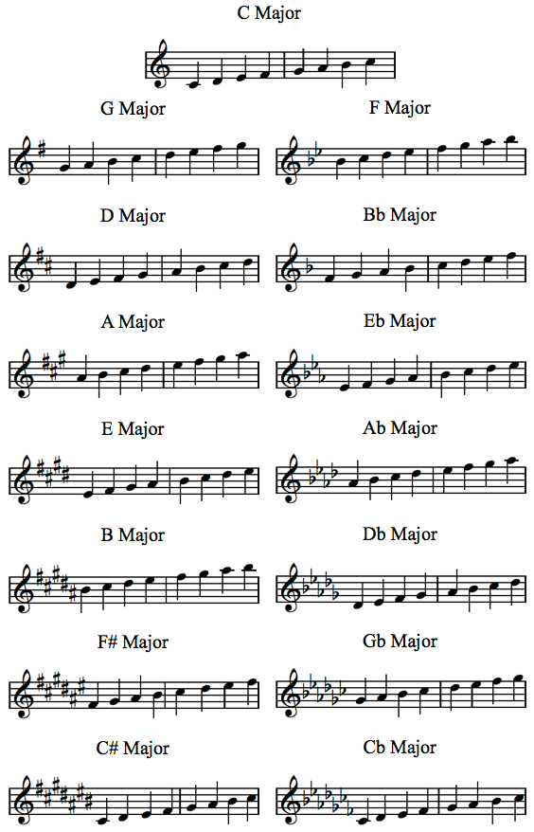

**F Major**

**C Major/Eb Concert**

**b Concert**

**Bb Major/Db Concert**

**F Major/Ab Concert**

**G Major/Bb Concert**

**Eb Major/Gb Concert**

**D Major/F Concert**

**A Major/C Concert**

**Ab Major/B Concert**

**E Major/G Concert**

**Db Major/E Concert**

**B Major/D Concert**

**F# Major/A Concert**

**Cb Major**

**C# Major/E Concert**

**Gb Major**