Science 3rd 9 Week Exam Study Guide: Answer questions on your own paper

Chapter 3
- List the 2 types of solids and give 1 example of each
Amorphous and Crystalline. Amorphous solids are like glass and rubber and Crystalline solids are like iron or diamond
- Compare/ contrast the particle size and speed of solid liquid and gas
  - Solids big and slow Liquids Medium size and speed Gases small and fast.
- Write Boyle’s Law and explain it’s purpose
Boyle’s law states that for a fixed amount of gas at a constant temperature, the volume of the gas is inversely related to pressure

- Write Charles’ Law and Explain it’s purpose
Charles’s law states that for a fixed amount of gas at a constant pressure, the volume of the gas changes in the same way that the temperature of the gas changes.

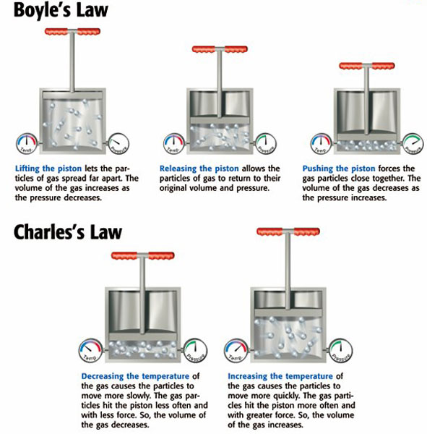

- What would affect the temperature at which water boils?
The Pressure. As the vapor pressure meets the atmospheric pressure liquids boil.
- Explain Surface Tension and tell what is does.
is a force that acts on the particles at the surface of a liquid
Allows liquids to form beads

- Explain Viscosity and tell how it affects liquids
is a liquid’s resistance to flow
Tells us how fast or slow a liquid flows.

- Changing from a solid to a liquid is called? Melting

- Changing from a liquid to a solid is called? Freezing

- Changing from a liquid to a gas is called? Evaporation

- Changing from a gas to a liquid is called? Condensation

- Changing from a solid to a gas is called? Sublimation

- Know how to graph phase change and what the graph looks like
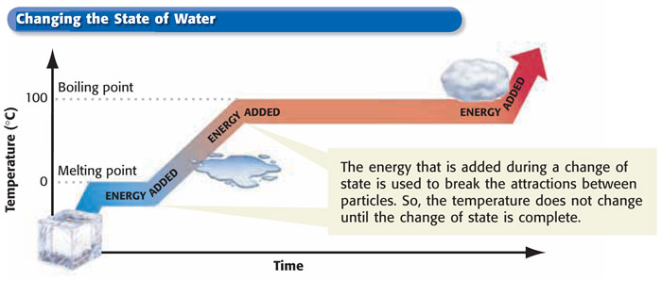
Chapter 4
- Define a mixture and give 2 examples
A mixture is a combination of two or more substances that are not chemically combined
No chemical change occurs when a mixture is made.
Each substance in a mixture keeps its own identity and properties
Examples: peas & carrots, milk, paint

- Define a solution and explain how it is different from a compound
A homogeneous mixture of two or more substances uniformly dispersed throughout a single phase
Same appearance and properties throughout the mixture
Solutions are mixtures they are not compounds. Compounds have chemical bonding of between elements to form a new substance with different properties

- Explain how mass ratios are important in forming compounds
The atoms of the elements that chemically combine to form compounds can only come together in specific, whole number ratios.
The number of outermost electrons, as indicated by which group number the element is in on the periodic table, controls the quantities needed to form compounds with a neutral charge.

- Compounds found in living things contain?
Proteins are compounds found in all living things. The element nitrogen is needed to make proteins.
Carbon dioxide is another compound that is required for life because plants use the carbon in the process of photosynthesis

- Define solute
Solute: The substance that is dissolved (the sugar in the sweet tea)

- Define Solvent
Solvent: substance in which the solute is dissolved (the water part of the sweet tea)
When two liquids or two gases are combined the solvent will be the substance present in the greatest amount

- Colloids have properties of what 2 other combinations?
Colloids are mixtures in which particles are dispersed throughout but are not heavy enough to settle out.
The particles are much smaller than in a suspension but will still scatter light.
The particles can not be separated by filtration.
Colloids have properties of suspensions and solutions.
Everyday examples: milk, mayonnaise, gelatin, whipped cream

- How are mixtures different than compounds?
Mixtures
Made of elements, compounds or both
No change in original properties of components
Separated by physical means
Formed using any ratio of components
Compounds
- Made of elements
- Change in original properties of components
- Separated by chemical means
- Formed using a set ratio of compounds

- How can you break down compounds? Mixtures? Solutions?
Methods for breaking down compounds
- Generally requires the addition of energy
- Apply heat
- Apply electric current
- Chemical changes

Common Ways to Separate a Mixture
Distillation
Magnetism
Centrifuge
Filtering
Evaporation
Physical Means

To separate a solution
- Insoluble substances can be removed by filtration
- Evaporation can be used to separate a solute
- Chemical reactions can separate the solute, which may be combined into a new compound

- Define a compound and list 2 examples
- Pure substances made of two or more elements
- Combine in specific ratios
- The combined elements lose their individual characteristics
- Can be broken down into simpler substances by chemical change only
- Examples: sodium chloride (salt) and water

Chapter 11
- What did JJ Thompson Discover? What was the model he used?
British scientist who discovered that there are particles inside the atom
Discovered electrons – negatively charged particles
Researched protons and gases
Won the Nobel Prize in Physics in 1906 for showing that subatomic particles with either + or – charge form at least part of the structure of an atom.
“Plum in a pudding” model
Electrons are evenly dispersed throughout the atom
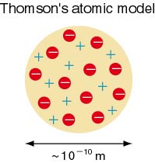

- What did John Dalton discover? What were the three parts to his theory?
Dalton found that:
Elements are composed of extremely small particles called atoms.
Compounds are formed when atoms of different elements combine with one another in small whole numbers.
The relative numbers and kinds of atoms are constant in a given compound
Daltons Atomic Theory:
- All substances are made of atoms. Atoms are small particles that cannot be created, divided or destroyed.
- Atoms of the same element are exactly alike, and atoms of different elements are different.
- Atoms join with other atoms to form new substances.

- What did Democritus discover?
Atoms are small, hard particles
Atoms made of a single material formed into different shapes and sizes.
The atomic theory of Democritus provided the basis for an explanation of the changes that occur when matter is chemically transformed.
Democritus’s theory was rejected by Aristotle.

- What did Ernest Rutherford Discover and what was his experiment?
- New Zealander who discovered that the atom is mostly empty space.
- Won the Nobel Prize in chemistry in 1908 for his work on radioactivity.
- In 1911 he made a new model to include the nucleus
- Gold-Foil experiment showed that atoms were mostly empty space.
- Proposed that in the center of the atom is a tiny, extremely dense, positively charged part called the nucleus
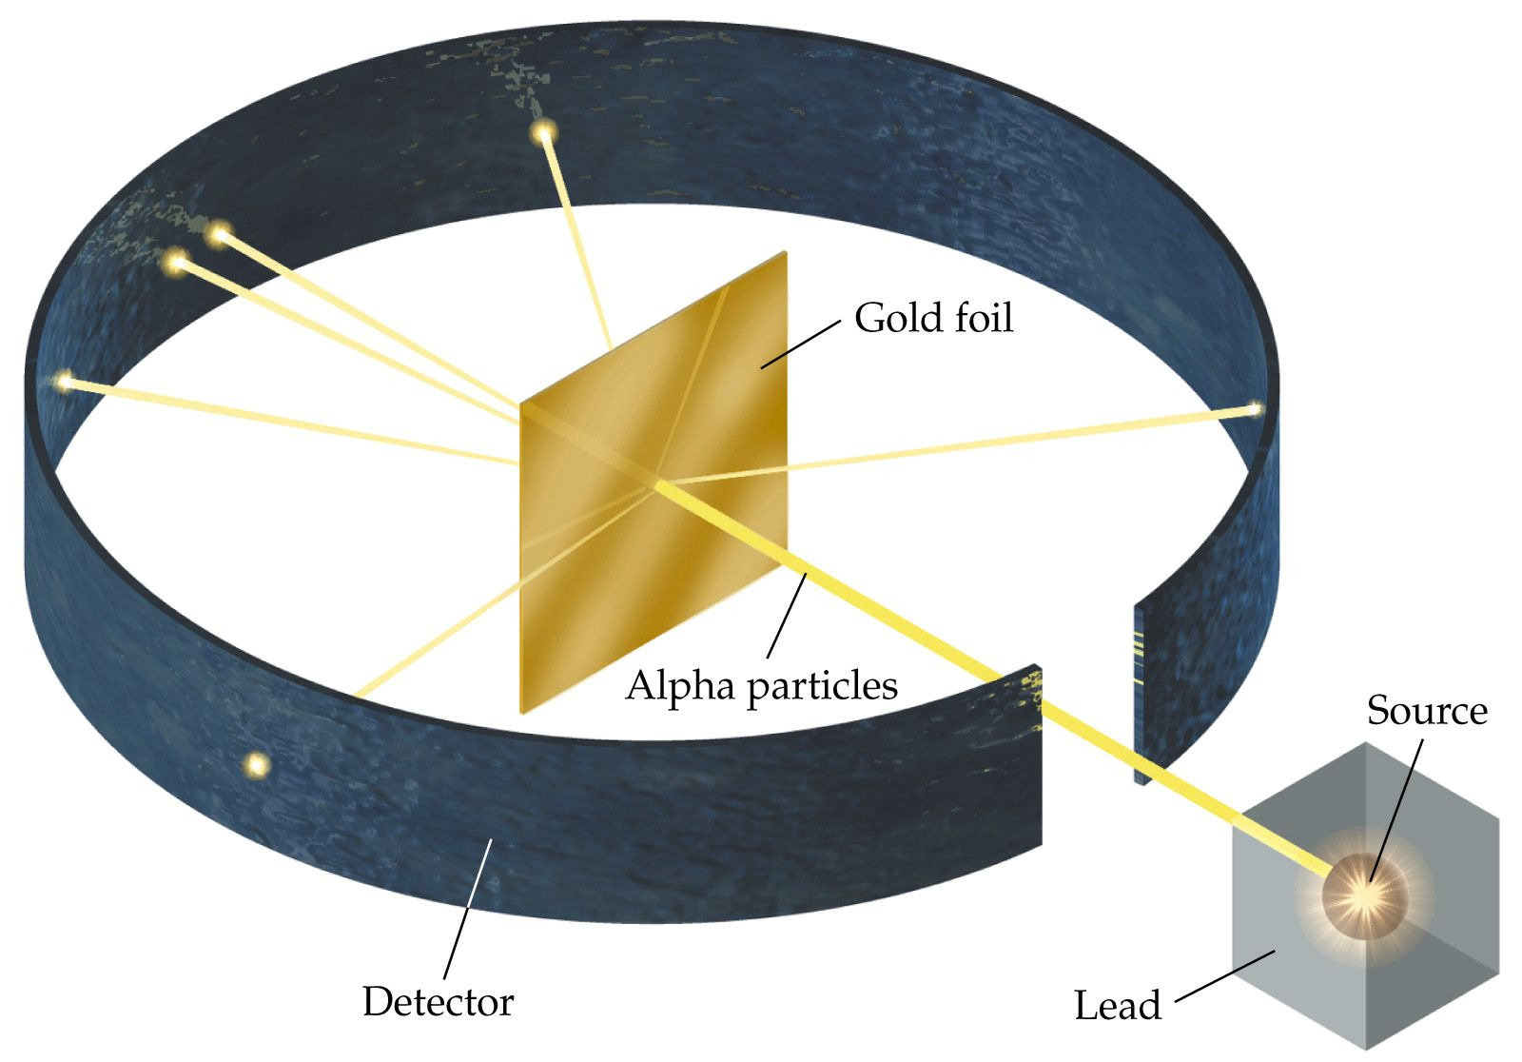

- What are the three parts of the atom and what are their charges?
Protons
- Have a positive charge (+)
- Found in the nucleus of the atom
- The atomic number for each element tells how may protons are in the nucleus of that particular atom.

Neutrons
- Neutrons have no charge (+/-) neutral
- Neutrons are found in the nucleus
- Each neutron had an amu of 1

Electrons
- Electrons are negative (-)
- Found outside the nucleus
- So small they are considered to have a mass of zero – it would take 1,800 electrons to each the mass of one proton
- When protons (+) and electrons (-) are equal in number the charge on the atom is neutral.

Chapter 12
1) Which Part of an atom is the smallest? Largest?
Smallest Electron. Largest Protons/ Neutrons

2) If an element has 8 protons, 8 neutrons and 8 electrons what is its atomic mass? Atomic Number? Identity? Ex: hydrogen helium
Mass 16, Atomic # 8 Identity Oxygen

4) Define Periodic
Describes something that occurs or repeats at regular intervals

- Write out the periodic Law
The chemical and physical properties of the elements are periodic functions of their atomic numbers.
Mendeleev found that his periodic table repeated after every seven elements

- The rows on the periodic table are called?
Periods
- The columns (vertical H-Fr) are called?
Groups
- What does the ziz zag line represent? What touches it? What is to the right of it? What is to the left of it?
Means “metal-like”
Dividing line between metals and nonmetals
Properties of both metals and nonmetals
Al is the exception

- How did Mendeleev arrange the elements?
  - Russian chemist and teacher
  - 1869 developed chart (periodic table) for his students to show relationships among elements
  - Periodic table is arranged into groups based on a set of repeating properties.
  - Arranged the elements in order of increasing atomic mass
  - Predicted discovery of more elements

- How often do the elements repeat?
Every 7 Elements

- What are some properties of metals? List 5
What comes to mind?
Most of the 109+ elements are metals
Weakly held outer e⁻
Properties of metals:
  - Good conductors of heat and electricity (p)
  - High density (p)
  - High melting points (p)
  - Luster (p)
  - Malleable (p)
  - Ductile (p)
  - Corrosive (c)

Material from Chapter 13: Chemical Bonding
- What is a valence electron? Where can they be found?
Valance electrons are those electrons found in the outermost shell or level of an atom. Valence electrons determine the atom’s chemical properties. These electrons are the only ones to be shared, lost or gained during chemical bonding. All elements in a group in the periodic table will have the same number of electrons (except for He, which only has 2. Figure 4 on page 366 explains how to determine the valence electrons for each group in the periodic table.

- How does an atom change into an ion? And what is an Ion
When an atom gains or loses valence electrons the number of - (negative)charges from electrons and + (positive) charges from protons is out of balance. Ions are the resultant charged atom, which has differing numbers of electrons to protons

- What is unique about arrangement of electrons of the noble gases?
The noble gases found in group 18 have their outmost energy shell or level filled up with the maximum number of valence electrons. Helium, He, is filled with two valence electrons, but all other number gases have 8 valence electrons. When the outmost level is full the atom is not going to easily bond with any other atom – it’s happy

- How does the energy of an atom change when an electron is gained? When lost?
  - When electrons are gained energy is given off by the nonmetal ions that easily gain electrons. The most energy is given off by the halogens in group 17, which are highly reactive. When electrons are lost by metal ions only a small amount of energy is needed. The least amount of energy is needed by the reactive group 1 and group 2 metals, which easily give up their 1 or 2 valence electrons

- What are the differences between ionic and covalent bonds?
In ionic bonding a metal atom gives up electrons to become a – charged metal ion and a nonmetal atom gains those electrons to become a + charged nonmetal ion. The metal transfers electrons to the nonmetal, which gives both the metal and nonmetal a full outermost electron energy level.
In covalent bonding atoms share one or more pairs of electrons. This type of bonding does not require as much energy.

- List examples of compounds formed by ionic bonds. List examples of molecules formed by covalent bonds.
Ionic Compounds Covalent Compounds
Sodium chloride (salt) sugar proteins
Other salts Soap diatomic molecules
Plastic

- Know how to show bonding using Lewis electron dots – give an example of a covalent bond and ionic bond.
Electron dot diagrams show only the valence (outermost energy level) of electrons for an element. You must first determine how many valence electrons each element has. The electron dots are placed around the element symbol in the following pattern: Starting at the right, draw 1 electron, or dot, counter-clockwise around the element symbol for each of the first 4 valence electrons. Again starting at the right of the symbol add a second dot beside first dot, counter-clockwise around the element for a maximum of 8 dots (2 for He). When you are diagramming a covalently bonding molecule the shared electrons will be to the right and bottom.

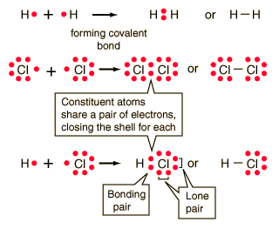

- What is crystal lattice?
A Three dimensional pattern that forms when Ions Bond

