AP US Government & Politics
Danika Powell
Carroll High School
2018-2019

Course Overview:
Advanced Placement US Government and Politics is a course that explores political theory, practices, and groups and explains the Constitution, public policy, and civil rights/liberties. This course is designed to teach students factual information, as well as analytical skills related to American government and politics. This is taught as a college level class and so much work is expected, including substantial amounts of reading and writing. Student learning objectives include:
­ Knowing facts, concepts and theories pertaining to US government.
­ Understanding political processes and behavior, along with their consequences.
­ Being able to analyze and interpret basic, relevant data/graphs/charts.
­ Being able to critically analyze relevant theories and concepts, apply them appropriately, and develop connections across the curriculum.
­ Being knowledgeable in their rights and responsibilities as citizens.
­ Being prepared for the AP exam in May.

Course Readings:
- Schmidt, Steffen, et al. American Government and Politics Today. Belmont, CA: Thomson Wadsworth 2005
- Serow, Ann and Ladd, Everett, ed. The Lanahan Readings in the American Polity 4th Edition. Baltimore, MD: Lanahan Publishers 2007

These readings may be supplemented with handouts, web pages, and other articles as necessary, throughout the course.

Grading:
Tests: 60% Homework: 25%
Journal: 5% Project: 10%

Course Calendar and Assignments:
This class is taught in 6 units over the course of 18 weeks. Questions and free-response writing will be done regularly in class to strengthen students’ skills. The unit lengths are based on the AP handbook, which provides the percentage of questions from each unit on the AP test. More time will spent on units that have more questions on the test. The six units, with percentage of questions on AP test, are as follows:
- Constitutional Underpinnings of US Government 5­15%
- Political Beliefs and Behaviors 10­20%
- Political Parties, Interest Groups, Mass Media 10­20%
- Institutions of National Government 35­40%
- Public Policy 5­15%
- Civil Rights and Civil Liberties 5­15%

Unit I: Constitutional Underpinnings of US Government
The study of modern politics in the US requires students to examine the kind of government established by the Constitution. Particular attention is paid to federalism, the separation of powers, and checks and balances. Students first understand some basic tenets of the government by answering such questions as:
- What is democracy?
- What are the roots of the American understanding of liberty, justice, equality, republicanism?
- What gives government legitimacy?

CR1: The course provides instruction in the Constitutional underpinnings of U.S. government.

Reading: Schmidt: Chapters 1, 2, 3
Lanahan Reader:
- Michael Kammen, A Machine that Would Go of Itself C.
- Wright Mills, The Power Elite
- James Madison Federalist Papers #10, 39, 46

Vocabulary:
Identify and explain the significance of the following:

Pluralism Majoritarianism Federalism
Elite theory Elastic Clause Selective Incorporation
Natural rights Supremacy Doctrine Madisonian Model
Judicial Review Supremacy Clause Unitary system
Confederal system Federal System Enumerated Powers
Commerce Clause

Analysis: Contrast Layer Cake and Marble Cake federalism, make an argument for one being better than the other. Use map provided of federally owned lands and create thesis statement to describe what you see. Discuss test taking strategies and take AP practice test for skills assessment.

Enrichment: Court Cases (The Classics) ­ Provide dates, key players, arguments, outcome, impact. Also create a mnemonic device to remember cases.
- Marbury vs. Madison
- Gibbons vs. Ogden
- McCulloch vs. Maryland
- Dartmouth vs. Woodward

Quizzes: Counts as homework grades.
- Lanahan readings ­ multiple choice
- Vocabulary word ­ matching
- Constitution Scavenger Hunt

Test: 30 Multiple choice questions, 3 free­response questions.
Unit II: Political Beliefs and Behavior
Individual citizens hold a variety of beliefs and opinions about government, political leaders, and the American political system, itself. These beliefs form the foundation for American political culture and behavior. Students should understand how political beliefs are formed and the role that various institutions like the media, family, and schools play in influencing citizens. Furthermore, a variety of other factors such as level of income and education, location, race, ethnicity, and religious ideology often effect a person’s political beliefs and should be understood by students. Political behavior is also an important area of understanding. Students need to know what types of political behaviors are commonly exhibited and why people choose to participate or not in things like voting, protesting, campaigning, contributing to candidates, etc. Students should also be aware of how political behavior affects the political system.

CR2: The course provides instruction in political beliefs and political behaviors

Reading: Schmidt: Chapter 6
Lanahan Reader:
- Cornel West, Race Matters
- Michael Kammen, People of Paradox
- Lawrence Jacobs and Robert Shapiro, Politicians Don’t Pander

Vocabulary:
Identify and explain the significance of the following:

Consensus Socioeconomic status Civil libertarians
Political Socialization Stratified Sampling Gender gap
Generational effect Political socialization Media
Margin of Error Republican Political Ideology
Public Opinion Random Sampling Polling (3 kinds)

Analysis/Activity:
Handouts with Questions Immigration:
When My Heart and My Chart Collide, Zogby International Motherhood, the Framers, and Political Socialization from Sabato. Public Polling Project.

Quizzes: Counts as homework grades.
- Lanahan readings ­ multiple choice
- Vocabulary Terms- matching

Test: 40 multiple choice questions, 3 free­response questions.

CR7: The course provides students with practice in analyzing and interpreting data and other information relevant to U.S. government and policies.

Unit III: Political Parties, Interest Groups, and Mass Media
This unit will help students better understand how citizens organize and communicate their political needs and interests. Analysis of the two current major political parties will take place. Students will trace the founding American parties and their evolution or demise. Students will work to understand the structure of political parties and their impact on elections. They must also look at laws relating to elections and understand their purpose and their impact. Another major force of citizens is the interest group. What are they and how do they work? What is a lobbyist? Students need to see the connection between these groups and public policy. Finally, students must understand the impact of the media on the political landscape. They need to recognize the impact that media coverage has on political opinion and behavior. Students should also be aware of the often-conflictual relationship of candidates or parties with the media, but ultimately its necessity in maintaining contact with the public. Students need to also become aware of the goals of the media in covering certain issues or not. A discussion on the evolution of the Big Three channels losing ground to opinion shows, cable news, and the Internet is also necessary. Student will discuss the social and political impact of “talk” shows masking themselves as news shows.

CR3: The course provides instruction in political parties, interest groups, and mass media.

Readings: Schmidt: Chapters 7, 8, 9, 10
Lanahan Reader:
    - Alexis de Tocqueville, Democracy in America
    - Earl Black and Merle Black, The Rise of Southern Republicans
    - Martin Wattenberg, Where Have All the Voters Gone?
    - Brian Anderson, South Park Conservatives
    - James Ceaser and Andrew Busch, Red Over Blue

CR8: The course includes supplemental readings, including primary source materials (such as The Federalist Papers) and contemporary news analyses.

Vocabulary:
Identify and explain the significance of the following:

Interest group Social movement Labor movement
Purposive incentive Reverse-income effect Safe seat
Managed news Spin Super delegate
Butterfly ballot Lobbyist Free riders
Public interest Climate control National convention
Plurality Yellow journalism Press Secretary
Elector Australian ballot Primaries
Solidarity incentives Material incentives Boycott
Unit rule Splinter party Sound bite
Bias Rational ignorance effect Party-column
Ballot office Ballot CHADs
Caucus primary (4) Polling FECA
PAC Soft money BCRA 2002
Analysis/Enrichment:
- Take World’s Smallest Political Quiz (http://www.theadvocates.org/quiz) & Political Compass Quiz (http://www.politicalcompass.org/test) & compare/contrast results.
- Compare/contrast 2012 elections results at http://elections.nytimes.com/2012/results/senate to the handout on 2008 election.
- Review AP FRQ from previous year, analyze student responses.

Quizzes: Counts as homework grades.
- Vocabulary­ matching
- Lanahan reading­ multiple choice
- Presidents­ list in chronological order including years in office and political party.

Test: 50 multiple choice, 4 free­response questions.

Unit IV: Institutions of National Government: The Congress, the Presidency, the Bureaucracy, and the Federal Courts
Students must gain an understanding of the various institutions that make up the American government. They should understand which powers and functions are given to each branch of the government and how that balance of powers is maintained or altered. Student should further know that these institutions of government are connected to and/or effected by each other, political parties, the media, interest groups, and state governments.

CR4: The course provides instruction in institutions of national government.

Readings: Schmidt: Chapters 11­14
Lanahan Reader:
- James Madison, The Federalist #51
- David Price, The Congressional Experience
- Thomas Cronin and Michael Genovese, The Paradoxes of the American Presidency
- James Wilson, Bureaucracy
- Alexander Hamilton, The Federalist #78 Peter Irons Brennan vs. Rehnquist

Vocabulary:
Identify and explain the significance of the following:

Constituent Oversight Reapportionment
Standing committee Majority leader Fiscal year
Chief executive Executive agreement Impeachment
OMB Bureaucracy Civil service
Precedent Jurisdiction Class­action
Remand Bicameralism Rules committee
Redistricting Select committee Minority leader
Appropriation Commander in chief Presidential powers­ 4
Cabinet NSC Capture
Whistleblower Case law Appellate court
Rule of four Judicial activism Enumerated power filibuster Gerrymandering Speaker of the House Whip
Head of state War Powers Resolution Executive privilege
Chief of staff 25th Amendment Spoils system
Iron triangle Common law Amicus Curie brief Senatorial courtesy Strict/broad construction

Analysis/Enrichment: View West Wing clips: Pardoning the Turkey, The Supremes, & Separation of Powers.
Analyze state maps with voting districts and find the strongest examples of gerrymandering. Divide class and debate topic­ The Supreme Court is too heavily influenced by politics.

CR9: The course requires students to answer analytical and interpretive free-response questions on a frequent basis.

Quizzes: Counts as homework grades.
- Lanahan readings ­ multiple choice tests (2 tests, 3 readings each)
- Vocabulary - matching (2 tests, 24 words each)

Tests: 60 multiple questions­ timed, day one/5 free response questions­ timed, day two.

Unit V: Public Policy
Public policy is important to study not only for the impact that policies have, but in order to understand how it is formed, who will be enforcing it, and how it will it be funded. Students must also be aware of the many important players involved in the creation of policy and how those groups work for and against each other. Further, major public policy initiatives will be taught. It is essential for students to see how issues like federalism, political parties, interest groups, and elections effect public policy and its implementation.

CR5: The course provides instruction in public policy.

Readings: Schmidt: Chapters 15­17
Lanahan Reader:
- Sharon Hayes, Flat Broke With Children
- E.E. Schattschneider, The Semi­Sovereign People
- Jeffrey Birnbaum, The Lobbyists

Vocabulary:
Define and explain the significance of the following:

Income Transfer SSI
Incarceration rate Inflation CPI
Budget deficit Monetary policy Regressive tax
Political realism CIA Negative constituents
In­kind subsidy Food stamps Medicaid
Recession Fiscal policy GDP
WTO Proportional/flat tax Moral idealism
NSA Military-industrial complex TANF
EITC Medicare Full employment
Keynesian econ. The Fed Progressive tax
Diplomacy Dept. of Defense Dept. of State
Isolationist Containment Détente
SALT I

Analysis/Enrichment:
Create hypotheses to explain economic charts provided. Policy Project­ Each group has to present major policy issue to class as an expert on the topic. Project will include PowerPoint with a minimum of 15 slides, a handout, and an activity or video clip related to policy. Counts as a project grade.

Quizzes: Counts toward homework grade.
- Lanahan readings- multiple choice
- Vocabulary- matching

Test: 50 multiple choice questions, 4 FRQs­ both timed.

Unit VI: Civil Rights and Civil Liberties
Students should recognize that civil rights are a class of rights that protect an individual’s freedom from unwarranted infringement by governments and private organizations, and ensure one's ability to participate in the civil and political life of the state without discrimination or repression. Civil liberties are rights and freedoms that provide an individual specific rights such as the right to life, freedom from torture, freedom from slavery and forced labor, the right to liberty and security, right to a fair trial, the right to defend one's self, the right to privacy, freedom of conscience, freedom of expression, freedom of assembly and association, and the right to marry and have a family. Crucial to this study is, the understanding of decisions made by the US Supreme Court. Students need to recognize the how the court’s rulings on issues such as rights of minority groups and women have evolved over the decades and how that in turn has effected change societal change. Particular attention will be paid to the Fourteenth Amendment and how the application of selection incorporation has been used to extend the protection of rights and liberties.

CR6: The course provides instruction in civil rights and civil liberties.

Readings: Schmidt: Chapters 4 & 5
Lanahan Reader:
- Donald Kettl, System under Stress
- Richard Kluger, Simple Justice
- Ellen Alderman and Caroline Kennedy, In Our Defense

Vocabulary:
Identify and explain the significance of the following:

Civil liberties Establishment clause Symbolic speech
Slander Actual malice Arraignment
Defacto Equal rights amendment Segregation
Civil law Civil rights Free exercise clause
Commercial speech Prior restrainst/censorship Defamation
Gag order Exclusionary rule Dejure segregation
Sexual harassment Incorporation theory Criminal law
Clear & present danger test Writ of habeas corpus Libel
Grandfather clause Civil disobedience Affirmative action Common law

Analysis/Enrichment: Supreme Court Case Project - Choose from list provided, a civil rights/liberties case and create a case study:
- The name of the case
- The law involved in the case
- The facts behind the case
- The holding (what the justices decided-both for and against)
- The result (how did/does the case effect society)

Requirements: 4 page typed research paper, double-spaced, size 11 font, with works cited, must use at least 5 websites and 2 books. Use information from paper to create PowerPoint to teach the class about the case. Must have a minimum of 10 slides, each slide needs to have information and an image related to the case. Each presentation must teach a mnemonic device to remember the key elements of the case. Each presentation must also include some sort of chart related to case (for example-a chart showing the average income of African Americans before Brown vs. BOE and in the years following). Students will take the Alabama literacy test as given to minorities in past generations to see how well they do.

Quizzes: Counts toward homework grade.
- Lanahan Readings- multiple Choice
- Vocabulary- multiple Choice

Test: 80 multiple choice- timed, day one. 5 FRQs- timed, day two.

Unit I
Constitution Scavenger Hunt
Article I
1. How often are Representatives to be elected?
2. How old must a Representative be to be elected?
3. How long is the term for a senator?
4. How were senators originally chosen? Which amendment changed that?
5. How old does someone have to be to be a senator?
6. Who is the president of the Senate and when may that person vote?
7. Which legislative body as the power of impeachment and which body has the power to try an impeached official?
8. Who shall officiate when a president is tried for impeachment?
9. What is the required vote that is necessary to convict someone who has been impeached?
10. What is the only penalty that can be imposed on someone who has been impeached?
11. Who decides the times, places, and manner for holding elections for Congress?
12. In what federal body do all bills concerning taxes originate?
13. What fraction of both houses must vote to override a veto?
14. What happens when a president doesn’t return a bill in 10 days and what is the exception to that rule?
15. In Section 8, the Constitution lists or enumerates the powers of Congress. List six of them.
16. In Section 8, which clause gives Congress the most general, non-specific powers?
17. In Section 9, there are three limitations on the power of Congress to deny people rights. What are those three limitations?
18. When may the writ of habeas corpus be suspended?
19. Name three limits on the powers of the states.

Article II
20. How old does someone have to be to be elected president?
21. How is it determined how many electors each state has?
22. Name three powers of the President.
23. Name the body of Congress that must approve a treaty that the president has negotiated and the fraction of the vote they must approve it by.
24. Which body of Congress approves nominations?
25. When can the president appoint people without approval by anyone else?
26. What can a president or other officers be impeached for?

Article III
27. What is the term of office for Supreme Court justices? When may they be removed?
28. Who gets to decide how many federal courts we have?
29. In which cases does the Supreme Court have original jurisdiction?
30. What must be necessary to convict someone of treason?

Article IV
31. What is the topic of Article IV?
32. What does the Constitution say about how one state must regard the laws of another state?
33. What limitation is put on admitting new states to the Union?

Article V
34. What fraction of the houses of Congress is necessary to approve a proposed amendment?
35. What fraction of the states must approve a proposed amendment for it to be ratified?
36. What fraction of the states can ask for a convention to propose new amendments?
37. What is the only limitation in the Constitution as to what can be the basis of an amendment?

Article VI
38. What does the Constitution say about which law shall predominate if there is any conflict between laws?
39. What qualification for holding any public office is forbidden?

Article VII
40. How many states had to ratify the Constitution?

Amendments:
41. Name the five basic civil liberties guaranteed in the First Amendment.
42. Which amendment extended the vote to 18 year olds?
43. Which amendment outlaws “cruel and unusual punishments?”
44. Which amendment ended slavery?
45. Put the Ninth Amendment in your own words.
46. Put the Tenth Amendment in your own words.
47. Which amendment prevents a citizen of North Carolina suing the state of Georgia?
48. Which amendment said that states couldn’t prevent people from voting based on their race?
49. Which amendment said that a person couldn’t be tried twice for the same crime?
50. When can the government take private property and what must the government give the owners? Which amendment establishes this?
51. What phrase is repeated in both the Fifth and Fourteenth Amendments?
52. Which amendment defined citizenship?
53. List the rights that the accused has when suspected of a crime.
54. Which amendment prohibited alcohol? Which Amendment repealed the prohibition on alcohol?
55. Which amendment gave women the right to vote and in what year was it passed?
56. Which amendment decided that a person could be president for only two terms?
57. On what day does the Constitution state that a new president shall be inaugurated? Which amendment establishes this? When must the new Congress meet?
58. Which amendment prevents the president and vice president from being inhabitants of the same state? In that same amendment, who should choose the president if no one gets a majority in the Electoral College? And the vice president?
59. Which amendment requires a warrant to search someone's property?
60. Which amendment gave government the power to impose an income tax?
61. Which amendment establishes what to do if the president is incapacitated and can’t perform his duties?

Unit I Continued
Layer Cake vs. Marble Cake Federalism
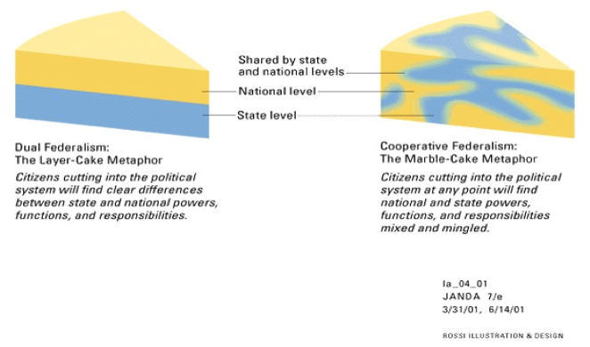

Unit I Continued
Federally-owned Lands
Create thesis statement based on what you see from this map
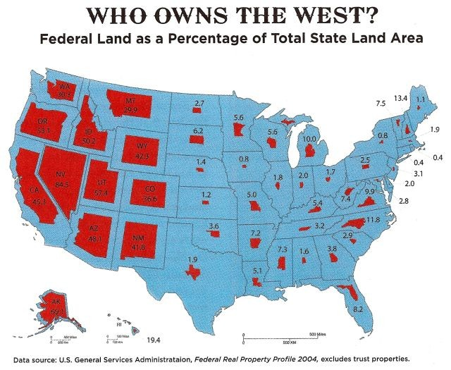
Unit II Articles for Analysis
Article 1: Motherhood, the Framers and Political Socialization
Sabato. American Government: Continuity and Change. 2008 ed. Chapter 11, p. 393

In the earliest days of the American republic, women were prohibited from voting in most elections and were excluded from many other forms of political participation. This does not mean, however, that the country’s early leaders saw no role for women in the creation and development of the new nation. Capitalizing on women’s traditional roles as wife and mother, early political leaders urged women to play a role in the country’s continued prosperity by educating and developing their sons into the next generation of political leaders. This phenomenon, which was later dubbed “republican motherhood” by historians, represents one of the most obvious acceptances of political socialization-and the family as a source of political socialization-in the American nation. However, the Framers were not the first to envision such a role for women. The republican mother, in fact, had her roots in the Spartan mother of ancient Greece, who raised virtuous and moral sons for the good of the community.

Although her role was considered important for the continued prosperity of the new nation, the republican mother was not a radical actor. Republican mothers did not hold protests in front of the White House demanding the right to vote, as suffragists did in the early twentieth century. However, the mere step of merging domesticity and politics opened the door for women’s gradual progress in other spheres. Many of the earliest women’s colleges, for example, were founded to educate women so that they would be able to better teach their children. These same schools later produced many of the revolutionaries who demanded greater rights for women.
The gradual expansion of American women’s political and social equality has only served to increase their role as agents of political socialization. Voting, for example, is often considered a learned behavior. If children-both male and female-see their parents voting, they are more likely to vote themselves. Since women vote in higher numbers than men, their influence on the next generation of voters cannot be ignored.
Unlike their predecessors, modern mothers may extend their role outside the home. Whether, it is through overtly political activity such as running for office, or less political activity such as ascending into upper management at a Fortune 500 company, women who defy traditional sex-role stereotypes set a powerful example for the next generation. These pioneers have the power to change the context and subject matter of some of the biggest policy discussions in the world. Some scholars have even argued that without pioneers who challenge sex-role stereotypes, the United States will never see gender parity in elected representation.
Questions:
- How is the “republican mother” concept consistent with the ideals traditionally espoused by the Framers? How is it different?
- How has socialization within your home shaped your political development? Which of your parents or other relatives played a particularly big role in the development of your ideology and why?
Article 2- Immigration: When My Heart and My Chart Collide
By John Zogby

As a pollster, I call them as I see them, and our surveys find decidedly negative opinions about immigration, especially about those who come here illegally. But in my heart, I wish the results were very different.
I am the son of an illegal immigrant. My father came here illegally from Lebanon, and my father is my heart. He opened a neighborhood grocery store, where he worked very hard, and with my mother raised two sons and a daughter. I'd like to think all of us have been productive members of society and good citizens and that most people who come here for opportunity will do likewise.
I have confidence in the accuracy of our polling data, and the findings of a recent Zogby poll about immigration sadden me. It found 79% of adults do not agree that illegal aliens are entitled to the same rights and basic freedoms as U.S. citizens. Sixty percent do agree that U.S. law should protect the basic human rights of illegal aliens, but I am deeply troubled that number isn't much higher. Among those 65 and older (an age group I am approaching), 52% don't believe we should protect the human rights of illegal immigrants.
I am not being judgmental. Another aspect of my career in this business has helped me to understand that peoples' experiences and backgrounds give them good reason to believe what they believe. Fear and insecurity are natural reactions to a period of rapid social and economic change. We worry about losing our jobs and the threat of crime. When it comes to our livelihoods and safety, anecdotal evidence about illegal immigrants is more compelling than research-based statistics that find no compelling evidence that they are taking away jobs or increasing crime.
Maybe more important to public antipathy toward illegal immigrants is the idea that they are not playing by the rules and taking advantage of the system. As many simply put it: "What part of illegal don't you understand."
So it is that our April 16-19 Zogby Interactive poll of 2,018 adults produced the results cited above. Here is more of what that survey found. When asked to choose between creating a path to citizenship for illegal immigrants or tougher measures like deporting illegal immigrants and prosecuting those who employ them, 61% chose the tougher measures and 31% the path to citizenship. Three times as many consider illegal aliens who live and work in the U.S. to be a burden, not a benefit.
Those are nationwide opinions, so we can expect that opinions opposing illegal immigration are even stronger in border towns. The new laws in Arizona that appall civil libertarians should come as no surprise.
I'd ask people to see immigration in its historical perspective. No one looks back fondly on the 19th-century nativist Know-Nothing Party or groups that opposed civil rights or racial integration. Immigrants were crucial to some of America's greatest achievements, such as the industrial revolution, winning two world wars, ending the Great Depression and the creation of a strong middle class.
The great sociologist Richard Florida says that tolerance is the key to the growth and health of our communities and our nation. Today's cheap immigrant labor will produce tomorrow's community college students, and they will be part of the next wave of entrepreneurs this nation so badly needs. We are not educating enough scientists and engineers, partly because many of our brightest students have been lured to Wall Street and finance, and we are not creating innovations that will both rebuild our economy and make the planet healthier.
Decide: How will Americans beliefs, on immigration, result in a change in public policy? Does this article reveal a strong liberal ideology? A conservative ideology? Or Both? Explain, in detail, your opinion.

Unit III Analysis
Compare/contrast this map to NYT website for 2012 election results

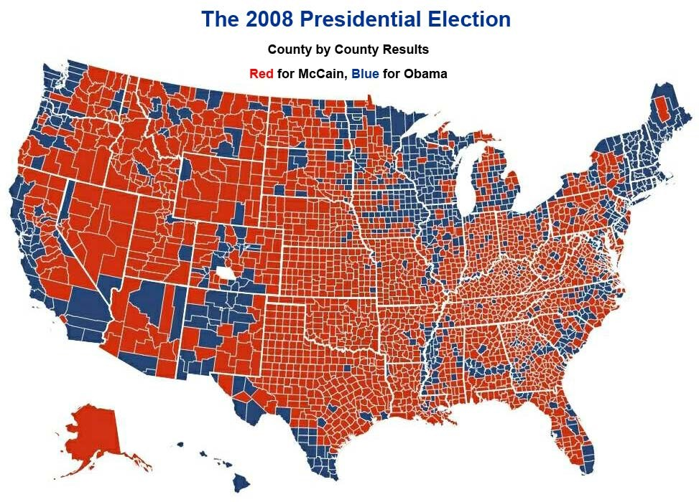

To compare go to…
http://elections.nytimes.com/2012/results/senate

Unit IV Gerrymandering Activity
Map Analysis

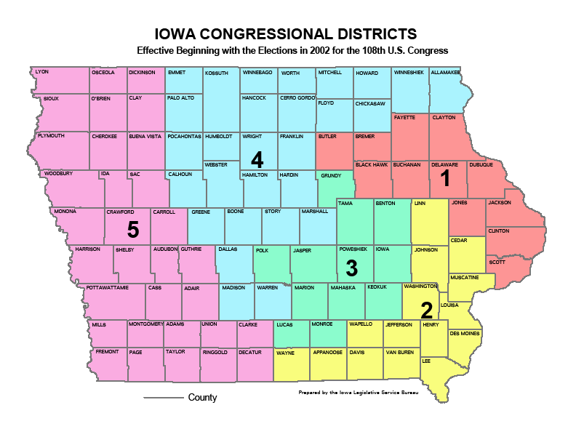
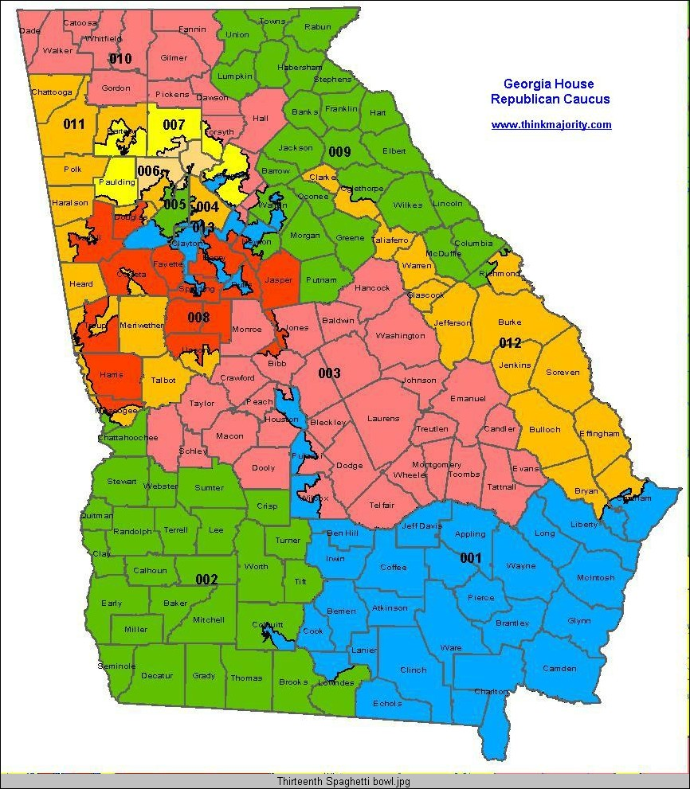

Unit IV Maps Continued

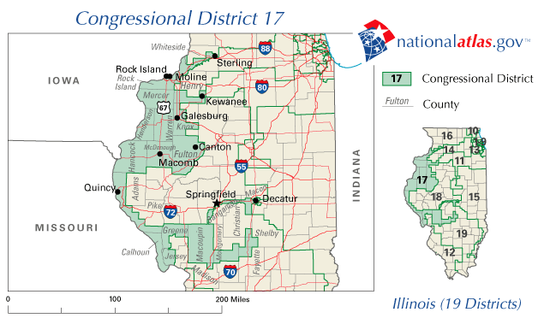

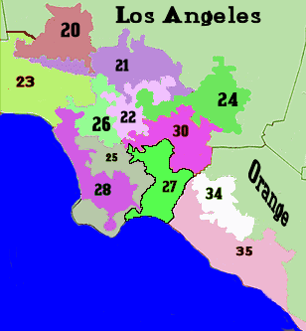

UNIT V GRAPHS

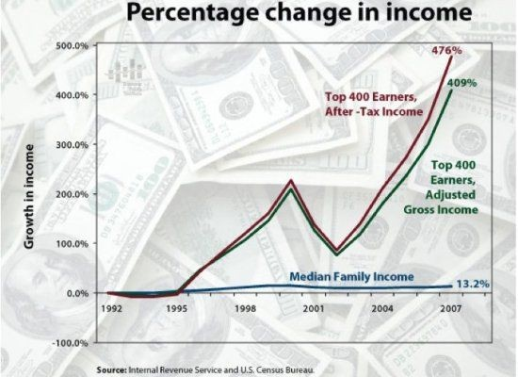

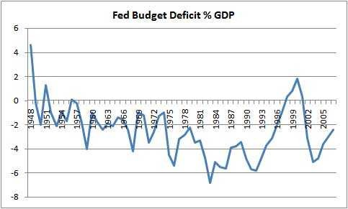

Unit V Graphs Continued

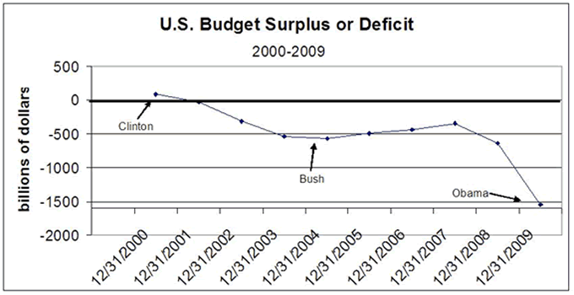

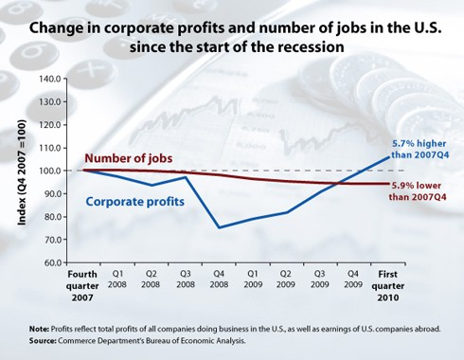

Unit VI Project
Civil Rights/Civil Liberties Court Case Rubric

Student: _________________________________ Date: ________________

Criteria: | 4 | 3 | 2 | 1
Background: | Background does not detract from text or other graphics. Choice of background is appropriate for this project. | Background does not detract from text or other graphics. Choice of background could have been better suited for the project. | Background does not detract from text or other graphics. Choice of background foes not fit project. | Background makes it difficult to see text or competes with other graphics on the page.
Text Font Choice and Formatting: | Font formats (e.g., color, bold, italic) have been carefully planned to enhance readability and content. | Font formats have been carefully planned to enhance readability. | Font formatting has been carefully planned to complement the content. It may be a little hard to read. | Font formatting makes it very difficult to read the material.
Spelling and Grammar: | Presentation has no misspellings or grammatical errors. | Presentation has 1-2 misspellings, but no grammatical errors. | Presentation has 1-2 grammatical errors but no misspelling. | Presentation has more than 2 grammatical and/or spelling errors.
Use of Graphics: | All graphics are attractive (size and colors) and support the theme/content of the presentation. | A few graphics are not attractive but all support the theme/content of the presentation. | All graphics are attractive but a few do not seem to support the theme/content of the presentation. | Several graphics are unattractive AND detract from the content of the presentation.
Presentation: | Student presented the material with confidence. | Student presented material but could have been more confident. | Student had many difficulties presenting materials. | Student was unable to complete presentation before the class.
Criteria: | 10 | 7 | 4 | 1
Timeline: | Timeline included 4 or more dates pertaining to the court case. | Timeline included 3 dates pertaining to the court case. | Timeline included 2 dates pertaining to the court case. | Timeline included 1 date pertaining to the court case.
Outcome: | Clearly and correctly explained ruling, immediate and long term impacts, and impact on students. | Clearly and correctly explained ruling, the immediate impact and the long term impact. | Clearly and correctly explained the ruling and the immediate OR the long term impact. | Clearly and correctly explained the ruling.
Participants: | Correctly identified case name, litigants, lawyers, and locations and created effective mnemonic device. | Correctly identified case name, litigants, and lawyers and created mnemonic device. | Correctly identified case name and litigants OR lawyers did not created mnemonic device. | Correctly identified the case name, made no mnemonic device.
Comments: Total Points: _______

Total Points Possible: 50

