**Head Quarters (HQ) Company Commander**

Darla Hunt

**Bravo Company Commander**

Arabian McLeod

**Battalion Commander**

Michael Simmons

**Executive Officer (XO)**

Wyatt Downing

**Command Sergeant Major (CSM)**

James Spears

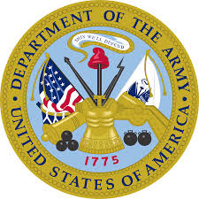

**Rifle Team Commander**James Spears

**S-5 (Public Affairs)**

Miranda Hughes

**S-3 (Operations)**

Rachel Harrell

**Drill Team Commander**

Darla Hunt

**S-4 (Supply)**

Desmond Palmer

**S-2 (Security)**

Allen Smith

**S-1 (Administration)**

Sofia Freeman

**Alpha Company Commander**

Kendra Newman

**JROTC**

**Eagle Battalion Chain of Command**

**Structure**

