Goshen Elementary Spirit Shirts
*DEADLINE to order is August 29, 2019.
*Make checks payable to Goshen Elementary
**Colored proofs are in the office.
White Goshen
Short Sleeve- Gilden
$10.00 each
Youth X-small ______
Youth Small______
Youth Medium ______
Youth Large ______
Adult Small ______
Adult Medium ______
Adult Large ______
Adult X Large ______
Adult 2X (add $2.00) ______
Adult 3X (add $4.00) ______

(purple front) (purple back) (yellow front) (white front)
Yellow Eagles
Short Sleeve- Gilden
$12.00 each
Youth X-small ______
Youth Small______
Youth Medium ______
Youth Large ______
Adult Small ______
Adult Medium ______
Adult Large ______
Adult X Large ______
Adult 2X (add $2.00) ______
Adult 3X (add $4.00) ______

Purple State
Short Sleeve- Comfort Color
$15.00 each
Youth X-small ______
Youth Small______
Youth Medium ______
Youth Large ______
Adult Small ______
Adult Medium ______
Adult Large ______
Adult X Large ______
Adult 2X (add $2.00) ______
Adult 3X (add $4.00) ______

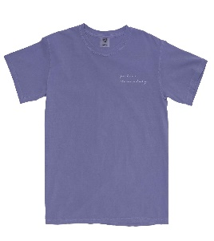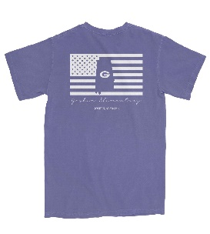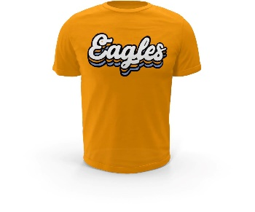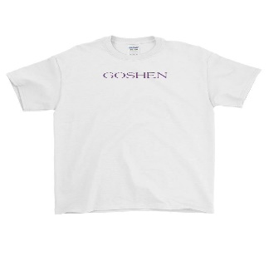
Student’s Name __________________________________________________________
Teacher’s Name __________________________________________________________
Total Amount Enclosed_________________________
Office use: Cash__________________ Check #__________________

