I hope you are excited about PCHS’s eBook collection. Several teachers are using them in their classrooms for entire classes or for individual students.
Open Portal page and click on Atrium Library Link on right hand side.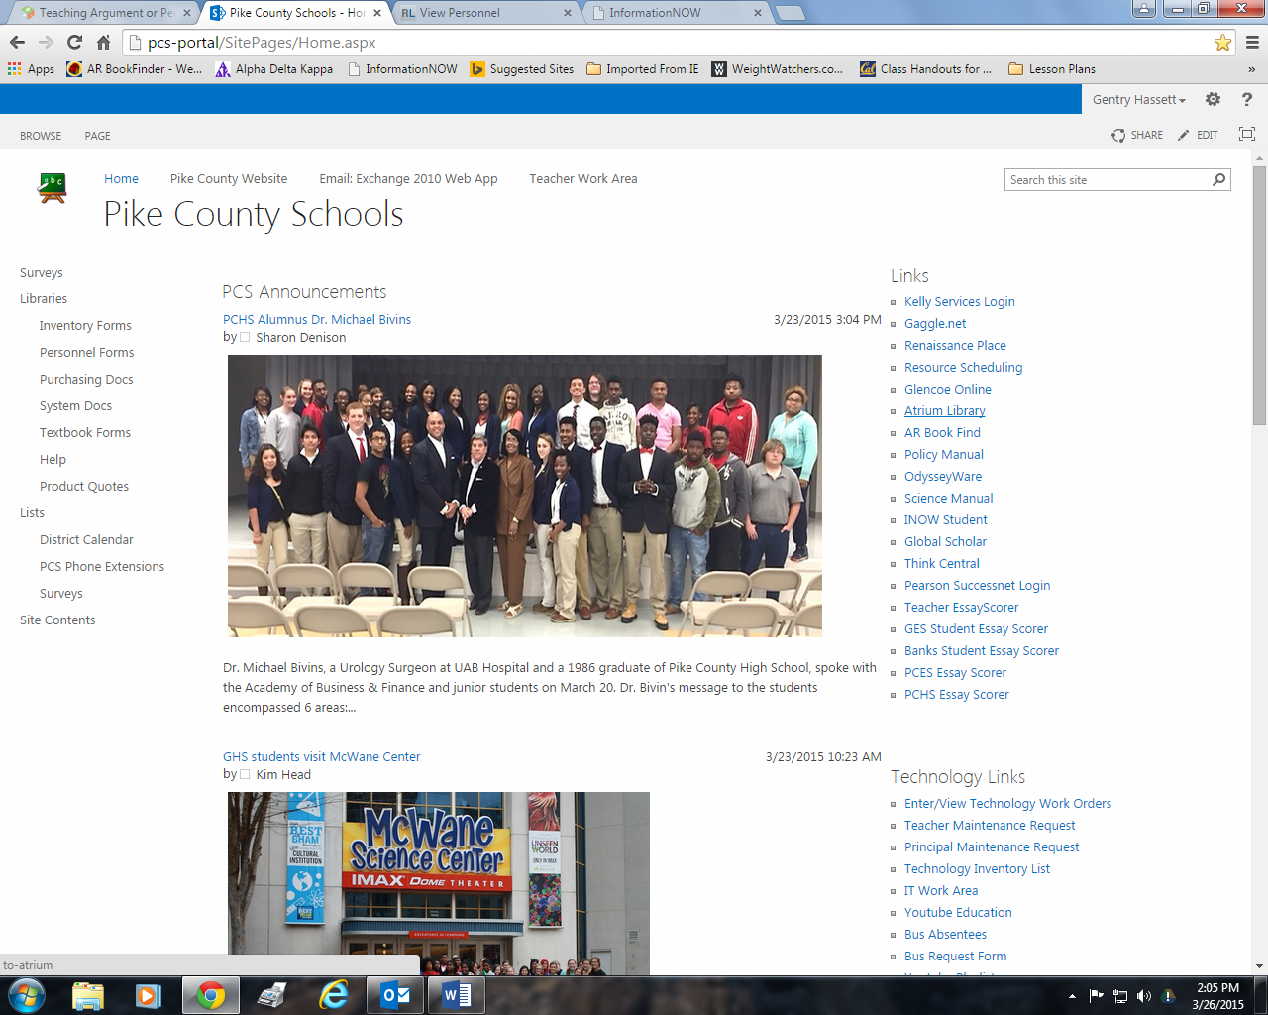

Click on Pike County High School Display
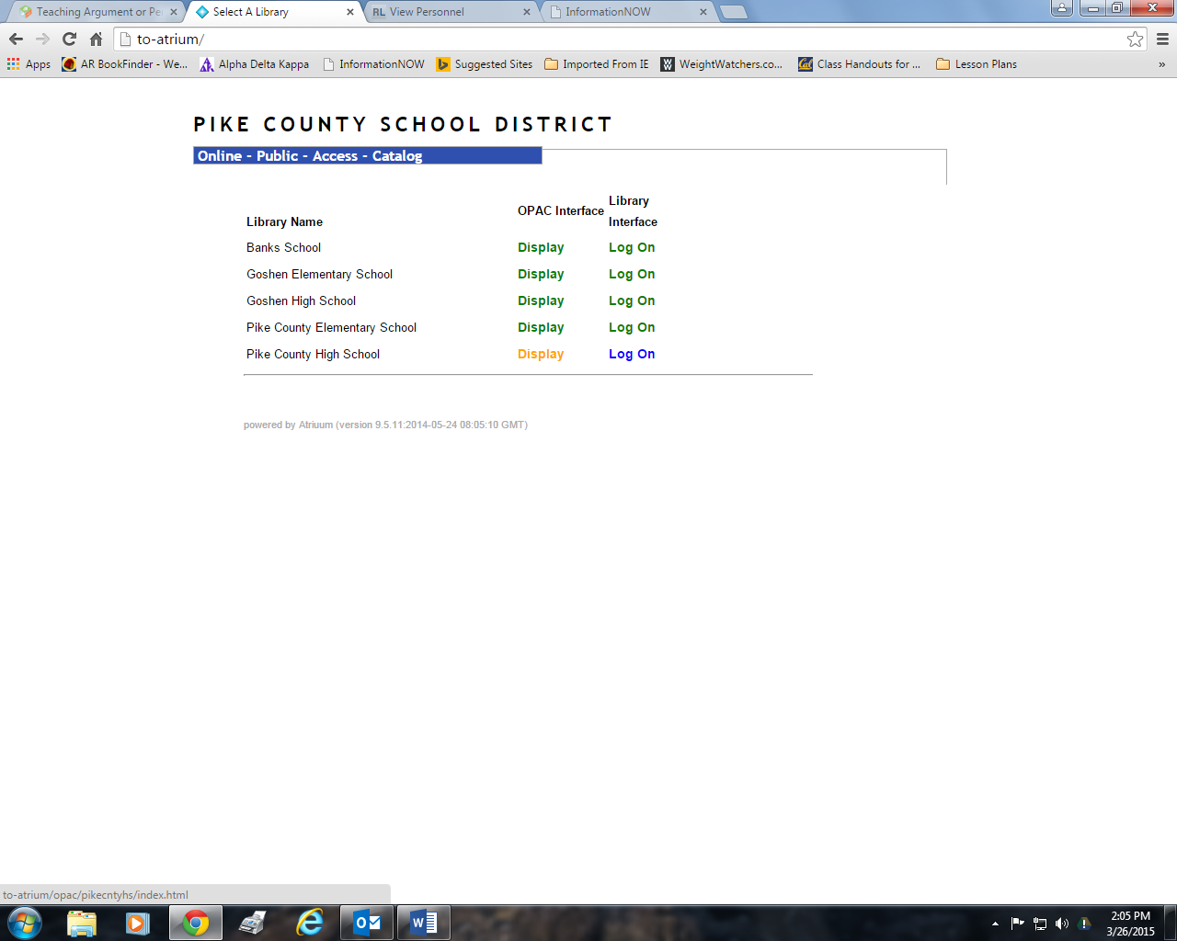

Under Account Log On with your first intial and last name and PIN.
For students, use first intial and last name then the four numbers from their Gaggle login for the PIN.
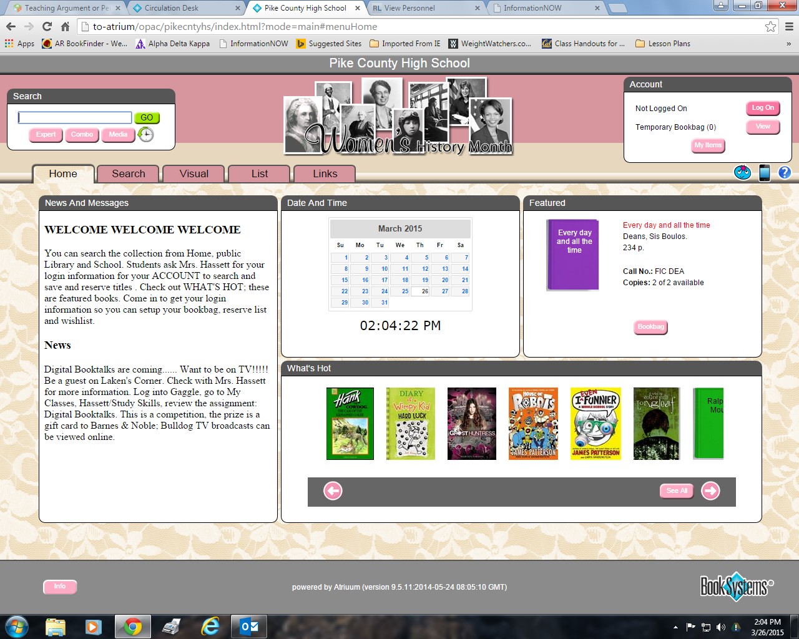

You can search by subject using the SEARCH
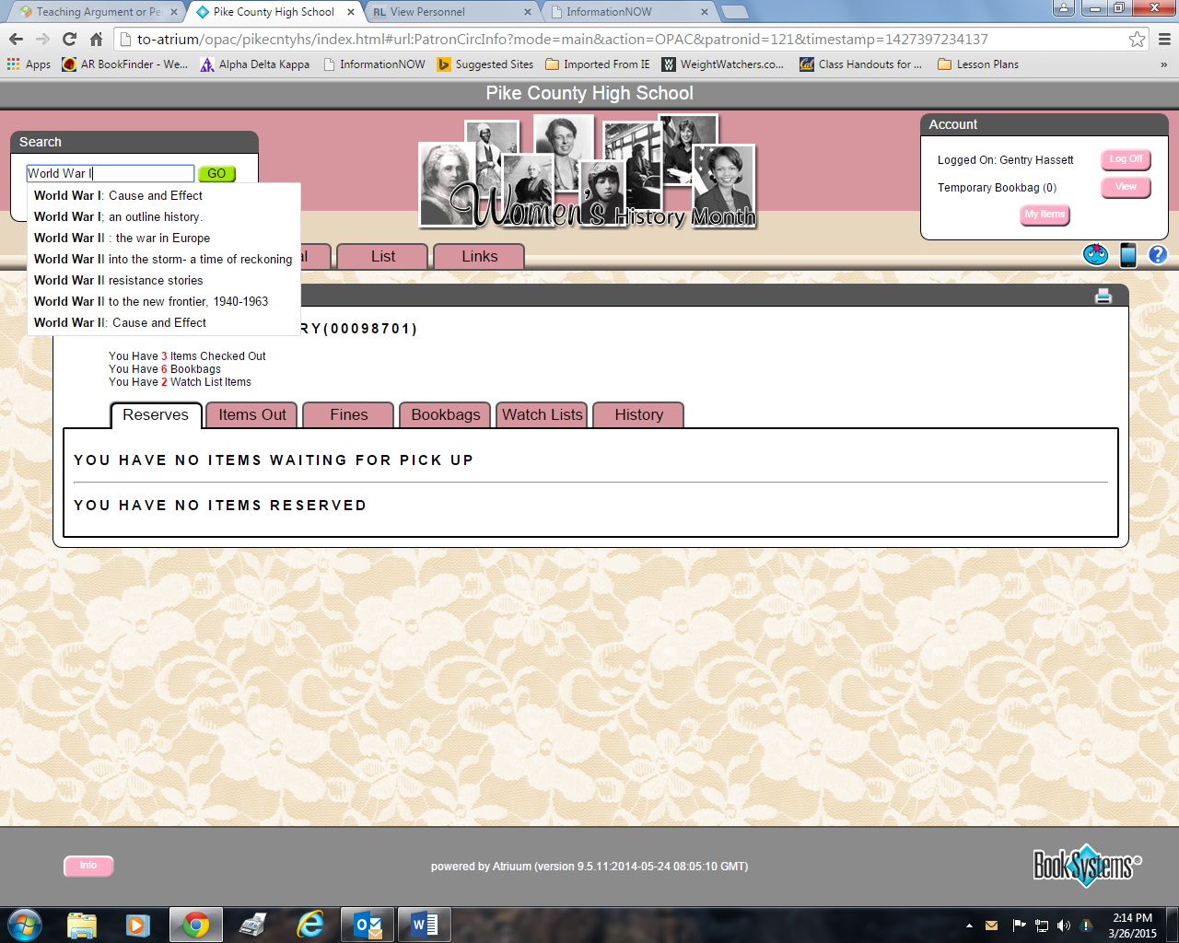
Finding the Material Type eBooks on left hand side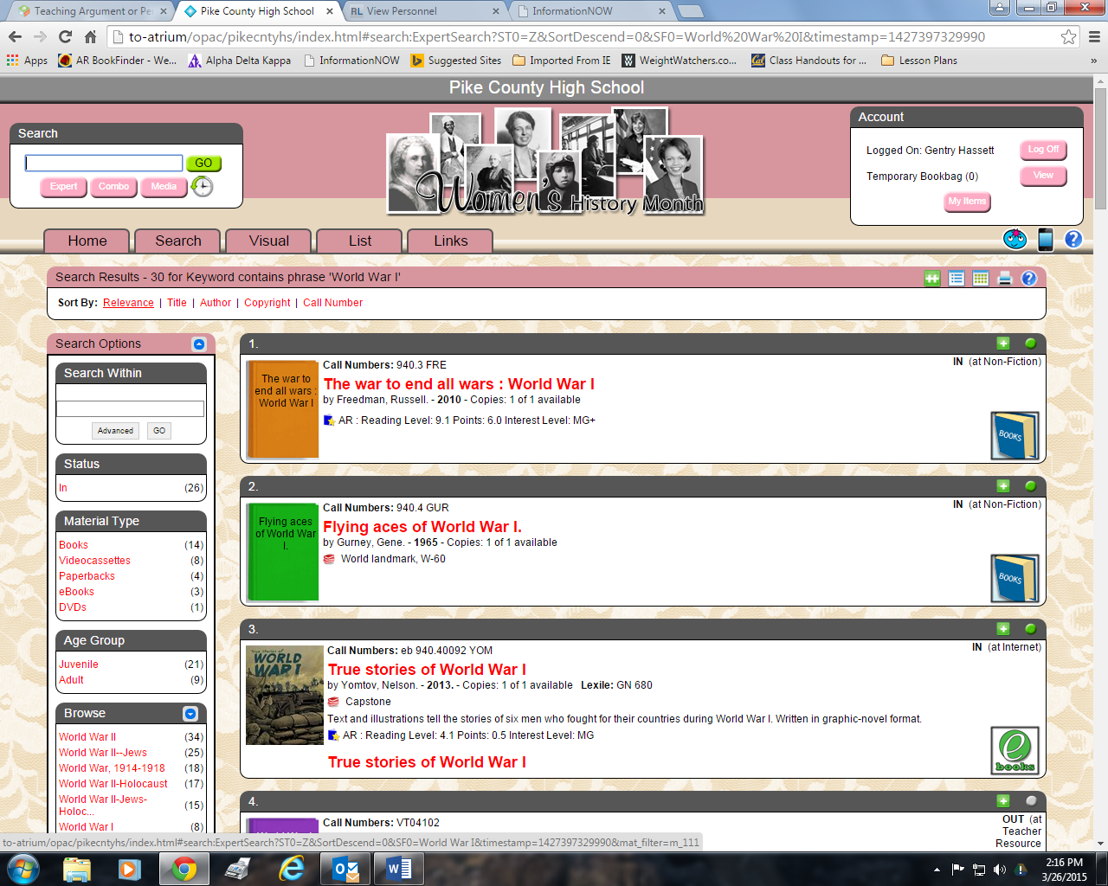

Click on eBooks, then click on title at the bottom of citation to open eBook.
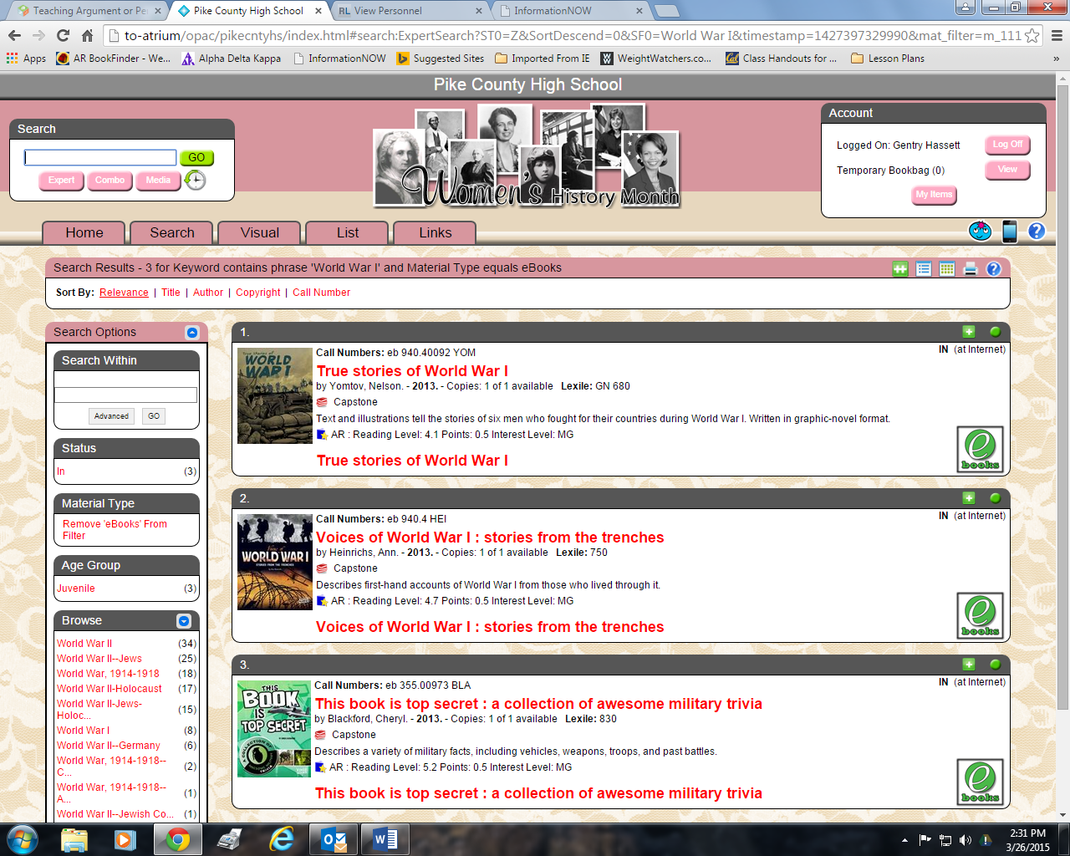

*eBook should open, but if it doesn’t look in the top right hand corner of page for a X, this is the block pop-up error message, click on it, select “Always allow atrium” to open.

If you just want to see all of the eBooks in our collection, in Search, select media, eBooks.
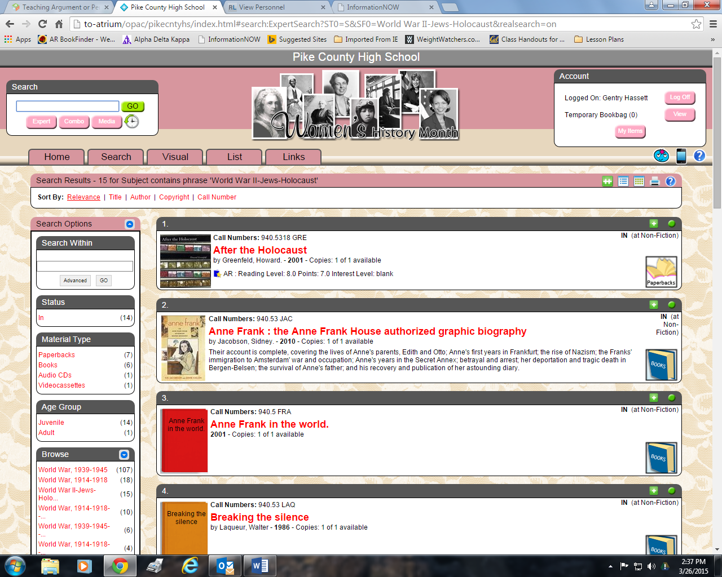
Be sure the CHECK eBooks
All 128 eBooks will be available to search and open.
If it is from Britannica, username is Pike, password Pike.
Perma-bound- eHub, username pchs and password bulldogs.
Capstone eBooks open without a username and password.
You do not have to download book unless you want to read it without internet.
The red arrow indicates the material type for eBooks.
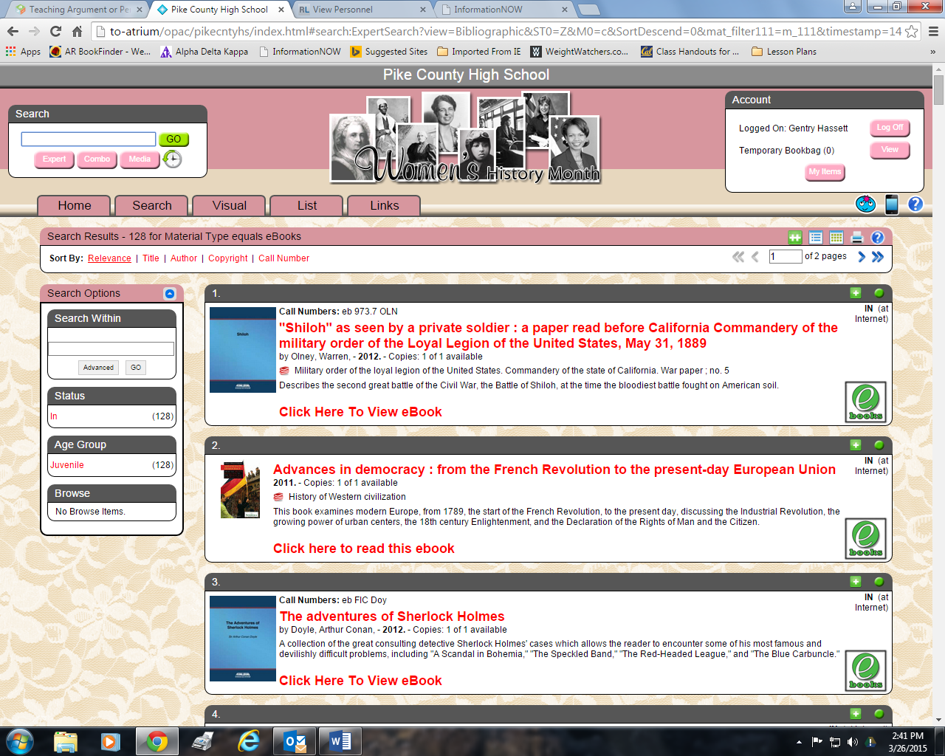
ENJOY!!!!!!!! I am only a phone call or email away.

