Advances in Genetics Handout
Selective Breeding
Selective breeding, cloning, and genetic engineering are three methods for developing organisms with desirable traits. The process of selecting organisms with desired traits to be parents of the next generation is called selective breeding. People have used selective breeding with many different plants and animals. Long ago, farmers chose cattle with beneficial traits such as larger size or producing more milk, and made them breed; and although they may have known nothing about genes, they knew that the beneficial traits could be inherited. The farmers selected for certain traits in their cattle and probably noticed that the offspring were becoming more and more productive with each generation. Two selective breeding techniques are inbreeding and hybridization.
The technique of inbreeding involves crossing two individuals that have similar characteristics. For example, a male and a female turkey which are both plump and grow quickly would produce offspring with these desirable qualities, as well. Inbred organisms have alleles that are very similar to those of their parents. Inbreeding increases the probability that organisms may inherit alleles that lead to genetic disorders. As purebred dogs are becoming increasingly inbred, problems are arising from a genetic standpoint. The frequency of being homozygous for rare recessive disorders increases when inbreeding occurs, potentially causing severe health problems (such as hip problems and breathing difficulties) down the road.
In hybridization, breeders cross two genetically different individuals. The hybrid organism that results is bred to have the best traits from both parents. For example, a farmer might cross corn that produces many kernels with corn that is resistant to disease. The result might be a hybrid corn plant with both of the desired traits.

Cloning
A technique called cloning can also be used to produce offspring with desired traits. A clone is an organism that has exactly the same genes as the organism from which it was produced. Stem cuttings used to produce identical offspring plants are considered to be clones. The new plant is genetically identical to the plant from which the stem was cut. Researchers have cloned a wide range of biological materials, including genes, cells, tissues and even entire organisms, such as a sheep. In reproductive cloning, researchers remove a mature somatic cell, such as a skin cell, from an animal that they wish to copy. They then transfer the DNA of the donor animal's somatic cell into an egg cell, or oocyte, that has had its own DNA-containing nucleus removed.

Genetic Engineering
In the process called genetic engineering, genes from one organism are transferred into the DNA of another organism. One type of genetically engineered, or genetically modified, bacteria produces a protein called insulin. Because bacteria reproduce quickly, large amounts of insulin can be produced in a short amount of time. 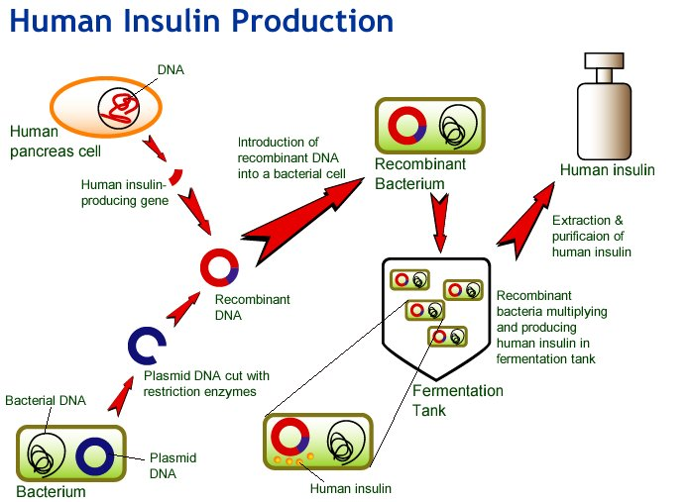

Scientists can also use genetic engineering to produce crops that are resistant to insect pests. Some people are concerned about the long-term effects of genetic engineered (GE or GMO) crops such as:
- Allergic reactions
- Gene mutation. Scientists don’t know if the forced insertion of one gene into another gene could destabilize the entire organism, and encourage mutations and abnormalities.
- Antibiotic resistance. Almost all GE foods contain antibiotic resistance marker genes that help producers know whether the new genetic material was transferred to the host plant or animal. GE food could make disease-causing bacteria even more resistant to antibiotics, which could increase the spread of disease throughout the world.
- Loss of nutrition. Genetic engineering may change the nutritional value of food.
- Environmental Damage. Insects, birds and wind might carry genetically altered pollen to other fields and forests, pollinating plants and randomly creating new species that would carry on the genetic modifications.

The Human Genome Project (HGP)
The human genome contains approximately 3 billion nitrogen base pairs, which reside in the 23 pairs of chromosomes within the nucleus of all our cells. Each chromosome contains hundreds to thousands of genes, which carry the instructions for making proteins. Imagine trying to crack a code that is 6 billion letters long. A genome is the entire DNA in one cell of an organism. The HGP was a collaborative effort carried out by scientists around the world; it was “completed” in April of 2003.
At the onset of the Human Genome Project several ethical, legal, and social concerns were raised in regards to how increased knowledge of the human genome could be used to discriminate against people. One of the main concerns of most individuals was the fear that both employers and health insurance companies would refuse to hire individuals or refuse to provide insurance to people because of a health concern indicated by someone's genes. In 1996, the United States passed the Health Insurance Portability and Accountability Act (HIPAA) which protects against the unauthorized and non-consensual release of individually identifiable health information to any entity not actively engaged in the provision of healthcare services to a patient.
DNA technology used in the Human Genome Project can also identify people and show whether people are related. DNA from a person’s cells is broken down into small pieces, or fragments. Selected fragments are used to produce a pattern called a DNA fingerprint. Except for identical twins, no two people have exactly the same DNA fingerprint.

