Week of August 13-17, 2018
Weekly Studies: 

Reading: The Twin Club by Ina Cumplano
Genre: Realistic Fiction (tells about made-up events that could happen in real life)
Skill: Character and Setting
Math: Unit 1 Addition/Subtraction/Time/Money
Spelling: Short Vowels and Consonants
Handwriting: Manuscript Writing (Zaner bloser)
Language Arts: Sentences
Science: AMSTI: Solids and Liquids

Mark Your Calendar:

August 13th PTO Coupon Book Fundraiser Kickoff
August 13th IReady Reading Assessment for our class
August 20th IReady Math Assessment for our class
August 30th Out of Uniform Day $2
September 2nd Labor Day Holiday (NO SCHOOL)
September 9th -13th Scholastic Book Fair Week
September 16th – 20th Homecoming Week
September 12th Open House at 5:30
October 21st Parenting Day
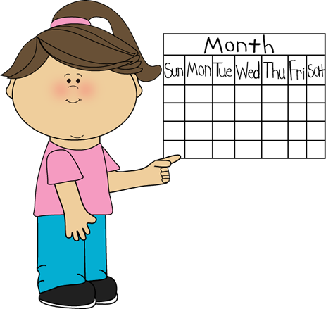

Homework & Tests:

*I have attached a word list that has words your child will need to know on this week’s reading test. Please see instructions on paper for more information.

Monday: Study Monday set of vocabulary and spelling words. Make Doubles Flash cards.

Tuesday: Study Tuesday set of vocabulary and spelling words. Go over Doubles Flash Cards.

Wednesday: Study Wednesday set of vocabulary and spelling words. Go over Doubles Flash Cards.

Thursday: Study all vocabulary and spelling words. Go over Doubles Flash Cards.

Friday:
The Twin Club Reading Test
Addition Drill with basic facts

(Both tests are for practice this week. They will have a grade on them but will not be used as a quarter grade. Please go over it with your child when I send it home on Friday. This will help them see what they can do better before their next assessment. )

Announcements 
Art and Library:
We will begin having special classes this week with art and library. Wednesday begins our computer class with Mrs. Faulkner. We will also be visiting the counselor this week. Our counseling days are on Monday (bi-weekly). Library and Art will begin next week. Library on Mondays and Art on Wednesdays.

Classroom Dojo:
If you have not signed up for Dojo for our classroom, please do so ASAP. Your child has already began earning points. If you need another copy of your id number, please send me a note. It is VERY important that you download the app to your phone or device, so that you are aware of your child’s behavior throughout the school day. I also use this as a means of communication with parents regarding school activities, projects, upcoming events, etc.

Homework Folder:
Please review this folder EVERYDAY! The Dojo tracker handout should STAY in folder! Keep class work at home! Folders must be returned every day!

Snack
The cost is $1.00. Please send this in an envelope with your child’s name and teacher name on it. Place it inside your child’s homework folder

Math Homework
You will need to purchase your child a set of Addition and Subtraction Flashcards for homework this school year. Your child will use these cards twice a week for fact practice. We will begin working on Addition facts for first semester. Subtraction will be given second semester. I have attached a set of Doubles Flash Cards for your child to make and review this week and next. We will begin working on Doubles this week.

Addition Facts:
We will be taking a practice fact drill this week. Your child will have 8 minutes to complete 50 addition facts. Please continue to practice these as much as you can to ensure your child has memorized all facts. When they have to use their fingers, it slows them down during the test.

