Important Information:

*Please be sure to have your child practice the “fluency phrases” each night. This will be in the homework section of their binder. Sorry for any confusion last week. Please just write down how many phrases they read per minute. Once we begin sending home actual passages, then we will record the words read per minute.

*Thank you for your support of our fundraiser!! Students are really having so much fun trying to win a day with Chomper and collecting monsters. Keep selling those items, let’s finish strong this week!

We are learning:

**Story:** Little Red Hen Gets Help

**Phonics:** short /e/; initial l blends

**Comprehension:** Compare and Contrast

**Language:** Exclamations

**Writing:** Four Square Writing Process

**Math:** Subtraction

**Theme:** Pumpkins/ Bats

Homework:

Homework must be completed each night to ensure your child’s success in first grade.

Study Spelling, HFW, and vocabulary each night

Monday: Fluency phrases

Tuesday: Fluency phrases; math sheet

Wednesday: Fluency phrases

Thursday: Fluency phrases

Friday: tests on Spelling, HFW, vocabulary

Important Dates

 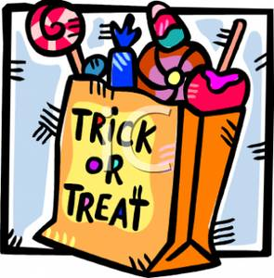

MES is asking for every student to send in a bag of candy for trick-or-treating! Thank you in advance for helping with this fundraiser to help us add books to the

MES library!

Ghoul

School

**Spelling Words**

pen hen send let get

but what all were when

**High Frequency Words (HFW)**

day said time eat first was

**Vocabulary Words**

**assemble-** If you assemble something, you put all its pieces together.

**consume-** If you consume something, you completely use it up.

**enthusiastic-** If you are enthusiastic about something, you really like it and are excited about it.

Oct. 20th- nacho & pickle sale

Oct. 21st- fundraiser ends

Oct. 25th- Ghoul School**-** Come trick or treat the halls of Moody Elementary. $1 per trick-or-treater!!

1st Grade Newsletter

Week of October 17th – 21st

