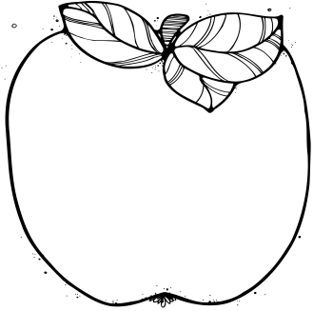M

Santa Store will be Dec 7th- 14th

December 8th will be our field trip to the Bass Pro Shop. We will meet at 10:10 outside the store. No class on 12/8.

Our Christmas Party will be December the 15th at 8:30 in the cafeteria.

We will release for Christmas Break on Wednesday December the 20th at 11:15.

Christmas Break will be December the 21st- January the 2nd.

We will return to school on January the 3rd. Each week we will have a color of the week. Please allow your student to wear this color one day during the week.

Our day begins at 7:50. If your child eats breakfast at school they need to be here by **7:30** so that they will not miss important learning activities. Thanks.

What We’re Learning:  
  
**Reading:**

**12/4-12/8 We will be reading Corduroy . Our letter of the week will be Oo. 12/11-12/15 We will be reading Christmas books. Our letter of the week will be Pp. 12/18-12/20 We will be reading Christmas books. 1/3-1/5 Happy New Year!! Welcome back to school.**

We will have show and tell each day. The item your student brings **should begin with the letter of the week**. Please make sure the share item fits in the child’s book bag and is not living.

**Math** **12/4-12/8 We will be working on the number 16. We will be learning about Ovals. Our color of the week will be orange. 12/11-12/15 We will be working on the number 17. We will be learning about diamonds. Our color of the week will be blue. 12/18-12/20 We will be learning about the number 18. Our shape will be circle. Our colors of the week will be red and green. 1/3-1/5 Happy New Year!!!**

Please make sure you are bringing your child’s nap mat to school each week. Thank you.

**.**

Pre-K   
 Newsletter

December