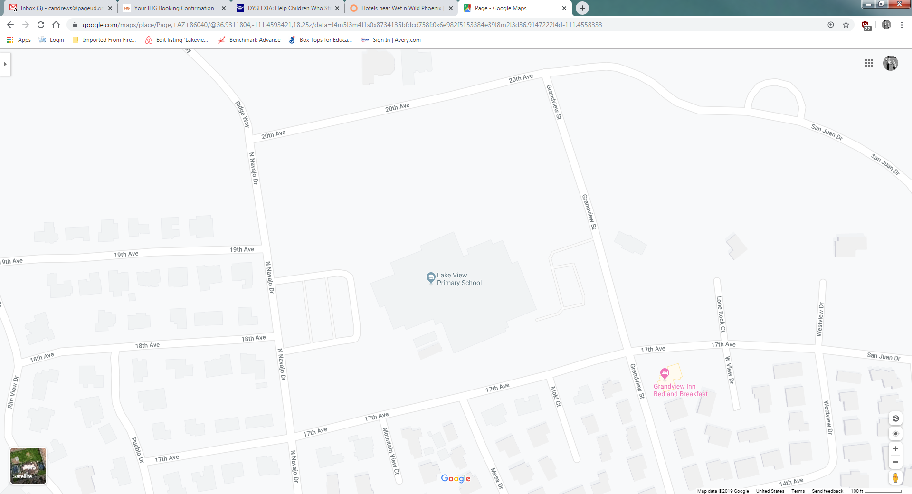

Parents/Guardians,

Due to continued concerns regarding student drop off and vehicle traffic along N. Navajo Dr. in the morning, Lake View Primary will be providing a second location to drop off students.

**N. Navajo Dr (Drop Off 1):**

All Grades may be dropped off here.

Students may be dropped off in the 1st lane of the parking lot (closest to the building) where our staff on duty will help them to cross and go to the correct playground.

The fire lane will still be closed to thru traffic, plan accordingly.

**Grandview St (Drop Off 2):**

First and Second grade (1-2) students may be dropped off here, where our staff on duty will receive them and direct them to the correct playground.

The rear parking lot will be staff access only, plan accordingly.

**\*This is a ONE WAY drop off only* See picture**

There is no crossing guard on duty at this location. For the safety of your child(ren) please do not allow them to cross the street unless you are crossing with them.

Staff are on duty starting at 7:15 AM. The final tardy bell rings at 8:05 AM. This offers a 50 minute window for student drop off.

**After 8:05 AM student drop off must be done in the front of the building.**

We ask that everyone is considerate and observant of others while dropping students off to Lake View Primary.

Thank you!

928-608-4200

Drop Off 2 – First & Second Grade Only (1-2)

Drop Off 1 – All Grades (K-2)