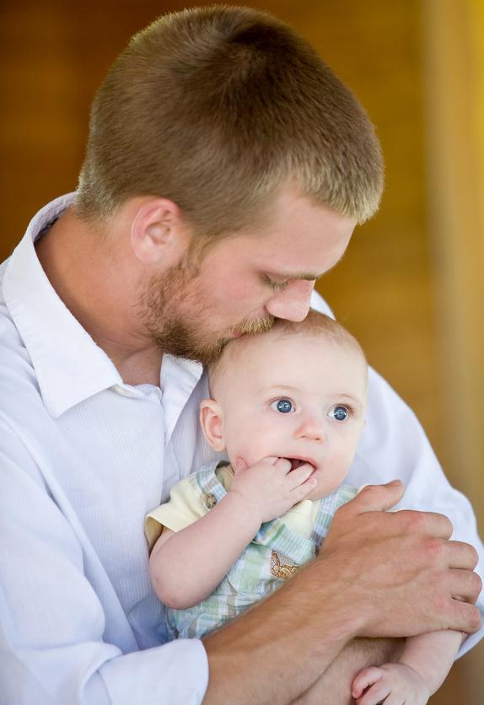
Responsible Parenting
Responsible Parenting

Description:
This unit presents strategies that will assist the student in understanding the decisions and responsibilities of parents as well as the benefits of learning about children and developing appropriate skills to meet physical, emotional, social, and intellectual needs of children. Students will understand and interpret the decisions and responsibilities involved in cross cultural parenting and family communications.

Objectives:
- Identify parenting responsibilities
- Analyze factors to consider when determining readiness for parenting in various cultures.
- Describe parenting skills that contribute to the optimum development of children through meeting their physical, emotional, social, and intellectual needs.
- Analyze the major decisions, changes, and adjustments required of parents.

Projects:

On going Baby Budget Project: In pairs or individually students will explore the financial, emotional and relational costs of having a child. Students will be given a scenario dictating age, educational level, relationship status, and salary. Based on their given salaries, students will create a budget charting basic baby needs and associated costs; including doctor visits, daycare, diapers, etc. Students will identify new found challenges within relationships due to the additional stress, lack of sleep, redistribution of wages, etc. In addition to the identification, students will identify possible solutions to aid in the given challenges. With the given information students will create a tri-fold display exhibiting their results.

Baby Think It Over Simulator: Students will use an infant simulator to represent a child. The student will take responsibility of providing daily care for the baby for one week (7 days). Students will log the activity times and general emotions they feel as they spend caring for the child. In addition, students will need to produce a 2 page reflective essay on their experience of being a parent. If the student losses points for the care or abuse of the baby, the student must do a separate research paper on child abuse and neglect.

ECDFS – A10.5 Standard 1: Responsibilities of Parents
Summarize the decisions and responsibilities involved in parenting in various cultures
  - Analyze factors to consider when determining readiness for parenting and identify parent responsibilities. (ECDFS – A10.5.1)
  - Describe parenting skills that contribute to the optimum development of children through meeting their physical, emotional, social, and intellectual needs. (ECDFS – A10.5.2)
  - Analyze the major decisions, changes, and adjustments required of parents. (ECDFS – A10.5.3)
  - Describe and evaluate the responsibilities, styles, and strategies of parenting. (ECDFS – A10.5.4)
  - Describe cultural influences on parenting. (ECDFS – A10.5.5)
  - Evaluate care giving options. (ECDFS – A10.5.6)

Readiness Characteristics for Parenting Outline:

A. Readiness Factors to Consider before Becoming a Parent
1. Demonstrate signs of readiness for parenting
- Emotional maturity
- Secure family environment and healthy relationships
- Desire for parenthood
- Health considerations
- Financial and management skills
2. Differentiate positive from negative reasons for becoming or not becoming a parent
- Positive and negative reasons to become a parent
- Positive and negative reasons not to become a parent
B. Assuming responsibility for a child
- Nurture children
- Protect children
- Teach children
- Guide children
- Fulfill legal responsibilities
  - Responsibilities
- Food, clothing, and shelter
- Medical care
- Education
- Consequences
- Food, clothing, and shelter
- Medical care
- Education
- Children placed in foster care or adoptive homes
- Termination of parental rights
- Provide financial support
C. Potential Rewards and Challenges of Parenting
1. Rewards
- Youthful perspective
- Emotional fulfillment
- Personal growth
- Family continuation
2. Challenges
- New responsibilities
- Lifestyle changes
- Emotional adjustments
- Changes in relationships
- Employment

Name __________________________________________ Date _ _____________
Life Management Curriculum Guide 2002
Quick Write
Responsibilities of Parenting
Directions: Using five minutes write in the space provided below as much as comes to mind about the responsibilities of parenting:

Using your list above, categorize your list below:
Physical
Social
Emotional
Cognitive

Name __________________________________________ Date _____ _________
Life Management Curriculum Guide 2002
Quick Write

Think About It
Why is helping children achieve their potential is a major goal of responsible parents?

The Developing Child
2-1 Enrichment Activity
How Important Is Parenting?

In a controversial book published in 1998, Judith Rich Harris made a bold argument. How parents raise children, she maintained, does not have a major effect on children. According to Harris, two other factors have the most impact on a child’s personality: genetics and peer relationships. Harris makes her argument in the book The Nurture Assumption.
Genes, she says, account for about half of the personality differences among people. For years, scientists believed that the rest of the differences came from the environment provided by parents.
The way they raised their children affected how those children turned out.
Studies of adopted children seem to undermine the idea, however. One research project looked at almost 500 children, half raised by their biological parents and half raised by adoptive parents. It found that biological parents and children scored similarly on personality and intelligence tests. The scores of adoptive parents and children were hardly close at all. These findings flew in the face of the accepted wisdom. If parents were so influential, why didn’t adoptive children become more like them?
Harris read other studies and felt that she found the answer in peer relationships. Children, she said, are oriented to their friends and schoolmates, not to their parents. It is these young people whom they imitate and whose behavior they adopt. She points to other studies that suggest how children are oriented toward their peers. One researcher found that as early as preschool, children develop complex sets of rules that other children must meet in order to join in group play or other activities.
Harris’s view came under intense criticism. Critics pointed out that Harris is not a professional social scientist and that she conducted no experiments of her own. Some say that she ignored evidence that did not fi t her theory. Noted child psychologist Jerome Kagan pointed out that study after study has shown that parents talking and reading to young children has a tremendous impact on children’s brains. Such children have strong language skills, get better grades, and tend to get good jobs. These studies alone, Kagan says, are enough to disprove Harris’s thesis. Respected pediatrician and author T. Berry Brazelton labeled Harris’s argument as “absurd.”

Taking Action
Based on what you have read in the text, evaluate Harris’s idea. Consider such questions as: to what extent are children shaped by heredity? By environment? What influences in the environment are more important—parents’ or peers’? Does that change during childhood?

Thinking about parenting
Directions: Read the following thoughts about parenting. Put a check by the word that best describes how you feel about parenting. Write one sentence after each thought to explain your selection.
Parenting is n easy job and is for everyone.  Agree  Disagree:  Uncertain: | Further education is out of the question after a child is born.  Agree  Disagree:  Uncertain: | Being a parent is fun and a way of adding creative activities in the family.  Agree  Disagree:  Uncertain:
Having a child is an expensive experience.  Agree  Disagree:  Uncertain: | Parenting is a lifelong responsibility.  Agree  Disagree:  Uncertain: | Deciding to have a child will repair a broken marriage  Agree  Disagree:  Uncertain:
Parenting can be fun but it is also hard work.  Agree  Disagree:  Uncertain: | Parenting requires no extra time or energy.  Agree  Disagree:  Uncertain: | Parenting involves thinking more about the needs of the child than the needs of the parent.  Agree  Disagree:  Uncertain:

The Developing Child
2-2 Enrichment Activity
Educational Options for Teen Parents

When teens become pregnant, finishing school becomes more challenging. As a result, many pregnant teens drop out of school and never finish their education. Teen fathers are also more likely to quit school before graduation. However, all teen parents need to make completing their education a top priority. Those who do not earn a high school diploma often have trouble finding jobs that will allow them to provide for their families.
Teen parents who have the support of their family and community have a better chance of achieving their educational goals. Studies have shown that a single teen mother who continues to live with her parents for the first two years after her baby is born is much more likely to remain in school. As a result, federal laws now require that teen mothers live in a home with adult supervision and attend school regularly in order to receive public assistance. These laws are intended to encourage teen mothers to complete their education.
Lack of affordable child care is the main reason many teen parents do not stay in school. In order to attend classes and have time to complete assignments, they need someone to provide child care. If family or friends cannot help, it may be necessary to get a job to pay for child care expenses. (Single teen mothers are entitled to child support from their baby’s father.) In the end, teen parents may feel that they have to choose between a full-time job and full-time enrollment in school.

TRADITIONAL HIGH SCHOOLS
Traditional high schools can help teen parents stay in school by providing on-site child care or by linking students to other affordable child care options. Attendance policies that allow teen parents the flexibility they need to get their children to doctors’ appointments and to and from child care can also make staying in school easier. Summer programs can help teen parents finish classes that they may not have had time to complete during the regular school year, or that they may have missed when their child was born.
In many cases, however, completing a traditional high school program is simply not feasible. In these cases, teen parents should be encouraged to pursue other options.

ALTERNATIVE PROGRAMS
Some school districts and cities have alternative programs that can help teen parents complete their high school education. These programs make it easier for teen parents to attend school and graduate. The programs usually provide child care while the parent is attending school.
In many cases, the child care center is nearby so that parents and children can interact throughout the school day and continue the bonding process.
Some of these programs create individual learning plans that tailor the program to meet the needs and goals of each student in the most efficient way possible. In addition to the regular high school curriculum, teen parents in these programs are often taught parenting skills. The main disadvantage of such programs is that students may not have access to all of the specialized or advanced courses offered in traditional high schools.

DISTANCE EDUCATION
Distance education programs allow students to take courses at home, by mail or through the Internet. These types of programs usually allow students to take courses at their own pace. This can be particularly helpful to teen parents who are working, as well as caring for their child.
The programs may be administered by states or area colleges or universities. One disadvantage of these programs is that they require self-discipline to keep up and complete the program. Some are also expensive.

THE GENERAL EDUCATIONAL DEVELOPMENT DIPLOMA (GED)
If teen parents find that they are not able to earn a high school diploma through any of these programs, another option is to work toward a General Educational Development Diploma (GED). A GED is the equivalent of a high school diploma. In order to receive a GED, a person must pass a test. The test is intended to determine if the person has a level of knowledge that is comparable to what a traditional high school graduate would have.
There are testing sites for the GED all over the United States. Many people take classes to prepare them for the GED test. The GED testing sites often offer these classes or can recommend places that provide the classes.

HIGHER EDUCATION
After earning their high school diploma or GED, teen parents should not assume that further education is not an option. Although higher education is expensive, many forms of financial assistance are available to those who wish to attend colleges or universities. Advisers at these institutions can help students who have children find the right schedule and course load to help them balance the demands of family, work, and education.
Although it is more difficult for teen parents to complete their education, the obstacles can be overcome. Eventually, their hard work will pay off. As young parents with an education, they are better able to provide for their children and know the feeling of accomplishment that comes from achieving their educational and career goals.

Taking Action
Find out what education options for teen parents are available in your area. Write a summary of what you find. Do you feel that there are enough options? Why or why not?

Name __________________________________________ Date ______ ________
Life Management Curriculum Guide 2002
Quick Write

Parenting Skills

Respond to the following: “Suppose you could have any skill, object, or situation before becoming a parent. What would you choose and why?”

Review the Maslow Power Point. We covered this in the first unit but it’s a good point to review.
Meeting Children’s Need Power Point Presentation
Slides | Notes
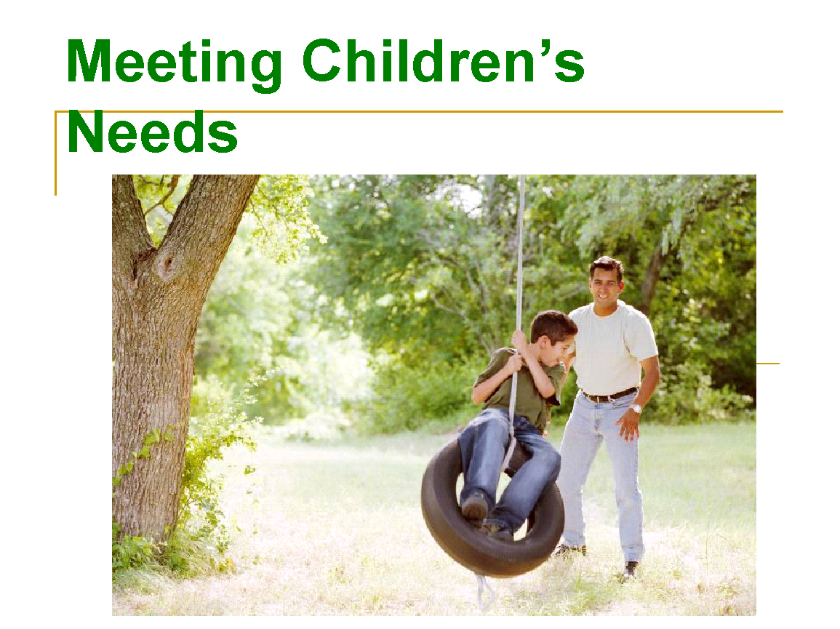
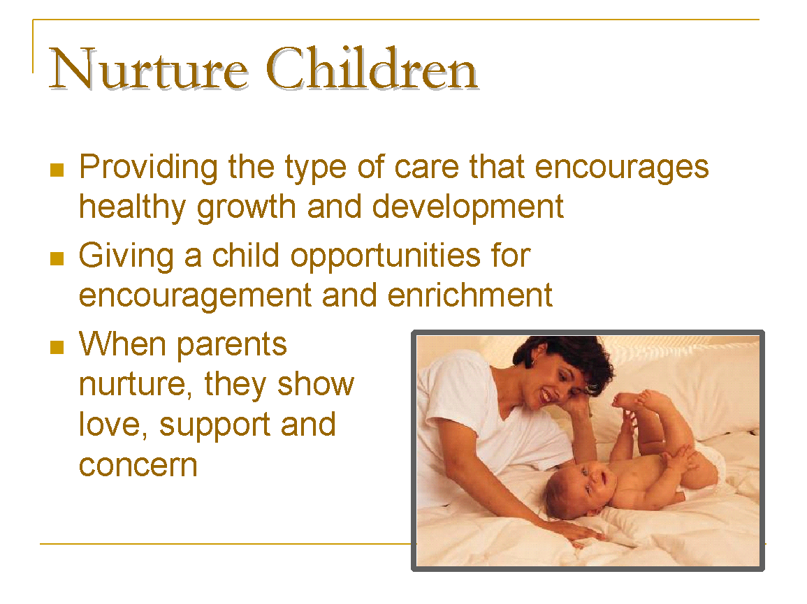 | When parents _____________, they show love, support and concern.
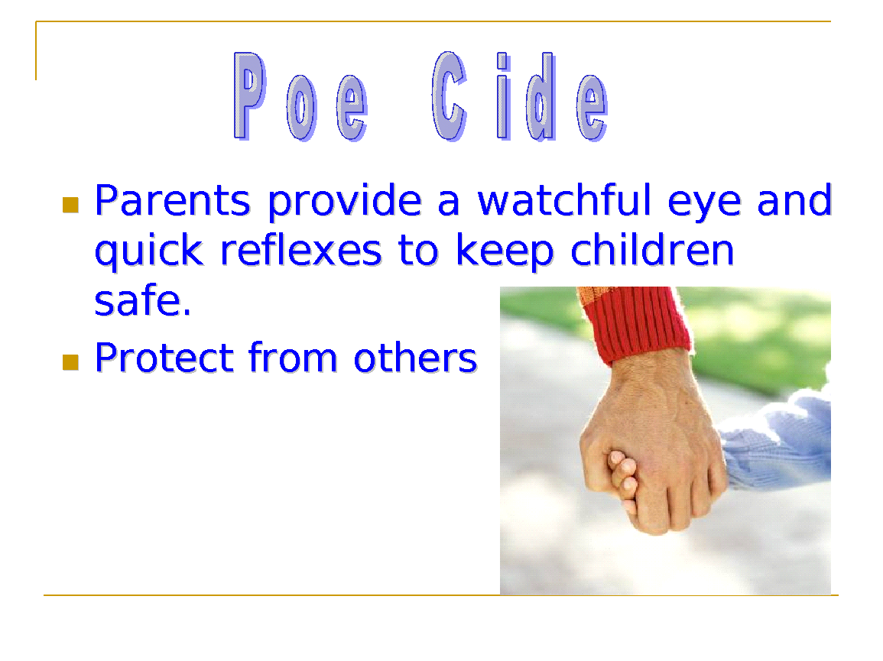
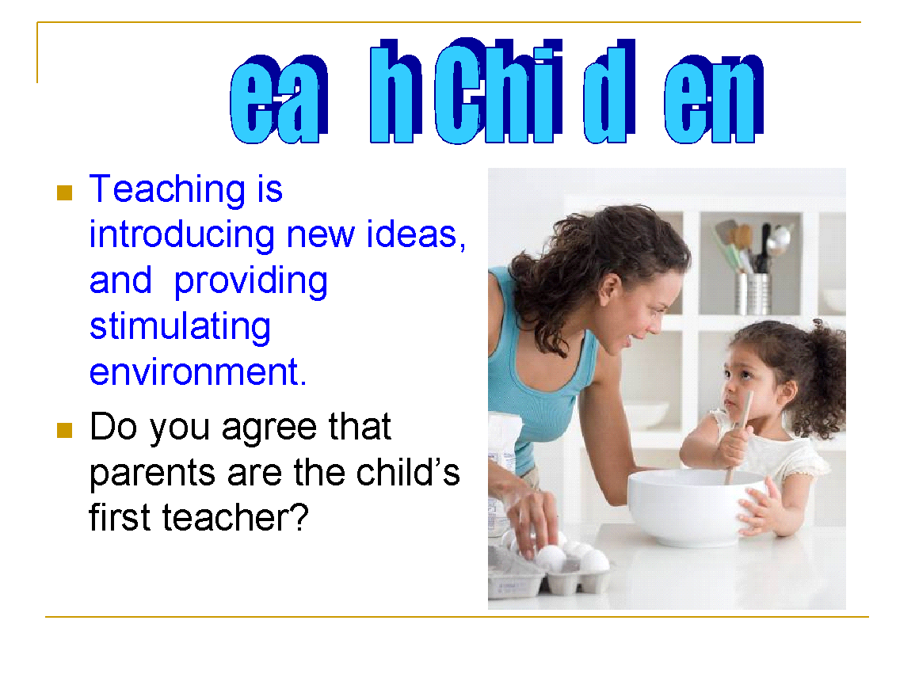 | ____________________________ is introducing new ideas, and providing stimulating environment
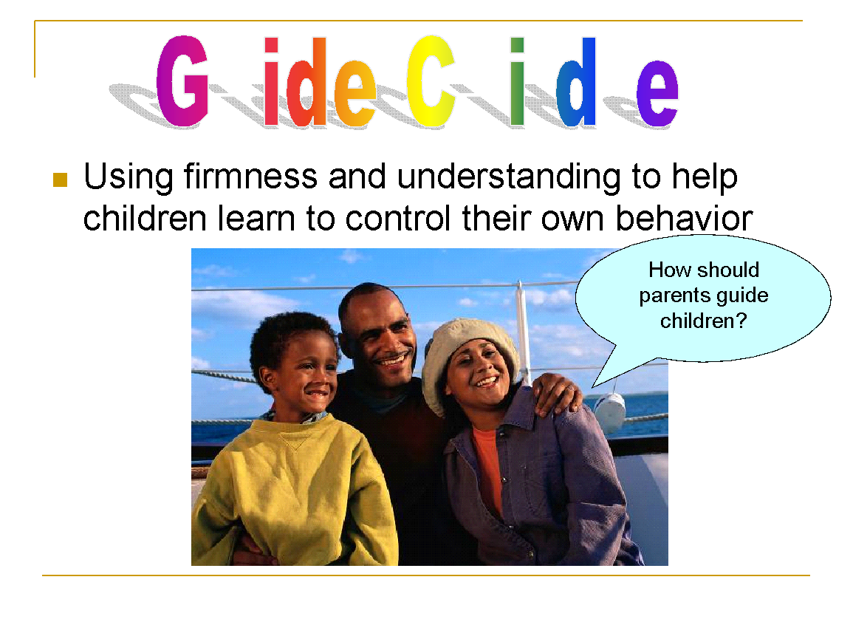 | Using firmness and understanding to help children learn to control their own behavior defines:
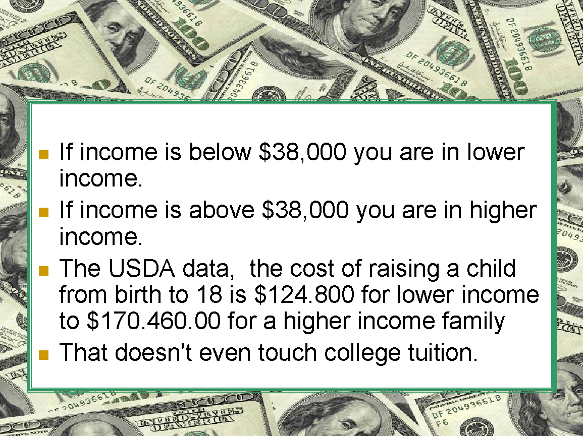
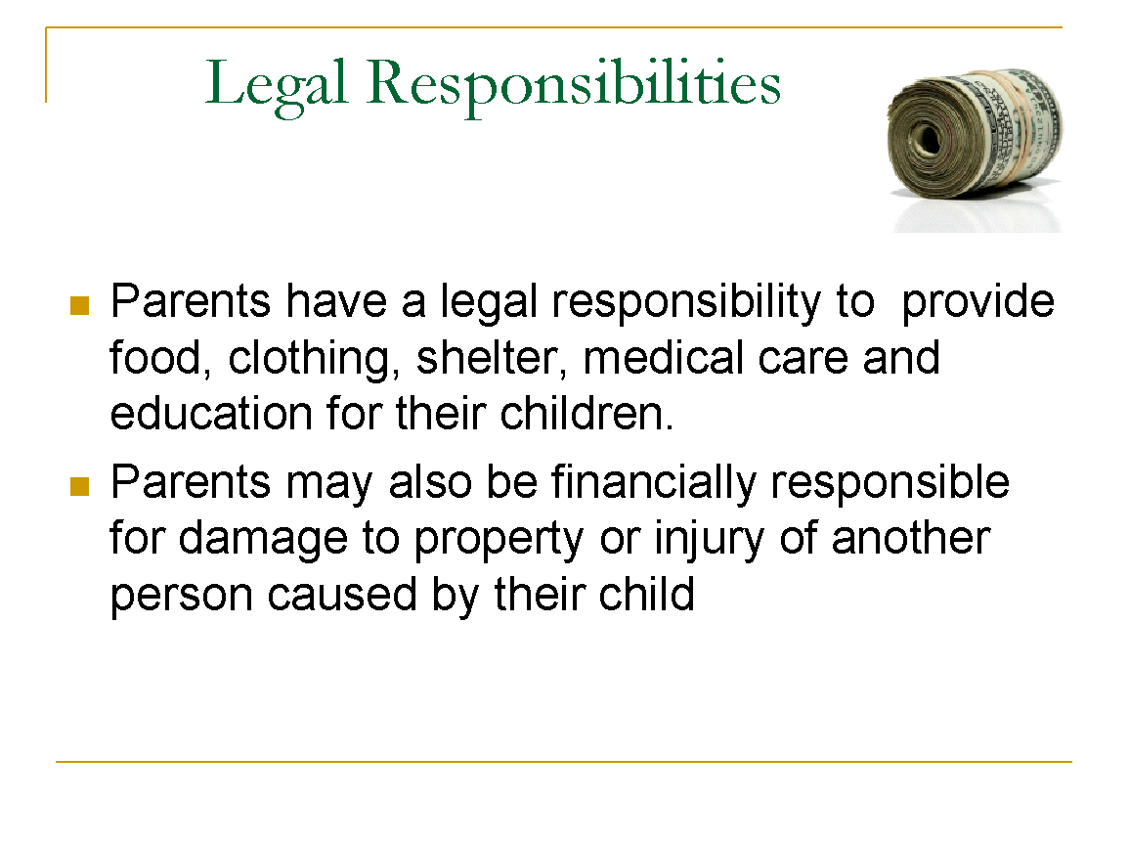 | Parents have a legal responsibility to provide:
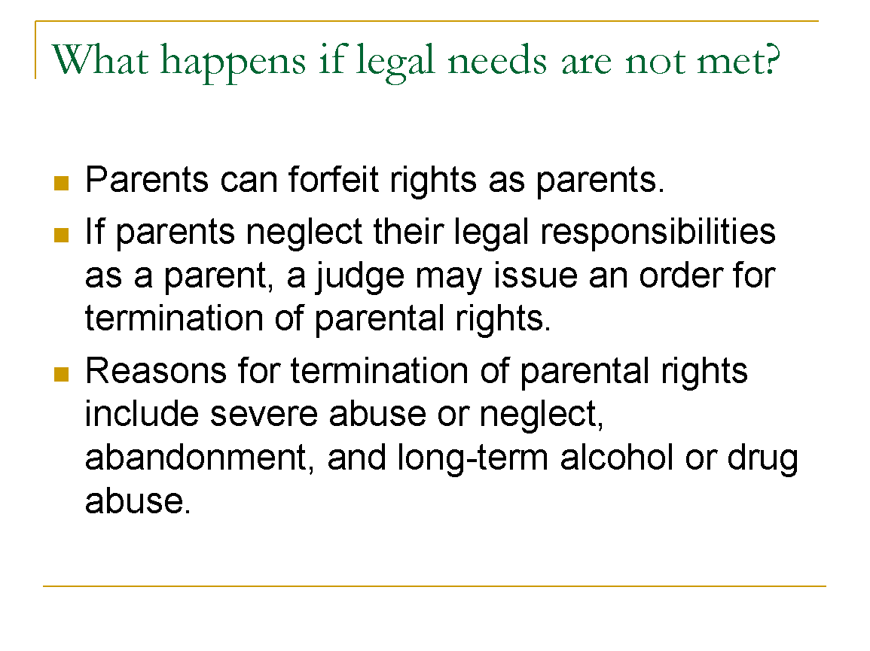 | Reasons for termination of parental rights include:
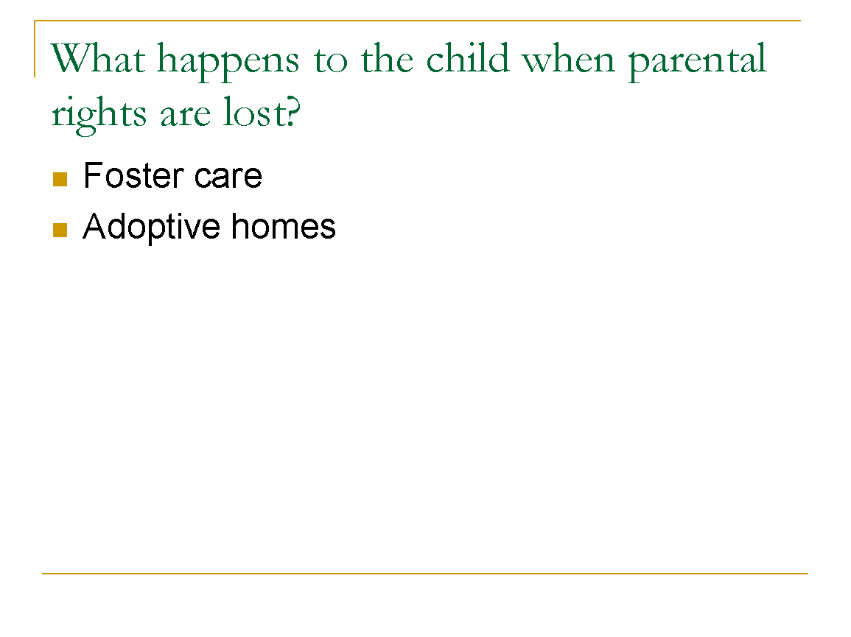 | What is the difference between foster and adopted care?
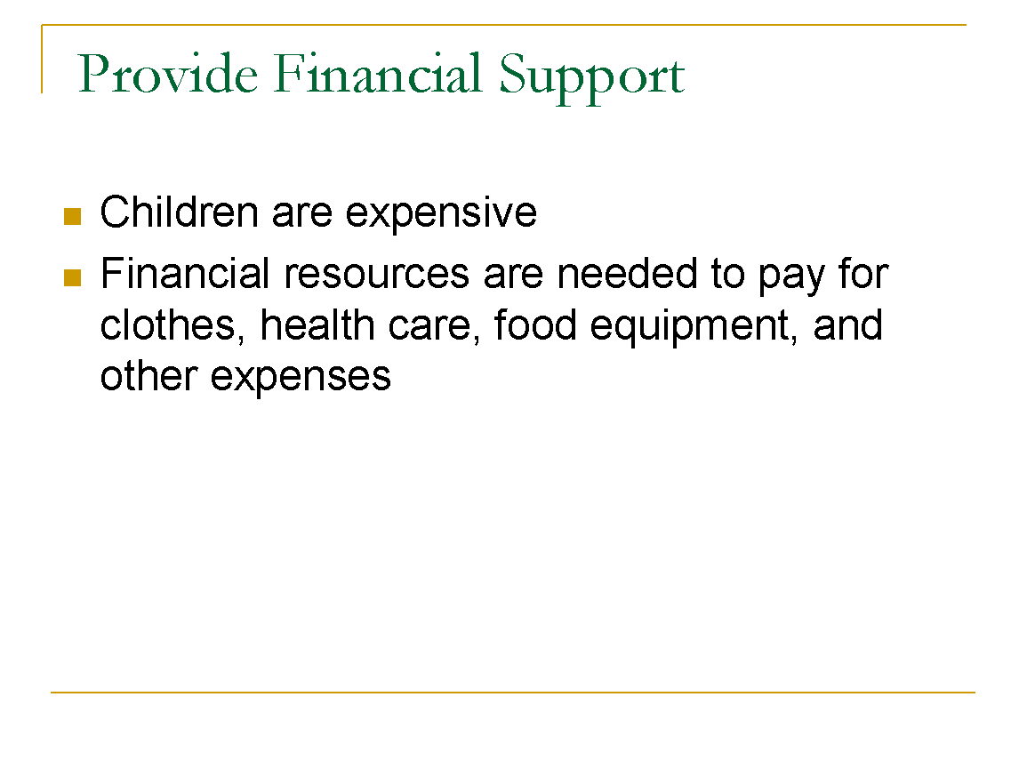
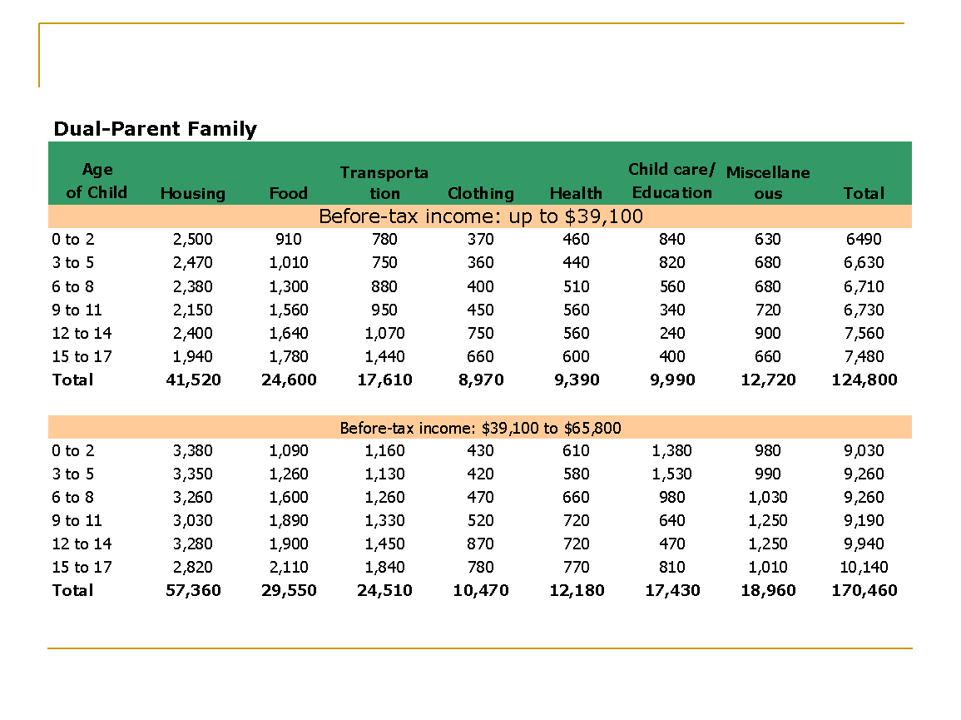
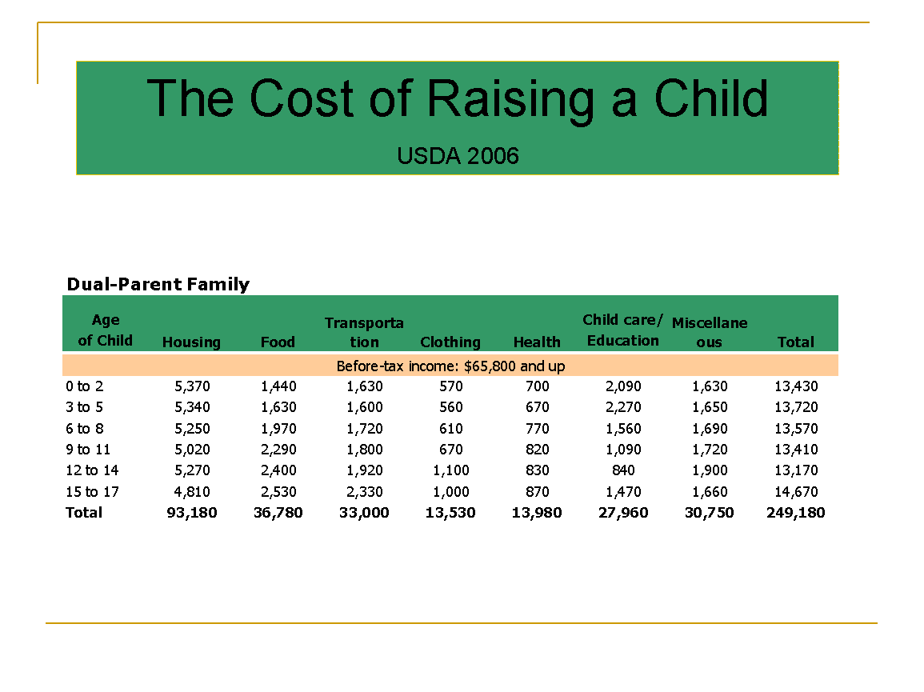
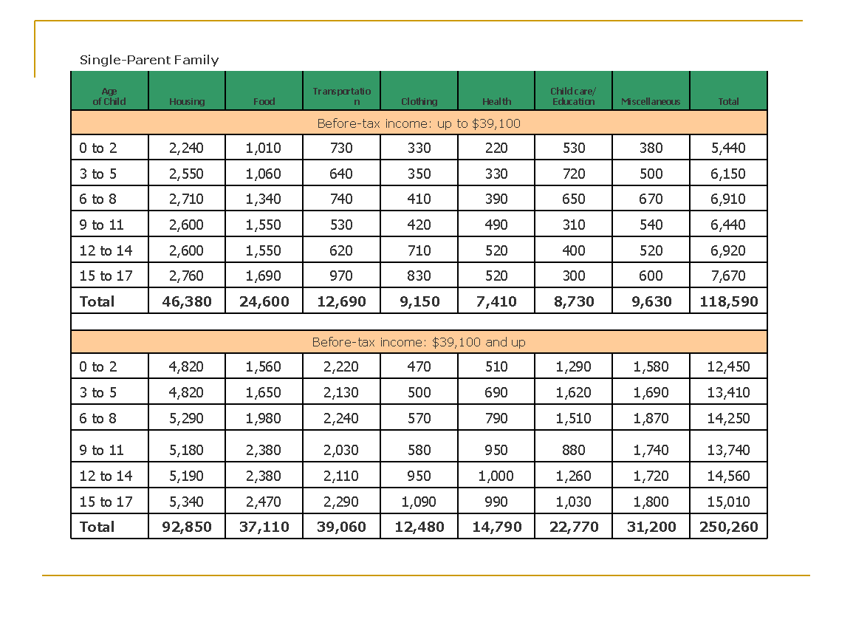
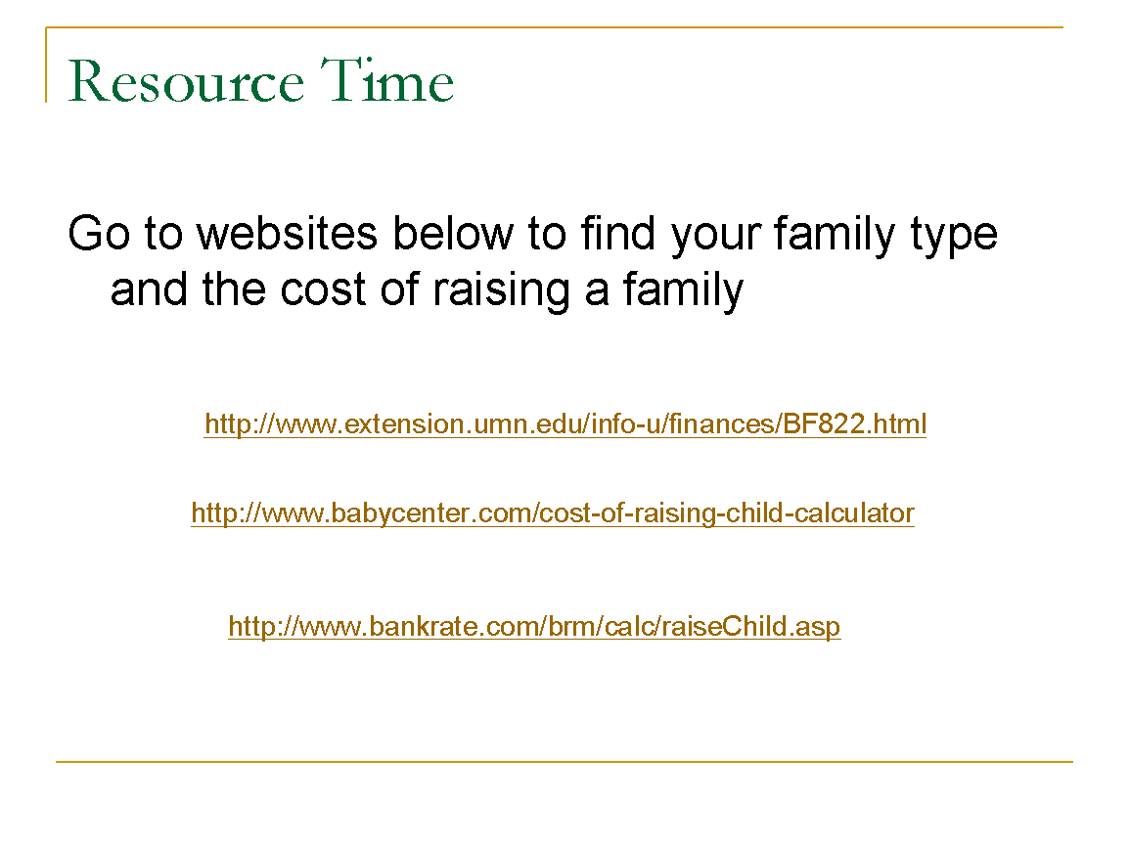

Name __________________________________________ Date ______ ________
The Developing Child
Student Activity
Parent Responsibility Survey

Directions: People at different ages and in different professions have different beliefs as to what is the most important decisions and responsibilities of parents. Survey adults you know and elicit a list of five to ten responsibilities of parents and rank the responses in order of importance.

Teen Parents
Parents in their Twenties
Parents in their Thirties
First time parents who are over 40

Child Psychologists or counselors
Mrs. Johns, Mrs. Williams
Teachers
Administrators
Coaches

Survey Results
Directions: Share your survey results with the class.
Determine the ways in which they correlate to Maslow’s Hierarchy of Needs.
Answer the following sentences:

An effective parent is…

Every child deserves a parent who…

Name __________________________________________ Date ________
Directions: Use your survey results and answers to the questions above to write a job description for parents.
Life Management Curriculum Guide 2002
Unit 5 Module 1
Resource 4
The Job of a Parent

Job Title:
Person/People to Whom Responsible:
Qualifications required (including education, experience, abilities):
Duties and responsibilities:
Work Schedule:
Salary Schedule:
Fringe Benefits:

Name ____________________________________ ______ Date ___ _
Developing Child Chapter 2.1: Parenting and Families p. 32
Directions: Use Cornell Note taking format to outline the section.
Summary: Parenting is a learning process. Parenting offers many challenges and rewards. Prospective parents of those considering parenthood should seriously consider their own readiness to become parents. Parenting can put a strain on emotions, relationships, time, money, and other resources. In spite of parenting’s many challenges, parents often feel happiness, pride, and love that they have never felt before.
Preparation for Parenthood
Define:
- Pride
- Parenting
- Who needs parenting skills?
- Describe three actions you could take to make a positive difference in a child’s life.
Having Reasonable Expectations
- How does knowledge of Child Development assist parents’ expectations?
- How can it help parents to learn about child development?
Parenthood Readiness
- Describe four actions you could take to help build your parenting skills.
Emotional Maturity
Define:
- Emotional Maturity
- Prospective

Health Considerations
- How would a parents health needs affect their ability to parent?
Financial Concerns
- List some items in need of financial resources.
Lifestyle Changes  - Describe at least three ways new parents’ lifestyles often change. | - a.  12 b.  12 c.
Emotional Adjustments
- Why might a new parent experience some negative emotions?
- List some emotional stressors.
- What should one do if they are unable to adjust to emotional adjustments?

Relationship Changes  - Comment on changes in social interactions and relationships.  - When new parents feel overwhelmed, they may argue with one another. Describe how they can get past such trouble spots. | 16.  17.
Employment Adjustments
- How will careers change with a child?
Legal Responsibilities
- What are parents legally responsible for?
- For how many years is a parent required to support their children?
Rewards of Parenthood
- List some of the many rewards

Resource Management  - Briefly describe the 5 step plan | 22 a.  22 b.  22 c.  22 d.  22 e.

Parenting Skills
- Is this an inert skill or can it be learned?
- Where can one find classes?
- Besides class how can a parent learn the skills necessary?
Stages of Parenthood
Briefly explain Galinsky’s 6 stages

Name __________________________________________ Date _________ _____
Developing Child Chapter 3.2: Parenting Skills
Directions: Use Cornell Note taking format to outline the section.
Summary: Parents use many skills to raise children. Children have physical, emotional, social, and intellectual needs that should be met by a family.

Children’s Needs
1. What makes you a parent?
2. How do parents become skilled effective parents?
3. Whose needs come first? The parent’s or child’s?
4. Describe the three areas of needs.
Define:
5. Deprivation
6. How is deprivation NOT poverty?
7. How are children affected by deprivation?
Physical Needs  - Describe how parents meet the physical needs of their children. | 8.

Emotional and Social Needs  - How do parents raise independent children? | 9.
Nurture Children  Define:  - Nurturing  - How can parents show love without spending money?  - Describe three outcomes of effective guidance. | 10.  11.  12.
Show Restraint  - How is too much attention a bad thing? | 13.
Intellectual Needs  - When do children begin learning?  - Who is your child’s first teacher?  - How does stimulation trigger brain growth? | 14.  15.  16.

Learning through the Senses  - How can parents nurture early learning?  - How do parents encourage a desire for lifelong learning? | 17.  18.
Learning Through Reading  - What item is “key” to intellectual development? | 19.
Learning through Exploring  - What is the best way to get children ready and excited about learning? | 20.

