Linden High School
18527 E. Front Street
Linden, CA 95236
209-887-3073
khadley@sjcoe.net

It’s amazing how quickly they grow up...
The Linden High School Yearbook staff is now accepting orders for personal ads in the 2016 yearbook, so it’s time to choose photos and start working on your message of congratulations, pride and love.

Sharing your pride is easy:
1. Decide which size ad and which design you want.
2. Collect the photos you want to use and compose the message to fit the ad space.
3. We prefer that you submit photos digitally by putting them on a flash drive in a bag that has the student’s name on it. This is so we can ensure you keep the originals of your photos.
3. Read all instructions for ad submission.
4. Complete the Ad Order Form; send it in with payment, photos and your message.

The deadline for receipt of completed ad materials is December 17, 2016, but the LHS Yearbook staff cannot guarantee that space will be available until that date. Ads will be accepted in the order in which they are received. Ads must be given to Mr. Hadley (room 18) or the attendance office only. Ad materials received after the pages are filled or after the due date will be returned immediately.

The yearbook staff is pleased to offer you this opportunity to honor your student and to support the 2016 Linden High School yearbook.

Ad Order Form
Please complete and return this advertising contract (or a copy of it) with payment and the photos and text for your ad.

Parent/Purchaser’s Name

Student’s Name

Street Address

City / State / Zip Code Daytime Phone

Is this ad supposed to be kept confidential? yes no E-mail Address

Types of Ads/Size

Full: $300 Design: Circle the layout you desire.

Half: $175 Design: Circle the layout you desire.

Quarter: $100 Design: Circle the layout you desire.

Eighth: $75 Design: Circle the layout you desire.

Payment

Cash included Check included Money Order included Amount enclosed $ _________________________

Make check or money order payable to LINDEN HIGH SCHOOL.

I agree to the terms and guidelines stated in this contract:
Customer Signature Date
Instructions for Ad Submission
• Select the desired ad size; then, using the sample layouts on pages 1 and 2, choose the design number within that size that you would like for your student’s yearbook ad.  • We cannot use photos which have been cut, glued or taped to paper.  Photos  • Each ad contains a number of photos; supply enough pictures to fill the photo blocks in the ad you chose.  • Using a pencil, write softly on the back of the picture the photo block number in which you want the picture to appear. If you do not number the photos, our staff will place the photos attractively. | DO NOT send original copies of any photo you value and cannot replace; we cannot guarantee its return. Instead, submit a photo quality copy of the photo. We do not recommend ink jet photo images on plain white paper and cannot be held responsible for the quality of the reproduction if you submit a photo in this manner.  Text  • The words you want to include in your ad are called “copy.” Please write (print) or type your copy legibly on a separate sheet of paper)  • Take into account the size of your ad when writing your message to your student. A large quantity of text in any ad will end up being set in small type which may not be easy to read.

Full Page Ads
- Approximate dimensions: 8 1/2˝ wide x 11˝ high
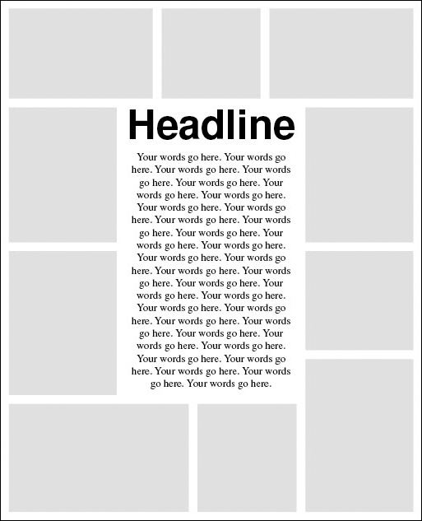
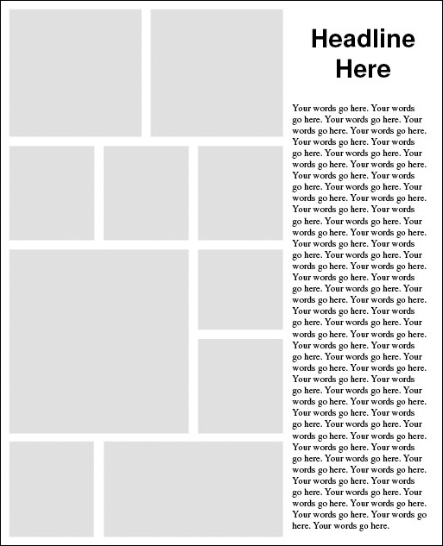

F-1 F-2 F-3

Half Page Ads  - Approximate dimensions: 8 1/2˝ wide x 5˝ high  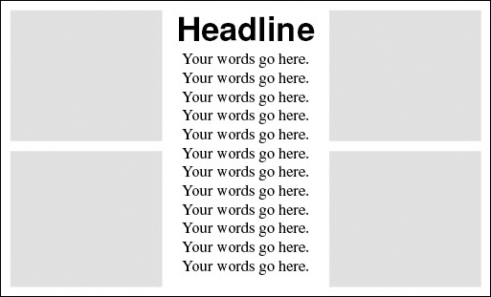  H-1 H-2  H-1 H-2 | Quarter Page Ads  - Approximate dimensions: 4˝ wide x 5˝ high  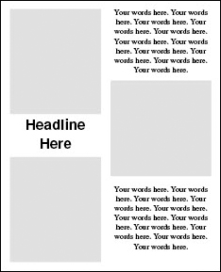  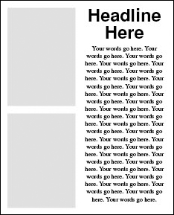  Q-1 Q-2 Q-3  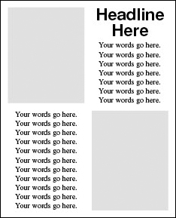  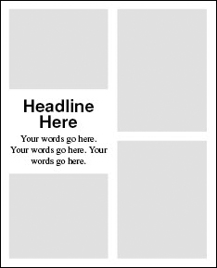  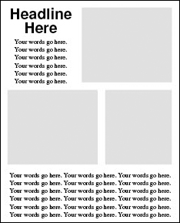  Q-4 Q-5 Q-6
Eighth Page Ads
- Approximate dimensions: 4˝ wide x 2 1/2˝ high
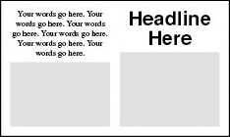
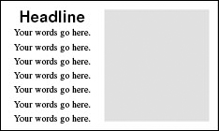

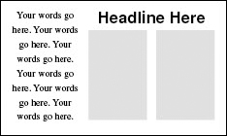
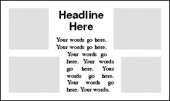
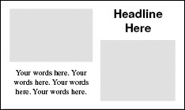

Full Page Ad (cont.)

