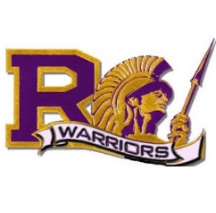
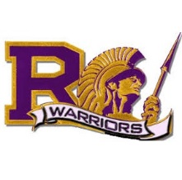
2016-2017 AP/Honors Information
RHS Course Title | Lunch Meeting Y/N | Date | Summer Homework Y/N
AP Art | Y | 5/10/2016 | Y
AP English Language and Composition | N | N/A | Y
AP English Literature and Composition | Y | 5/25/2016 | Y
AP Microeconomics | N | N/A | N
AP Government & Politics US | N | N/A | N
AP United States History | Y | 5/25/2016 | Y
AP World History | Y | 5/26/2016 | Y
AP Calculus AB | N | N/A | N
AP Calculus BC | N | N/A | N
AP Statistics | N | N/A | N
AP Biology | Y | 5/17/2016 | Y
AP Chemistry | Y | 5/11/2016 | Y
AP Environmental Science | Y | 5/18/2016 | Y
AP Physics 1 | Y | 5/19/2016 | Y
AP Spanish Language and Culture | N | N/A | N
AP Spanish Literature | N | N/A | N
English 10 Honors | Y | 5/13/2016 | Y
*Lunch Meeting only for current RHS students*
Text book pick up @ RHS library:
Incoming freshman 6/9/16-6/23/16 (bring JH ID)
Current RHS students 6/2/16-6/23/16
Summer homework can be found online at:
www.righetti.us

