RIGHETTI ATHLETICS

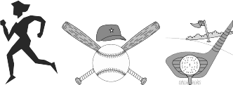

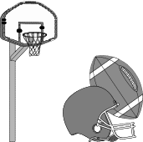
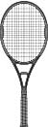
If you are interested in participating in one or more of the following sports, please contact the coaches listed below or the Athletic Director, Kevin Barbarick at 937-2051, extension 2715.

FALL SPORTS (August)
Cross Country, Football, Girl’s Tennis, Girl’s Volleyball, Boy’s Water Polo. Girl’s Golf Girl’s Water Polo

WINTER SPORTS (November)
Boy’s Basketball, Girl’s Basketball, Boy’s Soccer, Girl’s Soccer, Wrestling

SPRING SPORTS (February)
Baseball, Softball, Boy’s Volleyball, Golf, Swimming/Diving, Boy’s Tennis, Track and Field, Competitive Cheer

SPORTS PHYSICALS
Sports Physicals are offered several times a year at Marian Family Center at no cost. Check www.righetti.us for a specific dates. Any student missing that date will have to obtain a physical on their own prior to tryouts.

ELIGIBILITY FOR EXTRACURRICULAR ACTIVITIES
Students must maintain a minimum 2.0 GPA and be enrolled in 20 units concurrently, have satisfactory citizenship, no more than 18 period cuts/grading period and be clear of debt in the library and
bus iness office to be eligible for participation in athletics and activities.

Coaches may be reached for specific sport information at 937-2051:

FALL SPORTS WINTER SPORTS SPRING SPORTS

Football: Payne, x 2404 Girl’s Tennis: Seeds, x 2715
Boy’s Waterpolo: Shaffer, x 2122 Cross Country Boys:Garner, x 2627 Cross Country Girls: Garner x2627 Girl’s VB: Koertge, x 2715
Girl’s Golf: Tomooka, x 2613
Girl’s WP: Yee, x 2715
Girl’s BB: Hitch, x 2314

ATHLETICS INTEREST FORM
AVAILABLE ONLINE AT

www.righetti.us on the Athletics Page
OR
http://bit.ly/rhs2019athletics

Boy’s BB: Barbarick, 2715 Girl’s Soccer: DeAlba x 2715

Boy’s Soccer: Garcia, x 2715

Wrestling:Bronson, x 2527 /
Domingues, x 2104
Baseball: Tognazzini, x 2215 Softball: Tomooka, x 2613 Boy’s Tennis: Seeds, x 2715 Boy’s Swim: Shaffer, x 2122 Girl’s Swim: Powell, x 2611 Track: Hollinshead, x 2715 Boy’s Golf: Ramirez, x 2715 Boy’s VB: Koertge, x 2715
Competitive Cheer: Lopez, x2751

