Visual Sources

Considering the Evidence:

The Black Death and Religion in Western Europe
Among the most far-reaching outcomes of the Mongol moment in world history was the spread all across Eurasia and North Africa of that deadly disease known as the plague or the Black Death. While the Mongols certainly did not cause the plague, their empire facilitated the movement not only of goods and people but also of the microorganisms responsible for this pestilence (see Map in your textbook). The impact of the Black Death was catastrophic almost everywhere it struck, but it is from Western Europe that our most detailed accounts and illustrations have survived about how people responded to that calamity.
Religion permeated the cultural world of Western Europe in the fourteenth century. The rituals of the Roman Catholic Church attended the great passages of life such as birth, marriage, and death, while the major themes of Christian teaching-sin and repentance, salvation and heaven, the comfort available through Jesus, Mary, and the saints-shaped most people's outlook on life and the world. It is hardly surprising, then, that many people would turn to religion in their efforts to understand and cope with a catastrophe of such immense proportions.
Seeking the aid of parish priests, invoking the intercession of the Virgin Mary, participating in religious processions and pilgrimages, attending mass regularly, increasing attention to private devotion-these were among the ways that beleaguered people sought to tap the resources of faith to alleviate the devastating impact of the plague. From Church leaders, the faithful heard a message of the plague as God's punishment for sins.An Italian layman reflected this understanding when he wrote A History of the Plague in 1348.There he pictured God witnessing the world "sinking and sliding into all kinds of wickedness." In response, "the quivering spear of the Almighty, in the form of the plague, was sent down to infect the whole human race."
Accompanying such ideas were religiously based attacks on prostitutes, homosexuals, and Jews, people whose allegedly immoral behavior or alien beliefs had invited God's retribution. In Florence alone, some 17,000 men were accused of sodomy during the fifteenth century. Jews, who were sometimes held responsible for deliberately spreading the disease, were subject to terrible persecution, including the destruction of synagogues, massacres, burnings, expulsion, and seizure of property. Although several popes and kings defended them, many Jews fled to Poland, where authorities welcomed their urban and commercial skills, leading to a flourishing Jewish culture there in the several centuries that followed.
The most well-known movement reflecting an understanding of the plague as God's judgment on a sinful world was that of the flagellants, whose name derived from the Latin word flagella, "whips." The practice of flagellation, whipping oneself or allowing oneself to be whipped, had a long tradition within the Christian world and elsewhere as well. Flagellation served as a penance for sin and as a means of identifying with Christ, who was him­ self whipped prior to his crucifixion. It reemerged as a fairly widespread practice, especially in Germany, between 1348 and 1350 in response to the initial outbreak of the plague. Its adherents believed that perhaps the terrible wrath of God could be averted by performing this extraordinary act of atonement or penance. Groups of flagellants moved from city to city, where they called for repentance, confessed their sins, sang hymns, and participated in ritual dances, which climaxed in whipping themselves with knotted cords sometimes embedded with iron points. Visual Source 12.1 is a contemporary representation of the flagellants in the town of Doornik in the Netherlands in 1349. The text at the bottom reads in part:
In [1349] it came to pass that on the day of the Assumption of the Blessed Virgin (Aug. 15) some 200 persons came here from Bruges about noon .... [I]mmediately the whole town was filled with curiosity as to why these folk had come .... Meantime the folk from Bruges prepared to perform their ceremonies which they called "penance." The inhabitants of both sexes, who had never before seen any such thing, began to imitate the actions of the strangers, to torment themselves also by the penitential exercises and to thank God for this means of penance which seemed to them most effectual.
- Flagellation was but one form of penance. What other forms of self­ inflicted punishment for sin are suggested in the image'
- What is the significance of the Christ on the cross that precedes the flagellants?
- Does the procession seem spontaneous or organized? Do Church authorities appear to have instigated or approved this procession?
- How might the flagellants have understood their own actions?
- Church authorities generally opposed the flagellant movement. Why do you think they did so?
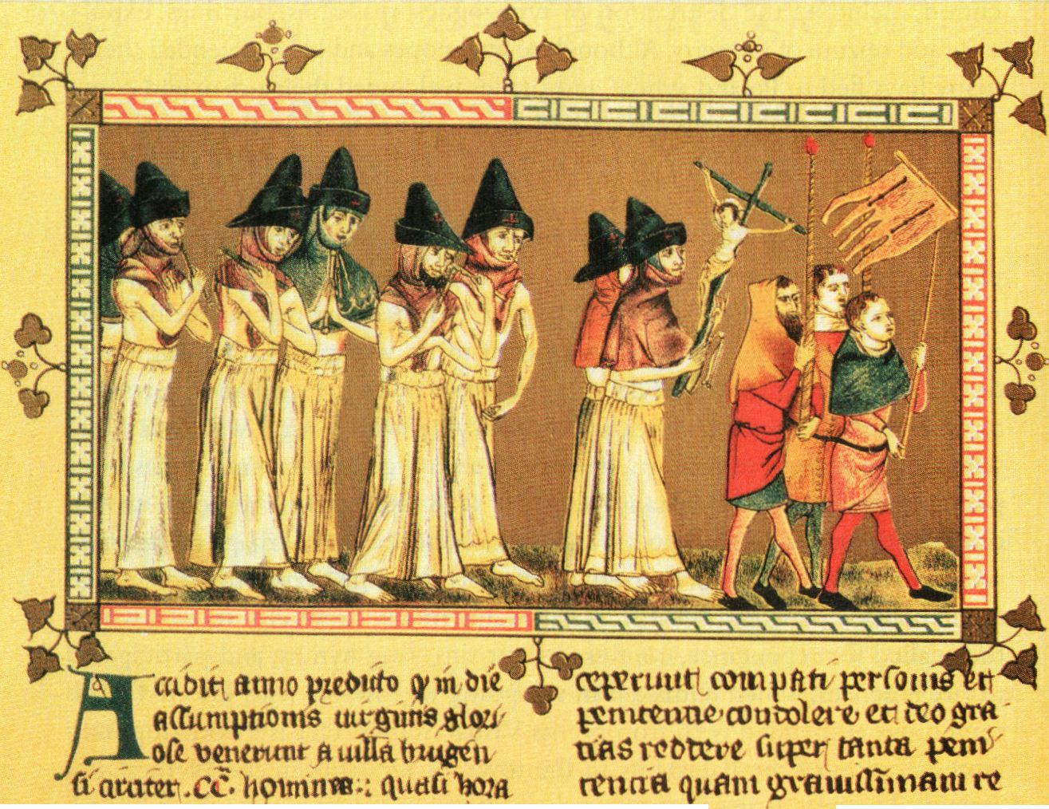
Visual Source 12.1 The Flagellants (Private Collection/The Bridgeman Art Library)

While many people certainly turned to religion for solace in the face of the unimaginable disaster of the Black Death, others found traditional Christian rituals and teachings of little use or difficult to reconcile with the overwhelming realities of the disease. For some the plague prompted an orgy of hedonism, perhaps to affirm life in the face of endless death or simply to live to the full in what time remained to them .. A contemporary Italian observer noted, "As they wallowed in idleness, their dissolution led them into the sin of glut­ tony, into banquets, taverns, delicate foods, and gambling. The rushed headlong into lust." In 1394 a representative of the pope threatened excommunication for those who practiced debauchery in the graveyards.
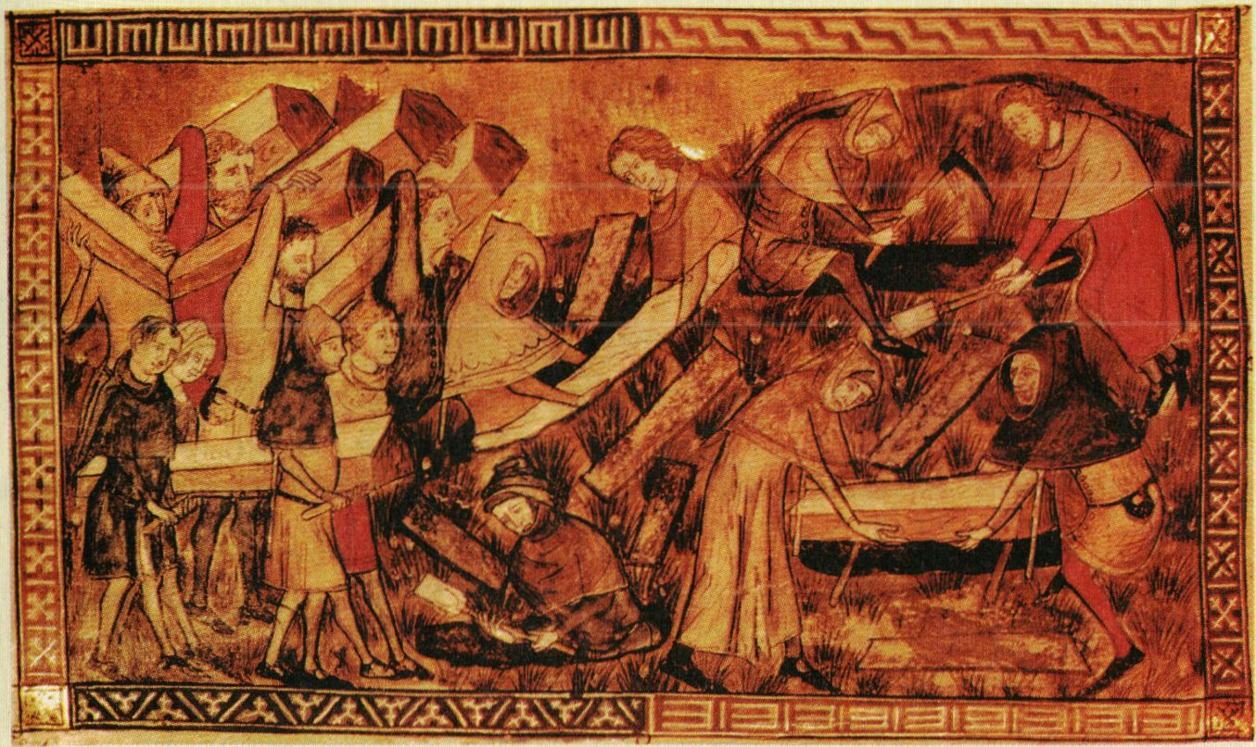
Visual Source 12.2 Burying the Dead (Bibliotheque Royale de Belgique, Brussels. Belgium/The Bridgeman Art Library)

Among the deepest traumas inflicted by the plague was its interference with proper Christian rituals surrounding death and dying, practices that were believed to assist the dead to achieve eternal rest and the living to accept their loss and find hope for reunion in heaven. Priests were scarce and sometimes refused to administer last rites, fearing contact with the dying. The sheer numbers of dead were overwhelming. City authorities at times ordered quick burials in mass graves to avoid the spread of the disease. A French observer in 1348 wrote, "No relatives, no friends showed concern for what might be happening. No priest came to hear the confessions of the dying or to administer the sacraments
to them." The fourteenth-century Italian poet Boccaccio echoed those sentiments: "[T]here were no tears or candles or mourners to honor the dead; in fact no more respect was accorded to dead people than would nowadays be shown toward dead goats." Visual Source 12.2, published in 1352, illustrates a burial of plague victims of I349 in the city of Tournai in what is now Belgium.

- How does this visual source support or contradict the written accounts excerpted above?
- How would you characterize the burial scene in this visual source?
- How does it differ from what an image of a proper Christian burial might contain? How might survivors of the plague have regarded such a burial?

The initial and subsequent outbreaks of the plague in Western Europe generated an understandable preoccupation with death, which was reflected in the art of the time. A stained-glass window in a church in Norwich, England, from about 1500 personified Death as a chess player contesting with a high Church official. A type of tomb called a cadaver tomb included a sculpture of the deceased as a rotting cadaver, sometimes with flesh-eating worms emerging from the body. An inscription on one such tomb in the Canterbury Cathedral in England explained the purpose of the image:
Whoever you be who will pass by, I ask you to remember, You will be like me after you die,
For all [to see]: horrible, dust, worms, vile flesh.

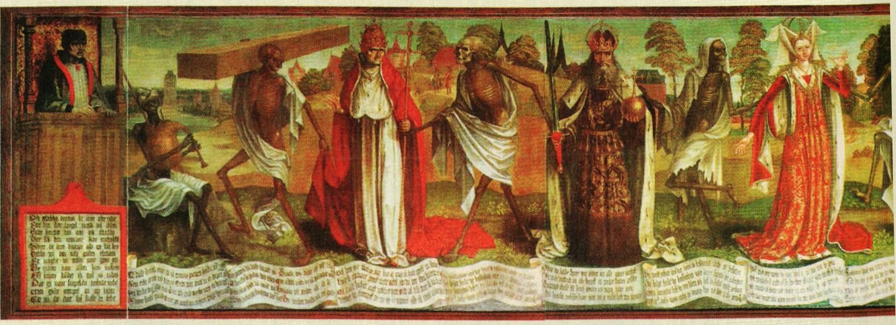
Visual Source 12.3 A Culture of Death (St. Nicolair's Church, Tallinn, now the Niguliste Museum. Phot Visual Connection Archive)
This intense awareness of the inevitability of death and its apparent indiscriminate occurrence was also expressed in the Dance of Death, which began in France in I348 as a ritual intended to prevent the plague or to cure the afflicted. During the performance people would periodically fall to the ground, allowing others to trample on them. By 1400 such performances took place in a number of parish churches and subsequently in more secular settings. The Dance of Death also received artistic expression in a variety of poems, paintings, and sketches. The earliest of the paintings dates from 1425 and depicts dozens of people-from an emperor, king, pope, and bishop to a merchant, peasant, and an infant-each dancing with skeletal figures enticing them toward death. Visual Source 12.3 reproduces a portion of one of these Dance of Death paintings, originally created by the German artist Berndt Notke in 1463 and subsequently restored and reproduced many times.
In the inscriptions at the bottom of the painting, each living character addresses a skeletal figure, who in turn makes a reply. Here is the exchange between the empress (shown in a red dress at the far right of the image) and Death. First, the empress speaks:
I know, Death means me!
I was never terrified so greatly!
I thought he was not in his right mind, after all, I am young and also an empress. I thought I had a lot of power, i had not thought of him or that anybody could do something against me.
Oh, let me live on, this I implore you!
And then Death replies:
Empress, highly presumptuous, I think, you have forgotten me. Fall in! It is now time.
You thought I should let you off?
No way! And were you ever so much, You must participate in this play,
And you others, everybody-
Hold on! Follow me, Mr. Cardinal?"

- How is the status of each of the various living figures-from left to right: the pope, the emperor, the empress-depicted?
- What does the white sheet around each of the death images represent?
- What do their expressions suggest about their attitude toward the living?
- Notice that the living figures face outward toward the viewer rather than toward the entreating death figures on either side of them. What might this mean?
- Does the portrayal of death pictured here reflect Christian views of death or does it challenge them?
- How is the exchange between the empress and Death reflected in the painting?
The horrific experience of the Black Death also caused some people to question fundamental Christian teachings about the mercy and benevolence of God or even of his power to affect the outcome of the plague. A late-fourteenth­ century clergyman in England expressed the dismay that many must have felt:
"For God is deaf nowadays and will not hear us And for our guilt, he grinds good men to dust."
In a similar vein, the fourteenth-century Italian Renaissance scholar Francesco Petrarch questioned why God's vengeance had fallen so hard on the people of his own time: "While all have sinned alike, we alone bear the lash." He asked whether it was possible "that God does not care for mortal men." In the end, Petrarch dismissed that idea but still found God's judgments "inscrutable and inaccessible to human senses.?" Thus the Black Death eroded more optimistic thirteenth-century Christian views, based on the ideas of the ancient Greek philosopher Aristotle, that human rationality could penetrate the mind of God.
Efforts to interpret Visual Source 12.4, a fifteenth-century English painting, raise similar issues to those expressed by Petrarch.
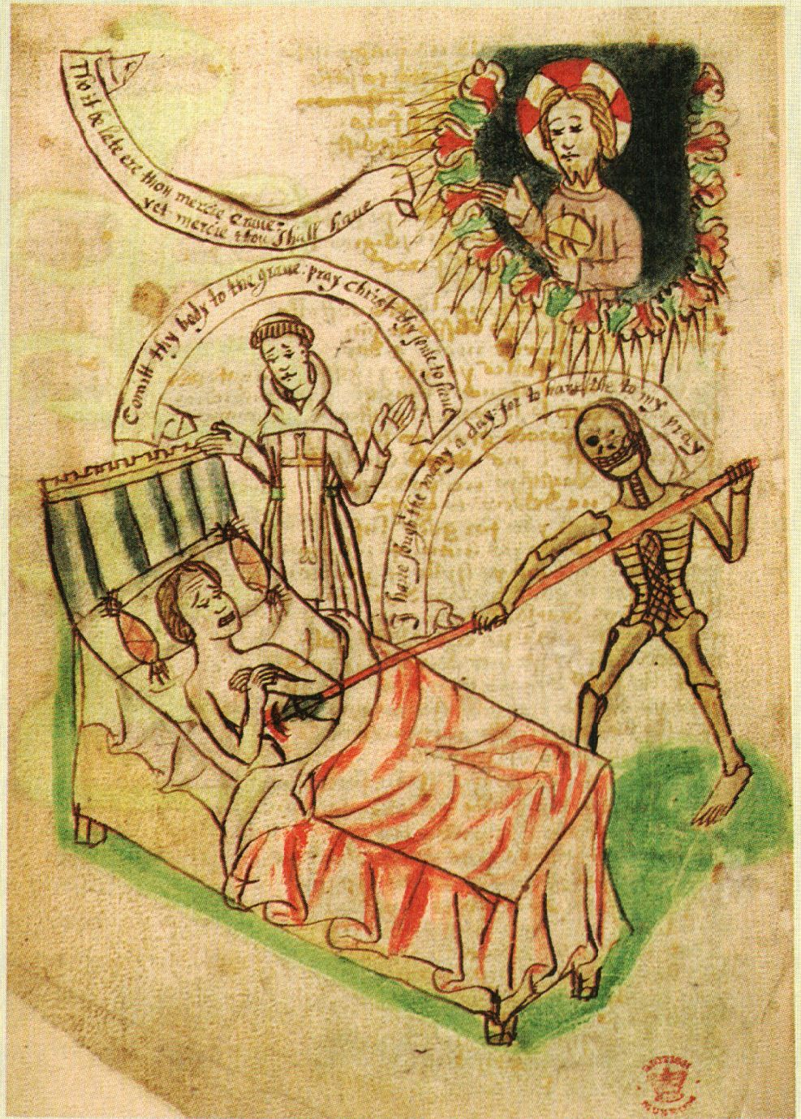
Visual Source 12.4 In the Face of Catastrophe -Questioning or Affirming the Faith (HIP/Art Resource, New York)
- Why is the death figure smiling?
- How does this skeletal figure differ from the ones in Visual Source 12.3?
- How are the priest and the Christ figure depicted? What possible interpretations of their gestures can you imagine?
- Notice that the death figure spears the dying person in the side, an action that evokes the biblical account of Jesus being speared in his side during his crucifixion. What might the artist have sought to convey by such a reference?
- The captions, from top to bottom, read: Christ figure: "Tho it be late ere thou mercie came: yet mercie thou shalt have." Priest figure:
"Commit thy body to the grave: pray Christ thy soul to save." Death figure:
"I have sought thee many a day: for to have thee to my pray." How do these captions influence your understanding of the painting?
- Would you characterize the overall message of this painting as one of hopefulness, despair, or something else? What elements in the painting might support each of these conclusions?

Using the Evidence:

The Black Death and Religion in Western Europe

- Assessing motives: Do you think the artists who created these visual sources sought to reinforce traditional Christian teachings or to challenge them?
- Using art as evidence: What do these visual sources tell you about the impact of and responses to the plague in fourteenth- and fifteenth-century Western Europe?
- Connecting past and present: Considering the various ways that people sought to avert, cope with, or explain the plague in these visual sources, what parallels to the human responses to crises or catastrophes in more recent centuries or in our own time can you identify?

