SMJUHSD- Tablet Theft
ort

dent reports t ablet has been stolen to Student Services, Assistant Principal.
Collect tablet
informa tion from student and bar code/ asset tag from Destiny.
e theft report with local law enforcement. Note: incident report number is required.

Complete and forward t ablet theft report.

Send report via email to
gnunez@smjuhsd .org

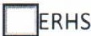School:
OsMHS OoHs

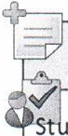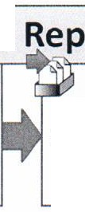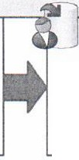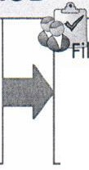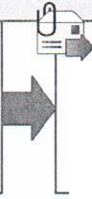
Date of theft :

Time of theft: Victim's Name: Student 6-digit permane nt ID# Address ofTheft : City of Theft : Insurance purchased? Oves 0No
Verified: Was Power Cord Sto len? Oves 0No Ounknown
Tablet Bar Code:

Name of law enforceme nt agency to w hich the loss was reported :

Incident report# Investigating Officer: Badge Number:
Details of Theft : * Include the last known location of the device and how it was stolen .

