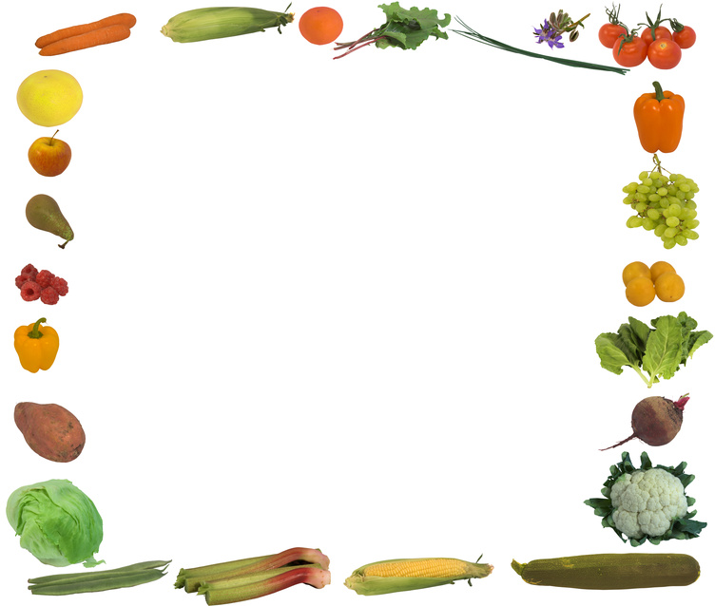
SCHOOL WELLNESS POLICY
Pursuant to federal law, the following parties have jointly developed this school wellness policy: members of the district’s Board of Education, students, parents, teachers (including but not limited to physical education teachers), the district’s director of food services, nurses, community members knowledgeable about children’s health.

The Board promotes healthy schools by supporting student wellness, good nutrition, and regular physical activity as part of the total learning environment. Schools contribute to the basic health status of students by facilitating learning through the support and promotion of good nutrition and physical activity. Improved health optimizes student performance potential, as children who eat well-balanced meals and are healthy are more likely to learn in the classroom.

The district will establish and maintain a district-wide Nutrition and Physical Activity Advisory Council. The purposes of the council shall be to monitor the implementation of this policy, evaluate the district’s progress on this policy’s goals, serve as a resource to schools (i.e. provide lists of healthy incentives, snacks, etc.) and recommend revisions to this policy as the council deems necessary and/or appropriate.

To further the Board’s beliefs stated above, the Board adopts the following goals:

Goal #1 The district will provide a comprehensive learning environment for developing and practicing lifelong wellness behaviors.

The entire school environment, not just the classroom, shall be aligned with health school goals to positively influence a student’s understanding, beliefs and habits as they relate to good nutrition and regular physical activity. Such learning environment will teach students to use appropriate resources and tools to make informed and educated decisions about lifelong healthy eating habits and beneficial physical activity.

The goal of providing a comprehensive learning environment shall be accomplished by:

- The adoption of a district content standard for health and nutrition education that teaches students about the effects of nutrition and physical activity on their health.
- The provision of age-appropriate and culturally sensitive instruction to students that teaches them lifelong healthy eating habits and a healthy level of physical activity.
- The availability of nutrition education in the school cafeteria as well as the classroom, with coordination between the district’s food services staff and teachers.

Goal #2 The district will support and promote proper dietary habits contributing to students’ health status and academic performance.

All foods and beverages available on school grounds and at school-sponsored activities shall meet or exceed the district’s nutrition standards. All schools participating in the School Breakfast and/or National Lunch Program shall comply with any state and federal rules or regulations regarding competitive food service and the service of Foods of Minimal Nutritional Value, as defined by the USDA.

The goal of supporting and promoting proper dietary habits shall be accomplished by

- Adoption of district nutrition standards that limit the amount of fat and sugar content and limit portion sizes.
- The adoption of rules specifying the time and place at which competitive foods may be sold on school property to encourage the selection of healthful food choices by students.*
- Accessible information to students and their parents/guardians concerning the nutritional content of foods and beverages sold by or available to students, as well as the nutritional content of competitive foods sold or available on school district property.*
- An assurance that the school cafeteria is as pleasant an eating environment as possible, including displays of student art, natural light if possible, and reduced noise.

Goal #3 The district will continue to provide opportunities for students to engage in physical activity.

A quality physical education program is an essential component for all students to learn about and participate in physical activity. Physical activity should be included in a school’s daily education program from grades pre-kindergarten through 12. Physical activity should include regular instructional physical education, in accordance with the district’s content standards, as well as co-curricular activities and recess.

Non-Discrimination Statement: This institution is an equal opportunity provider.
(please see the back for adoption date and legal references)
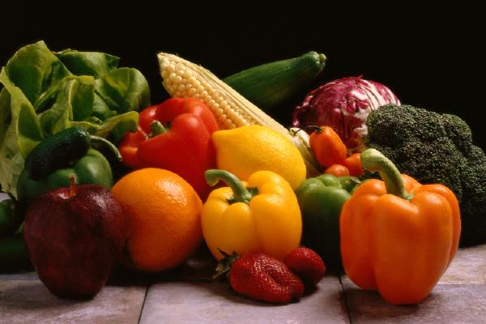
Adoption date: May 10, 2006
Revised: October 24, 2011
Revised: September 28, 2016

LEGAL REFS.: Section 204 of P.L. 111-296
C.R.S. 22-32-134.5
C.R.S. 22-32-136
C.R.S. 22-32-136.3
C.R.S. 22-32-136.5 (3) (a) and (b)
1CCR 301-79

CROSS REFS.: EF, Food Services
EFC and EFC-R, Free and Reduced-Price Food Services
EFEA*, Nutritious Food Choices
IA, Instructional Goals and Learning Objectives
IHAE, Physical Education
IHAM and IHAM-R, Health Education
IHAMA, Teaching About Drugs, Alcohol and Tobacco
IHAMB and IHAMB-R, Family Life / Sex Education
JLJ, Physical Activity

Arriba-Flagler Consolidated School District No. 20, Flagler, Colorado

