Westward Expansion Group Project

Beginning in the mid 1800’s, the increased migration of ranchers and miners to the western territories of the United States helped complete a nation. During this era, the United States began to take shape as the nation that we know today. This westward expansion saw a population of settlers utilize hard work, ingenuity, and perseverance to create homes, build towns and establish cities, which eventually led to the creation of states. This project is designed to allow you to journey westward as a settler, experiencing the hardships, relishing in the triumphs and learning about this new way of life. The goal of this project is to travel west, using clues and directions to find the next location. At each location, each member of your group will be responsible for answering all of the questions. On the map, a travel route will be documented and a picture will be drawn at each location on the map. After the journey is over, each group will turn in a map with a travel route, and each member will turn in the answers to each question. Have fun and good luck!!

DIRECTIONS:
- You will choose your group. No less than 2 and no more than 3 students in a group. Collaboration is an important skill to develop, and this project will help you practice the skill of completing a single goal as a group. Remember that all students in a group must participate. A group self-assessment rubric will be used!
- You will create a map of the U.S. Materials for this will be provided. Your group will use the textbook as a resource for your journey.
- As a group, you will begin your travels westward by opening up envelope #1. It is important to follow the directions in the envelope, and it is also important to open up the envelopes in order—it will be easy to get lost if you do not follow the instructions!
REMEMBER! Following instructions is vital to the successful completion of this project. If you do not follow the directions in the envelopes correctly, you could easily get lost, and you do not want to get lost on this journey!

Grading Rubric
Group Work Individual Work
Completed Map____/20 Completed answers______/70
Travel Routes ______/10
Visual Aides ______/20 Total group + Individual work _____/120

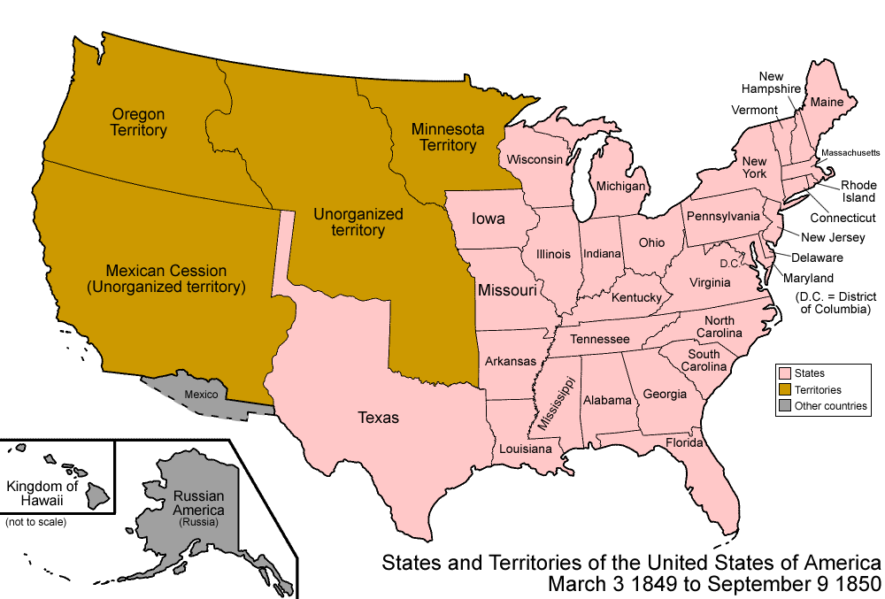
ENVELOPE 1

It is the spring of 1850. You and your family are farmers Eastern Ohio. Life is hard for you, your spouse and your children. You work all day, everyday in your fields, but you seem to never catch a break. For the last 3 years, your crops have failed to produce enough to make a profit, and over the winter, almost half of your chickens died because of disease. You are constantly in debt, and everyday you hope for a better life.

One afternoon, while tending to your chores, a man arrives by horseback with a bundle of letters for you. He is a brutal looking man, draped in animal skins and sporting a long grey beard. He informs you that he is the letter carrier from Sutter’s Fort, California and he was sent from there with letters from your Cousin William. He gruffly apologizes for the delay of some of the letters, but he explains that he can only make 1 trip per season, and this was it. As the man slowly rides eastward from your farm, you excitedly open the bundle of letters.

After reading the letters and newspaper ads, answer the following questions on a separate piece of paper. Use this piece of paper to answer all of the questions from the envelopes.

- After gold was found near San Francisco, what two ways did people from the east get to California? Which way do you think was safest? Why didn’t all people take this route?
- Look at the map on page 269 in your text book. Answer the first question in the “Geography Connection” box.
- Answer the second question in the “Geography Connection” box.

Once completed, trade envelope 1 for envelope 2.

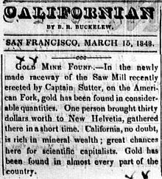

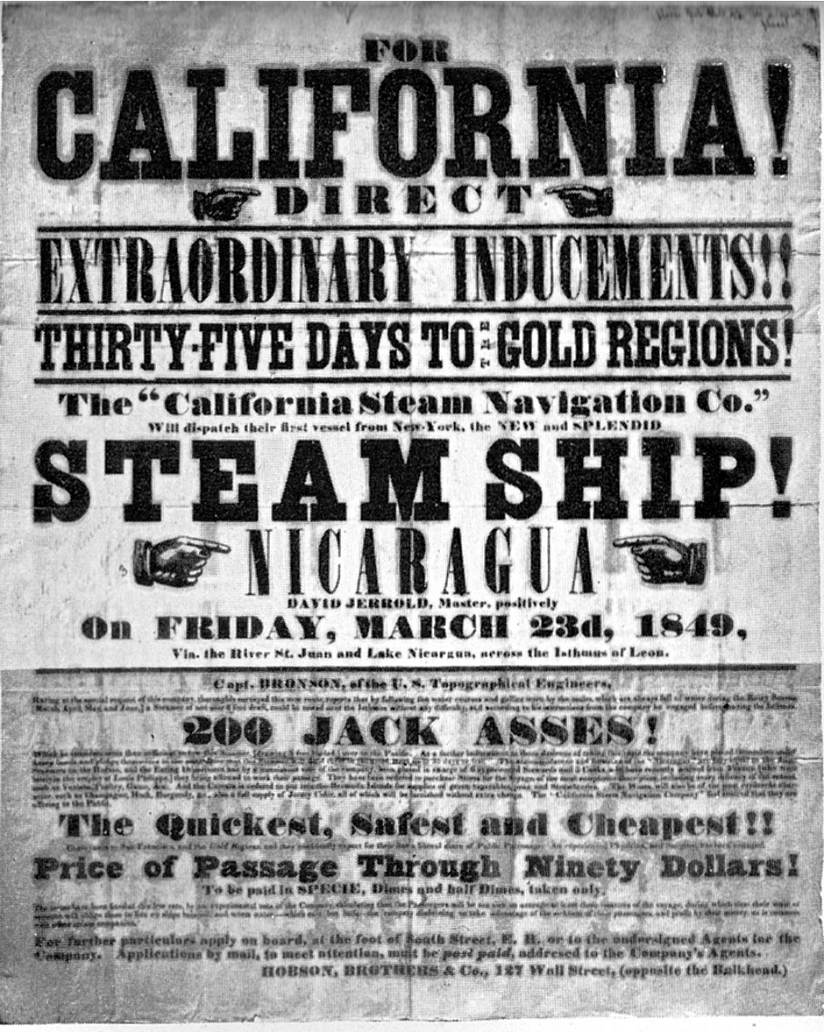
July 4, 1849
I have just left the celebration dinner table, where the company are now drinking toasts to everything and everybody and cheering at no small rate. I enjoy myself better in conversing with you through the medium of the pen. It is now some time since I wrote home, or at least since I wrote at any length, having written to you a line by a returning emigrant whom I met on the road and had just time to say that we were all well. But there is no certainty in sending letters by such conveyance. You may or may not have received some of the many letters I have sent you by traders and others, on many of which I have paid postage of 25 cents.
...We shall pass Fort Laramie tomorrow, where I shall leave this to be take to the States. It will probably be the last time I can write until I get to my journey's end, which may take till the middle of October. We have had uncommon good health and luck on our route, not having had a case of sickness in the company for the last four weeks. Not a creature has died, not a wagon tire loosened, and no bad luck attended us. The country is becoming very hilly; the streams rapid, more clear, and assuming the character of mountain streams. The air is very dry and clear, and our path is lined with wild sage and artemisia.
We had a fine celebration today, with an address by Mr. Sexton, which was very good; an excellent dinner, good enough for any hotel; and the boys drank toasts and cheered till they are now going in all sorts around the camp. I often think of home and all the dear objects of affection there: of George; dear Mother, who was sick; and of yourself and poor little Sister. If it were consistent, I should long for the time to come when I shall turn my footsteps homeward, but such thoughts will not answer now, for I have a long journey yet to complete and then the object of the journey to accomplish.
I am hearty and well, far more so than when I left home. That failing of short breath which troubled me at home has entirely left me. I am also more fleshy. Notwithstanding these facts, I would advise no man to come this way to California. Give my love to George and Mother and tell them that I am well and enjoy myself. Kiss my little girl for me, and when I get home I will kiss you all.
William Swain

[TEXT: J. S. Holliday, The World Rushed In (1981), pp. 168-70.]
January 6, 1850
South Fork of Feather River
25 miles from Long's Trading Post, and
16 miles above Bidwell's Trading Post
We arrived at Lawson's Ranch on the 8th day of November, tired and worn down with toil and exposure but hardy, healthy, and in good spirits, buoyant with hope. We were in the Sacramento Valley in the rainy season, destitute of provisions, without shelter, and everything eatable worth from $1 to $1.50 per pound. In fact, all was dear but rain and mud which was everywhere. We rested three days and put out for the Feather River mines, where we arrived on the 14th of November at Long's Trading Post, the first mines on this stream. The swollen river prevented the miners from operating near its bed where gold is found most abundantly. Generally they were doing no more than boarding themselves, though occasionally one would make a lucky hit and find this thousands. During the fall, miners could average their ounce clear in working with rockers on the bars and edges of the streams, and those who were lucky enough to make dams across the streams before the rains often made large sums in a few days and frequently in a few hours. In late November we bought provisions at Long's Trading Post and took packs of fifty pounds each. We traveled over the mountains for twenty--five miles through rain, mud and clouds and arrived on the South Fork on the third day. After prospecting two days, we located a spot favorable for damming and draining the river. We made our claim and then built a house as soon as possible to shelter our heads from the soaking rains. So here we are, snug as schoolmarms, working at our race and dam. Whenever the rain will permit, a fall of the river will enable us to get into the bed of the river and know what is there. If there is no gold, we shall be off to another place, for there is an abundance of gold here, and if we are blessed with health, we are determined to have a share of it. The rapidity with which this country is settling is only equaled by the change being made by Yankee enterprise. When we first located on this stream, no mor than six houses were built on it. Now, within a distance of ten miles, 150 dwellings are built.
The natives of these mountains are wild, live in small huts made of brush and go naked as when they are born. They subsist on acorns and what game they kill with their bows and arrows. They are small in stature, and their character is timid and imbecile. When they visit the camps of the miners, they evince the most timid and friendly nature. They are charged with killing miners occasionally when they find one alone, away among the hills hunting. The miners, especially the Oregon men, are sometimes guilty of the most brutal acts with the Indians, such as killing the squaws and papooses. Such incidents have fallen under my notice that would make humanity weep and men disown their race. I shall write often as I can and shall fill my engagements to different persons to whom I promised to write as soon as I have gained sufficient knowledge of the country to do so understandingly. Often for weeks during the rainy season it is damp, cold, and sunless, and the labor of getting gold is of the most laborious kind. Exposure causes sickness to a great extent, for in most of the mines tents are all the habitation miners have. But with care I think health can be preserved.
William Swain
[TEXT: J. S. Holliday, The World Rushed In (1981), pp. 312-29.]

ENVELOPE 2

Before moving on, locate your farm in east Ohio on your map. Draw a picture of what you think your farm looks like. Next, accurately draw and color the gold and silver mine locations on your map. You can find these locations on page 269.

- According to the letters, describe how life was like for a settler on the journey westward.
- According to the letters, what was life like for a miner in California?

Imagine what a miner’s camp would look like. Using the information that William has told you, and using your own imagination, draw a picture in Northern California that depicts a gold miner’s camp

After reading the letters from your cousin, you decide that following in his footsteps is the only way that you and your family will survive. Although William urged no person to trek across the country, you do not have the funds for the steam ship, so you must head west via wagon.
After selling the farm to a wealthy neighbor and packing up what little belongings you have, you and your spouse and children begin your journey west. After a long three week journey upon the rugged, muddy trails through Ohio, Indiana, Illinois and Missouri, you finally reach St. Louis, a vital city for anyone heading west. As you approach the Mississippi river, you stop to read this excerpt from the St. Louis Convention and visitor’s commission:

“St. Louis has become the last stop for mountain men
and trappers heading to the newly opened frontier. St. Louis’ booming
fur trade lasted until 1840, but the westward movement
of Americans through St. Louis – “the gateway to the
west”–is now creating a thriving economy.
Entrepreneurs make fortunes in St. Louis by selling
goods to pioneers and adventurers who gather their
supplies and headed west for land, gold and glory.”

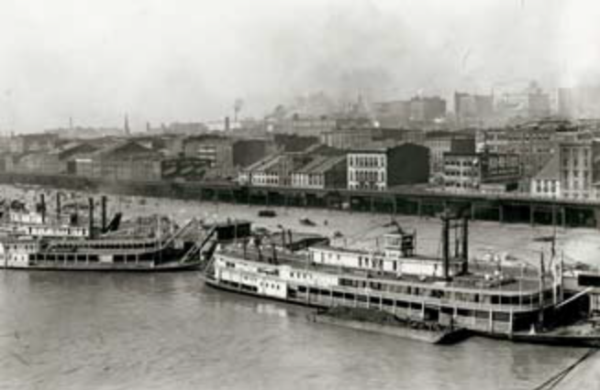

On your map, accurately locate St. Louis, MO and the Mississippi River. Also, record the path you have taken so far in your travels.

- In your own words, why was St. Louis called the “Gateway to the West”?
- Thinking about the future of your journey, and keeping in mind your limited funds, what are the 5 most important supplies that you should buy in St. Louis? Which supplies will you have to go without? Explain your reasoning. You must consider all possible scenarios—disease, weather, sustenance, protection, etc.

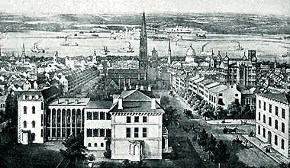
Once completed, trade envelope 2 for envelope 3.

http://www.sidneyrigdon.com/dbroadhu/MO/1854MRep.jpg
Before moving on to Envelope 3, read this and complete these tasks:

A pioneer’s typical outfit wasn’t terribly expensive; usually one or two small, sturdy farm wagons, six to 10 head of oxen, a milk cow or two. Plus all the necessary food, clothing and utensils needed for survival. Often heavy items such as furniture, stoves, pianos would be freighted to the West Coast by clipper ship around the Horn of South America. If such heavy things were packed in the wagons, they usually ended up left along trailside along the way.
To survive the long journey, a family of four would need 600 lbs. of flour, 120 lbs. of biscuits, 400 lbs. of bacon, 60 lbs. of coffee, 4 lbs. of tea, 100 lbs. of sugar, and 200 lbs. of lard. These would just be the basic staples. Other food stuffs could include sacks of rice and beans, plus dried peaches and apples. Bacon was often hauled in large barrels packed in bran so the hot sun would not melt the fat. Each man took a rifle or shotgun and some added a pistol. A good hunting knife was essential.

Below is an example of supplies needed for the westward trip. You sold your farm and the remainder of your chickens and crops for $2800.00. This is all the money that you have.

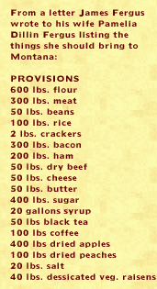
After studying this, and knowing how much money you have, you must create a list of items to buy from “Ol’ Sammy’s Supply Store” and calculate the costs. You need to remember to save enough money to resupply later on your trip and also save enough to live on in California while you mine for gold. Write this list and the costs of the items on your map (somewhere east of Ohio) and keep track of how much money you have spent.

PBS - Frontier House: Frontier Life www.pbs.org
ENVELOPE 3

Read page 274 in your book. Afterwards, draw a picture depicting what the next part of your journey will look like.

As you and your family head west from St. Louis, you are amazed at the vastness of the landscape. The open prairie seems to go on forever, and as the days pass with no signs of human existence except for the trail that you travel on, you begin to question your decision to attempt this journey. You and your family suffer through heat, wind and hunger, hoping for the sight of another town on the horizon.

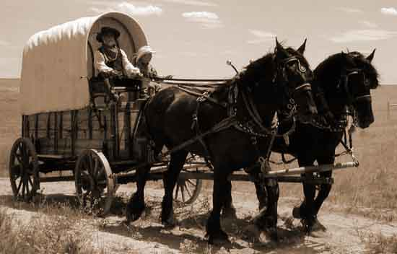
http://shelledy.mesa.k12.co.us/staff/computerlab/images/KFW_5th_Grade_Westward_Expansion.jpg

- To pass the time, you and your family sing songs together. As a group, write a song describing your experience so far on your journey westward. The lyrics to the song will be the answer for #6.

Once completed, trade envelope 3 for envelope 4.

ENVELOPE 4

As you continue to travel through the western territories, you suddenly are aware that you are not alone. You had heard from others about Native Americans on the prairies out west, but have yet to come across any other people out here. Regardless, you are aware that you travel on land that belongs to someone else, and you are also aware that with more and more settlers heading west, the chance of confrontation and violence will probably increase as time goes on.

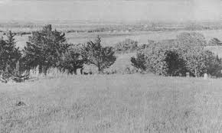
http://www.nps.gov/

Read pages 277 – 281 in your textbook. After reading these pages, answer the following questions.

- From the point of view of a Native American living in the plains, how would you describe the recent influx of settlers? How does this make you feel?
- How does the arrival of these settlers affect your daily life?
- Describe the Dakota Sioux uprising in your own words.
- Describe Red Cloud’s war in your own words.
- Describe the Sand Creek Massacre in your own words.
- Describe the Battle of Little Big Horn in your own words.
- Describe the flight of the Nez Perce in your own words.
- Describe the tragedy at Wounded Knee in your own words.

On your map, accurately locate, describe and date the 6 major Native American battles shown on the map on page 279.

Look at pages 266 – 267. Read the quotes on page 266.

- How did the Battle of Little Big Horn alter many people’s perceptions about Native Americans? What was the main reason for this?
- Answer the DBQ on page 266.

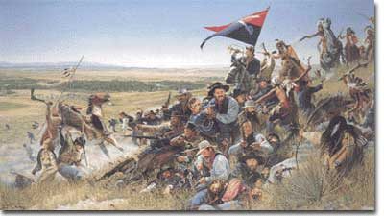

http://www.ushistory.org/us/images/00000905.jpg

Once completed, trade envelope 4 for envelope 5.

ENVELOPE 5

After a grueling month long journey through the plains, you begin to see the Rocky Mountains in the distance. This sight rejuvenates you and your family who are all depleted, tired and hungry. You suddenly see in the distance an adobe building. As you get closer, you see other people bustling about, wagons hastily circling the fort and horses drinking from barrels of water. This is Ft. Lupton, a trading post on the eastern plains of what will become Colorado.
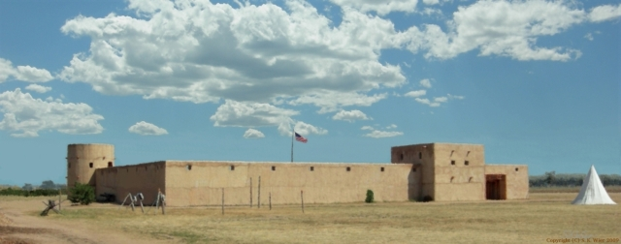
http://www.westernexplorers.us/Fort_Lupton_painting_(c)_2009_S_K_Wier_small.jpg

Upon arrival at Fort Lupton, you are able to buy more supplies and ask about the best route to California. As you wonder the fort, a wide variety of different people appear before you. Old mountain men, draped in animal pelts, with fingers blackened and bloody from mining, Spanish cowboys with dusty hats and weathered chaps. As you seek advice about the best route to Sutter’s Fort you overhear two old miners discussing the best way to mine the silver and gold out of Pike’s Peak in the Rocky Mountains.

Locate and draw the Rocky Mountains on your map. Accurately locate and draw Pike’s Peak on your map. Also continue drawing the path that you have taken so far on your journey.

Once completed, trade envelope 5 for envelope 6.

ENVELOPE 6
The two old miners continue to argue over the best way to mine. As you listen, you begin to imagine your future life as a miner, arguing these same kinds of things with your cousin William in just a few short months.

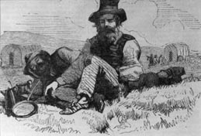

The first miner explains to his partner the benefits of one particular type of mining:

“Sheesh to all heck, ya yella bellied moose kisser! If ya talkin’ bout peterin’out the side o’ the hill, ya needs ta use that darn hard shootin’ water pistol, ya see! If ya lookin’ t’ fill the pockets with the grubsteak, dag nabbit, ya need t’ fill them riffle boxes with the shiny stuff!”

After a moment, the other miner wholeheartedly responds:

“No, no, no, ya flapjack eating son of a birds tail! Ya got it all wrong! Ya see that hard shootin’ water pistol, you are so darn fond of, ain’t doin’ nutin’ but washin’ the black sand into the darn drinkin’water! You silly egg beater, you really lookin’ to flood the darn rivers with that soot”

You are really having a hard time following this conversation, so you decide to move on to the supply store to resupply some essentials.

Read page 270 to help dissect this conversation that you just witnessed.

- What kind of mining was the first old miner referring to in the conversation? Why did the second old miner disagree with him?
- According to the book, what are 2 other methods used to mine for gold?
- Congress passed a law in 1893 banning what? Why did Congress pass this law? After this law passed, what kind of mining became more popular?

On your map, near one of the mine locations previously drawn, draw a picture of what you think 1of the 4 mining methods looked like, and label which method it is.

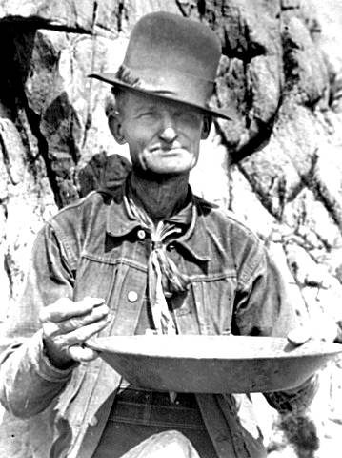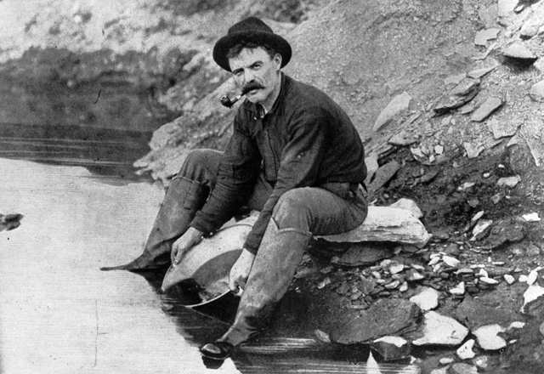
americaslibrary.gov

Once completed, trade envelope 6 for envelope 7.

ENVELOPE 7

At the supply store, you need to prepare for colder weather in the mountains. You also need to restock food. A cord of logs will make about 20 fires. You have gone about half way to the west coast, and you have gone through about half of your provisions. Calculate how much you are able you spend, keeping in mind leaving extra money available for when you get to California. Add your spending totals to your previous list of items bought and keep track of the money you have left. Below is a list of supplies available at Fort Lupton:

Fort Lupton Trading Post Provisions Sold:
Flour, per 100 pounds ..........$50.00
Fresh beef, per 100 pounds ..... 35.00
Sugar, per 100 pounds .......... 50.00
Cheese, per pound .......... 1.50
Fresh Pork, per pound .......... .25
Butter, per pound .......... 1.00
Cheese, per pound .......... 1.00
Ham, per pound .......... 1.00
Flour, per barrel .......... 18.00
Pork, per barrel .......... $35 to 40.00
Boots, per pair .......... $20 to 25.00
Shoes .......... 3 to 12.00
Wool Blankets…… $5 a piece
Buffalo Hyde Jackets……$15 a piece
Logs, per cord………….$25
Once completed, trade envelope 7 for envelope 8.

ENVELOPE 8
Rested and well supplied, you begin your journey west again, leaving behind the arguing old miners with directions to California in hand. As Fort Lupton fades away behind you, you hear a low rumbling sound and the ground vibrates underneath you. You stop the wagon to listen closer. The low rumbling turns into an ear piercing thunder. The ground is shaking so hard that it feels like the wagon hasn’t stopped. Suddenly, charging from the south is a massive herd of animals. You stand to gaze at this amazing site as the beasts trample the earth ahead of you, no more than 100 feet away. You have heard of these great creatures, but have never seen them before.

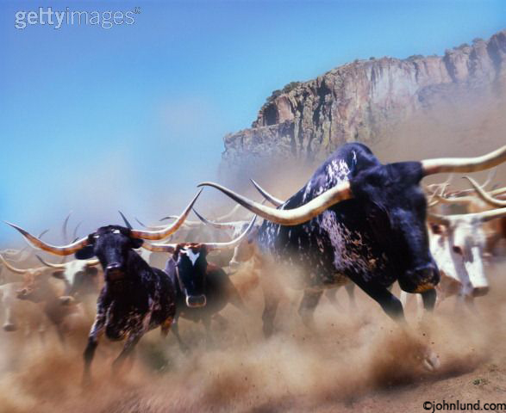

Men, on horseback, ride quickly with strength and determination around these great creatures, corralling them, with loud hoots and hollers, lassos, whips and guns waving in the air. There are around 200 head of animals and about 6 men on horseback. For the first time on your journey, you feel like you are finally in the “Wild, wild west.”

22. What is going on right in front of you?

- What are these “great creatures” that are stampeding right in front of you?
- Who are these men riding on horses? What are they doing?
- According to the book, what was the “open range” and what invention caused the end of it? Why did this happen, and what were the benefits to this invention?

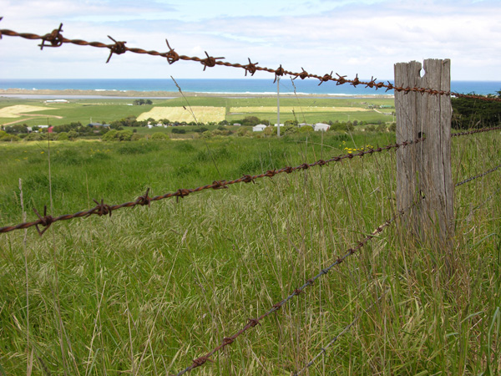
moyne.vic.gov.au

Once completed, trade envelope 8 for envelope 9.

ENVELOPE 9
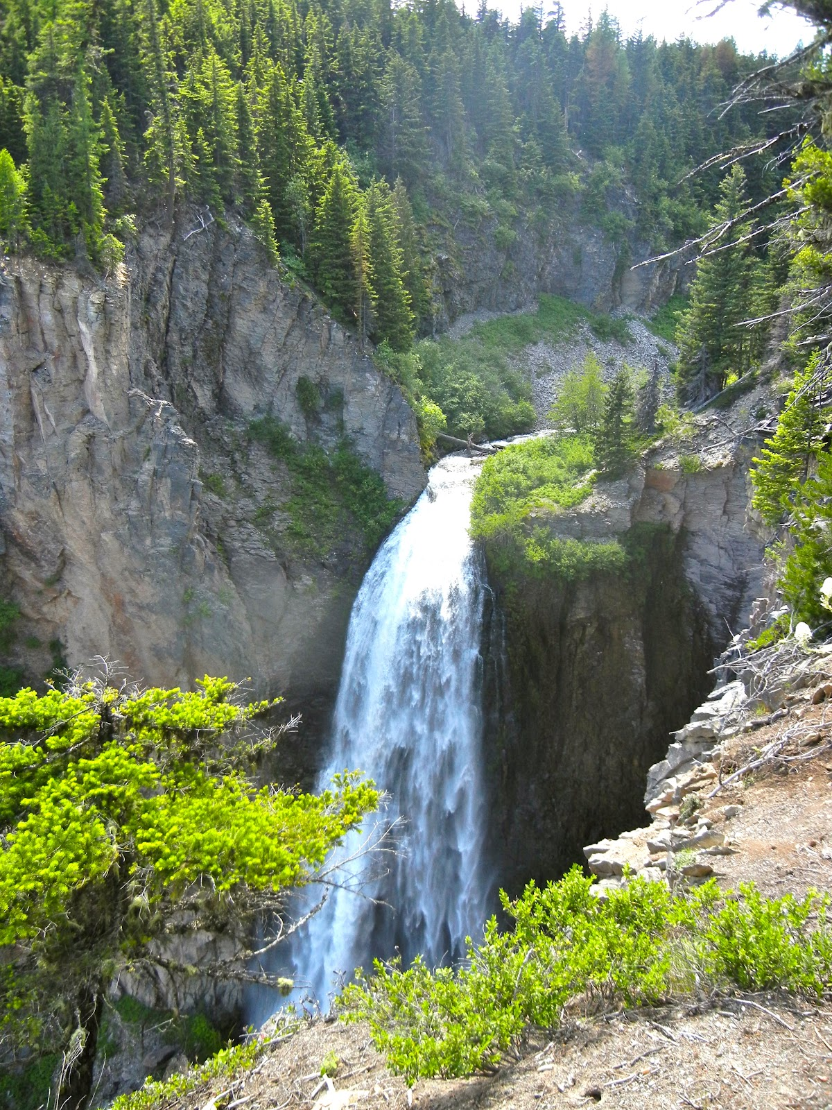
As the plains fade away behind you, your environment changes drastically. What was a seemingly endless, straight trail through tall grass and meadows has turned into a hazardous and rough climb over mountain passes. The days are getting shorter, and the air is getting colder. Tall pine trees and looming aspens cloud the sky, which seems so far away. Rocky outcroppings and rugged terrain give way to fast moving rivers that have spent thousands of years eating away at limestone canyons. At some points, you don’t think that you will be able to continue and become frustrated, while other times you find the beauty of these beautiful mountains to be overwhelming, and you am glad that you are here, right now.
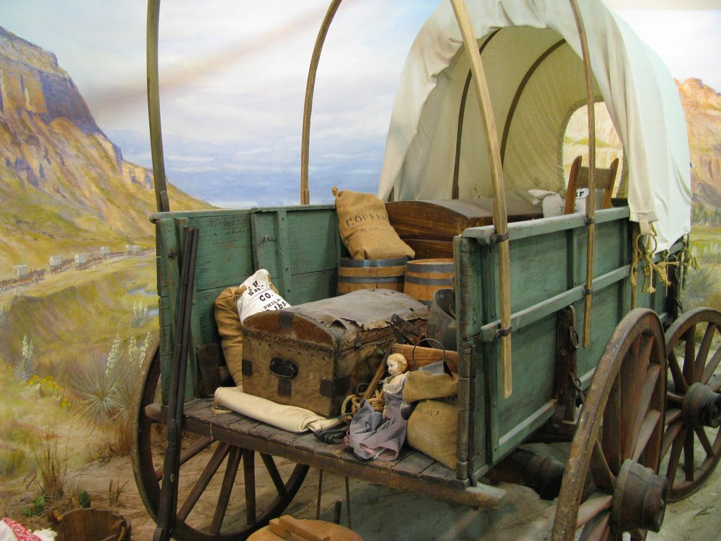
As you and your family approach a steep ravine, you carefully maneuver your wagon along the edge. Suddenly, your
myviewfromthegarden.blogspot.com
wagon tips over on its side! As you and your family jump off, you watch as all but 1 barrel of meat and all of your blankets fall into the river below. You are able to tip your wagon right side up. As you do, you see that one of your wagon wheels is broken, and one of your oxen has a broken leg. You need to find a way to fix your wheel, and decide what to do with the lame oxen. You also need to make decision about the future of the trip. parablesblog.blogspot.com

Astonished and angry, you weigh your options:
Do you continue moving westward and hope that you will find a supply fort to restock your lost items?
Or do you set up camp here for a week, hunt deer and elk for meat and make blankets from the pelts?

26. For this answer, write a list of 5 pros and 5 cons for each decision. You must consider several things: weather, supplies, safety, time and hunting abilities.
27. How will you fix the wheel? Describe the process that you followed to fix the wheel. Below is what you have to work with:

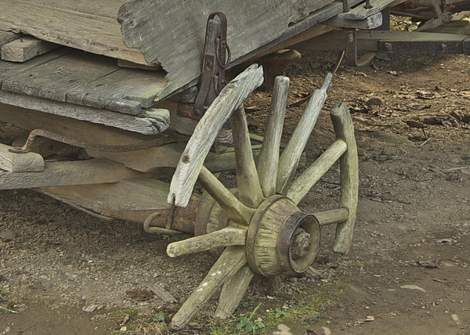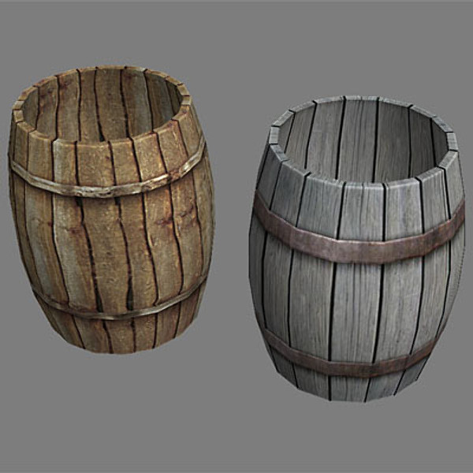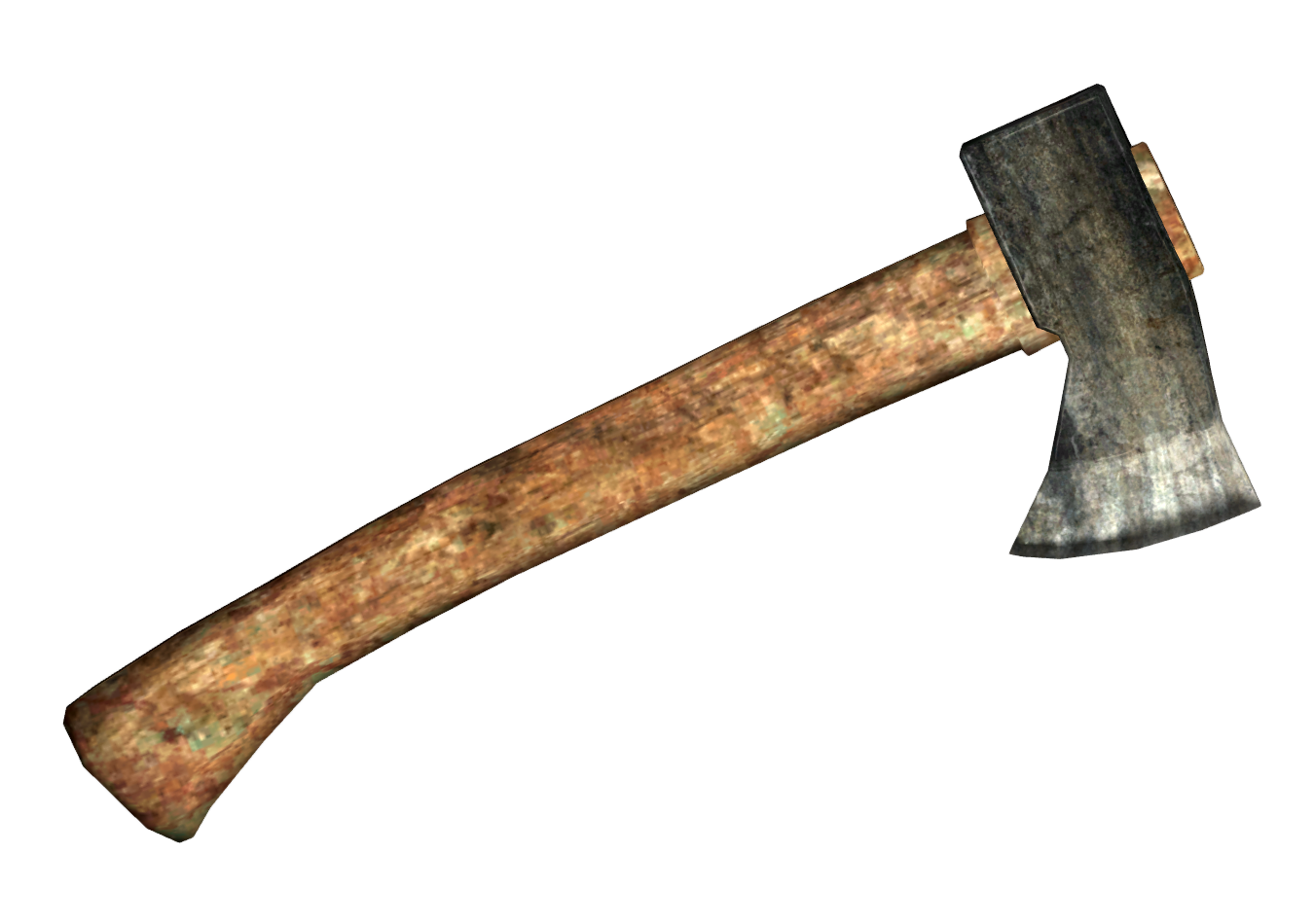
Here is your wheel A couple of empty barrels A hatchet

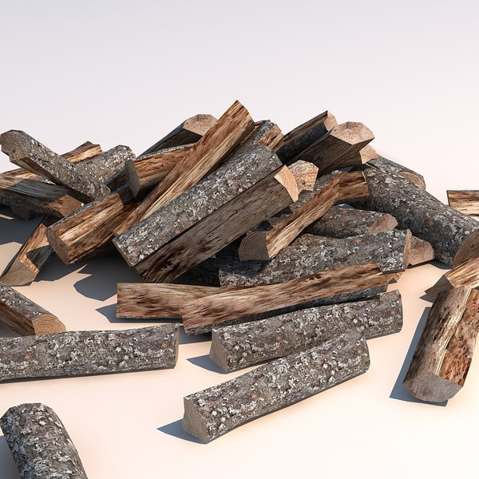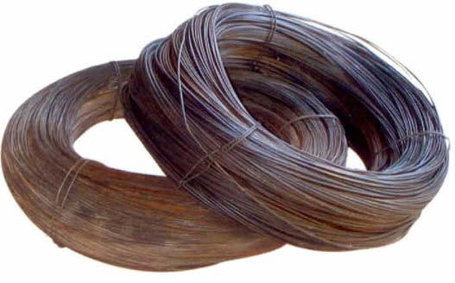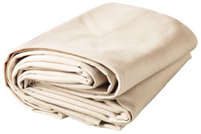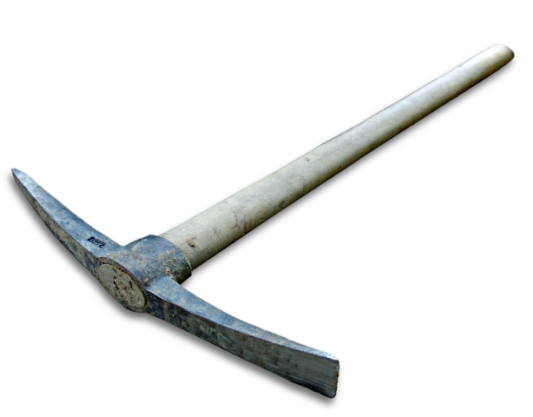
Some logs Wire Cloth Tarp A pick axe

fineartamerica.com http://www.turbosquid.com/3d-models/wooden-barrel http://fallout.wikia.com/wiki/Throwing_hatchet http://www.turbosquid.com/3d-models/wood-pile-woodpile www.americanbluesscene.com http://www.gemplers.com www.ghananewsagency.org

28. What do you do with the lame oxen?

What did your group decide to do? If you decided to stay and camp, trade this envelope in for envelope 9A.

If you decided to continue westward, trade this envelope in for envelope 9B.
Envelope 9A

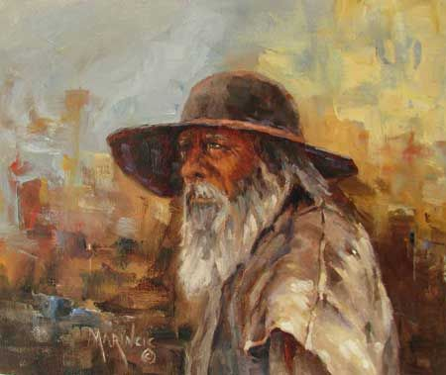
After deciding to camp here, and find your own food, you leave your family behind to find a place to hunt. You are unfamiliar with this territory so you must keep track of where you are going, or else you could get lost. You try for three days to hunt a deer or elk, but you are unsuccessful. Cold tired and hungry, you begin to venture back to your camp site. Along the way you, run across a game trail and decide to follow it. The trail does not lead you to any animals, but instead to a mountain man, who claims to be a medicine man. He has a barrel of salted meat, 2 barrels of other food items, bear hide jackets, medicine and tools. www.marincic.com

29. He wants to trade you meat for your rifle. He will also trade you 2 barrels of food for your bullets. Do you make the trade? Why or why not?

You return to your campsite to find your family upset and starving. According to your family, yesterday, an old mountain man, claiming to be a medicine man, approached the camp site. Your family, afraid of the man, hid in the woods surrounding the campsite. While they hid, he rummaged through all of your stuff, and he stole 1 barrel of meat and 2 barrels of food. Did you make the trade?

Reassess what supplies you have and need and continue on your journey.

Once completed, trade envelope 9A for envelope 10A.
Envelope 9B

After fixing your wheel, you decided to continue westward. Once you get past the ravine, you begin a slight decent into a beautiful valley. Here you discover a smooth wagon trail, pressed out of the ground from previous settlers heading west. This trail is a good sign, and rejuvenates your spirits. After a few days of winding downward off the pass, you see a small trading post next to a lake.
Once inside the trading post, you discover that this area has recently struck gold in the river that feeds the lake, and that we are some of the first settlers to show. You explain to the shop keeper that you have lost many of your rations, including all but 1 barrel of meat and all of your blankets. He, apparently delirious from finding gold, babbles on and on about the importance of helping your fellow humans and that you cannot let a good deed pass you by. He gives you 4 bear skin blankets and 300 pounds of beef and pork.
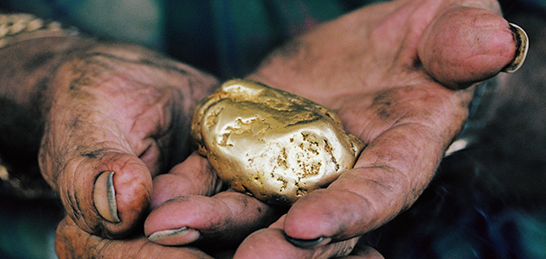
You claim that you cannot accept without payment, but he insists, claiming that the goodness of his heart will bring him luck in the river.

He also gives you a gold nugget. He wants you to show all www.smithsonianmag.com the other settlers that you come across this nugget, and tell them where his shop is. He is using you as an advertisement. Congratulations.
Once completed, trade envelope 9B for envelope 10B.

ENVELOPE 10A
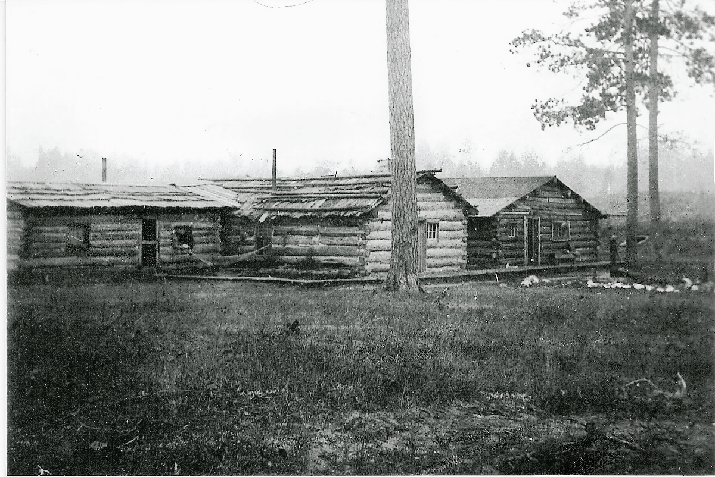
After being robbed by the mountain man, you and your family are in bad shape. Cold, hungry and lacking supplies, you begin your journey once again westward, but this time lacking hope and full of anger. Your children are sick, and you are in dire need of medication for them. As you approach the westward slope of the Rocky Mountains, you find a trail leading downward to what seems to be a small trading post next to a lake. You hope for the sake of your children’s health that you can find some help down there.
As you approach the post, you see http://www.rootsweb.ancestry.com/~wioconto/memoirsBuckman.htm
wagon tracks, the remains of small fires and other signs of human existence, but do not see anyone around. You approach the post to find it quiet. It is locked up and a sign on the door says “Gon Minin’” You continue on the trail, past the post and westward, heartbroken and ashamed.

After a few more days, you have exited the mountains, and find yourself in the high desert, surrounded by mesas and buttes. Your 2 children have passed away from Cholera and you feel like it has gotten to you as well. You stop just west of the San Juan mountains, and bury your children. You feel defeated and ashamed, but must carry on. As you continue westward, you begin to feel that you will never make it to California. Your heart hurts because of your children and you are sick to the bones as well.

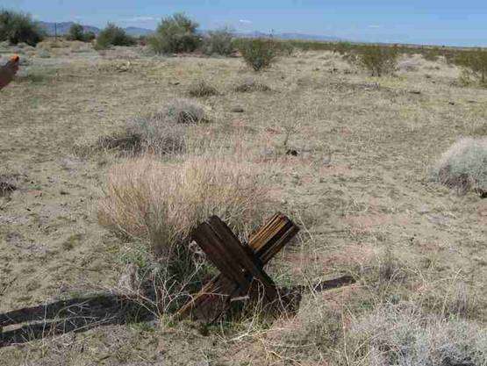
Read the passage and the primary sources below. This will help you understand better how hard the life for a settler was.
http://www.apcrp.org/BLOCK_KATHY/FRANCONIA/Franconia_Writeup.htm
Cholera
Perhaps the biggest problem on the Trail was a mysterious and deadly disease--called cholera for which there was no cure. Often, an emigrant would go from healthy to dead in just a few hours. Sometimes they received a proper burial, but often, the sick would be abandoned, in their beds, on the side of the trail. They would die alone. Making matters worse were animals that regularly dug up the dead and scattered the trail with human bones and body parts.
Settler Agnes Stewart:
"We camped at a place where a woman had been buried and the wolves dug her up. Her hair was there with a comb still in it. She had been buried too shallow. It seems a dreadful fate, but what is the difference? One cannot feel after the spirit is flown."
Cholera killed more emigrants than anything else. In a bad year, some wagon trains lost two-thirds of their people.
Settler John Clark:
"One woman and two men lay dead on the grass and some more ready to die. Women and children crying, some hunting medicine and none to be found. With heartfelt sorrow, we looked around for some time until I felt unwell myself. Got up and moved forward one mile, so as to be out of hearing of crying and suffering." From: http://oregontrail101.com/Hardships.html
30. On the westward trail, what killed more settlers than anything else? Describe in your own words your experience as a settler with cholera. Write your description it as if you were one of the settlers being quoted above.
Trade this envelope in for envelope 10C.

ENVELOPE 10B

You are now out of the Rocky Mountains and are heading southwest. The jagged cliffs of the San Juan Mountains give way to majestic mesas and buttes. The landscape westward is mysterious, with pine trees turning into pinions and junipers, cacti and yucca plants appearing everywhere below you, and the climate becoming warmer and dryer.
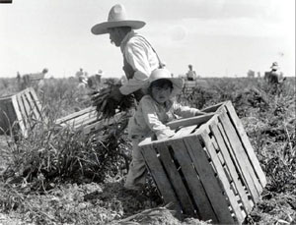
As you approach a settlement in the distance, you notice that you are surrounded by fields of onions, chilies, pecans. In the fields are hard working people. You have never seen fields like this before, and http://www.ncfh.org/?pid=4&page=2
have never seen people like this before. As
you approach the small town in the distance, you notice that many of them seem to not care about your presence. You are not the first white settler to come through here, and you are sure that you are not the last.

Read pages 272 – 273 in your book to help answer these questions.

- Who are these people? Where do you think you are at in the US right now? Find your location on your map and draw a picture of where you are.
- What is a hacienda? What is a Vaquero? What is a barrio? What is a charro?
- How did the influx of settlers to the west impact the Hispanic population in the southwest? Give specific examples of this interaction.

As you get closer to the hacienda, 2 Vaqueros approach you. They ride quickly and majestically toward you. One has a pistol in his hand, and the other yields a rifle. You are scared, but at this point, there is nothing you can do. You stop the wagon and await the confrontation.
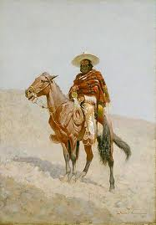
They circle your wagon a few times, and the one with pistol stops at your side. He points the gun at you and notions you to put your hands up and stand.
“Oro!” He yells in a gruff voice, with a heavy Spanish accent.
“Oro!”
You shake your head in confusion.
“Gold?!”
You look at him. He boldly glares back at you. You have to make a decision.

www.upf.edu

Do you give the vaquero the gold nugget that the shopkeeper gave you? If you do, trade this envelope for envelope 11A.
If you do not give him the gold, trade this envelope for envelope 11B.

ENVELOPE 10C

You are now out of the Rocky Mountains and are heading southwest. The jagged cliffs of the San Juan Mountains give way to majestic mesas and buttes. The landscape westward is mysterious, with pine trees turning into pinions and junipers, cacti and yucca plants appearing everywhere below you, and the climate becoming warmer and dryer.
As you approach a settlement in the distance, you notice that you are surrounded by fields of onions, chilies, pecans. In the fields are hard working people. You have never seen fields like this before, and http://www.ncfh.org/?pid=4&page=2
have never seen people like this before. As
you approach the small town in the distance, you notice that many of them seem to not care about your presence. You are not the first white settler to come through here, and you are sure that you are not the last.
You are extremely sick and needing of medical assistance, so you decide to attempt going into the small town. As you approach it, your mind wonders about who these people are.

Read pages 272 – 273 in your book to help answer these questions.

- Who are these people? Where do you think you are at in the US right now? Find your location on your map and draw a picture of where you are.
- What is a hacienda? What is a Vaquero? What is a barrio? What is a charro?
- How did the influx of settlers to the west impact the Hispanic population in the southwest? Give specific examples of this interaction.
As you get closer to the hacienda, 2 Vaqueros approach you. They ride quickly and majestically toward you. One has a pistol in his hand, and the other yields a rifle. You are scared, but at this point, there is nothing you can do. You stop the wagon and await the confrontation.
They circle your wagon a few times, and the one with pistol stops at your side. He points the gun at you and notions you to put your hands up and stand.
“Oro!” He yells in a gruff voice, with a heavy Spanish accent.
“Oro!”
You shake your head in confusion.
“Gold?!”
You look at him. He boldly glares back at you.
“ NO ORO!” you yell back at him.
www.upf.edu

The vaquero cocks his gun and smirks. The second vaquero enters the back of your wagon. He helps himself to your rifle, and some sacks of sugar. You, unfortunately, hid the rest of your money in one of these sacks, and the vaquero finds it.
Satisfied with the loot, the vaqueros discuss something in Spanish to each other, laugh, and turn back towards the hacienda. You have just been robbed again, and this time you will not survive. On this trip, one bad decision can cost you your life. This was the way of the wagon trail. This was the fate of many settlers heading west. Some, however, had it worse than others:

From November 20, 1846 to March 1, 1847, Irish immigrant Patrick Breen, a Donner party member, kept a diary of his ordeal in the mountains. Clinging to survival with his wife Margaret and their seven children, Breen described the harsh winter weather, the leather hides they resorted to eating, and the deaths of their traveling companions.
As spring approached, rescuers made their way to the Donner party’s mountain encampment. By March, Breen and his family were safely at Sutter’s Fort in California. All seven children and both parents had survived. Baby Isabella, who remembered nothing of the ordeal, lived until 1935, the last survivor of the Donner party.

“came to this place on the 31st of last month that it snowed we went on to the pass the snow so deep we were unable to find the road, when within 3 miles of the summit then turned back to this shanty on the Lake, Stanton came one day after we arriveed here we again took our teams & waggons & made another unsuccessful attempt to cross in company with Stanton we returned to the shanty it contiuneing to snow all the time we were here we now have killed most part of our cattle having to stay here untill next spring & live on poor beef without bread or salt”
— November 20, 1846
“still snowing now about 3 feet deep…killed my last oxen today will skin them tomorrow gave another yoke to Fosters hard to get wood”
— November 29, 1846
“... shot Towser today & dressed his flesh Mrs Graves came here this morning to borrow meat dog or ox they think I have meat to spare but I know to the Contrary they have plenty hides I live principally on the same”
— February 23, 1847
“... The Donnos told the California folks that they commence to eat the dead people 4 days ago, if they did not succeed that day or the next in finding their cattle then under ten or twelve feet of snow…”
— February 26, 1847
“... there has 10 men arrived this morning from bear valley with provisions we are to start in two or three days & Cash our goods here there is amongst them some old they say the snow will be here untill June”
- What are the 4 things that the Donner party resorted to eating after they got stuck in the snow? If you were part of this wagon train, would you have eaten these things? Why or why not?

Unfortunately, your attempt to get to California ends here. You will never be able to gaze upon the west coast, and hold nuggets of gold in your hand. You will instead die penniless, hungry and alone on your journey westward.

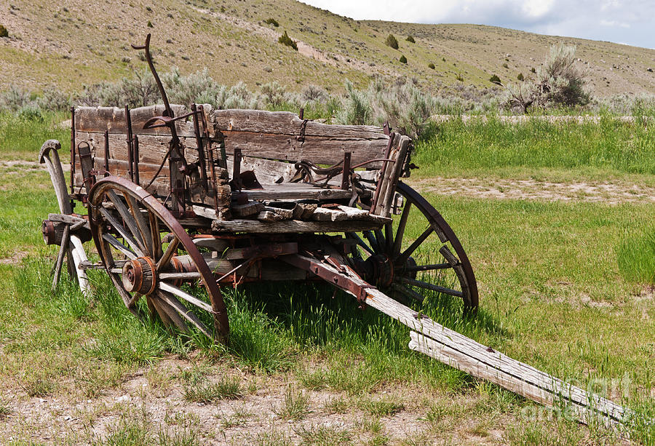
http://fineartamerica.com/featured/dilapidated-wagon-with-leaning-wheels-sue-smith.html

Attention:
Your journey has ended. Please write on your answer sheet the reason why your journey was unsuccessful. Afterwards, trade the last envelope that you have for envelope 13. Read what you missed out on and answer the remaining questions.

ENVELOPE 11A

You shakily take out the gold nugget from your pocket and toss it to the vaquero. He examines it for a second, looks up at you and smiles. He yells something in Spanish to the other vaquero, who rides up to you on the other side of the wagon. He pulls a rolled up piece of paper out of his saddle bag and tosses it to you. The first vaquero points towards the Northwest, and yells, “Que manera de oro!” Later on, you will learn that this means, the golden way!

The scroll that was given to you is a map, showing you how to get to California via the Spanish Trail. This resource will help you greatly in your journey to San Francisco.

You continue your journey to California full of hope, with uncommon health, food and a sense of pride in your decisions. A few days later, you and your family see some wagons, halted on the horizon in the distance. As you approach the wagons, you notice that there are several graves on either side of the wagon trail. As you get closer to the wagons, you see a couple of coyotes scamper off into the brush. The wagons are quit and there is no sign of life. As you pass through the eerie scene, you see a dead body hunched over an old dirty mattress. You tell your children to not look, and you pick up the pace, hoping to escape this scene. As you pass through, a few more bodies are seen. All of them dead. There are no signs of foul play, and you wonder what has happened here.
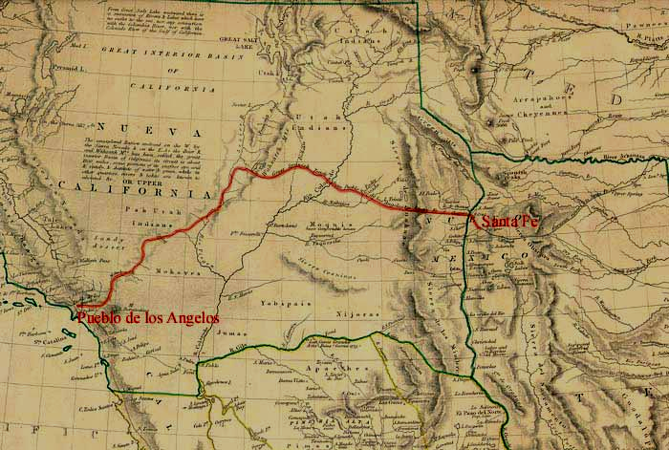http://freepages.genealogy.rootsweb.ancestry.com/~wallner/mapold_spanish.htm
Read the passage and the primary sources below. This will help you understand better how hard the life for a settler was.
http://www.apcrp.org/BLOCK_KATHY/FRANCONIA/Franconia_Writeup.htm
Cholera
Perhaps the biggest problem on the Trail was a mysterious and deadly disease--called cholera for which there was no cure. Often, an emigrant would go from healthy to dead in just a few hours. Sometimes they received a proper burial, but often, the sick would be abandoned, in their beds, on the side of the trail. They would die alone. Making matters worse were animals that regularly dug up the dead and scattered the trail with human bones and body parts.
Settler Agnes Stewart:
"We camped at a place where a woman had been buried and the wolves dug her up. Her hair was there with a comb still in it. She had been buried too shallow. It seems a dreadful fate, but what is the difference? One cannot feel after the spirit is flown."
Cholera killed more emigrants than anything else. In a bad year, some wagon trains lost two-thirds of their people.
Settler John Clark:
"One woman and two men lay dead on the grass and some more ready to die. Women and children crying, some hunting medicine and none to be found. With heartfelt sorrow, we looked around for some time until I felt unwell myself. Got up and moved forward one mile, so as to be out of hearing of crying and suffering." From: http://oregontrail101.com/Hardships.html
30. On the westward trail, what killed more settlers than anything else? Describe in your own words your experience as a settler with cholera. Write your description it as if you were one of the settlers being quoted above.

Trade this envelope in for Envelope 12.

ENVELOPE 11B

You look into the eyes of the vaquero, and lie to him. “No Oro!”
The vaquero cocks his gun, and motion to his partner to get on the wagon. You hear your family screaming, so you quickly reach down and grab your rifle. As you turn back to shoot the raiding man, the vaquero on the horse, fires his gun.
You feel a sharp pain in your back. You whip around to shoot the man on the horse, but another shot is fired. Your ears are ringing, and you lose sensation in your body. The rifle drops from your hands and the screams of your family fades away.

On this trip, one bad decision can cost you your life. This was the way of the wagon trail. Being killed by indigenous people was just one fate of many settlers; however, there were other ways that settlers died on this journey.

Read the passage and the primary sources below. This will help you understand better how hard the life for a settler was.
http://www.apcrp.org/BLOCK_KATHY/FRANCONIA/Franconia_Writeup.htm
Cholera
Perhaps the biggest problem on the Trail was a mysterious and deadly disease--called cholera for which there was no cure. Often, an emigrant would go from healthy to dead in just a few hours. Sometimes they received a proper burial, but often, the sick would be abandoned, in their beds, on the side of the trail. They would die alone. Making matters worse were animals that regularly dug up the dead and scattered the trail with human bones and body parts.
Settler Agnes Stewart:
"We camped at a place where a woman had been buried and the wolves dug her up. Her hair was there with a comb still in it. She had been buried too shallow. It seems a dreadful fate, but what is the difference? One cannot feel after the spirit is flown."
Cholera killed more emigrants than anything else. In a bad year, some wagon trains lost two-thirds of their people.
Settler John Clark:
"One woman and two men lay dead on the grass and some more ready to die. Women and children crying, some hunting medicine and none to be found. With heartfelt sorrow, we looked around for some time until I felt unwell myself. Got up and moved forward one mile, so as to be out of hearing of crying and suffering." From: http://oregontrail101.com/Hardships.html
32. On the westward trail, what killed more settlers than anything else? Describe in your own words your experience as a settler with cholera. Write your description it as if you were one of the settlers being quoted above.

This was unfortunately the fate of many settlers heading west. Some, however, had it worse than others:

From November 20, 1846 to March 1, 1847, Irish immigrant Patrick Breen, a Donner party member, kept a diary of his ordeal in the mountains. Clinging to survival with his wife Margaret and their seven children, Breen described the harsh winter weather, the leather hides they resorted to eating, and the deaths of their traveling companions.
As spring approached, rescuers made their way to the Donner party’s mountain encampment. By March, Breen and his family were safely at Sutter’s Fort in California. All seven children and both parents had survived. Baby Isabella, who remembered nothing of the ordeal, lived until 1935, the last survivor of the Donner party.

“came to this place on the 31st of last month that it snowed we went on to the pass the snow so deep we were unable to find the road, when within 3 miles of the summit then turned back to this shanty on the Lake, Stanton came one day after we arriveed here we again took our teams & waggons & made another unsuccessful attempt to cross in company with Stanton we returned to the shanty it contiuneing to snow all the time we were here we now have killed most part of our cattle having to stay here untill next spring & live on poor beef without bread or salt”
— November 20, 1846
“still snowing now about 3 feet deep…killed my last oxen today will skin them tomorrow gave another yoke to Fosters hard to get wood” — November 29, 1846
“... shot Towser today & dressed his flesh Mrs Graves came here this morning to borrow meat dog or ox they think I have meat to spare but I know to the Contrary they have plenty hides I live principally on the same”
— February 23, 1847
“... The Donnos told the California folks that they commence to eat the dead people 4 days ago, if they did not succeed that day or the next in finding their cattle then under ten or twelve feet of snow…”
— February 26, 1847
“... there has 10 men arrived this morning from bear valley with provisions we are to start in two or three days & Cash our goods here there is amongst them some old they say the snow will be here untill June”
- What are the 4 things that the Donner party resorted to eating after they got stuck in the snow? If you were part of this wagon train, would you have eaten these things? Why or why not?

Unfortunately, your attempt to get to California ends here. You will never be able to gaze upon the west coast, and hold nuggets of gold in your hand. You will instead die penniless, hungry and alone on your journey westward.
http://fineartamerica.com/featured/dilapidated-wagon-with-leaning-wheels-sue-smith.html
Attention:
Your journey has ended. Please write on your answer sheet the reason why your journey was unsuccessful. Afterwards, trade the last envelope that you have for envelope 13. Read what you missed out on and answer the remaining questions.

ENVELOPE 12

Although diseases caused a fatality rate amongst settlers heading westward, many other travelers succumbed to different fates. Many died due to confrontations with indigenous peoples, while others faced some of Mother Nature’s harshest conditions:

From November 20, 1846 to March 1, 1847, Irish immigrant Patrick Breen, a Donner party member, kept a diary of his ordeal in the mountains. Clinging to survival with his wife Margaret and their seven children, Breen described the harsh winter weather, the leather hides they resorted to eating, and the deaths of their traveling companions.
As spring approached, rescuers made their way to the Donner party’s mountain encampment. By March, Breen and his family were safely at Sutter’s Fort in California. All seven children and both parents had survived. Baby Isabella, who remembered nothing of the ordeal, lived until 1935, the last survivor of the Donner party.

“came to this place on the 31st of last month that it snowed we went on to the pass the snow so deep we were unable to find the road, when within 3 miles of the summit then turned back to this shanty on the Lake, Stanton came one day after we arriveed here we again took our teams & waggons & made another unsuccessful attempt to cross in company with Stanton we returned to the shanty it contiuneing to snow all the time we were here we now have killed most part of our cattle having to stay here untill next spring & live on poor beef without bread or salt”
— November 20, 1846
“still snowing now about 3 feet deep…killed my last oxen today will skin them tomorrow gave another yoke to Fosters hard to get wood” — November 29, 1846
“... shot Towser today & dressed his flesh Mrs Graves came here this morning to borrow meat dog or ox they think I have meat to spare but I know to the Contrary they have plenty hides I live principally on the same”
— February 23, 1847
“... The Donnos told the California folks that they commence to eat the dead people 4 days ago, if they did not succeed that day or the next in finding their cattle then under ten or twelve feet of snow…”
— February 26, 1847
“... there has 10 men arrived this morning from bear valley with provisions we are to start in two or three days & Cash our goods here there is amongst them some old they say the snow will be here untill June”
- What are the 4 things that the Donner party resorted to eating after they got stuck in the snow? If you were part of this wagon train, would you have eaten these things? Why or why not?

As you follow the map west from New Mexico territory and then north from San Diego, you and your family relish in the California sun. You feel accomplished and proud of the decisions that you made. This was a tough journey, but you have fortunately been blessed with the luck of your cousin, whom you hope to see soon.
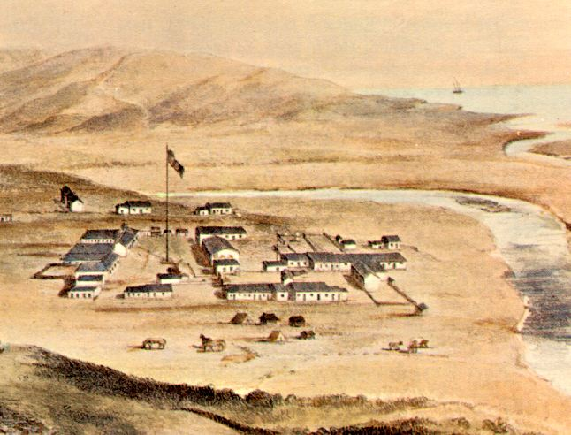
http://www.sandiegohistory.org/timeline/timeline1.htm

You are almost there! Trade in this envelope for envelope 13.

ENVELOPE 13

You and your family find a stream of wagons all heading for San Francisco from Los Angeles. You find comfort and solace in the fact that you have almost made it, and you are now surrounded by hundreds of other settlers and their families, looking to make it rich in the gold mines in northern California. As you slowly move north, you wonder about how many have made this journey.

Read the following excerpts and answer the questions below.

The Gold Rush was the largest mass migration in U.S. history.
In March 1848, there were roughly 157,000 people in the California territory; 150,000 Native Americans, 6,500 of Spanish or Mexican descent known as Californios and fewer than 800 non-native Americans. Just 20 months later, following the massive influx of settlers, the non-native population had soared to more than 100,000. And the people just kept coming. By the mid 1850s there were more than 300,000 new arrivals—and one in every 90 people in the United States was living in California. All of these people (and all of this money) helped fast track California to statehood. In 1850, just two years after the U.S. government had purchased the land, California became the 31st state in the Union. http://www.history.com/news/8-things-you-may-not-know-about-the-california-gold-rush

34. (for some of you this will be #35) What percentage of the California population was non-Californians in 1848? What percentage of the population was non-Californians in 1850?

Congratulations! You reached the bay area, and are amazed at the amount of people that are here. You stop on a hill just outside of San Francisco and gaze down at the bustling streets and the thousands upon thousands of miners and settlers scurrying about. Draw a picture on your map, somewhere in Northern California, of what you think San Francisco looked like from atop this hill.

Early sections of San Francisco were built out of ships abandoned by prospectors.
The Gold Rush conjures up images of thousands of “’49ers” heading west in wagons to strike it rich in California, but many of the first prospectors actually arrived by ship—and few of them had a return ticket. Within months, San Francisco’s port was teeming with boats that had been abandoned after their passengers—and crew—headed inland to hunt for gold. As the formerly tiny town began to boom, demand for lumber increased dramatically, and the ships were dismantled and sold as construction material. Hundreds of houses, banks, saloons, hotels, jails and other structures were built out of the abandoned ships, while others were used as landfill for lots near the waters edge. Today, more than 150 years after the Gold Rush began, archeologists and preservations continue to find relics, sometimes even entire ships, beneath the streets of the City by the Bay. http://www.history.com/news/8-things-you-may-not-know-about-the-california-gold-rush

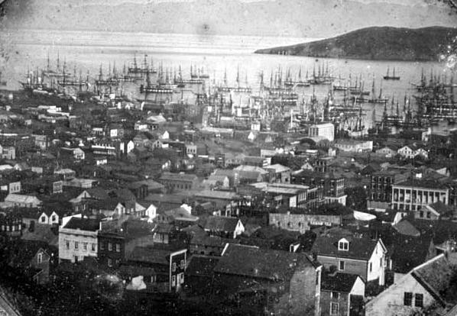
http://www.old-picture.com/daguerreotypes/Francisco-1850-San.htm

35 (36). What materials were many of early San Francisco’s buildings built from? What are portions of San Francisco’s down town area built upon? What is the reasoning behind this?

As the boom continued, more and more men got out of the gold-hunting business and began to open businesses catering to newly arrived prospectors. In fact, some of America’s greatest industrialists got their start in the Gold Rush. Phillp Armour, who would later found a meatpacking empire in Chicago, made a fortune operating the sluices that controlled the flow of water into the rivers being mined. Before John Studebaker built one of America’s great automobile fortunes, he manufactured wheelbarrows for Gold Rush miners. And two entrepreneurial bankers named Henry Wells and William Fargo moved west to open an office in San Francisco, an enterprise that soon grew to become one of America’s premier banking institutions. One of the biggest mercantile success stories was that of Levi Strauss. A German-born tailor, Strauss arrived in San Francisco in 1850 with plans to open a store selling canvas tarps and wagon coverings to the miners. After hearing that sturdy work pants—ones that could withstand the punishing 16-hour days regularly put in by miners—were more in demand, he shifted gears, opening a store in downtown San Francisco that would eventually become a manufacturing empire, producing Levi’s denim jeans. http://www.history.com/news/8-things-you-may-not-know-about-the-california-gold-rush

36 (37). List 3 businesses that sprung up from the gold rush of 1849 in San Francisco. Why were these businesses so successful?

Most of the men who flocked to northern California arrived with little more than the clothes on their backs. Once there, they needed to buy food, goods and supplies, which San Francisco’s merchants were all too willing to provide—for a cost. Stuck in a remote region, far from home, many prospectors coughed up most of their hard-earned money for the most basic supplies. At the height of the boom in 1849, prospectors could expect prices sure to cause sticker shock: A single egg could cost the equivalent of $25 in today’s money, coffee went for more than $100 per pound and replacing a pair of worn out boots could set you back more than $2,500.

37 (38). What caused this massive inflation of prices? What impacts do you think this had on the miner’s success rate of “striking it rich?”

Because of this economic situation in San Francisco, many miners, who had come to California to become rich, found that any luck they had in the hills was spent on survival. After the gold mines “dried up” many settlers decided to stay in California. Some, however, decided to try their luck at farming the very plains that they rode across a few short years ago. Read page 275 and answer the last questions on this long and exciting journey that you have endured.

38 (39). What did the Homestead Act do, and how did it change the demographics of the western United States?

39 (40). List and describe 3 innovations in farming that came about in the 1860’s. In what situations did these help farmers succeed?

40 (41). Now that your journey is over, you have learned a great deal about the hardships of settling the west. Now it is your turn to write a letter to a relative back east, describing and reflecting on your journey. Were you successful? If not, why did you fail? Would you recommend making this trip to a family member back east? Why or why not? Make sure that you include details of your journey and any thoughts or feelings that are relevant.

