Common Core State Standards for Mathematics
There are Standards for Mathematical Practice that are skills that are necessary for any mathematics course. Mathematically Proficient Students should be able to
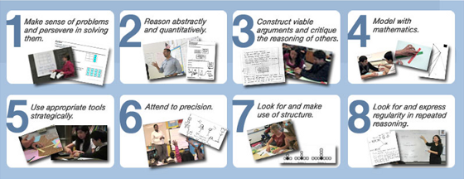
Every subject area in mathematics has its own content standards. Content Standards for Algebra One:
Unit 1: Patterns
Unit 2: Linear Equations and Inequalities
Unit 3: Functions
Unit 4: Linear Functions
Unit 5: Scatter Plots and Trend Lines (working with univariate and bivariate data)
Unit 6: Systems of Linear Equations
Unit 7: Introduction to Exponential Functions
Unit 8: Quadratic Functions and Equations

For more detailed information on these content standards, go the welcome page of my website and scroll down to Common Core Standards.

