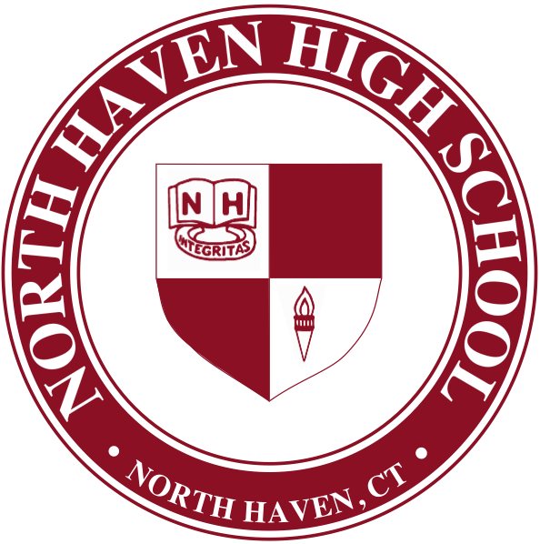

RUSSELL J. DALLAI, Ed.D.

*Principal*

CHRISTOPHER MCLAUGHLIN

*Assistant Principal*

ANDREW A. PETTOLA

*Assistant Principal*

NORTH HAVEN

221 Elm Street • North Haven, CT 06473-3251

HIGH SCHOOL

Telephone (203) 239-1641 • Fax (203) 234-7436

SANDRA M. PRENETA

*Assistant Principal*

*North Haven Public Schools Vision: As a result of their experience in the North Haven Public Schools, every student will acquire the skills necessary to meet the demands of the twenty-first century.*

Dear Parent/Guardian:

The North Haven School District is pleased to provide all students in grades 6-12 access to Microsoft Office 365 for Education.

Office 365 provides the potential to improve the way our staff and students create, share and collaborate with each other. Microsoft Office 365 for Education will provide students anytime, anywhere access to the Microsoft Office Web Apps for Word, PowerPoint, Excel, and OneNote, as well as One Drive for document storage, and the Outlook Email Web App in a “closed campus” email environment, which means that students will only be able to send or receive emails with-in our District’s email domain (@north-haven.k12.ct.us).

In order to log in to Microsoft Office 365 for Education, students will need to point their browser to:

<http://portal.microsoftonline.com>

The student’s username/email address will be his/her last name followed immediately by the first name. The password will be the student’s entire ID number (same a s lunch PIN code) until updated or changed.

If you do not want your child to be assigned a Microsoft 365 account as discussed above, please return this form no later than November 10, 2016. If we do not receive this back, your student will automatically be assigned an account. Please further understand that at any time, you can ask for your child’s account to be removed by submitting a request in writing.

Please do not assign my student a Microsoft 365 account for the 2016-2017 school year.

Students Name \_\_\_\_\_\_\_\_\_\_\_\_\_\_\_\_\_\_\_\_\_\_\_\_\_\_\_\_\_\_\_\_\_\_\_\_\_\_\_\_\_\_\_\_\_\_\_\_\_\_\_\_\_\_\_\_\_\_\_\_\_\_\_\_\_\_\_\_\_\_\_\_\_ Grade \_\_\_\_\_\_\_\_\_\_\_

Parent/Guardian’s signature \_\_\_\_\_\_\_\_\_\_\_\_\_\_\_\_\_\_\_\_\_\_\_\_\_\_\_\_\_\_\_\_\_\_\_\_\_\_\_\_\_\_\_\_\_\_\_\_\_\_\_\_\_\_ Date \_\_\_\_\_\_\_\_\_\_\_\_\_\_\_\_\_\_\_\_\_\_\_\_

Sincerely,

Russ Signature Small.tiff

Russell J. Dallai, Ed.D.

Principal

Student_Office%20365%20Directions.pdf