Non-Objective Painting
Student Learning:
- Students can understand the difference between realistic, abstract, and non-objective artwork.
- Students can create a non-objective work of art using elements and principles of art and through application of painting techniques.
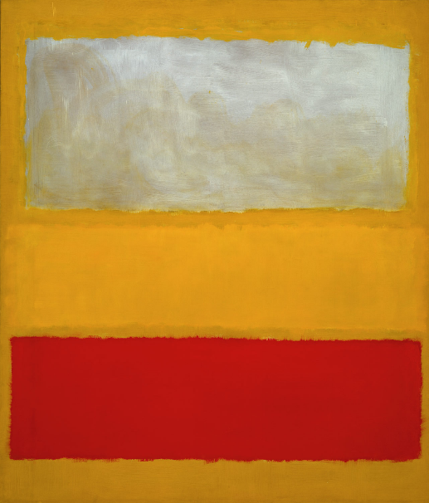
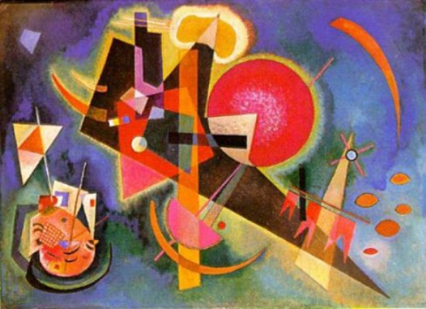
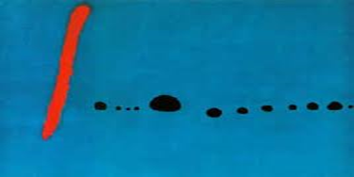

Kandinsky In Blue 1925
Josef Albers Homage To The Square With Rays 1959
Miro Bleu II 1961
Jackson Pollock’s Grayed Rainbow 1953
Mark Rothko Untitled Number 13 White, Red on Yellow

National Core Arts Standards:
Creating:
Anchor Standard 1: Generate and conceptualize artistic ideas and work.
VA:Cr.1.1. 7a: Apply methods to overcome creative blocks.
VA:Cr.1.1. 8a: Document early stages of the creative process visually and/or verbally in traditional or new media.
Anchor Standard 2: Organize and develop artistic ideas and work.
VA:Cr.2.1.7a: Demonstrate persistence in developing skills with various materials , methods, and approaches in creating works of art or design.
VA:Cr.2.1.8a: Demonstrate willingness to experiment, innovate, and take risks to pursue ideas, forms, and meanings that emerge in the process of art-making or designing.
VA:Cr.2.3.7a: Apply visual organizational strategies to design and produce a work of art, design, or media that clearly communicates information or ideas.
VA:Cr.2.3.8a: Select, organize, and design images and words to make visually clear and compelling presentations.
Anchor Standard 3: Refine and complete artistic work.
Presenting:
Anchor Standard 5: Develop and refine artistic techniques and work for presentation.
Responding:
Anchor Standard 7: Perceive and analyze artistic work.
VA:Re.7.2.7a: Analyze multiple ways that images influence specific audiences.
VA:Re.7.2.8a: Compare and contrast contexts and media in which viewers encounter images that influence ideas, emotions, and actions.
Anchor Standard 8: Interpret intent and meaning in artistic work.
VA:Re.8.1.7a: Interpret art by analyzing art-making approaches, the characteristics of form and structure, relevant contextual information, subject matter, and use of media to identify ideas and mood conveyed.
VA:Re.8.1.8a: Interpret art by analyzing how the interaction of subject matter, characteristics of form and structure, use of media, art-making approaches, and relevant contextual information contributes to understanding messages or ideas and mood conveyed.
Anchor Standard 9: Apply criteria to evaluate artistic work.
Connecting:
Anchor Standard 10: Synthesize and relate knowledge and personal experiences to making art.

Student Learning Plan:

Φ= There is a video or another resource available on my website for this step.
Student  signs | Teacher  signs | Step | Task | Why?
 |  | 1.  2. | Participate in an introduction to the lesson through a PowerPoint presentation contrasting realistic, abstract, and non-objective paintings  Work collaboratively to classify a work of art as realistic, abstract, or non-objective  Φ: PowerPoint available online on my site  Collaborative index card response:  5 points | - Students can understand the difference between realistic, abstract, and non-objective artwork.  Responding:  Anchor Standard 7: Perceive and analyze artistic work.  VA:Re.7.2.7a: Analyze multiple ways that images influence specific audiences.  VA:Re.7.2.8a: Compare and contrast contexts and media in which viewers encounter images that influence ideas, emotions, and actions.  Anchor Standard 9: Apply criteria to evaluate artistic work.
 |  | 3. | Review the definition of non-objective art and discuss and analyze the images in the PowerPoint to determine how the elements and principles are used and any expressive properties of the paintings  - Line  - Shape  - Color  - Rhythm  - Unity  - Emphasis- rule of thirds focal point  Φ: PowerPoint available online on my site | Responding:  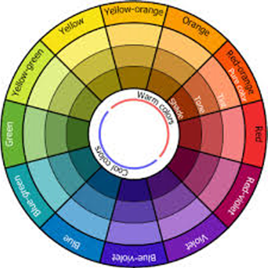  Anchor Standard 9: Apply criteria to evaluate artistic work.

 |  | 4. | Technique Sampler:  Students will experiment with painting techniques  20 points  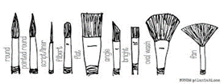  Φ: technique video demonstrations available online on my site | 1-emerging 2-progressing 3-meeting goal 4-exceeding goal  Creating:  Anchor Standard 1: Generate and conceptualize artistic ideas and work.  VA:Cr.1.1. 7a: Apply methods to overcome creative blocks.  VA:Cr.1.1. 8a: Document early stages of the creative process visually and/or verbally in traditional or new media.

 |  |  |  | 5. |  | Planning Worksheet:  Artist’s Intention  Decide on a focus-intent for a non-objective painting and complete a planning worksheet selecting a focus of a specific mood or a focus on a specific element of art and principle of design  Planning worksheet:  20 points |  | Check in with someone at your table to get a peer’s take on your plan. Have them sign their initials here ______  2 points  Creating:  Anchor Standard 2: Organize and develop artistic ideas and work.  VA:Cr.2.1.7a: Demonstrate persistence in developing skills with various materials , methods, and approaches in creating works of art or design.  VA:Cr.2.1.8a: Demonstrate willingness to experiment, innovate, and take risks to pursue ideas, forms, and meanings that emerge in the process of art-making or designing.
 |  |  |  | 6. |  | Process:  Work on non-objective painting |  | - Students can create a non-objective work of art using elements and principles of art and through application of painting techniques.  VA:Cr.2.3.7a: Apply visual organizational strategies to design and produce a work of art, design, or media that clearly communicates information or ideas.  VA:Cr.2.3.8a: Select, organize, and design images and words to make visually clear and compelling presentations.  Presenting:  Anchor Standard 5: Develop and refine artistic techniques and work for presentation.
 |  |  | 7. |  | Non Objective Painting - Peer Critique:  Work collaboratively with a peer to offer positive constructive input  10 points |  | 1-emerging 2-progressing 3-meeting goal 4-exceeding goal  For a “4”- the responses should show thoughtful, positive constructive comments using art vocabulary with clarity and accuracy.

 |  | 8. | Refine and Complete artwork | 1-emerging 2-progressing 3-meeting goal 4-exceeding goal  Anchor Standard 3: Refine and complete artistic work.  Read comments from peer and list something that you will do to refine your work here  _____________________________________________________________  5 points

 |  | 9. | Art History Criticism Activity:  Select an art history reference work of non-objective art to describe, analyze, interpret, and judge.  10 points | Responding:  Anchor Standard 8: Interpret intent and meaning in artistic work.  VA:Re.8.1.7a: Interpret art by analyzing art-making approaches, the characteristics of form and structure, relevant contextual information, subject matter, and use of media to identify ideas and mood conveyed.  VA:Re.8.1.8a: Interpret art by analyzing how the interaction of subject matter, characteristics of form and structure, use of media, art-making approaches, and relevant contextual information contributes to understanding messages or ideas and mood conveyed
 |  | 10. | Self-assess and compare and contrast finished student artwork to student-selected art historical work.  Painting: 100 points  Self-assessment:20 points | 1-emerging 2-progressing 3-meeting goal 4-exceeding goal  See attached rubric and self-assessment questions  Responding:  Anchor Standard 9: Apply criteria to evaluate artistic work.  Connecting:  Anchor Standard 10: Synthesize and relate knowledge and personal experiences to making art.

Non-objective Painting Assessment

- Understand the difference between realistic, abstract, and non-objective artwork

Part 1: Using images from the textbook or in the classroom- find one strong example to represent realistic, abstract, and nonobjective. For each one include a quick sketch of the composition, identifying information (title, artist, page number or location) and a brief reason to support your choices.

- Realistic _____________________________________
_____________________________________
because _____________________________________

- Abstract______________________________________
_______________________________________
because _________________________________________

- Nonobjective____________________________________
____________________________________
because _____________________________________

- Create a non-objective work of art effectively communicating artist’s intent of formalist or expressive using elements and principles of art and through application of painting techniques-
Assess your nonobjective painting:

Intention:
Did you choose to focus more on a formalist intent (designs and use of art elements and principles) or emotionalist/expressive through your design and painting techniques. Explain your answer citing visual evidence from your painting.
___________________________________________________________________________________________________________________________________________________________________________________________________________________________________________________________________________________________________________________________________________________________________

Nonobjective painting | 1  (emerging) | 2  (progressing) | 3  (meeting goal) | 4  (exceeding goal)
Criteria:  Intention and application in painting  Meets criteria:  Focal point uses rule of thirds for placement | The intention and the painting are not clearly connected or they may be incomplete.  Focal point is either unclear or placed inaccurately using the rule of thirds. | There is some inconsistency between the student’s stated intent and the painting.  Focal point is either not clear or is off in its placement based on the rule of thirds. | Student has communicated the intention of the painting and the painting satisfies the expectations.  Focal point uses rule of thirds for placement. | Student has skillfully articulated the intention of the painting and the painting exceeds intentions.  Focal point uses rule of thirds for placement and is obvious.
Creativity:  Innovative solutions in composition,  color selections,  use of painting techniques to support intention | Painting little evidence of a creative solution in the use of color, composition, or painting techniques. | Painting shows some evidence of a creative solution in the use of color, composition, or painting techniques. | Painting shows unique solutions in use of color, composition, or painting techniques. | Painting shows innovative solutions in composition, use of color, and painting techniques to support student’s intention.
Craftsmanship:  Control with paint media | Minimal control / effort in painting craftsmanship | Inconsistent painting craftsmanship | Good painting craftsmanship | Excellent painting craftsmanship
Due date  / /2016 | ½ done for  / /2016 | ¾ to almost complete for  / /2016 | Completed project for  / /2016 | Completed with attached rubric and questions for  / /2016

- Create a Venn diagram comparing your painting to the work of art you focused on in the art criticism activity. What are three things in common and three that are different. Try to come up with original and unique answers.

