**Planning worksheet for non-objective painting:**

**Artist’s intention**

Objective:

* Create a non-objective work of art effectively communicating artist’s intent of

formalist or expressive

using elements and principles of art: line, shape, color , emphasis/focal point, unity, rhythm

and

through application of painting techniques-

**Artist’s Intention:**

Will you choose to focus more on a formalist intent or expressive through your use of design (line, shape, color, rule of thirds focal point, rhythm, unity)

and

through application of painting techniques.

Explain how you will do this in your painting:

___________________________________________________________________________________________________________________________________________________________________________________________________________________________________________________________________________________________________________________________________________________________________

1. How will you use line to achieve your intent?

Which kind of line will you focus on and why?

5 types of line (vertical, horizontal, curved, zig-zag, diagonal)

______________________________________________________________________________________________________________________________________________________________________________________________________________________________

1. How will you use shape to achieve your intent?

Which kind of shapes- geometric or free-form/organic will you focus on to achieve your intent and why?

______________________________________________________________________________________________________________________________________________________________________________________________________________________________

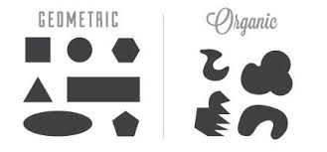

1. What colors will you use to achieve your intent and why?

____________________________________________________________________________________________________________________________________________________

1. How will you place your focal point using the rule of thirds to make the viewer look here first?

______________________________________________________________________________________________________________________________________________________________________________________________________________________________

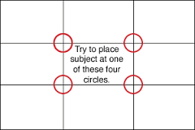

**Rule of Thirds**

**Placement of Focal Point**

1. Look at your painting technique practice worksheet. What painting techniques will help you achieve your intent and why?

______________________________________________________________________________________________________________________________________________________________________________________________________________________________

1. How will you create a visual rhythm? How will you use rhythm to achieve your intent?

______________________________________________________________________________________________________________________________________________________________________________________________________________________________

**Rhythm:** the principle of design that repeats elements to create the illusion of movement**-** Visual rhythm is perceived through the eyes and is created by repeating positive spaces separated by negative spaces.

There are five types (listed below):

* Regular: Visual rhythm achieved through repeating identical motifs using the same intervals of space between them.
* Alternating: Visual rhythm set up by repeating motifs, but changing position or content of motifs, or spaces between them:
* Progressive: Visual rhythm that gradually changes a motif each time it is repeated.
* Flowing: Visual rhythm created by repeating wavy lines.
* Random: Visual rhythm in which a motif is repeated in no apparent order, with no regular spaces.

1. How will you create unity in your painting? (Unity is what holds together the whole painting. Sometimes a kind of line, shape or color that is repeated can achieve unity. )

______________________________________________________________________________________________________________________________________________________________________________________________________________________________