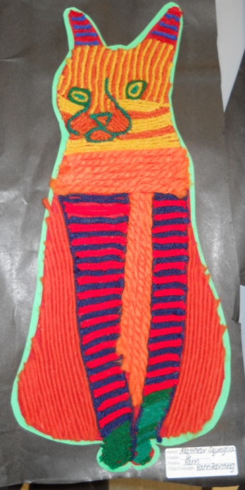
Yarn Paintings inspired by the Huichol People
Student Learning:
- Students can understand the distinction between Fine Art and Folk Art with consideration given to the purpose for creating art and the materials that are used to create art.
- Students can demonstrate an understanding of how yarn paintings are made using stylized/simplified animals as subjects and the application of pattern and creation of unity.
- Students can explain the aesthetic view of formalism.
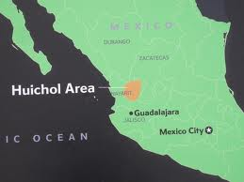
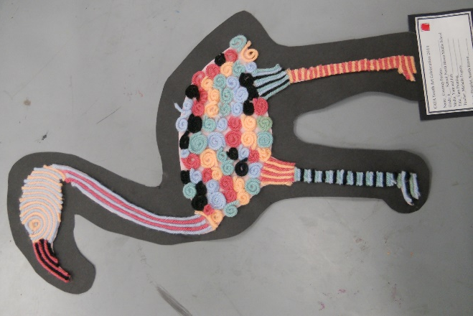
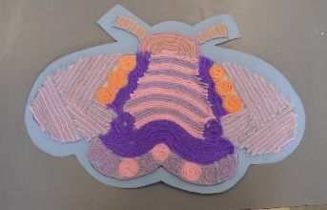

Cat- student work- Matthew Squeglia
Bee-student work -Tessa
Map
Flamingo- student work- Courtney Perfetto
Nearika -Huichol People

National Core Arts Standards: 6th grade
Creating:
Anchor Standard 1: Generate and conceptualize artistic ideas and work.
VA:Cr.1.1. 6a: Combine concepts collaboratively to generate innovative ideas for creating art.
Anchor Standard 2: Organize and develop artistic ideas and work.
VA:Cr.2.1.6a: Demonstrate openness in trying new ideas, materials, methods, and approaches in making works of art and design.
Anchor Standard 3: Refine and complete artistic work.
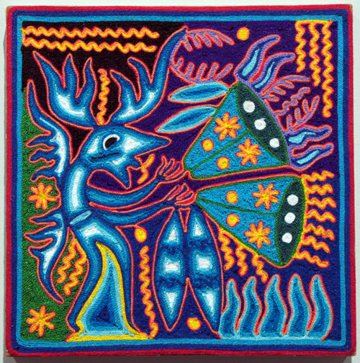
VA:Cr.3.1.6a: Reflect on whether personal artwork conveys the intended meaning and revise accordingly.
Presenting:
Anchor Standard 5: Develop and refine artistic techniques and work for presentation.
VA:Pr.5.1.6a: Individually or collaboratively, develop a visual plan for displaying works of art, analyzing exhibit space, the needs of the viewer, and the layout of the exhibit.
Responding:
Anchor Standard 7: Perceive and analyze artistic work.
VA:Re.7.1. 6a: Identify and interpret works of art or design that reveal how people live around the world and what they value.
VA:Re.7.2.6a: Analyze ways that visual components and cultural associations suggested by images influence ideas, emotions, and actions.
Anchor Standard 9: Apply criteria to evaluate artistic work.
VA:Re.9.1.6a: Develop and apply relevant criteria to evaluate a work of art.

Vocabulary:
- Yarn Painting: brightly colored paintings made with beeswax and strips of yarn by the Huichol Indians
- Folk Art: art created by peasants or common people reflecting the lifestyle or customs of a specific group or region
- Line: diagonal, vertical, horizontal, zigzag, curved
- Stylized: descriptive of works based on forms in the natural world, but simplified or distorted for design purposes
- Pattern: 2-D decorative visual repetition
- Real Texture: texture that can be perceived through touch
- Geometric Shapes: precise shapes that can be described using mathematical formulas. Basic shapes include circles, squares, triangles, and so forth.
- Freeform Shapes: also called organic shapes. Irregular, uneven shapes. Examples of freeform shapes are in ink drop and object’s shadow.
- Unity: The quality of wholeness or oneness that is achieved through the effective use of the elements and principles of design. Unity can be achieved through simplicity, harmony, repetition, proximity, and continuation.
- Formalism: aesthetic theory of art that emphasizes the design qualities that appear in the subject of the work. Some critics think that the most important factor in a work of art is the composition; they evaluate the arrangement of the elements of art using the principles of design.

Student Learning Plan:

Φ= There is a video or another resource available on my website for this step.
Student  signs | Teacher  signs | Step | Task | Why?
 |  | 1. | Students will actively participate in a PowerPoint presentation that introduces the ideas of Fine Art compared with Folk Art.  Students will examine the artwork of the Huichol Indians of Mexico and learn about the requirements of the project.  Φ: PowerPoint available online on my site | - Students can understand the distinction between Fine Art and Folk Art with consideration given to the purpose for creating art and the materials that are used to create art.  Responding:  Anchor Standard 7: Perceive and analyze artistic work.  VA:Re.7.1. 6a: Identify and interpret works of art or design that reveal how people live around the world and what they value.  VA:Re.7.2.6a: Analyze ways that visual components and cultural associations suggested by images influence ideas, emotions, and actions.  Anchor Standard 9: Apply criteria to evaluate artistic work.  VA:Re.9.1.6a: Develop and apply relevant criteria to evaluate a work of art.
 |  | 2. | Pattern Planning Worksheet:  Students will participate in a review of the PowerPoint and learn more about yarn paintings through class discussion and viewing an authentic yarn painting.  Students will review vocabulary.  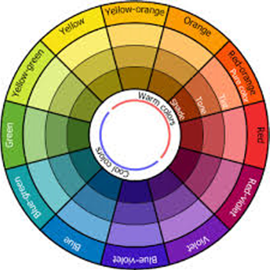  Students review the requirements of the project.  - Created a large, stylized animal  - Created unity  - Used 5 different yarns  - Color scheme is either warm or cool + neutral  - Created 3 or more patterns  - Smooth edges of the felt and mat  - No evidence of glue  - Little to no felt showing  - Yarn is adhered well and lays flat  - Original, one-of-a-kind patterns  - Application of yarn is varied/unique  - The animal is stylized in a unique way  - Students will begin and complete the pattern planning sheet.  Φ: Planning sheet will be distributed in class- a copy is also available online on my site | - Students can brainstorm and generate ideas to use within an artwork.  - Students can plan ideas for artwork:  pattern idea sheet  Creating:  Anchor Standard 1: Generate and conceptualize artistic ideas and work.  VA:Cr.1.1. 6a: Combine concepts collaboratively to generate innovative ideas for creating art.  1-emerging 2-progressing 3-meeting goal 4-exceeding goal  Planning worksheet __________/20 points
 |  | 3. | Demonstration on how to create a stylized/simplified animal.  Students will draw a stylized animal (from a personal photo or a teacher photo)  show the teacher/gain approval,  draw onto drawing paper  and cut it out. | - Students will determine what simplified means by examining posted artwork. (Ragee Eegyvudluk, Cape Dorset Series, Untitled #3 & Innukjuakjuk Pudlat, Female Owl)  - Students can plan ideas for artwork:  rough draft that reflects their knowledge of pattern, shape, line, and unity and their application to a stylized/simplified  Responding:  Anchor Standard 7: Perceive and analyze artistic work.  VA:Re.7.1. 6a: Identify and interpret works of art or design that reveal how people live around the world and what they value.  VA:Re.7.2.6a: Analyze ways that visual components and cultural associations suggested by images influence ideas, emotions, and actions.  Anchor Standard 9: Apply criteria to evaluate artistic work.  VA:Re.9.1.6a: Develop and apply relevant criteria to evaluate a work of art.
 |  |  | Φ: demonstration video on creating a stylized/simplified animal | Teacher approval_______________________________

 |  | 4. | Rough Draft:  Students will determine how to create unity when applying pattern.  Students will watch a demonstration on how apply pattern to the rough draft of the stylized/simplified animal.  Students will add pattern and color to their rough drafts (using crayons and pencils).  Check in with someone at your table to get a peer’s take on your plan. Have them sign their initials here ______  2 points | 1-emerging 2-progressing 3-meeting goal 4-exceeding goal  - Students will understand how to create  artwork that is stylized/simplified.  Rough Draft should demonstrate the following  - Created a large, stylized animal (4 pts)  - Created unity (2 pts)  - Used 5 different colors to represent 5 yarns (2 pts)  - Color scheme is either warm or cool + neutral (4 pts)  - Created 3 or more patterns (4 pts)  - The animal is stylized in a unique way (4 pts)  Rough draft _____ 20 points

 |  |  |  | 5. |  | Yarn Painting:  Transfer rough draft on to felt and begin working in yarn.  Refine.  Observe other yarn paintings and try to get ideas for application of yarn.  Continue refining and working.  Complete Yarn Painting.  Φ: demonstration video on working on yarn painting |  | Anchor Standard 2: Organize and develop artistic ideas and work.  VA:Cr.2.1.6a: Demonstrate openness in trying new ideas, materials, methods, and approaches in making works of art and design.  Anchor Standard 3: Refine and complete artistic work.  VA:Cr.3.1.6a: Reflect on whether personal artwork conveys the intended meaning and revise accordingly.  Presenting:  Anchor Standard 5: Develop and refine artistic techniques and work for presentation.  VA:Pr.5.1.6a: Individually or collaboratively, develop a visual plan for displaying works of art, analyzing exhibit space, the needs of the viewer, and the layout of the exhibit.
 |  |  | 6. |  | Yarn Painting- Peer Critique:  Index card  Work collaboratively with a peer to offer positive constructive input  10 points |  | 1-emerging 2-progressing 3-meeting goal 4-exceeding goal  - Students can demonstrate an understanding of how yarn paintings are made using stylized/simplified animals as subjects and the application of pattern and creation of unity.  For a “4”- the responses should show thoughtful, positive constructive comments using art vocabulary with clarity and accuracy.  Anchor Standard 9: Apply criteria to evaluate artistic work.  VA:Re.9.1.6a: Develop and apply relevant criteria to evaluate a work of art.

 |  | 7. | Refine and Complete artwork | 1-emerging 2-progressing 3-meeting goal 4-exceeding goal  Anchor Standard 3: Refine and complete artistic work.  Read comments from peer and list something that you will do to refine your work here  _____________________________________________________________  5 points
 |  | 8. | Mat artwork  Φ: demonstration video on matting artwork for presentation | - Students can carefully prepare artwork for presentation  Presenting:  Anchor Standard 5: Develop and refine artistic techniques and work for presentation

 |  | 9. | Art History Criticism Activity:  Nearika & Yarn Painting Reading and Questions  30 points  Φ: reading and question files available on my website | - Students can understand why the Huichol People cre  create their artwork through the PowerPoint  presentation, class discussions and a  reading assignment.  Responding:  Anchor Standard 7: Perceive and analyze artistic work.  VA:Re.7.1. 6a: Identify and interpret works of art or design that reveal how people live around the world and what they value.  VA:Re.7.2.6a: Analyze ways that visual components and cultural associations suggested by images influence ideas, emotions, and actions.
 |  | 10. | Self-assess  Questions and Rubric  .  Yarn Painting: 100 points  Self-assessment:16 points | 1-emerging 2-progressing 3-meeting goal 4-exceeding goal  See attached rubric and self-assessment questions  Responding:  Anchor Standard 9: Apply criteria to evaluate artistic work.  Connecting:  Anchor Standard 10: Synthesize and relate knowledge and personal experiences to making art.

 |  | * | Bill Reid Formalist Drawing | Extension activity
 |  | * | Yarn weaving extension | Extension activity

Elements and Principles of Art:
Grade 6: Nearikas/Yarn Paintings Assessment Sheet
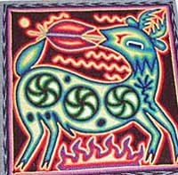

Directions: Answer the following questions using complete sentences.

- Is your yarn painting folk art or fine art? Explain why. (4 pts.)
________________________________________________________________________________________________________________________________________________________________________________________________________________________________________________________________________________________________________________________________________________________________________

- How does your yarn painting show unity?
Cite examples from your yarn painting to explain. (4 pts.)
________________________________________________________________________________________________________________________________________________________________________________________________________________________________________________________________________________________________________________________________________________

- What is something that is successful about your yarn painting? Explain why. (4 pts.)
________________________________________________________________________________________________________________________________________________________________________________________________________________________________________________________________________________________________________________________________________________________________________

- What is something that you think needs improvement or that you might have done differently from your yarn painting? Explain why. (4 pts.)
________________________________________________________________________________________________________________________________________________________________________________________________________________________________________________________________________________________________________________________________________________________________________

Please turn the paper over to complete the rubric on the back.

Circle the boxes that you feel best describes your artwork. If you would like to write any additional information you may use arrows and write your notes in the margin or attach a post-it note- make sure to initial the post-it
Animal Yarn Painting | 1-Emerging | 2-Nearly Proficient  Progressing | 3-Meeting Goal  Proficient | 4-Exceeding Goal  Exemplary
Craftsmanship  - Smooth edges of the felt and mat  - No evidence of glue  - Little to no felt showing  - Yarn is adhered well and lays flat | My artwork is a little neat. | My artwork is somewhat neat. | My artwork is neat. | My artwork is extremely neat.
Creativity  - Original, one-of-a-kind patterns  - Application of yarn is varied/unique  - The animal is stylized in a unique way | My artwork is a little creative. | My artwork is somewhat creative. | My artwork is creative. | My artwork is extremely creative.
Criteria  - Created a large, stylized animal  - Created unity  - Used 5 different yarns  - Color scheme is either warm or cool + neutral  - Created 3 or more patterns  - Covered the felt completely | I followed few of the directions. | I followed some of the directions. | I followed most of the directions. | I followed all of the directions.
Presentation of Artwork | I completed less than ½ of this artwork by the due date. | I completed about ½ to ¾ of the yarn painting by the due date. | I completed the yarn painting by the due date.  Date: | I completed the yarn painting and matted it by the due date and attached my self-assessment with my name on my work  Date:

