Organic Low Relief Cardboard Architecture: Requirements
Incorporate idea of organic architecture by creating a
- 1. “house/building” that fits its environment
- 2. looks like it uses natural materials from the location of the building
- 3. and the design reflects the building’s function/purpose
- Recycled paper materials: Use cardboard, chipboard, product boxes (soda can cardboard etc.), coffee cardboard sleeves, paper bags, foam core, newspaper, magazine, security envelopes, found paper (recycled notes, receipts, lists) and glue
- Show a foreground & background
- Apply good craftsmanship- cutting and gluing- no pencil/marker/pen should show-
Use text from magazine, newspaper, and product boxes carefully so logos and words do not distract from your design
- Demonstrate creative ideas in design and in use of the materials
- Base must be flat-cardboard-and 9” x 12”- your sculpture may extend beyond this size, but should not change the base dimensions

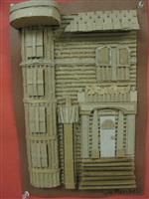
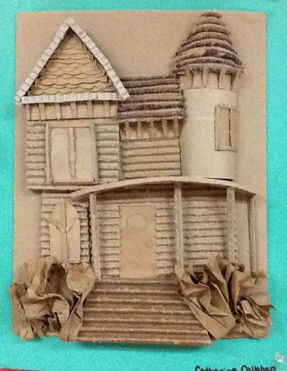
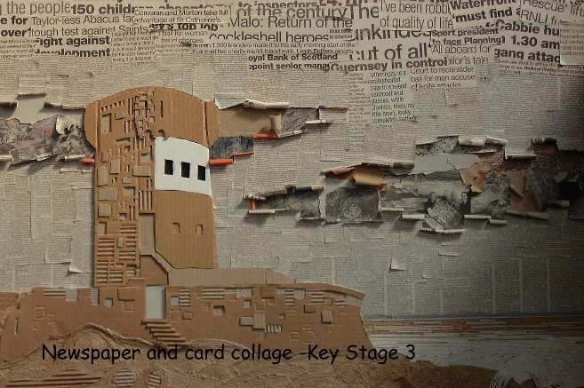

Organic Low Relief Cardboard Architecture: Assessment
Name: __________________________________________________________3-D Art and Design Grade: ______ Day: ______ Directions: Circle the boxes that best describes your artwork. Then answer the questions on the back.
 | 1 | 2 | 3 | 4
Creativity  -took risks  -uniqueness | The artwork has minimal manipulation of materials and design. | The artwork shows inconsistent areas of creative manipulation of materials or design. | The artwork shows some creative manipulation of materials and/or design. | The artwork is sophisticated and creative showing inventive manipulation of materials and/or design.
Organic Architecture  1. house/building fits the environmental location  2. includes environmental elements  3. design matches the function of the building | The artwork does not show the idea organic architecture. | The artwork makes an attempt to show the idea of organic architecture and may represent one of the three components | The artwork shows the basic idea of organic architecture through the three components. | The artwork clearly shows the idea of organic architecture through the sophisticated demonstration of the three components.
Craftsmanship  -pieces are securely attached  -materials are cut well; edges are smooth  -glue/pencil does not show | The artwork shows little evidence of effort or care in working with the materials. | The artwork shows inconsistent craftsmanship. | The artwork shows very good craftsmanship and care. | The artwork shows excellent craftsmanship, thought, and care.
Foreground/Background  -details  -overlapping  -size  -placement | The artwork does not show a foreground and background. | The artwork shows an attempt at creating foreground and background but it is not convincing. | The artwork shows a foreground and background using some techniques. | The artwork clearly shows a convincing foreground and background using varied techniques.
On time | The artwork is less than ½ completed by the due date. | The artwork is partially completed by the due date. | The artwork is completed by the due date. | The artwork is completed by the due date – clearly marked with name- and assessment with name is carefully attached.

1. Describe how you applied the idea of organic architecture to your house/building.
_____________________________________________________________________________________________________________________________________________________________________________________________________________________________________________________________________________________________________________________________________________________________________________________________________________________________________________________________

2. Do you think you were successful in creating a convincing foreground and background? Explain why, citing evidence from your artwork.
____________________________________________________________________________________________________________________________________________________________________________________________________________________________________________________________________________________________________________________________________________________________________

3. You used mostly recycled elements to construct your sculpture. Which materials did you enjoy working with the most and how is this different from more traditional sculpture materials like clay?
____________________________________________________________________________________________________________________________________________________________________________________________________________________________________________________________________________________________________________________________________________________________________

