Clay Cake Boxes inspired by Wayne Thiebaud:
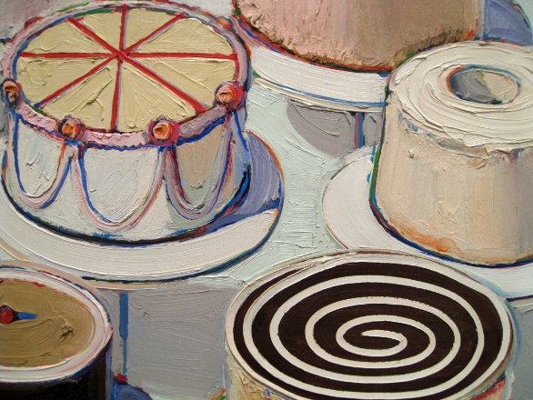
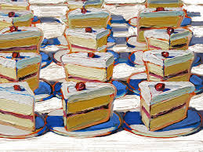
National Core Arts Standards:

Creating:
Anchor Standard 1: Generate and conceptualize artistic ideas and work.
VA:Cr.1.2.7a: Develop criteria to guide making a work of art or design to meet an identified goal.
VA:Cr.1.2.8a: Collaboratively shape an artistic investigation of an aspect of present day life using a contemporary practice of art or design.
Anchor Standard 2: Organize and develop artistic ideas and work.
VA:Cr.2.3.7a: Apply visual organizational strategies to design and produce a work of art, design, or media that clearly communicates information or ideas.
VA:Cr.2.3.8a: Select, organize, and design images and words to make visually clear and compelling presentations.
Anchor Standard 3: Refine and complete artistic work.
VA:Cr.3.1.7a: Reflect on and explain important information about personal artwork in an artist statement or another format.
VA:Cr.3.1.8a: Apply relevant criteria to examine, reflect on, and plan revisions for a work of art or design in progress.
Presenting:
Anchor Standard 5: Develop and refine artistic techniques and work for presentation.
VA:Pr.5.1.7a: Based on criteria, analyze and evaluate methods for preparing and presenting art.
VA:Pr.5.1.8a: Collaboratively prepare and present selected theme-based artwork for display, and formulate exhibition narratives for the viewer.
Responding:
Anchor Standard 7: Perceive and analyze artistic work.
VA:Re.7.1. 7a: Explain how the method of display, the location, and the experience of an artwork influence how it is perceived and valued.
VA:Re.7.1. 8a: Explain how a person’s aesthetic choices are influenced by culture and environment and impact the visual image that one conveys to others
Anchor Standard 9: Apply criteria to evaluate artistic work.
VA:Re.9.1.7a: Compare and explain the difference between an evaluation of an artwork based on personal criteria and an evaluation of an artwork based on an established criteria.
VA:Re.9.1.8a: Create a convincing and logical argument to support an evaluation of art.
Connecting:
Anchor Standard 10: Synthesize and relate knowledge and personal experiences to making art.
VA:Cn10.1.7a: Individually or collaboratively create visual documentation of places and times in which people gather to make and experience art or design in the community.
VA:Cn10.1.8a: Make art collaboratively to reflect on and reinforce positive aspects of group identity.
Anchor Standard 11: Relate artistic ideas and works with societal, cultural, and historical context to deepen understanding.
VA:Cn.11.1.7a: Analyze how response to art is influenced by understanding the time and place in which it was created, the available resources, and cultural uses.
VA:Cn.11.1.8a: Distinguish different ways art is used to represent , establish, reinforce, and reflect group identity

Φ= There is a video or hyperlink for this step.
Student  signs | Teacher  signs | Step | Task | Why?
 |  | 1 | Sketch ideas for clay slices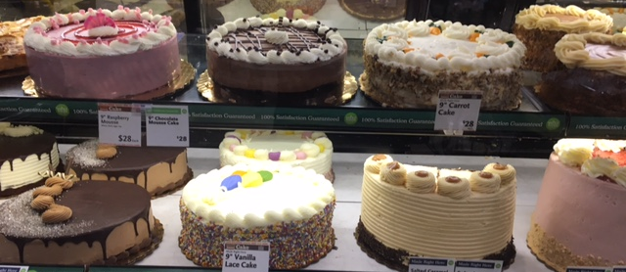 | Creating:  Anchor Standard 1: Generate and conceptualize artistic ideas and work.  VA:Cr.1.2.7a: Develop criteria to guide making a work of art or design to meet an identified goal.  VA:Cr.1.2.8a: Collaboratively shape an artistic investigation of an aspect of present day life using a contemporary practice of art or design.
 |  | 2Φ | Watch Wayne Thiebaud video  https://www.youtube.com/watch?v=vI_QJ5D9Qm8 | Anchor Standard 11: Relate artistic ideas and works with societal, cultural, and historical context to deepen understanding.  VA:Cn.11.1.7a: Analyze how response to art is influenced by understanding the time and place in which it was created, the available resources, and cultural uses.  VA:Cn.11.1.8a: Distinguish different ways art is used to represent , establish, reinforce, and reflect group identity

 |  | 3Φ | Interactive activity to design cakes through the National Gallery of Art  http://www.nga.gov/education/classroom/interactive/cake.htm | Anchor Standard 2: Organize and develop artistic ideas and work.  VA:Cr.2.3.7a: Apply visual organizational strategies to design and produce a work of art, design, or media that clearly communicates information or ideas.  VA:Cr.2.3.8a: Select, organize, and design images and words to make visually clear and compelling presentations.

 |  | 4 | Create a cardboard model to create templates for clay | 1-emerging 2-progressing 3-meeting goal 4-exceeding goal  Anchor Standard 2: Organize and develop artistic ideas and work.  VA:Cr.2.3.7a: Apply visual organizational strategies to design and produce a work of art, design, or media that clearly communicates information or ideas.  VA:Cr.2.3.8a: Select, organize, and design images and words to make visually clear and compelling presentations.

 |  | 5 | Construct box | Anchor Standard 3: Refine and complete artistic work.  VA:Cr.3.1.7a: Reflect on and explain important information about personal artwork in an artist statement or another format.  VA:Cr.3.1.8a: Apply relevant criteria to examine, reflect on, and plan revisions for a work of art or design in progress.
 |  | 6 | Create Lid to make sure it fits within box to hold in place | 1-emerging 2-progressing 3-meeting goal 4-exceeding goal  Anchor Standard 5: Develop and refine artistic techniques and work for presentation.  VA:Pr.5.1.7a: Based on criteria, analyze and evaluate methods for preparing and presenting art.  VA:Pr.5.1.8a: Collaboratively prepare and present selected theme-based artwork for display, and formulate exhibition narratives for the viewer.
 |  | 7 | Refine clay- additive and subtractive elements- texture of clay- decorative elements | Anchor Standard 3: Refine and complete artistic work.  VA:Cr.3.1.7a: Reflect on and explain important information about personal artwork in an artist statement or another format.  VA:Cr.3.1.8a: Apply relevant criteria to examine, reflect on, and plan revisions for a work of art or design in progress.

 |  | 8 | Dry out clay- Bonedry-  Fire to create bisque
Clay Quiz on clay vocabulary
Clay Vocabulary:
Clay: a natural material found in the earth, made up of fine minerals such as kaolin and feldspar; when it is wet it can be molded and hold a shape; when it dries it becomes brittle and fragile; when it is fired it becomes very hard and its shape is permanent
Glaze: a colored, glassy surface coating that is fired onto bisqueware to decorate pottery and to make it waterproof
Kiln: a special oven or furnace that is used to fire clay at extremely high temperatures, over 1,500˚ Farenheit
Slab: a sheet of damp clay created from rolling out/flattening clay with a slab roller or a rolling pin

Forming/Joining clay vocabulary
Slab Construction: a pottery technique in which a form is built up by joining shapes cut from thick sheets of damp clay
Scoring: the process of scratching cross hatching marks into the clay in order to join two pieces of clay
Slip: very wet clay (clay with water) that is used like a glue to join two pieces of clay
Press/Blend: the final step to join clay after scoring and adding slip to the two pieces in order to seal them by smoothing the two edges together to unite the piece
Additive: a way to add detail to a clay piece by adding on pieces of clay, scoring and adding slip
Subtractive: a way to add detail by subtracting clay, by carving or engraving into the clay with carving tools
Clay Tools:
Elephant Ear Sponge: natural sponges used to smooth/add moisture to the clay
Needle Tool: used to score the clay, pierce air bubble, and to draw onto the clay
Modeling Tools: used for general smoothing, blending, sculpting and texturing of clay
Wire Loop Tool: wooden handled tools with stiff wire ends used to carve or to remove clay
Serrated Rib: used for scoring the clay; roughens the surface of clay; adds texture to clay
Smooth Rib: used to smooth clay
Rolling Pin: used to roll slabs of clay
Fettling Knife: used to cut (small pieces), score or carve clay

 |  | 9 | Glaze- Glaze Fire | Anchor Standard 7: Perceive and analyze artistic work.  VA:Re.7.1. 7a: Explain how the method of display, the location, and the experience of an artwork influence how it is perceived and valued.  VA:Re.7.1. 8a: Explain how a person’s aesthetic choices are influenced by culture and environment and impact the visual image that one conveys to others
 |  | 10 | Rubric  Self-assess  Calculate the volume of your finished sculpture | 1-emerging 2-progressing 3-meeting goal 4-exceeding goal  Responding:  Anchor Standard 9: Apply criteria to evaluate artistic work.  VA:Re.9.1.7a: Compare and explain the difference between an evaluation of an artwork based on personal criteria and an evaluation of an artwork based on an established criteria.  VA:Re.9.1.8a: Create a convincing and logical argument to support an evaluation of art.  Connecting:  Anchor Standard 10: Synthesize and relate knowledge and personal experiences to making art.  VA:Cn10.1.7a: Individually or collaboratively create visual documentation of places and times in which people gather to make and experience art or design in the community.  VA:Cn10.1.8a: Make art collaboratively to reflect on and reinforce positive aspects of group identity.

