Choose a color scheme and check/circle it below.
- Monochromatic- dark and light values of one color- for example red, dark red, pink
- Analogous- 3-4 colors side by side on the color wheel- for example yellow-green, green, blue-green
- Neutral- gray, black, brown, white
- Warm- reds, oranges, yellows
- Cool- blues, greens, violets
- Primary- red, blue, yellow
- Secondary- orange, green, violet
- Intermediate- RO, YO, YG, BG, BV, RV
- Complementary- opposites on the color wheel- for example orange and blue
Open Microsoft Paint
Go under file- save as- write your name and save under C- under your folder
Editing and selecting new colors: I will expect you to custom some of your colors.

The colors in Microsoft paint are on the tool bar-
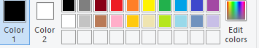
You can custom your own color selections by following these steps.
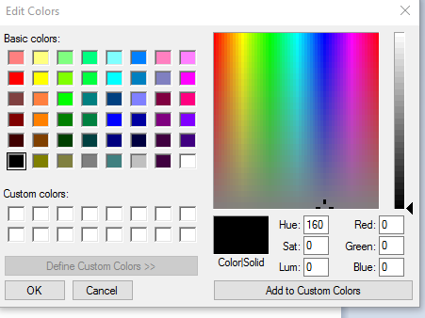
- click on edit colors.
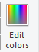

2.
Position the cursor over the part in the rainbow that represents the color you want

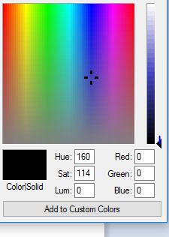
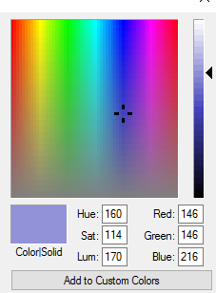3. Move the arrow on the side up or down to determine the value/dark/light that you want.
You will see the change in the color box.

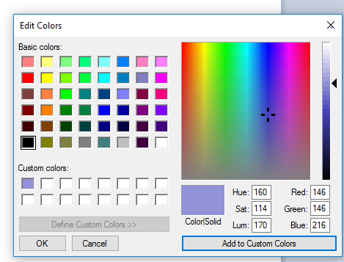

4. click on add to custom color

5. You will then see it in your home screen color swatches.
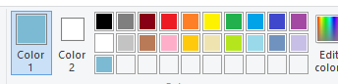

Select a brush and choose a color in your color scheme or use black and select a brush width. Draw 4 flowers. Use the brush or the paint can to add color. Add texture to the background. You need to make sure to follow your selected color scheme.

Save your work.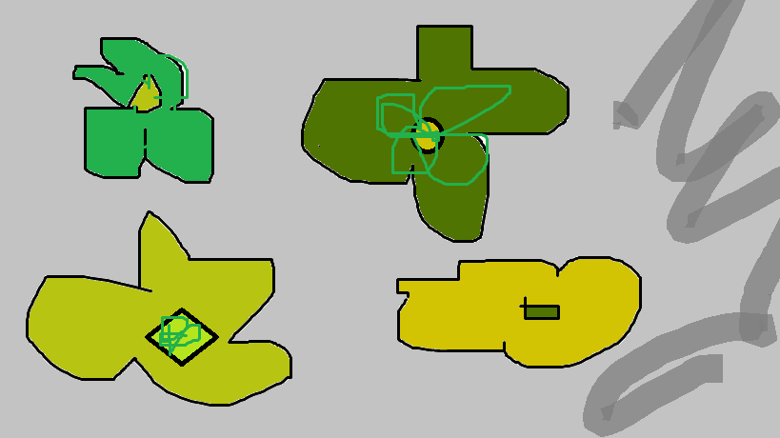
Andy Warhol inspired digital flowers | 1  Emerging | 2  Nearly proficient | 3  Proficient- at goal | 4  Exemplary- exceeding goal
Criteria:  4 flowers with a textured-grass background  Demonstrating a specific color scheme | Does not meet criteria  Inconsistent use of class time- and or design could have been more challenging | Almost meets criteria- Good use of class time, design presents some challenge | Meets criteria-  Good use of class time, challenging design | Exceeds criteria-  Excellent use of class time- ambitious, yet realistic idea for project
Craftsmanship:  Good use of materials and techniques | Majority of digital drawing could be more controlled/ neater- no custom colors | Inconsistent use of Microsoft Paint- no custom colors- minimal use of techniques | Good use of Microsoft Paint techniques- some custom colors | Excellent use of Microsoft Paint techniques- variety of techniques and custom colors
Creativity:  Unique ideas and spin on presentation | Looks exactly like design teacher showed or another student in class | Some individuality in design, but very similar to others in class or demonstration piece | Unique ideas and spin on design and or techniques | Very innovative and creative design – unique from others in class based on either design or techniques
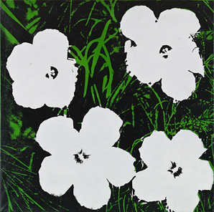
Grade _______________/100

