Low Relief Cardboard Architecture:
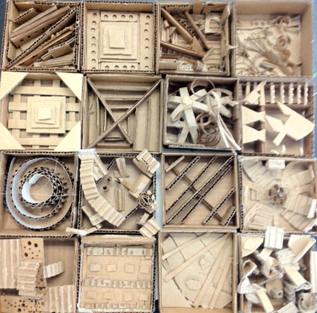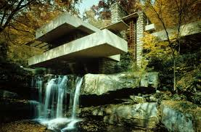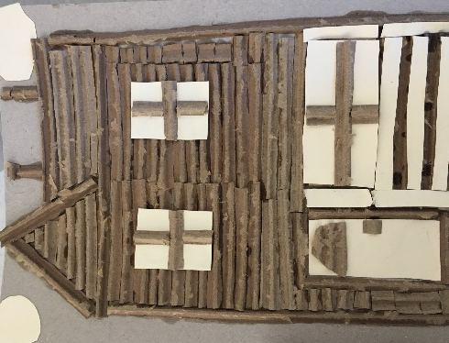
National Core Arts Standards:

Creating:
Anchor Standard 1: Generate and conceptualize artistic ideas and work.
VA:Cr.1.1. 7a: Apply methods to overcome creative blocks.
VA:Cr.1.1. 8a: Document early stages of the creative process visually and/or verbally in traditional or new media.
VA:Cr.1.2.7a: Develop criteria to guide making a work of art or design to meet an identified goal.
VA:Cr.1.2.8a: Collaboratively shape an artistic investigation of an aspect of present day life using a contemporary practice of art or design.
Anchor Standard 2: Organize and develop artistic ideas and work.
VA:Cr.2.1.7a: Demonstrate persistence in developing skills with various materials , methods, and approaches in creating works of art or design.
VA:Cr.2.1.8a: Demonstrate willingness to experiment, innovate, and take risks to pursue ideas, forms, and meanings that emerge in the process of art-making or designing.
VA:Cr.2.2.7a: Demonstrate awareness of ethical responsibility to oneself and others when posting and sharing images and other materials through the Internet, social media, and other communication formats.
VA:Cr.2.2.8a: Demonstrate awareness of practices, issues, and ethics of appropriation, fair use, copyright, open source, and creative commons as they apply to creating works of art and design.
VA:Cr.2.3.7a: Apply visual organizational strategies to design and produce a work of art, design, or media that clearly communicates information or ideas.
VA:Cr.2.3.8a: Select, organize, and design images and words to make visually clear and compelling presentations.
Anchor Standard 3: Refine and complete artistic work.
VA:Cr.3.1.7a: Reflect on and explain important information about personal artwork in an artist statement or another format.
VA:Cr.3.1.8a: Apply relevant criteria to examine, reflect on, and plan revisions for a work of art or design in progress.
Presenting:
Anchor Standard 4: Select, analyze, and interpret artistic work for presentation.
VA:Pr.4.1. 7a: Compare and contrast how technologies have changed the way artwork is preserved, presented, and experienced.
VA:Pr.4.1. 8a: Develop and apply criteria for evaluating a collection of artwork for presentation.
Anchor Standard 5: Develop and refine artistic techniques and work for presentation.
VA:Pr.5.1.7a: Based on criteria, analyze and evaluate methods for preparing and presenting art.
VA:Pr.5.1.8a: Collaboratively prepare and present selected theme-based artwork for display, and formulate exhibition narratives for the viewer.
Anchor Standard 6: Convey meaning through the presentation of artistic work.
VA:Pr.6.1.7a: Compare and contrast viewing and experiencing collections and exhibitions in different venues.
VA:Pr.6.1.8a: Analyze why and how an exhibition or collection may influence ideas, beliefs, and experiences.
Responding:
Anchor Standard 7: Perceive and analyze artistic work.
VA:Re.7.1. 7a: Explain how the method of display, the location, and the experience of an artwork influence how it is perceived and valued.
VA:Re.7.1. 8a: Explain how a person’s aesthetic choices are influenced by culture and environment and impact the visual image that one conveys to others
VA:Re.7.2.7a: Analyze multiple ways that images influence specific audiences.
VA:Re.7.2.8a: Compare and contrast contexts and media in which viewers encounter images that influence ideas, emotions, and actions.
Anchor Standard 8: Interpret intent and meaning in artistic work.
VA:Re.8.1.7a: Interpret art by analyzing art-making approaches, the characteristics of form and structure, relevant contextual information, subject matter, and use of media to identify ideas and mood conveyed.
VA:Re.8.1.8a: Interpret art by analyzing how the interaction of subject matter, characteristics of form and structure, use of media, art-making approaches, and relevant contextual information contributes to understanding messages or ideas and mood conveyed.
Anchor Standard 9: Apply criteria to evaluate artistic work.
VA:Re.9.1.7a: Compare and explain the difference between an evaluation of an artwork based on personal criteria and an evaluation of an artwork based on an established criteria.
VA:Re.9.1.8a: Create a convincing and logical argument to support an evaluation of art.

Connecting:
Anchor Standard 10: Synthesize and relate knowledge and personal experiences to making art.
VA:Cn10.1.7a: Individually or collaboratively create visual documentation of places and times in which people gather to make and experience art or design in the community.
VA:Cn10.1.8a: Make art collaboratively to reflect on and reinforce positive aspects of group identity.
Anchor Standard 11: Relate artistic ideas and works with societal, cultural, and historical context to deepen understanding.
VA:Cn.11.1.7a: Analyze how response to art is influenced by understanding the time and place in which it was created, the available resources, and cultural uses.
VA:Cn.11.1.8a: Distinguish different ways art is used to represent , establish, reinforce, and reflect group identity.

Φ= There is a video or hyperlink for this step.
Student  signs | Teacher  signs | Step | Task | Why?
 |  | 1 | Prior learning sketch  Introduction of unit  PowerPoint-  Define organic architecture  Create a sketch-  Label at least 4 architectural elements in the sketch.  10 points | Reflect on and analyze various works of art by selected artists to understand the idea of organic architecture.
 |  | 2 | Cardboard techniques  Techniques worksheet  15 points | Demonstrate an understanding of how low relief sculptures are made using cardboard/chipboard and paper bags.

 |  | 3 | Frank Lloyd Wright reading and questions

 |  | 4 | Research architecture ideas | Research locations based on geography, climate, and resources to plan the design of the house/building and its surroundings.

 |  | 5 | Planning handouts for architecture  - 1 point perspective practice  - 2 point perspective practice  - Refine planning sketch from step 1
 |  |  | *must have approval before starting cardboard version of building design
 |  | 6 | Begin cardboard construction of approved sketch | Demonstrate an understanding of how low relief sculptures are made using cardboard/chipboard and paper bags.
 |  | 7 | Peer activity/in-progress critiques | Participate in a final and/or in-progress critique of a peer’s work or class work by working with a partner to demonstrate their understanding of the requirements of the assignment and their ability to accurately evaluate artwork.

 |  | 8 | Analyze in groups an image as organic or not organic and support position with 3 specific reasons referencing the visual (text) | Participate in a final and/or in-progress critique of a peer’s work or class work by working with a partner to demonstrate their understanding of the requirements of the assignment and their ability to accurately evaluate artwork.

 |  | 9 | Complete cardboard construction | Demonstrate an understanding of organic architecture through their artwork.
 |  | 10 | Self- assessment and reflection questions | Self-assess their work by evaluating their artwork, reflecting on the process through which their art work was created.
 |  | * | Extensions: | Perspective drawings of the same building using one point, two point and three point perspective

Vocabulary

- Relief: refers sculptural elements that are on top of a flat surface.
- Low relief: means objects barely stand out from the background.
- High relief: is where in general more than half the mass of the sculpted object(s) project from the background.
- In the Round: sculptures that are standing free with all sides showing
- Foreground: in the front; the portion of a scene nearest to the viewer
- Background: the part of a scene or picture that is farthest from the viewer: the part of a scene that is behind a main figure or object in a painting, photograph, etc.
- One point perspective: a technique from the Italian renaissance which creates realistic sense of space on a flat surface using lines that go toward a single vanishing point as well as verticals and horizontals
- Vanishing point: a point that diagonal lines go toward to make objects appear to get smaller as they approach the vanishing point
- Horizon line: where the sky and land/water in the distance meet- represents the viewer’s eye level
- Two point perspective: a system of using two vanishing points to show buildings that are not perpendicular to the viewer – but are on an angle

Organic Architecture: Organic architecture is a philosophy of architecture which promotes harmony between human habitation and the natural world through design approaches so well integrated with its site, that buildings, furnishings, and surroundings become part of a unified, interrelated composition
For a building to be considered organic architecture it should have the following 3 criteria:
- “house/building” that fits its environment
- looks like it uses natural materials from the location of the building
- the design reflects the building’s function/purpose

