Andy Warhol inspired printmaking color scheme collage:

- Please indicate which color scheme you selected by circling or checking it off below.
- Monochromatic- dark and light values of one color- for example red, dark red, pink
- Analogous- 3-4 colors side by side on the color wheel- for example yellow-green, green, blue-green
- Neutral- gray, black, brown, white
- Warm- reds, oranges, yellows
- Cool- blues, greens, violets
- Primary- red, blue, yellow
- Secondary- orange, green, violet
- Intermediate- RO, YO, YG, BG, BV, RV
- Complementary- opposites on the color wheel- for example orange and blue
2. Why did you pick this color scheme? __________________________________________________________________________________________________________________________________________________________
3.What do you like best about your project? __________________________________________________________________________________________________________________________________________________________
4.What was something that you learned in this unit on Andy Warhol and color?
__________________________________________________________________________________________________________________________________________________________
5. Connect: How can you connect something you learned in this unit to something you learned in another class or in your life?
____________________________________________________________________________________________________________________________________________________________________________________________________________________________________________________________________________________________________________________

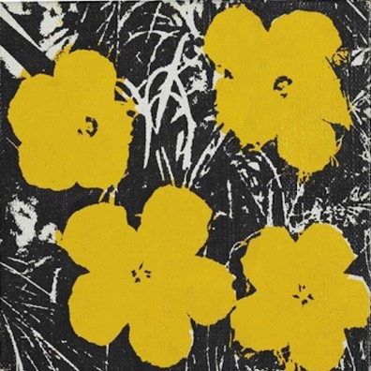
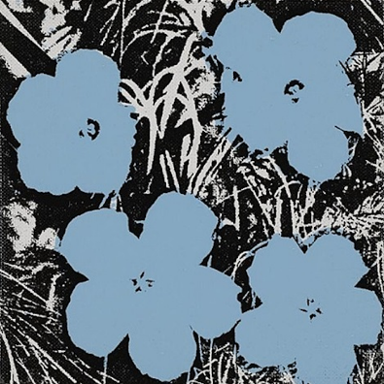
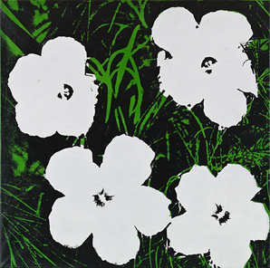

Andy Warhol inspired printmaking color scheme flowers | 1  Emerging | 2  Nearly proficient | 3  Proficient- at goal | 4  Exemplary- exceeding goal
Criteria:  4 flowers from printing on Gelli-plate and layering color scheme colored paper to create stacked or layered flowers with a textured-pattern background  Demonstrating student selected specific color scheme | Does not meet criteria  Inconsistent use of class time- and or design could have been more challenging | Almost meets criteria- Good use of class time, design presents some challenge | Meets criteria-  Good use of class time, challenging design | Exceeds criteria-  Excellent use of class time- ambitious, yet realistic idea for project
Craftsmanship:  Good use of materials and techniques | Majority of printmaking and collage (Cutting-gluing) could be more controlled/ neater | Inconsistent use of printmaking and collage techniques | Good use of printmaking and collage techniques | Excellent use printmaking and collage techniques
Creativity:  Unique ideas and spin on presentation | Looks exactly like design teacher showed or another student in class | Some individuality in design, but very similar to others in class or demonstration piece | Unique ideas and spin on design and or techniques | Very innovative and creative design – unique from others in class based on either design or techniques
Grade _______________/100

