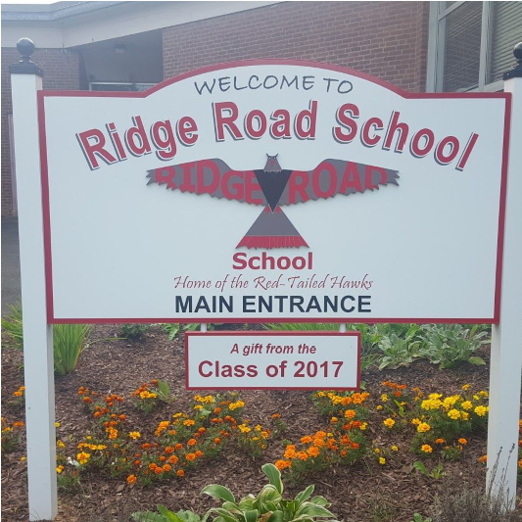
Ridge Road Review
Ridge Road School November 2018

November Report Card Conferences
Report Card Conferences will be held on the following dates:
- Wednesday, November 28: 5:00pm-8:00pm
- Thursday, November 29: 4:00pm-6:00pm
- Friday, November 30: 1:15pm-3:15pm
**Each of these days will be a 1:00pm dismissal day for students.

Food Drive for the NH Food Bank
Thank you to all the families who donated items to our food drive. We collected enough food to fill the 6 ft. bed of a pick-up truck. The representative from the NH Food Bank also send her thanks.

New Playground Update
Construction is underway! The tentative plan is to have the playground open in April. Unfortunately, our current playground cannot be accessed during construction. Our wonderful PTA has purchased toys and supplies for the students to use out at recess. Thank you to our PTA, Mr. Freda and our entire community for supporting this effort!!

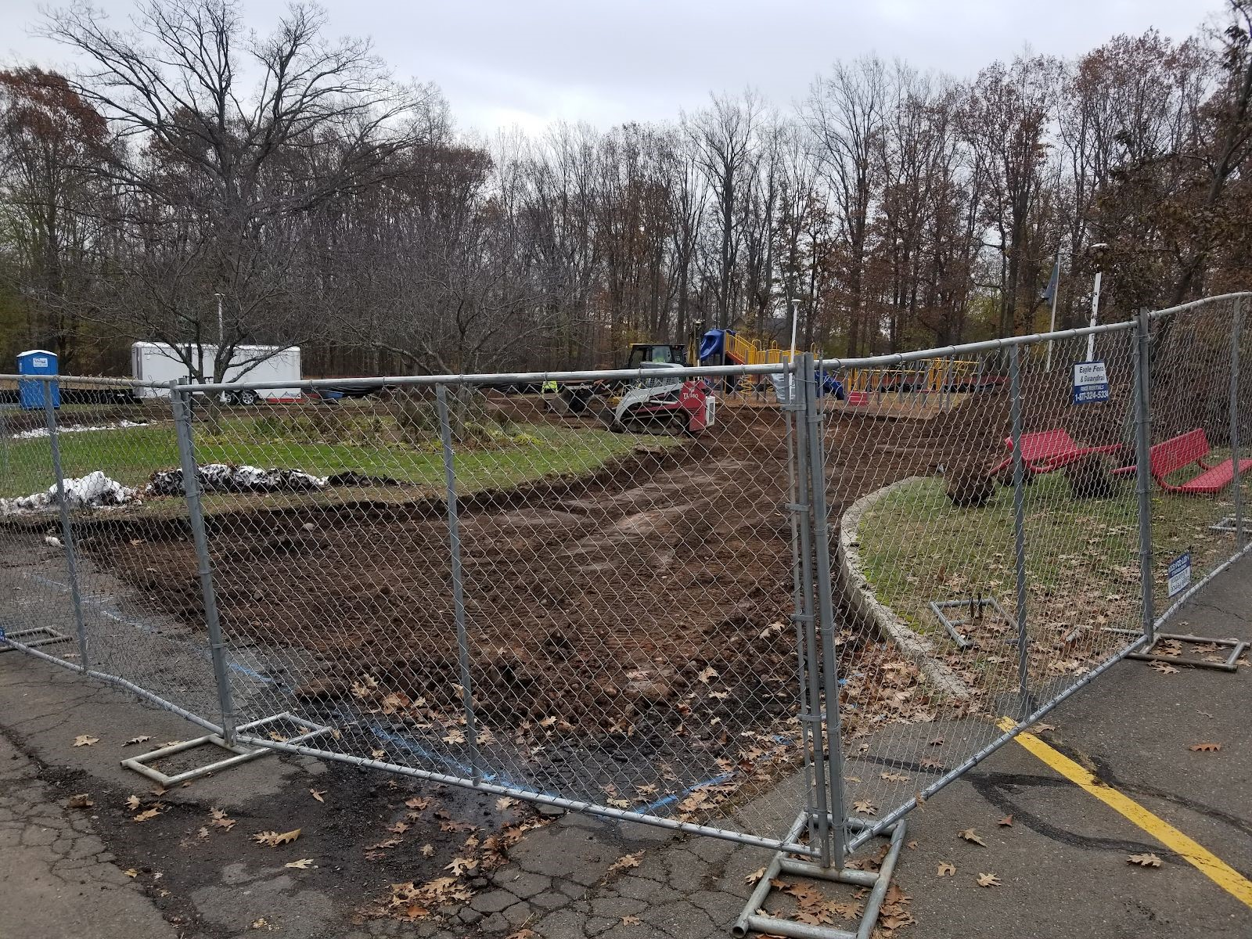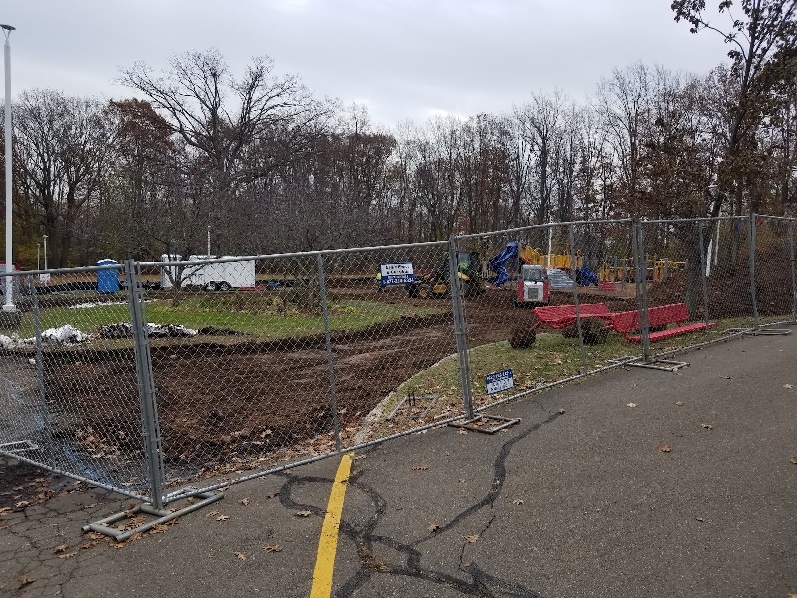

Math & Literacy Night
Come on out December 5th from 5:30-6:45 p.m. for our annual Literacy and Math Night. This year’s theme is “Parents as Partners!’’ This is a family event for students and parents featuring a look into reading workshop and how to be an effective partner with your child, make and take math games, and strategies to support decoding, fluency, and comprehension at home through make and take games. This event is coinciding with the Ridge Road Scholastic Book Fair evening hours. You can shop for books before or after our sessions. Please use the link below to RSVP, so we can plan accordingly.
Reply link for parents: ​https://goo.gl/forms/OGYdHZLwUdDTUAyU2
Important Dates
11/21: ​Early dismissal, 1:00pm  11/22-11/23​: No School, Thanksgiving Break  11/27​: Report Cards emailed home  12/5-12/7: ​Book Fair  12/7: ​Early dismissal, 1:00pm | 12/11​: PTA Meeting, 7:00pm  12/20​: Winter Concert, 6:30pm  12/21​: Early dismissal, 1:00pm  12/24-1/1​: No School, Winter Break

News from Our Health Office from Mrs. Avitable​
With the cold weather upon us, please remind your children about dressing appropriately for the weather. It is best to dress in layers so as your child warms up they can remove a layer and still feel not too warm in school. Also, remind your children to wear their hats and gloves/mittens to keep warm when they are outside for recess. The students will continue to go outside for recess unless there is severe
cold or bad weather.
Also with the cold weather, children’s skin and lips can become quickly dry and chapped. Extra applications of lotion and keeping lip balm in your child’s backpack for when they need to apply for chapped lips is helpful. It would be a good idea to provide your child with a change of clothes to keep in their cubby if they do happen to get their clothes soiled & wet from indoor or outdoor recess.
Please remember to use the Dismissal Manager when your child will be tardy or absent from school. If your child is ill please advise the Health Office of their illness so we can keep track of illnesses in the building. Also if your child has been ill for several days and they have been seen by the doctor it is best practice to provide a note from the doctor regarding the reason for your child’s absence. Please refer to the attendance policy in the Ridge Road Handbook pages 6 – 8. (Located on the Ridge Road Elementary School website)
Have a safe, healthy and fun filled Thanksgiving!

Art Room Happenings from Mrs. Snow​

Kindergarten​ students continue their exploration of the ELEMENTS of ART (LINE, SHAPE, COLOR, TEXTURE, and FORM) in their work They have just completed a steam train collage using rectangles, squares, circles and triangles to make a town and a train.
Learning to cut their own shapes for a “Visit to the Zoo” collage has been a fun project for the ​Grade 1​ students.
I give them only rectangles and they must cut the needed shapes to make lions, tigers, bears, penguins,giraffes and many more zoo animals.
Their imagination has amazed me!
​U​sing TEXTURE and VISUAL TEXTURE in an underwater collage is the goal of grade 2 students. Fish, turtles, seaweed, coral, starfish, sharks and jellyfish are some of the creatures students are drawing and adding to their folder so they will be ready to create an interesting and busy undersea scene.
​Grade 3​ students are completing beautiful drawings of Connecticut songbirds after viewing the work of the famous naturalist painter,John James Audubon.
​Grade 4​ have been working on one of my favorite units - learning about the art of the Medieval Ages. Students are working on their Illuminated Page containing a Beast description and illustration, as well as a decorative border and large fancy Initial letter.
​Grade 5​ students always focus on learning about different styles (or schools) of Art. They have finished an autumn scene with pumpkins or an outer space scene in the style of REALISM. Some beautiful blending of oil pastel shadows and highlights can be seen.

News from the Media Center from Mr. Mayo​

The Book Fair is coming ! Mark your calendars for December 5th through the
7th when the Scholastic Book Fair makes its appearance in the Ridge Road Library. Students will have a chance to "preview" materials during the school day on Wednesday the 5th. We will stay open late on Wednesday evening for parents to return with their children to double check their lists and find the
perfect book. The PTA is also planning on manning the cash registers on Thursday and Friday, both before and just after regular school hours. There is also an opportunity for you to purchase a gifted book to your classroom teachers. Teachers will pre-select their wish list and have book bins on a table just outside the library. So, get some Holiday shopping out of the way and come buy some books! We'll see you at the Book Fair!

Music News from Mr. Hutton and Mr. Lafond​

Ridge Road Chorus and Advanced Band are working hard to prepare for our Winter Concert next month.
December, 20th, 6:30 pm, in the Ridge Road Gymnasium.
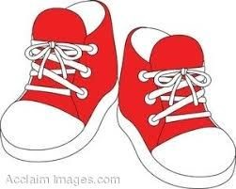
PE News from by Mr. Stonaha​

- Remember sneakers on PE days for your child/children. They may bring sneakers with
them and change into them if necessary
- Layers are good for PE—as the weather gets colder, students tend to dress warmer. It is
helpful for students to be able to take off warmer clothing to participate in PE
- Grades 2 and 3 health is nearing completion. Projected end date is November
27, 2018. K and 1 health will begin in December.
- 4​^{th​} grade fitness testing is now finished. Results are available on the Ridge Road School website (in forms section). If you did not receive your child’s individual results, please let me know
- Save the date: Parent/Teacher Basketball Game is Friday, April 12, 2019 @ NHHS, 7 pm. Parent lottery information will be available in mid to late January 2019
- Tentative field day date: Friday, May 31, 2019
- If you have any questions, please contact me at 203.248.4050 x 6117 or Stonaha.Marc@northhavenschools.org

Tech News from Mrs. Ardolino​
Students have been working in Google Suite learning to use Google Docs, Slides and Classroom. Fourth and Fifth graders were able to show off their newly acquired tech skills by participating a flyer contest. The Math and Literacy
Specialist chose the flyer submitted by students to send home to parents for the Literacy and Math Night Event in December. Right after Thanksgiving, Tech Ed will start the coding and robotics unit. Please do not hesitate to contact me if you have any questions about curriculum or the new technology. ardolino.michele@northhavenschools.org​.

Reading News from Mrs. Sullivan​
It has been full speed ahead with Reading and Writing workshop here at Ridge Road. Many grade levels are wrapping up their second reading and writing units and moving right along into their third unit. The BAS (Benchmark Assessment System) testing has wrapped up for students in grades 1 through 5. This provides valuables information about a student’s decoding, fluency and comprehension. While it is one measure of reading ability, it is not the only source of data. Teachers are constantly conferring 1:1 with students and pulling small groups on a daily basis to gather data about a student’s reading strengths and goals.

In thinking about the purpose of teaching children to read, we consider decoding, fluency and comprehension to be important skills. Above all we hope to cultivate readers who THINK and TALK about books. Every grade level utilizes reading partnerships, and students in grade 3-5 have to opportunity to participate in book clubs throughout certain units. Ask your child who their reading partner is and how they help each other. The ability to think and talk about books is transferable to writing workshop.
When students are able to create mental movies (think) and orally rehearse (talk) how their piece might go, the writing flows much more smoothly. Sharing a good book with your child is wonderful, but gowing ideas together about the books you share opens up a whole new world of possibility. To get your child thinking and talking more at home, try out some of these stems:
❏ I’m thinking….. Because….
❏ Maybe…
❏ Why do you think that?
❏ Can you explain what you mean?
❏ I’m starting to notice…
❏ An example of this…

For more information on Reading Workshop and how to be an effective reading partner with your child, be sure to join us for Literacy-Math Night on Wednesday, December 5th from 5:30-6:45PM.

