The School District of DeSoto will comply with and implement the requirements of section 1118(a)(2) of the Elementary and Secondary Education Act (ESEA) to include the following:
- Programs, activities, and procedures for the involvement of parents in all of its schools with Title I, Part A programs consistent with Section 1118 of the ESEA. These programs, activities, and procedures will be planned and operated with meaningful consultation with parents of participating children;
- Work with schools to ensure that the required school-level parental involvement policies meet the requirements of Section
1118(b) of the ESEA, and each include, as a component, a school-parent compact consistent with Section 1118(d) of the ESEA;
- The district will incorporate the district-wide parental involvement policy into its Local Educational Agency (LEA) plan developed under Section 1112 of the ESEA;
- In carrying out the Title I, Part A, parental involvement requirements to the extent practicable, the district and its schools will provide full opportunities for the participation of English Language Learners (ELL), parents with disabilities, and parents of migratory children, including providing information and school reports required under Section 1111 of the ESEA in an understandable and uniform format and, including alternative formats upon request, and to the extent practicable, in a language that parents can understand;
- If the district plan for Title I, Part A, developed under Section 1112 of the ESEA, is not satisfactory to the parents of participating children, the district will submit any parent comments with the plan when it is submitted to the Florida Department of Education (FLDOE);
- The district will involve the parents of children served in Title I, Part A schools in decisions about how the one percent of Title I, Part A funds reserved for parental involvement is spent, and will ensure that not less than 95 percent of the one percent reserved goes directly to the school, after equitable provisions have been provided to participating private schools;
- The district will be governed by the statutory definition of “parents” and “parental involvement” defined in Section 9101(31-32), and expects that its Title I schools will carry out programs, activities, and procedures in accordance with this definition;
- The district will inform parents and parent organizations of the purpose and existence of both Parent Information and Resource Centers (PIRC) in the state.

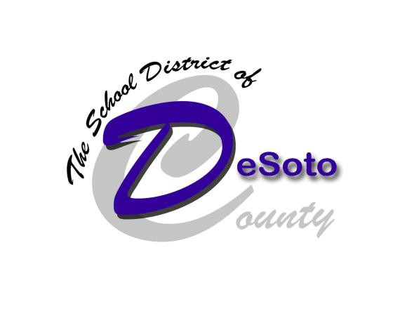

Superintendent Dr. Karyn E. Gary
karyn.gary@desoto.k12.fl.us

School District Office 530 LaSolona Avenue
Arcadia, Florida 34266
Phone: 863-494-4222

District Parent Involvement Specialist Davida Goldman

Email: davida.goldman@desoto.k12.fl.us

Parents: Please find valuable district information related to you online. www.desotoschools.com

DeSoto County High School
Parent Involvement Plan

1710 East Gibson Street Arcadia, FL 34266

Mission Statement

Our Mission at DeSoto County High School is to empower all students
to become life-long learners to compete in today’s society.
We believe that parent involvement is a crucial component in the success of our school and our students.
When parents are actively involved in their student’s education the chance of student success greatly increases.

Principal Tod Baldwin tod.baldwin@desoto.k12.fl.us Phone: 863-494-3434

DeSoto County High School Parental Involvement Plan

Parent involvement activities will be organized by the school and the PI Specialist and will include the following:

Open House
Title 1 Parent Night
Parent-Teacher Conferences
Academic Award Ceremonies
Athletic Award Ceremonies
STEM Scholar Parent Nights
AVID Parent Night

The target audiences for these activities will be:
Parents
Students
Teachers

The expected outcomes of these activities are:
Improved Parent Communication
Student Success
Increased Parent Involvement in the Child’s Education

All planned parental involvement activities include a translator for ELL parents.
When teachers hold parent conferences, every effort is made to provide a translator.
Every school office includes a bilingual staff member to provide a friendly contact for non-English parents.
All written communications to parents will be provided in the appropriate language.
Messages sent by phone are provided in the language a parent can understand to the extent practicable.
Parent meetings and workshops are held at various times to allow parents greater flexibility in receiving the information to assist their children.

Professional Development Activities:
Annual Training for staff and teachers will include:

New Teacher Mentor Program
AVID Strategies Training
Faculty Meetings
Identify and Reporting Child Abuse Training
Communication
The school encourages communication with parents through:

The School Website
The Daily Bulletin
Phone Calls/Robo Calls
Written Correspondences

District-Wide Parent Advisory Council (DPAC)

The School District of DeSoto has established a District-Wide Parent Advisory Council (DPAC). The DPAC will provide advice on all matters related to
parental involvement in Title I, Part A programs {Section 1118(e)(12)}. The DPAC will meet a minimum of twice per year to review the district parent involvement plan, the Title I Plan and district improvement plans.

Parents are an important piece of the puzzle when it comes to the academic success of their children.

Please contact Davida Goldman at the district office, 863-494-4222 ext.1123, if you are interested in serving on the
D PAC.
DeSoto Parental Involvement Policy
The district parental involvement policy, including how the 1% set-aside will be used, has been developed in consultation with parents, school parental involvement specialists, PIRC, principals and district staff from Title I, Student Services, and Instructional Services departments.
Parental involvement specialists at each school work with school staff and administrators to plan for parental activities.

Programs and Coordination

VPK—District staff serves as liaison to council.

Title I, Part C—PI Specialists coordinate activities between Part A & C.

Title I, Part D—Part A staff serve on district Dropout Task Force to coordinate efforts to involve parents in parent education activities.

Title III—PI Specialists ensure that translators are provided for parent involvement activities.

District Instructional Services, Student Services, the DPAC and PI Specialists review student data to determine areas of need.

All parent communication is provided in understandable and accessible formats.

District staff will participate in parental involvement training and provide that information to school level staff through workshops, meetings, and memos.

The District PAC will meet and review the LEA plan, the school level plans, the activity logs for the schools, the SAC minutes, and committee minutes.

Parent surveys will be conducted and reviewed. By correlating this information with student performance, a gauge of the effectiveness of parental involvement activities can be construed.

