Metric Mass (Weight)

Most common units of measure:

• Grams

• Kilograms

Grams
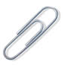 | A paperclip weighs about 1 gram.  Hold one small paperclip in your hand. Does that weigh a lot? No! A gram is very light. That is why you often see things measured in hundreds of grams.
Grams are often written as g (for short), so "300 g" means "300 grams". A loaf of bread weighs about 700 g (for a nice sized loaf)

Kilograms
Once we have 1,000 grams, we have 1 kilogram.
1 kilogram = 1,000 grams  A dictionary has a mass of about one kilogram. | 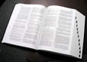
Kilograms are great for measuring things that can be lifted by people (sometimes very strong people are needed of course!).
Kilograms are often written as kg (that is a "k" for "kilo" and a "g" for "gram), so "10 kg" means "10 kilograms". Scales measure our weight using kilograms. An adult weighs about 70 kg. How much do you weigh?

Metric Length
These are the most common measurements:
- Millimeters
- Centimeters
- Meters
- Kilometers
- Small units of length are called millimeters.
- A millimeter is about the thickness of a plastic id card (or credit card).
- Or about the thickness of 10 sheets of paper on top of each other.
- This is a very small measurement!
- When we have 10 millimeters, it can be called a centimeter.
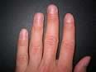
- 1 centimeter = 10 millimeters
- A fingernail is about one centimeter wide.
- 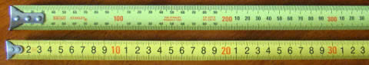
Two tape measures, one in mm, the other in cm
- We can use millimeters or centimeters to measure how tall we are, or how wide a table is, but to measure the length of football field it is better to use meters.

- 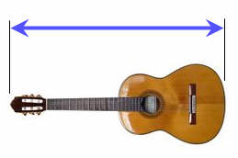A meter is equal to 100 centimeters.
- 1 meter = 100 centimeters
- The length of this guitar is about 1 meter
- Meters can be used to measure the length of a house, or the size of a playground.
- And because a centimeter is 10 millimeters:
- 1 meter = 1000 millimeters
- 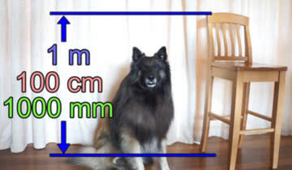
The back of this kitchen chair is 1 meter

- A kilometer is equal to 1000 meters.
- When we need to get from one place to another, we measure the distance using kilometers.
- The distance from one city to another or how far a plane travels can be measured using kilometers.

- Final thoughts about measuring length:
- 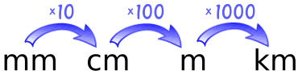
- 1 centimeter = 10 millimeters
- 1 meter = 100 centimeters
- 1 kilometer = 1000 meters

Metric Volume
These are the two most common measurements:
- Milliliters
- Liters

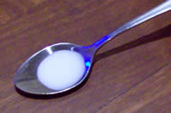
A milliliter (that is "milli" and "liter" put together) is a very small amount of liquid.
Here is a milliliter of milk in a teaspoon.
It doesn't even fill the teaspoon!

If you collect about 20 drops of water, you will have 1 milliliter:
20 drops of water 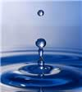 makes about 1 milliliter
And a teaspoon can hold about five milliliters:
1 teaspoon of liquid 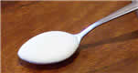 is about 5 milliliters

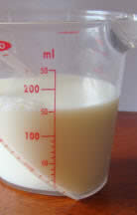
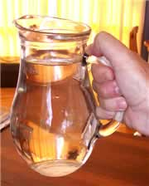
Milliliters are often written as ml (for short), so "100 ml" means "100 milliliters".
Here we have 150 ml of milk in a measuring cup.
It doesn't say "150" ... it says "50" ... but it is half-way between 100 and 200 so you can figure out it is 150 ml.

Liter
A liter is just a bunch of milliliters put all together. In fact, 1000 milliliters makes up 1 liter:
1 liter = 1,000 milliliters
This jug has exactly 1 liter of water in it.
Liters are often written as L (for short), so "3 L" means "3 Liters" (some people use lowercase l, but that looks too much like 1).
Milk, soda and other drinks are often sold in liters.

