West Elementary Cowboy Boosters Order Form
West Elementary Cowboy Boosters Order Form

Show your school spirit with a West Elementary T-Shirt and Tervis Tumbler!
Student Name: _______________________________________________________________
Teacher: __________________________________________________________________
Grade: _________________
Contact Number: ___________________ Email: _______________________________

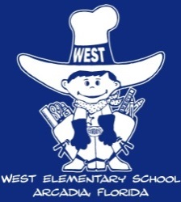
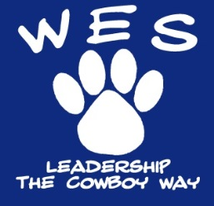
Back of shirt
School Spirit T-Shirts: $8.00 each
Please indicate the number of shirts ordered per size:
YOUTH MEN WOMEN (V-Neck)
Small: ____ Adult Small: ____ Small: ____
Youth Med: ____ Adult Med: ____ Medium: ____
Youth Large: ____ Adult Large: ____ Large: _____
Youth X-Large: ____ Adult XL: ____ X-Large: _____
Other Size: ____________
If you require a size that is not listed please fill in the size and number needed on the “Other Size” line. Any size not listed will be $10 a shirt.
Tervis Tumblers (Quantities limited, first come first serve)
Customized with the West Elementary Cowboy and blue lid.

Please indicate the number of tumblers ordered:
24oz: _______ $15.00 each
TOTAL COST /ORDER: ___________
Please make checks payable to the WES Cowboy Boosters. The deadline to order is Friday, August 28, with delivery to students in early September.

Front left side of shirt

