Home of the Warriors

Volume 1, Number 1

School News

Helping Others
By :Juleigha Boynton,Jayna Carver, Megan Oliver, and Raven Hobbs

Have you ever wanted to help the homeless or the needy in our community? A great start could be to help with the Thanksgiving Food Drive. The Thanksgiving Food Drive is sponsored by the student council, but anyone can bring items in. This food drive runs through October 31st to November 17th. All students and teachers can help bring in items.

Each grade level brings in specific items. Sixth grade can bring in green beans, peas, and yams. Seventh grade can bring in stuffing mix, mac and cheese, and corn. Eighth grade can bring in cake mix, cornbread mix, and cake frosting. Anyone can bring in dollar donations, fruit cocktail, and cranberry sauce for the food drive. If teachers bring in $10, they can wear jeans for the month of November,but if they bring in $20 they can wear jeans for the months of November and December.

If you bring in canned foods for your homeroom, you get a feather. The feather is for your turkey on your homeroom door. You want to get your turkey filled all the way with feathers because the homeroom class who brings in the most canned food gets a reward. The homeroom with the most canned food will receive a pizza and dessert party. The next two homeroom classes with the most canned food donations will receive a cookie party. The food baskets will be given to needy families in our area.

Warrior Pride All The Way
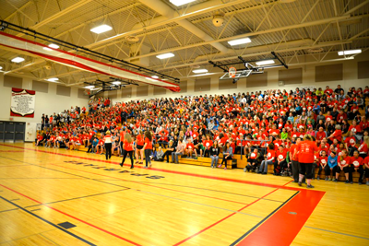
We have a lot of cool events at Lakeview, but the one that stands out the most is our academic pep rallies. Pep rallies are rewards for the kids that have good behavior and good grades. There are usually about 500-600 kids there.
We have them in the month of October and February. They usually start at 2:15 and end at 3:20. When you are at a pep rally, you sit in the bleachers or the floor. We have games and activities. The pep rally usually takes place in the old gym, and we have special guests from different schools and other places.
Most of the time we have drinks and snacks at the pep rally for the kids that were able to go. Cool songs are played like, “Juju on that Beat.”
We just had a really cool pep rally back in October. The theme was Olympics 2016. We had cool games and activities, and it was amazing. The kids were given headbands that stood for their grade and their pride. During the games, students wore their headband for their teams to show support. We had special games called elephant run and dress the graduate. We had a computer that kept the scores, so the kids would know who was in the lead. Overall the seventh grade was the winners.

Garden Club of LMS
By Tres Brown and Hunter Blevins
Sunshine, flowers, and planting can be fun. At LMS we started a garden club for our school. With the garden, we can now plant vegetables, fruits, and flowers, and we have chickens. Mr. Cook and Mrs. Daugherty started the garden club last year. We interviewed Jennifer Hicks, one of the garden club members. She said that she loves the garden club and really thinks after a long day of work at school that being in the garden club is a mind relaxation for her. The garden club meets at 4:30 after school on Tuesdays or Thursdays. This club lasts all year round except winter because it is too cold. The garden club is located at the back of the school between the 7th grade hallway and the 6th grade Warrior Council Room. There are chicken dens and rows filled with flowers for each class that Mr. Cook and Mrs. Daugherty has. The garden club is very good for kids to get involved at our school, and it makes us Warrior Strong!

A Feature of the Gifted Program
By: Kalea Barr , Madison Stroud , Estrella Pacheco
Lakeview Middle School has a lot of school programs, and one of the programs is gifted. We chose to interview Dasia Sewell , a gifted 6th grade student and Mrs.Petty, the gifted ELA teacher. The classes for gifted are located upstairs in the 8th grade hallway, and the teachers that teach gifted are Mr.Phillips, Mrs.Petty, and Mrs.McKown. The classes that are offered to the gifted students are ELA, math, and social studies. It takes responsibility and focus to be a part of gifted classes. For you to be in gifted, you have to pass two tests. One of the tests is something your teachers have to fill out.
The gifted students go over the standards and work on higher levels and take challenges. Mrs.Petty and Mr.Phillips sometimes give out projects for the students to do. Mrs.Petty will give out research projects to her students, and Mr.Phillips going to give out social studies projects. Mrs.Petty does not give homework out on wednesdays or on the weekends unless it is work that you don’t finish in the classroom. Then, the work becomes homework. Mr.Phillips doesn’t give homework at all. The students and Mrs.Petty think that gifted is fun and very interesting.They think that gifted classes are interesting because of it’s projects and the plans that the gifted teachers have in store for the students.
Arts and Entertainment
LMS News
Art

By: Bradley Whitfield & George Krich

Everybody should know our favorite art teacher, Mrs. Patterson. We thought you should know a little bit more about Mrs. Patterson!

She has been teaching since 2001 and has always been the art teacher. She likes art because her grandmother inspired her. If you ask me, her grandmother had a big impact on her life. Her most favorite painting ever is one that her grandmother painted of Mrs. Patterson's daughter.

Here is something that I bet you’ve never heard anyone say, “I feel a different color everyday.” She said it describes her mood and what she is feeling like. It’s very rare to hear something like that.

She doesn’t know who made up the LMS symbol, the warrior, but she would like to know. Lastly, she likes to hangout with her family and craft things with them in her free time.

Autumn and Her Ways of Band
BY: Jamillion Womble, Jaylen Morris-murrell, and Zachary Foster
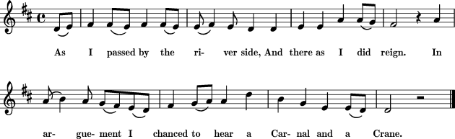
We interviewed Autumn Dickerson, a member of the LMS band for two years. Her favorite song is “ Jingle Bell Rock,” a 1980’s song for Christmas that people still listen to today. Autumn’s favorite instrument is the euphonium, a nice golden brass instrument that makes a nice tune and a nice sound to listen to.
This LMS student plays four to five songs in band everyday . Autumn is very ok with the things that she plays. She likes being in band because she gets to go to Six Flags and concerts. Autumn plays one instrument, which of course is the euphonium.
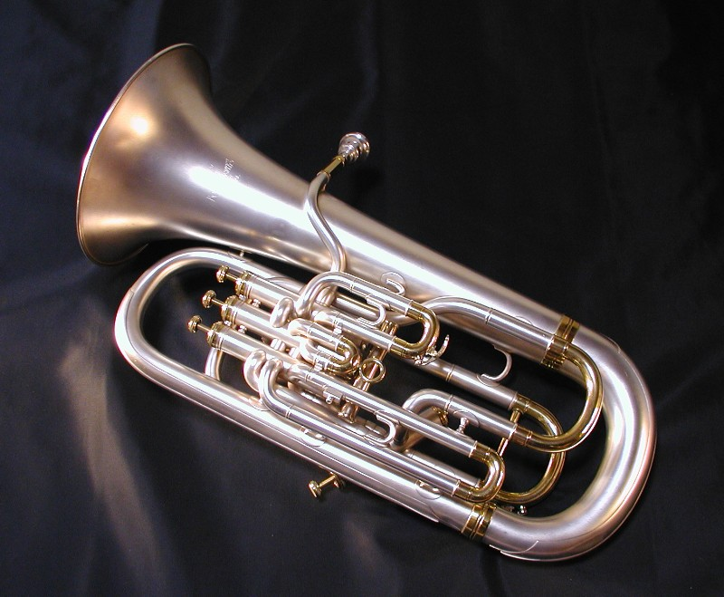

Autumn does band with her friends in her group. She has a lot of friends in the LMS band and goes to football games. She thinks band is important because she gets to do things people usually wouldn't do. The reason she wanted to be in band is because she wanted to learn how to play the euphonium and a couple other instruments one day. Autumn has decided that when she is in band she feels good about herself.

Theater Life
By Amaya Smith and Brianna Brownfield

LIGHTS
CAMERA
ACTION!!!

Community theater is something fun that people can do. There are two people at our school that are in the community theater; they are Mrs. Jenkins and Makayla Ware. We interviewed them to see what they think about community theater and how to get involved. Community theater is where you go and be involved in a play. First, you have to try out. When you try out, you get a script, the words from a play, and you act out the play they give you. If they think that you are good, then they let you in the play. If you make it, then you go and help set up. If you don’t make it, they still want you to help out with the play and sometimes they will let the people that don’t make it be an understudy.
Some of the locations for the community theater are the Colonnade Theater across from the Catoosa County Library, the Chattanooga Theater in Downtown Chattanooga, and the Ringgold Playhouse in the old Ringgold Train Depot.
How can you get involved? Once you have auditioned and made the play, you go and set up for the play that you are going to do. The actors remember their lines by studying them and asking someone to run through them a couple of times so that they can remember them.
Some upcoming plays at the Colonnade are White Christmas and The Princess and the Pea. Some people wonder if the community theater is fun to be in. Mrs.Jenkins and Makayla think that it is fun because you get to meet new people and learn new stuff. What do you think?

If you are intrestered in being in a play, you can go on coloannadecenter.org or call 706-935-9000.

Sports
Home of the Warriors
By:Grace Wright & Mataeya Nintirat

The Lakeview Middle School softball team had a great season, and
the players loved this year a lot. The coaches were great this year because they were loving, kind, and helpful. For the LMS softball team, we interviewed Auna Roffle and Coach Castleberry. Auna said that she loved the attitude that the players had because it kept up good sportsmanship. She wished that she could change the effort that the players gave because they didn’t give it their all. Auna thought that the softball year was better than her last two years she had been on the Lakeview softball team. She thinks that Haley Kendrick gave the best effort because she worked very hard and had a great attitude.
The coaches this year were Johnny Phillips and April Castleberry. Coach Castleberry has been coaching for about 11 years. Coach Phillips has been coaching for 6 years. The first game in 2016 was a home game, and it was against Heritage. The Lakeview softball team lost that game, but the season got better. There were a lot of important players that were hurt during the 2016 softball year, but the team didn’t give up just because of the hurt players. The record for the LMS softball team in 2016 was 8 wins and 6 losses, and that is probably the best for the Lakeview Middle School softball team. Coach Castleberry said that a lot of players gave effort at different times, but she wishes we would have all given the same effort at the same time.

Current Events
Halloween Now and Then BY ; Raveen Flemister and Jer’Metria Gladden

Haunted houses ? Scary stories ? Costumes? Candy? Scary decorations ? I'm definitely not missing out on this holiday. This holiday is known as Halloween. It was originally called “Hallows Eve.’’ It is on october 31 . It was called all hallows eves because hallow means saint.
Halloween first started in Ireland as a festival for the dead called Samhain. People believed the ghosts came back to earth on that night, so people would dress up and leave candy on their front porches to please the spirits.
Halloween has changed over the years because back then you had to dance for candy . Now all you have to say is, “Trick or Treat.” Now days on Halloween kids dress up as a character or animals that they like. They also don’t celebrate for the spirits anymore; they celebrate to have fun and to get candy. Millions of people from all over the world dress up and go trick - or - treating. We polled some of the connections classes at Lakeview Middle School, so we could see who went trick - or - treating this year. 42 8th graders went and 33 did not . 64 7th graders went and 21 did not . In addition 64 6th graders went and 42 kids did not go. These are some out of millions of people who celebrated Halloween this year.

Clown Craze
By Madison Shrader ,Tristen Snyder, and Freedom Saunders

Whoa! Did you see a shadow and hear those leaves crunch? You may wonder what is going on in our generation. Well for starters, there is this clown craze, and it is where people are dressing up like clowns to scare people and lure them in them in the woods. It started off as a prank and has extended much further.

What are these sick people doing? Well they are luring kids into the woods by using money and candy . In Jasper, Georgia two girls claimed that a man dressed in a clown outfit chased them with a machete. On a Sunday in September of 2016, chattanooga police responded to 14 incidents in 24 hours. These clowns are also chasing people up and down the roads and to their vehicles. A clown in Miami actually opened a car door on an 18 year old girl. She was so spooked that she put her car in reverse and laid on the gas and horn.

The sightings have been spotted all around the world but mainly in the United States.They are spotted mainly in the states of South Carolina , Georgia , Ohio, and Alabama. In South Carolina there have been 20% of the state who has spotted clowns. In Georgia there has been 12%. In Ohio there was 14% and in Alabama 18%.

Why is this happening? Well it started off as a joke and has expanded. Apparently, it has gotten to the wrong people and now some people have started a gang theme called Juggalo; they’ve come from Mexico and travelled to different states including Tennessee.

What are the police doing about this nightmare? Well the police are doing everything they can do. They are arresting everyone they see in a clown outfit; the cops are not taking “It’s a joke” for an answer. They have band clown outfits in schools in states like New Jersey. At Lakeview Middle School, principals have stated not to talk about it here on school property. Also, some haunted houses were closed for a few days like Blowing Screams Farm and Ruby Falls Haunted Cavern due to the clown sightings. They have also band clown outfits in the U.S. Police have shut down multiple schools like Red Bank Middle School and schools in Washington state counties like Issaquah county, Mukilteo county, and Pierce county.

If you see or hear a clown go to your parents or call 9-1-1. If one comes up to you or chases, yell as loud as possible and run as fast as you have never ran before until you come across an adult.

The Presidential Election
By: Logan Dunwoody, Josh Brumbaugh, and Josh McCracken

I’m sure many of you like Hillary Clinton or Donald Trump, but do you know who the candidates are and what they are going to do for America? Hillary and Trump have different thinking on lots of important plans. For example, Trump wants to make taxes lower and simpler. Hillary will make taxes higher for the rich. Hillary wants to keep the same healthcare plan, but Trump wants to change it with universal care.

Hillary and Trumps’ backgrounds are very different. Trump was a businessman
and a television star. Hillary was a first lady, a senator, and the secretary of state for President Obama . Also, Hillary is the first woman to be a presidential nominee. Trump has chosen Mike Pence for his vice president, and Hillary has chosen Tim Cane for her vice president.

The election day is November 8, 2016. We asked some LMS students who they would vote for, if they could. The eighth graders voted 7 for Hillary and 5 for Trump. 7th grade said 15 for Hillary and 24 for Trump. Sixth graders voted 17 for Hillary and 33 for Trump. It’s going to be exciting to see who the president is going to be !

