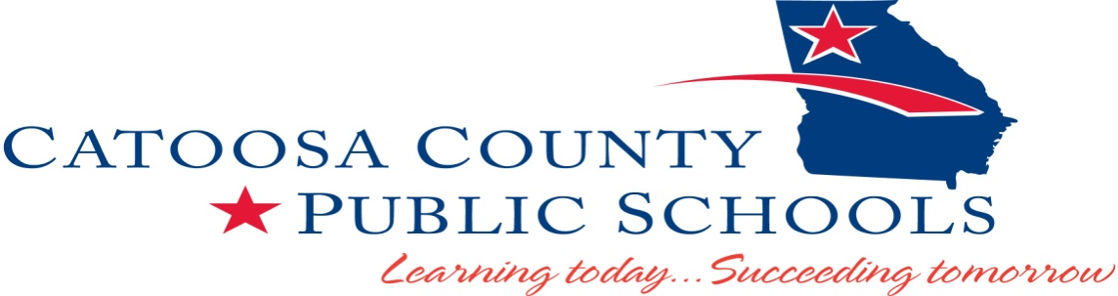

TITLE I SCHOOL DESIGNATION PARENT NOTIFICATION
08-08-2018
Dear Parent(s)/Guardian(s):

The Elementary and Secondary Education Act (ESEA) of 1965 requires that parents or guardians who have children attending a Title I school be notified of how well their school is preparing its students for college and/or a career, as well as the school’s designation status under Georgia’s ESEA Flexibility Waiver.

Under the 2015 renewal of Georgia’s ESEA Flexibility Waiver, certain Title I schools continue to be designated as Reward, Priority, or Focus Schools. The Waiver allows the use of the College and Career Ready Performance Index (CCRPI) as the comprehensive report card for all schools in Georgia, providing a score between 0-100 for each school—measuring how well the school is doing in preparing its students to be successful in college and/or a career.

Ringgold Elementary School’s CCRPI score for the 2017 school year was 72.1. To view the report, go to www.gadoe.org. The report is found under the “Data & Reporting” tab. Click on “College and Career Ready Performance Index” and then “View 2016 CCRPI Reports”. The report is also available in the main office of the school.

I am very proud to tell you that Ringgold Elementary School has not been given a school designation this year, which means we are a Title I school that is continuing to provide a quality education to all of our students.

% of Students  At Levels 3&4 | English Language Arts | Math | Science | Social Studies
3rd Grade | 38% | 53% | NA | NA
4th Grade | 44% | 44% | NA | NA
5th Grade | 41% | 33% | 28% | 21%

The students at Ringgold Elementary are continuing to grow in the areas of ELA and Math.

At Ringgold Elementary, we take pride in the teaching we provide for our children. Our teachers and staff members work very hard to meet the needs of all students to ensure they achieve at their highest potential.

An important part of Ringgold Elementary School’s success is parent participation and support in developing activities to improve student achievement. We hope that you will become involved in our school improvement work as we continue to monitor student achievement and set high expectations. If you are interested in participating in the development of our school improvement plans, being a part of our family engagement team or have questions about how you can better help your child in school, please contact Connie Cawood, Parent Involvement Coordinator at 706-935-2912 or ccawood.res@catoosa.k12.ga.us.

Thank you for all that you do to support your child’s education.

Sincerely,

Kim Erwin, Principal

