The Accounting Cycle

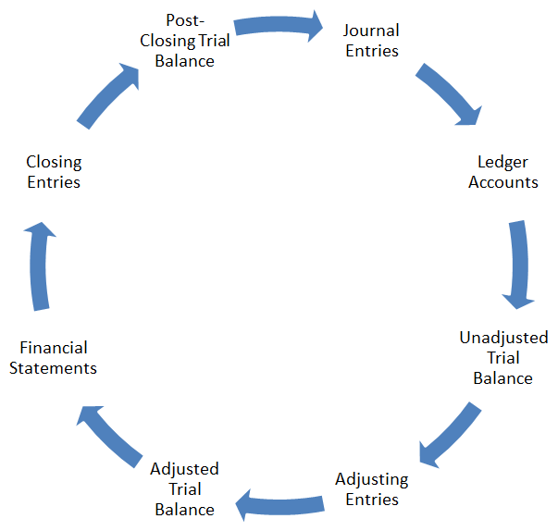

Review the links below:

Eight Steps of the Accounting Cycle

Steps of the Accounting Cycle

Nine Steps of the Accounting Cycle

