Chapter 8: Understanding Populations Lecture Guide

What Is a Population?
- A _____________________________________ is a group of organisms of the ________________ species that live in a specific geographical area and interbreed.
- A population is a __________________________ group because organisms usually breed with members of their own population.
Properties of Populations
- __________________________________ is the number of individuals of the same species in that live in a given unit of area.
- __________________________________ is the pattern of distribution of organisms in a population.
- A population’s dispersion may be even, clumped, or random.
How Does a Population Grow?
- The resulting population change over time can be represented by the equation below:

How Does a Population Grow?
- __________________________________ is an expression of the increase in the size of an organism or population over a given period of time.
- Growth rate =

- Overtime, the growth rates of populations change because birth rates and death rates ______________________________________________________________.
How Does a Population Grow?
- For the growth rate to be zero, the average number of births must _______________________ the average number of deaths.
Reproductive Potential
- A species’ ____________________________________ is the fastest rate at which its populations can grow.
- ______________________________________________ is the maximum number of offspring that a given organism can produce.
  - Examples: Bacteria
Reproductive Potential
- Reproductive potential __________________________________ when individuals produce more offspring at a time, reproduce more often, and reproduce earlier in life.
- Reproducing early ______________________________________ the generation time, or the average time it takes a member of the population to reach the age when it reproduces.
Exponential Growth
- ___________________________________________ is logarithmic growth or growth in which numbers increase by a certain factor in each successive time period.
- Exponential growth occurs in nature only when populations have _____________________________________________________________________________.
- For example, population explosions occur when bacteria or molds grow on a new source of food.
What Limits Population Growth?
- Under the forces of __________________________________________ in a given environment, only some members of any population will survive and reproduce. Thus, the properties of a population may change over time.
Carrying Capacity
- ____________________________________________ is the largest population that an environment can support at any given time.
Resource Limits
- A species reaches its carrying capacity when it _______________________________ a particular natural resource at the same rate at which the ecosystem produces the resource.
- That natural resource is then called a ___________________________________________.
- The supply of the most ______________________________________ limited resources determines the carrying capacity of an environment for a particular species at a particular time.
Competition Within a Population
- Instead of competing for a limiting resource, members of a species may compete indirectly for _____________________________________________________________.
Competition Within a Population
- A _______________________________________ is an area defended by one or more individuals against other individuals.
- The territory is of value not only for the ______________________ but for the _______________________________________________________________ it contains.
Two Types of Population Regulation
- Causes of death in a population may be ______________________________________________________________________.
Population Regulation
- When a cause of death in a population is ____________________________________________, deaths occur __________________________________________ in a crowded population than in a sparse population.
- This type of regulation happens when individuals of a population are ______________________________ packed together.
- _________________________________________________________________________ result in higher rates of death in dense populations than in sparse populations.
Population Regulation
- When a cause of death is ___________________________________________________, a certain proportion of a population _______________________________________ regardless of the population’s density.
- This type of regulation affects all populations in a _____________________________________________________________________.
- _____________________________________________________________________ are often density independent causes of death.
Chapter 8: Understanding Populations Lecture Guide
An Organism’s Niche
- A _______________________________ is the unique position occupied by a species, both in terms of its physical use of its habitat and its function within an ecological community.
- A niche can also be thought of as the _________________________________________________ of a particular species in an ecosystem.
Symbiosis and Coevolution
- ______________________________________ is a relationship in which two different organisms live in close association with each other.
- Symbiosis is most often used to describe a relationship in which ______________________________________________________________________________.
- Overtime, species in close relationships may __________________________________________.
- These species may evolve adaptations that _______________________________________________________________________ of the relationship.
Ways in Which Species Interact
- Interactions between species are categorized at the level where one population interacts with another.
- The five major types of species interactions are:
  - _______________________________________________________
  - _______________________________________________________
  - _______________________________________________________
  - _______________________________________________________
  - _______________________________________________________
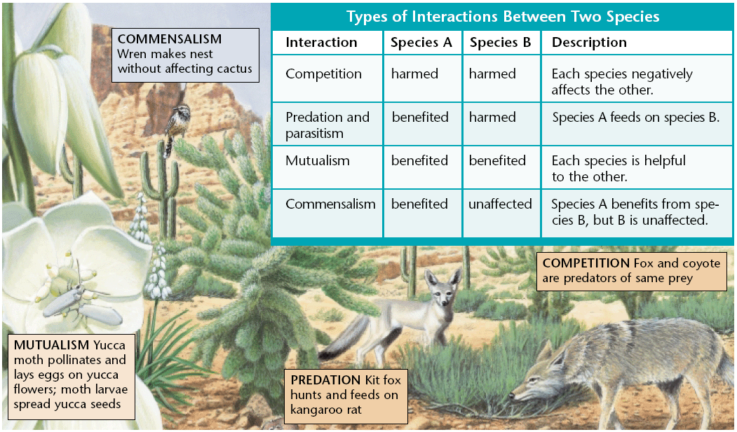

Ways in Which Species Interact
- These categories are based on whether each species causes _________________________________________ to the other species in a given relationships in terms of total effects over time.
Competition
- _____________________________________ is the relationship between two species (or individuals) in which both species (or individuals) attempt to use the same limited resource such that both are negatively affected by the relationship.
- Members of the same species must compete with each other because they _________________________ the same resources because they occupy the same niche.
Indirect Competition
- For example, suppose that one insect feeds on a certain plant during the day and that another species feeds on the same plant during the night.
- Because they use the same food source, the two species are ________________________________________________.
Adaptations to Competition
- But in the course of evolution, adaptations that ____________________________________________________________will also be advantageous for species whose niches overlap.
- One way competition can be reduced between species is by ____________________________________________________________ in time or space.
Adaptations to Competition
- ___________________________________________________________ is when each species uses less of the niche than they are capable of using.
Predation
- ______________________________________________________ is an interaction between two species in which one species, the predator, feeds on the other species, the prey.
Parasitism
- An organism that lives in or on another organism and feeds on the other organism is a _____________________________________.
  - Examples include ticks, fleas, tapeworms, heartworms, and bloodsucking leeches.
- The organism, the parasite, takes its nourishment from is known as the _____________________________.
- _____________________________________________ is a relationship between two species, the parasite, benefits from the other species, the host, and usually harms the host.
Parasitism
- The differences between a parasite and a predator are that a parasite spends some of its life __________________________ the host, and that the parasites do not usually kill their hosts.
Mutualism
- __________________________ is a relationship between two species in which both species benefit.
Commensalism
- ______________________________________ is a relationship between two organisms in which one organism benefits and the other in unaffected.

