SIMULATED SATELLITE SEA ICE DATA

JOE BLOGGS, DEPARTMENT OF GEOPHYSICS, UNIVERSITY OF LONDINIUM

INTRODUCTION

THIS DOCUMENT DESCRIBES THE GENERATION OF SYNTHETIC DATA ON FREEBOARD AND THICKNESS MEASUREMENTS BY THE CRYOSAT ALTIMETER SYSTEM. THE RAW THICKNESS DATA ARE DERIVED FROM MODEL OUTPUTS SUPPLIED BY NERSC WHICH ARE THEN MODULATED TO ACCOUNT FOR THE INSTRUMENTAL AND GEOPHYSICAL ERRORS WHICH ARE LIKELY TO BE INTRODUCED FOR THE REAL SYSTEM. THE ERRORS ARE DERIVED FROM THE INSTRUMENT SIMULATIONS CARRIED OUT IN WP3000 (DOCUMENT REFERENCE) AND BROADLY DEPEND ON SURFACE STATE PARAMETERS INCLUDING ICE CONCENTRATION, THICKNESS, TEMPERATURE AND BACKSCATTER CO-EFFICIENT. THE SURFACE STATE PARAMETERS ALSO GOVERN CIRCUMSTANCES WHERE NO RETRIEVAL IS POSSIBLE ACCORDING TO EXPERIENCE GAINED FROM THE ERS RADAR ALTIMETERS. THE SPATIAL AND TEMPORAL SAMPLING CHARACTERISTICS ARE ACHIEVED USING A SYNTHESISED CRYOSAT ORBIT FOR A PERIOD OF 12 MONTHS.

CRYOSAT ORBIT

FIGURE 1 SHOWS THE CRYOSAT GROUND TRACKS GENERATED BY THE SIMULATOR FOR A PERIOD OF 14 DAYS. THE COMPLETE DATA SET CONSISTED OF 12 MONTHS OF DATA GIVING TIME (IN JULIAN SECONDS FROM JAN1) AND LATITUDE AND LONGITUDE ALONG THE ORBIT TRACKS. POINTS ALONG THE GROUND TRACK ARE GENERATED AT 1 SECOND INTERVALS, EQUIVALENT TO THE TYPICAL SAMPLING FOR SATELLITE ALTIMETER GEOPHYSICAL PRODUCTS. THE FIRST STAGE OF THE SIMULATION WAS TO EXTRACT THE MODEL ICE STATE FOR EACH LOCATION AND TIME FOR WHICH A CRYOSAT OBSERVATION IS PREDICTED. MODEL PARAMETERS ARE PROVIDED AT TWO WEEKLY INTERVALS THROUGHOUT THE YEAR AND THEREFORE THE MODEL GRIDS CORRESPONDING TO THE PARTICULAR TWO WEEK PERIOD ARE EXTRACTED. THE MODEL PARAMETERS OF INTEREST ARE :

- MODEL ICE THICKNESS
- MODEL ICE FRACTION (CONCENTRATION)
- MODEL SNOW THICKNESS
- MODEL ICE TEMPERATURE

THESE PARAMETERS CONTROL WHETHER OR NOT A RETRIEVAL OF WATER OR ICE ELEVATION IS POSSIBLE AND IF SO WHAT THE RETRIEVAL ERROR WILL BE. A FIFTH PARAMETER REQUIRED IS THE BACKSCATTER CONTRAST BETWEEN OCEAN AND ATMOSPHERE WHICH IS OBTAINED USING AN EMPIRICAL RELATIONSHIP BETWEEN ICE BACKSCATTER AND THICKNESS.

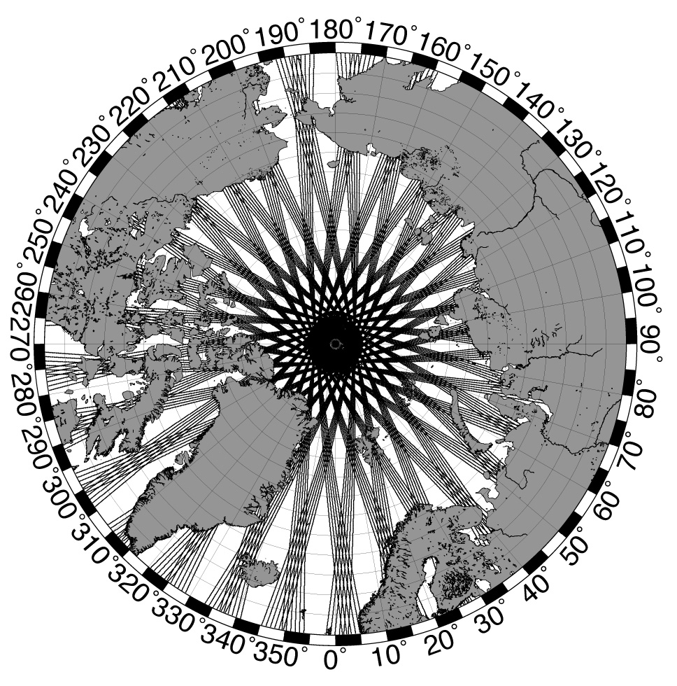
FIGURE 1 CRYOSAT GROUND TRACKS FOR A 14 DAYS OF DATA.

DATA GENERATION PROCEDURES

GENERATION OF NULL DATA

UNDER CERTAIN CONDITIONS RETRIEVAL OF ICE ELEVATIONS IS NOT POSSIBLE. OBSERVATIONS FROM ERS INDICATE THAT AS THE SURFACE TEMPERATURE APPROACHES THE MELTING POINT THE LOCATION OF THE SURFACE REFLECTION BECOMES AMBIGUOUS. THIS IS LIKELY TO OCCUR ONCE THE SURFACE SNOW LAYER PASSES THROUGH ONE THAW/MELT CYCLE. COMPARISONS OF ERS ICE THICKNESS TIME-SERIES WITH SURFACE TEMPERATURES SUGGEST THIS TRANSITION OCCURS WHEN THE MEAN SURFACE TEMPERATURE EXCEEDS –5°C. THE SECOND CONDITION UNDER WHICH ICE RETRIEVALS WILL NOT BE POSSIBLE OCCURS WHEN ICE CONCENTRATIONS FALL BELOW A CERTAIN THRESHOLD. THE INSTRUMENT SIMULATIONS (WP3000) SUGGEST A LOWER LIMIT OF 70% IS A REASONABLE LOWER LIMITS. IF EITHER OF THESE THRESHOLDS IS EXCEEDED A ‘NULL’ VALUE OF ICE THICKNESS (-999) IS GENERATED.
NULL DATA ARE ALSO GENERATED AT RANDOM ACCORDING TO THE INVERSE OF THE PROBABILITY OF AN ICE RETURN OCCURRING AT ANY GIVEN LOCATION. HENCE FOR PICE = 0.1 A NULL RETURN WILL BE GENERATED FOR 9 OUT OF TEN DATA POINTS EVEN IF THEY SATISFY THE CONCENTRATION AND TEMPERATURE REQUIREMENTS. PICE IS DETERMINED USING TO THE INPUT MODEL ICE. THE CHANGING PROBABILITY OF AN OCEAN RETURN DOES NOT INFLUENCE THE GENERATION OF ‘NULL’ DATA SINCE AN OCEAN RETURN IS NEVER IN ANY CASE CO-INCIDENT WITH AN ICE RETURN. IT IS ASSUMED THAT THE OCEAN USED IN ANY ICE ELEVATION RETRIEVAL TO BE OBTAINED USING AN AVERAGE OVER A DISTANCE OF 100KM EITHER SIDE OF THE ICE ELEVATION ESTIMATE. INSTEAD THE OCEAN RETURN PROBABILITY AFFECTS THE ERROR IN OCEAN.

ICE THICKNESS ERROR MODULATION

THE FIRST STEP IS TO COMPUTE THE MODEL ICE THICKNESS TO ICE FREEBOARD, THAT IS THE LEVEL ABOVE THE WATER SURFACE OF THE SNOW/ICE INTERFACE. SNOW THICKNESS IS OBTAINED FROM THE MODEL AND FIXED VALUES ARE USED FOR THE DENSITIES OF SNOW ( ), ICE ( ) AND WATER ( ).
ONCE CALCULATED A RANDOM ERROR IS APPLIED TO THE MODEL FREEBOARD ACCORDING TO THE ERROR VARIANCE TO OBTAIN THE OUTPUT ICE FREEBOARD. THIS MODULATED FREEBOARD IS THEN CONVERTED BACK TO THICKNESS USING THE SAME MATERIAL DENSITIES AND THE MODEL SNOW THICKNESS BUT THIS TIME WITH A RANDOM ERROR TO ACCOUNT FOR THE LIKELY ERROR IN SNOW THICKNESS ESTIMATION (CURRENTLY 0.2CM). CALCULATION OF THE ICE ELEVATION ERROR VARIANCE ( ) IS DESCRIBED IN EQUATION 2 AND THE MEAN OCEAN ELEVATION ERROR VARIANCE ( ) IN EQUATIONS 3 AND 4.

ESTIMATION OF BACKSCATTER CONTRAST

THE RADAR BACKSCATTER CONTRAST BETWEEN OCEAN AND ICE AFFECTS THE ACCURACY OF RETRIEVALS AND THEREFORE MUST BE ESTIMATED FOR ANY PARTICULAR LOCATION AND TIME OF YEAR. A FIXED BACKSCATTER CO-EFFICIENT OF 40DB WAS ADOPTED FOR THE SMOOTH OCEAN SURFACE/NEW ICE WHICH ARE FREQUENTLY ENCOUNTERED IN THE POLAR REGIONS AND IN THE ABSENCE OF OTHER INFORMATION IS CONSIDERED REASONABLE. TO ESTIMATE ICE BACKSCATTER WE DERIVED AN EMPIRICAL RELATIONSHIP USING DATA FROM THE ERS ALTIMETER SHOWN IN FIGURE 2.
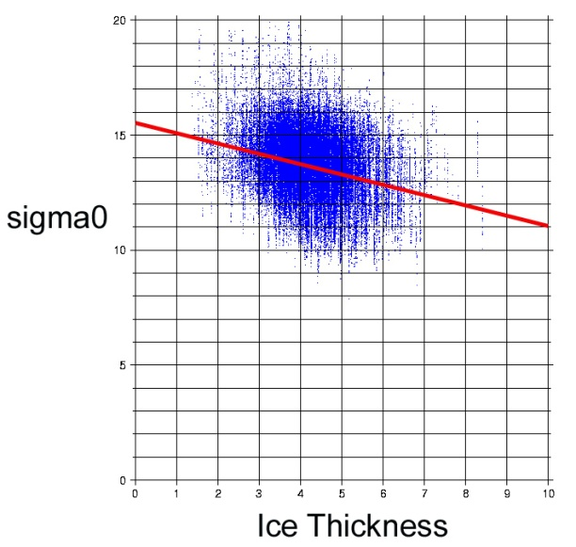

FIGURE 2 OBSERVED ICE BACKSCATTER CO-EFFICIENT (DB) AND ICE THICKNESS (METRES) FROM ERS OBSERVATIONS OBTAINED BETWEEN JAN-MAR 1997. THE LARGE SCATTER IN POINTS IS DUE TO NOISE ON INDIVIDUAL RETRIEVALS.

THE LSQ FIT TO THE DATA SHOWN IN FIGURE 2 YIELD THE FOLLOWING RELATIONSHIP BETWEEN ICE THICKNESS AND NORMAL INCIDENCE BACKSCATTER CO-EFFICIENT AT 13 GHZ :

EQUATION 1

THIS IS USED TO ESTIMATE ICE BACKSCATTER FROM THE INPUT MODEL ICE THICKNESS AND HENCE ICE-OCEAN BACKSCATTER CONTRAST.

ESTIMATION OF FREEBOARD VARIANCE

ASSUMING THAT AN ICE THICKNESS ESTIMATE IS OBTAINED (I.E. NOT A ‘NULL’ MEASUREMENT) THEN THE ERROR VARIANCE IN ICE FREEBOARD MUST BE COMPUTED WHICH IN TURN DEPENDS ON THE ERROR VARIANCES OF THE WATER AND ICE ELEVATIONS. THESE ARE DERIVED FROM THE MODEL SURFACE STATE USING THE INSTRUMENT SIMULATION RESULTS (WP3000). AS AN EXAMPLE WE NOW DEAL WITH THESE ESTIMATES. THE ERROR VARIANCE IS THEN USED TO RANDOMLY SELECT A VALUE FROM A NORMAL DISTRIBUTION. FIGURE 3 IS AN EXAMPLE OF THE DISTRIBUTION OF ICE THICKNESS WHICH WOULD BE EXPECTED FOR A MEAN OF 2 METRES AND A STANDARD ERROR OF 1 METRE.
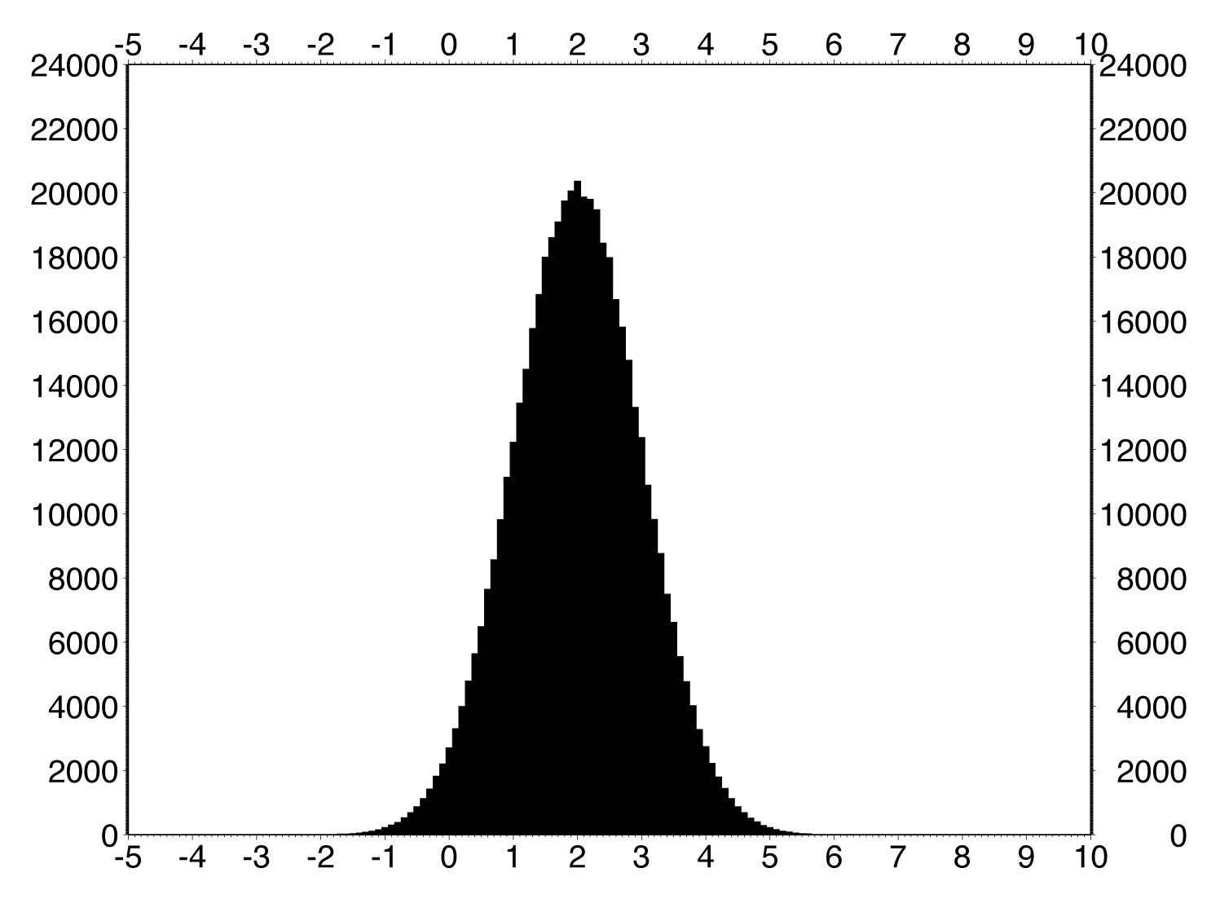

FIGURE 3 EXAMPLE OF OUTPUT ICE THICKNESS FOR A MEAN THICKNESS OF 2 METRES AND STANDARD DEVIATION OF 1 METRE. THE FIGURE SHOWS THAT THE OUTPUT DATA CAN INCLUDE NEGATIVE ICE THICKNESS.

PROBABILITY OF ICE/WATER RETRIEVALS

THE PROBABILITY OF ICE RETRIEVALS IS USED IN THE ‘NULL’ RETURN LOGIC WHILST THE OCEAN PROBABILITY IS USED IN THE OCEAN ELEVATION ERROR VARIANCE, HENCE WE DEAL WITH THESE HERE. THE SIMULATIONS INDICATE THAT THE PROBABILITY OF AN OCEAN/ICE RETRIEVAL IS DOMINATED BY THE ICE CONCENTRATION AND THAT OTHER EFFECTS (DUE TO BACKSCATTER CONTRAST, ICE THICKNESS) ARE NEGLIGIBLE.

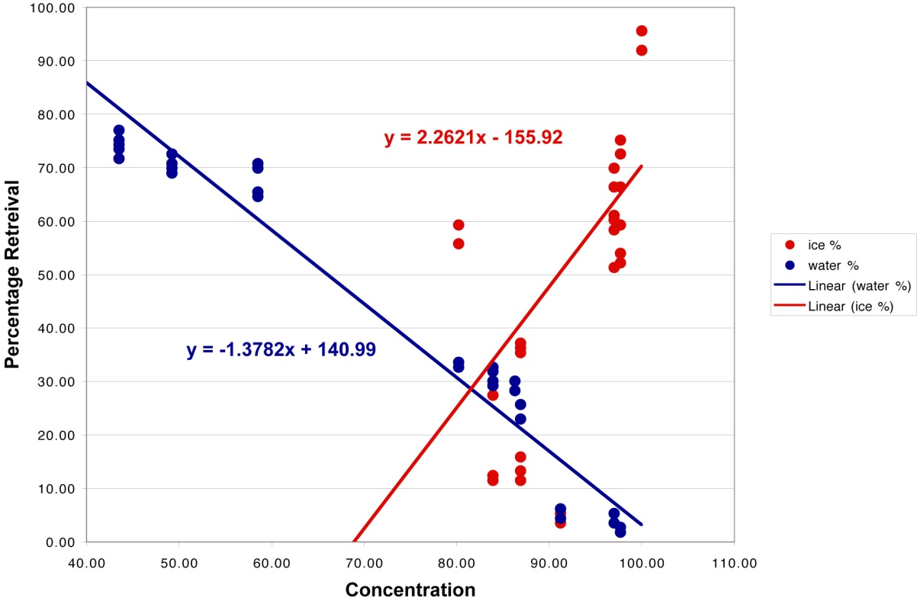

FIGURE 4 ICE/OCEAN RETRIEVAL PROBABILITIES DETERMINED FROM INSTRUMENT SIMULATIONS.

FIGURE 4 SHOWS THE PERCENTAGE RETRIEVALS FROM THE MODEL SIMULATIONS. THE LINEAR FITS SHOWN ARE TAKEN TO REPRESENT A REASONABLE ESTIMATE OF THE FIRST ORDER DEPENDENCE ON ICE CONCENTRATIONS. THE REGRESSION COEFFICIENTS SHOWN ARE USED TO ESTIMATE THE PROBABILITIES OF ICE/OCEAN RETURNS USING THE INPUT MODEL ICE CONCENTRATIONS.

ICE/OCEAN ELEVATION RETRIEVAL ERROR VARIANCE

INSTRUMENT SIMULATIONS PROVIDED ESTIMATES OF THE RMS DIFFERENCES BETWEEN INPUT AND RETRIEVED ELEVATIONS OF THE OCEAN AND ICE SURFACE ELEVATION FOR A GIVEN INSTRUMENT SURFACE MODEL. THIS ENABLES US TO ESTIMATE THE TOTAL ERROR DUE TO THE DIFFERENT COMBINATIONS OF ICE CONCENTRATION, THICKNESS AND BACKSCATTER CONTRAST. ONE CONSEQUENCE HOWEVER IS THAT IT IS NOT POSSIBLE TO ESTIMATE THE ERROR CONTRIBUTION OF EACH EFFECT INDEPENDENTLY. FORTUNATELY ONE VARIABLE, ICE CONCENTRATION DOMINATES THE ERROR VARIANCE OF RETRIEVALS. WITH BACKSCATTER CONTRAST AND ICE THICKNESS PLAYING A MUCH MORE MINOR ROLE. THE STRATEGY ADOPTED THEREFORE WAS TO FIRST ESTIMATE THE TOTAL ERROR VARIANCE ACCORDING TO ICE CONCENTRATION ALONE AND THEN MODULATE USING THE BACKSCATTER CONTRAST AND THICKNESS. LINEAR FITS WERE USED TO ESTIMATE THE PARTIAL DERIVATIVES OF ERROR VARIANCE AGAINST THE THREE CONTROLLING PARAMETERS AS SHOWN IN FIGURE 5. THE FITS ARE USED TO ESTIMATE THE PARTIAL DERIVATIVES OF ERROR VARIANCE AS SHOWN IN TABLE 1.

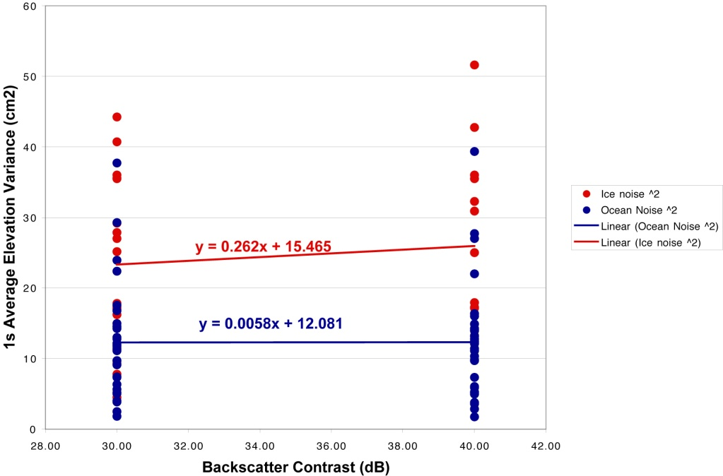
FIGURE 5 ICE/OCEAN ELEVATION VARIANCE DEPENDENCE ON BACKSCATTTER CONTRAST.

RANGE
-1.24 | -0.021 | 70-100
0.262 | 0.0058 | 30-40
0.0611 | 0.1439 | 1.6 – 6.4

TABLE 1 ICE/OCEAN PARTIAL DERIVATIVES OF ERROR VARIANCES VERSUS ICE CONCENTRATION ( ), BACKSCATTER CONTRAST ( ) AND ICE THICKNESS ( ). THE PARTIAL DERIVATIVE WHEN COUPLED WITH THE RANGES, INDICATE THAT ICE CONCENTRATION DOMINATES THE ERROR IN RETRIEVALS.

THE ICE/OCEAN ELEVATION ERROR VARIANCES ARE CALCULATED AS FOLLOWS :

EQUATION 2
EQUATION 3

THE ICE ELEVATION ERROR VARIANCE IS USED DIRECTLY IN THE CALCULATION SHOWN IN FIGURE 3. THE DEPENDENCE OF OCEAN ELEVATION ERROR VARIANCE ON BACKSCATTER CO-EFFICIENT IS NEGLIGIBLE AND IS THEREFORE NEGLECTED. THE ERROR REQUIRED FOR THE OCEAN SURFACE IS THE ERROR IN THE MEAN OCEAN ELEVATION ERROR VARIANCE ( ), I.E. THE ERROR IN THE OCEAN ELEVATION AVERAGED OVER SOME DISTANCE AROUND THE ICE ELEVATION OBSERVATION. THIS ERROR IS DEPENDENT ON THE ERROR VARIANCE OF AN INDIVIDUAL OCEAN ELEVATION ESTIMATE, THE AVERAGING DISTANCE AND THE PERCENTAGE OF OCEAN RETRIEVALS AVAILABLE IN THE AREA.

