COLLEGE PENNANT PROJECT
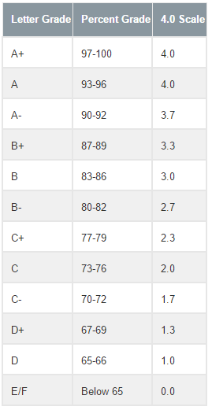
Directions: Since you are about to embark on the college application process, you’re going to need to do some research first. For this assignment, you will research a college you are interested in applying to and then use the information to create a pennant. These will be displayed in the classroom and hallway, so you will be able to get exposure to a variety of colleges and universities.

Include the following information on your pennant:
- Name and location (city and state) of college
- Mascot
- Total undergraduate student enrollment
- Percentage of accepted students
- Tuition (include room and board if that is an option)
- Average GPA and SAT scores of accepted students
- Five most popular Bachelor degrees
- At least two additional interesting piece of information about the college

Other requirements:
- Your pennant should look like a pennant. Use the template provided.
- Make sure the name of the college is large, readable, and the focal point
of your pennant
- Use the color(s) of your college to decorate your pennant
- Neatly write the required information on your pennant. Do not just print out information and paste it onto your pennant.
- Pictures, logos, etc. must be related to the college and need to be in color.
- Select a college that is within your current academic range. Don’t go more than half a point more or below your average, so that the college you select is within your range. For example, if your average is a 2.0, you can select a school where the average is a 2.5 to a 1.5.
- For help researching colleges, go to collegeboard.com and select “College Search” in the blue bar at the top of the page.
GRADING RUBRIC
Grading Criteria | Points Possible | Points Earned
Use of school colors | 10
College name is visible and stands out and includes location | 10
Mascot | 5
Student enrollment | 5
Percentage of accepted students | 10
Tuition and room and board | 10
Average GPA and SAT scores | 10
Five popular bachelor’s degrees | 10
Two interesting pieces of information | 10
Creativity and neatness | 10
Grammar and mechanics | 10
TOTAL | 100

