Byzantine Empire Visual Discovery
Images and Descriptions come from Metropolitan Museum of Art “The Byzantine State Under Justinian” Exhibit
http://www.metmuseum.org/toah/hd/just/hd_just.htm#thumbnails

#1 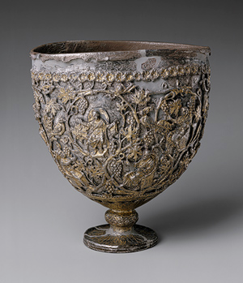
“When it was discovered at the beginning of the twentieth century, this "chalice" was claimed to have been found in Antioch, a city so important to the early Christians that it was recognized with Rome and Alexandria as one of the great sees of the church. The chalice's plain silver interior bowl was then ambitiously identified as the Holy Grail, the cup used by Christ at the Last Supper. The elaborate footed shell enclosing it was thought to have been made within a century after the death of Christ to encase and honor the Grail. The fruited grapevine forming the rinceau pattern of the gilded shell is inhabited by birds, including an eagle; animals, including a lamb and a rabbit; and twelve human figures holding scrolls and seated in high-backed chairs. Two of the figures are thought to be images of Christ. The other ten figures have been variously identified as ten of the twelve apostles, or philosophers of the classical age, who, like the prophets of the Old Testament, had foretold the coming of Christ. The sixth-century chronicler Malalas of Antioch was among those who sought to make such links between Christianity and classical philosophy.

The identification of the "Antioch Chalice" as the Holy Grail has not been sustained, and even its authenticity has at times been challenged. The work has usually been considered a sixth-century chalice for the Eucharist. Most recently, however, its shape has been recognized as more closely resembling sixth-century standing lamps, its decoration possibly in recognition of Christ's words "I am the light of the world" (John 8:12). It has been argued to be part of a treasure of liturgical objects found in 1908 belonging to the Church of Saint Sergios in the town of Kaper Koraon southeast of Antioch. If so, Saint Sergios' parishioners might well have traveled to Antioch to purchase the object as a donation for their church. Or it may have been used in one of the churches in or near Antioch.”

#2 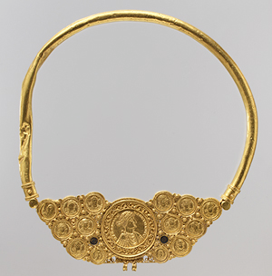

“This imposing neck ring may have been made for an aristocrat or general associated with the Byzantine court. The large central medallion, formed from two gold sheets worked in repoussé, depicts an unidentified emperor on the front and a personification of a city, probably Constantinople, on the back. The gold coins date from Theodosius II (r. 408–50) to 539, when Justinian (r. 527–65) changed his portrait type, suggesting that the necklace was made about this time. A framed, solid-gold imperial medallion of Theodosius I (r. 379–95), found in the same hoard, probably once hung from the pectoral”

#3 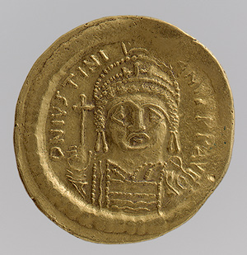
“Coins connected an emperor to his subjects. Through inscriptions and images, they conveyed imperial ideals and commemorated auspicious events. The emperor paid the army and received taxes in coins, and he was responsible for maintaining their weight and purity. This coin was minted under Justinian, whose preference for a completely frontal portrait—rather than the traditional profile—would set a standard for the rest of Byzantine history.”

#4 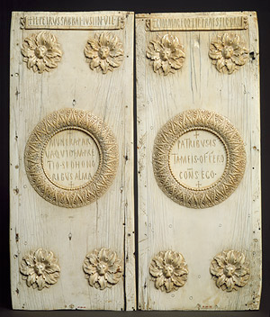
“Justinian, who would be the greatest emperor of the Early Byzantine period, presented these handsome ivory panels to a member of the Roman Senate announcing his election as consul, once the highest rank in the Roman state and still one of great honorific importance. The eight elegantly carved lion's heads surrounded by acanthus leaves at the borders of the panels focus attention on the inscriptions written in Latin, the official language of the empire. Across the top of the panels is the donor's name and titles: "Flavius Petrus Sabbatius Justinianus, noble, officer, and chief of the cavalry and commander-in-chief of the infantry and consul entering his office at the proper time"; in the center medallions is "These gifts, slight indeed in value but rich in honors, I as consul offer to my senators." Only the small crosses at the top and bottom of the central medallions offer evidence of the donor's religion.Once hinged together with the names of the other consuls inscribed in wax on the interior, these panels were probably presented as an invitation to the great public games that new consuls hosted in Constantinople's hippodrome (stadium). Earlier consular diptychs, also of ivory, often displayed events from the games, including animal fights and gladiator contests.”

#5 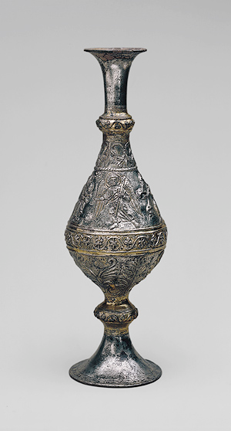
“In the varied depictions of the events of the life of Christ that appear in the art of the early church, some have details that later were omitted from the more usual narratives of the event. Here the three Magi come to offer their gifts to the Christ Child sitting upright in his mother's lap. Her high-backed latticework chair resembles those holding the seated figures, including Christ, on the "Antioch Chalice," a work close in date. Above the Christ Child is the star described in the Gospel of Matthew (2:1–12) as having led the three wise men to Christ. In addition, the archangel Gabriel is shown dramatically striding forward presenting the three Magi with their gifts to the Christ Child. The archangel is described as their guide only in the Armenian Infancy Gospel, a popular early text elaborating the gospel descriptions of Christ's early life. At the base of the flask are phoenixes, birds whose legendary rebirth from the ashes of a fire may have been meant to symbolize the salvation offered by Christ's birth. With its unusual iconography, or imagery, this work may have been used by any of the Christian communities in the East.”

#6 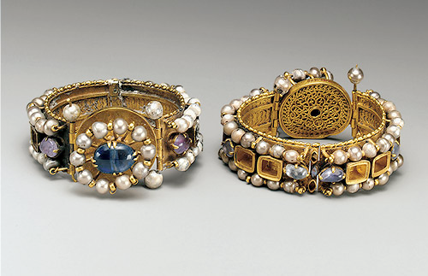
“These elaborately decorated bracelets have richly jeweled exteriors and finely detailed opus interassile (openwork) patterns on their interiors. The luminous beauty of pearls was highly prized in the Byzantine world. These bracelets are only two of thirty-four pieces of gold jewelry from Egypt said to have been found near Lycopolis (now Assiut) or Antinoopolis (Antinoe, now Sheik Ibada) in Egypt at the turn of the century. Whether discovered together, or later assembled, they represent the standard of luxury common among the elite in Egypt during the period of Byzantine rule and the close connections between the wealthy province and the capital in Constantinople. Multicolored, or polychrome, jewelry was very popular in the Early Byzantine world.”

#7 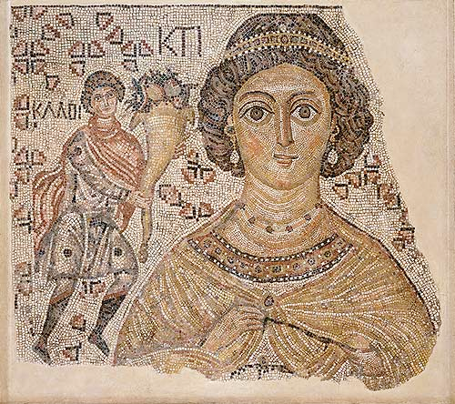
“The bust of a richly bejeweled woman stares from this fragment of a floor mosaic that was once part of a large public building. The partially restored Greek inscription near her head identifies her as Ktisis, the personification of the act of generous donation or foundation. To emphasize her role as donor, she holds the measuring tool for the Roman foot. On her right a man extends a cornucopia toward her as if offering a gift; the Greek word for "good" is near his head. Originally a similar figure probably appeared to her left, and an inscription by his head would have completed the legend "Good wishes."
The classical tradition of personifying abstract ideals continued during the Christian era in many places around the Mediterranean basin, including Antioch (modern Antakya, Turkey), Cyprus, and North Africa. The carefully arranged and sized marble and glass tesserae forming this floor fragment are typical of the exceptional mosaics created throughout the Byzantine world in the 500s.”

#8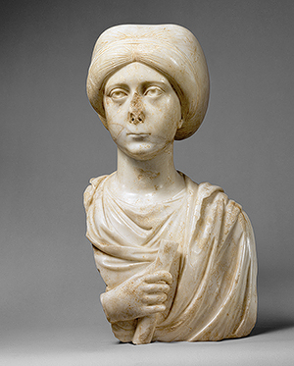
“This superbly carved portrait bust presents a pensive woman with a compelling gaze. She holds a scroll, the symbol of an educated person. The delicate, sensitive carving and the highly polished finish suggest that it was carved in Constantinople, capital of the Byzantine empire, perhaps as the funerary monument of a leading member of the imperial aristocracy. Her long fingers draw attention to the scroll in her hand, indicating her pride in being recognized as among the educated elite in an era that prized learning for both men and women.”

Byzantine Empire Visual Discovery
 | Describe this work of art; what do you see? What is it made of? What was it used for? Etc. | What does this artifact tell you about the Byzantine Empire? | What evidence of other civilizations and cultures can you see in this artifact from the Byzantine Empire?
1
2
3
4
5
6
7
8

